JOB DESCRIPTION

1. JOB IDENTIFICATION
Job Title: Quality Manager

Responsible to: Quality & Safety Improvement Lead

Department(s): Medical Education

Directorate: Medical Education Directorate (MED)

Job Reference: 214019

No of Job Holders: 1

2. JOB PURPOSE
To work with, support and report to the Quality & Safety Improvement Lead in the implementation of a Quality Management system within the Medical Education Directorate. Responsible for the Project Management of improvement projects and quality infrastructure across MED. Assisting teams in accessing and using data appropriately to inform quality planning, improvement and control activities. Where appropriate lead on improvement projects utilising quality improvement tools and methodology.

Assist with organisation, communication and delivery of improvement coaching, training and events including managing relevant MED webpages and Teams channels.

The Quality Manager will support the team with administration and reporting relating to Deanery processes, visits and action plans.

The Quality manager will also manage the recognition and approval of trainers process across NHS Lothian in keeping with the GMC Recognition of Trainers policy, the Greatix/Datix administration and manage JISC access across the Directorate.

3. DIMENSIONS
NHS Lothian employs 25% (1200) of Scottish postgraduate Doctors in training (DiT) and hosts 850+ University of Edinburgh (UoE) Medical School students on their clinical placements. There are 900 medical trainers (Consultant/SAS) in NHS Lothian who are supported to meet the standards set by the General Medical Council for recognition as a named trainer; there are strong correlations between satisfaction with the educational and training experience (undergraduate and postgraduate), the quality and safety of care provided to our patients and the recruitment and retention of staff within our Health Board area.

Staffing Responsibilities:
The post may involve supervision and oversight as and when Education Managers and Administration staff are involved in project support, including allocation of work, review and mentorship.

NB: The number of staff being coached or supervised will vary throughout the lifecycle of an improvement project, depending on the phase and scope of supported projects and resources required within a programme of work.

Financial Responsibilities:

Responsible for managing and operating within a project-specific budget approx. £500 - authorising additional hours payments and staff travel expenses within agreed project-specific budgets agreed with senior staff.

Purchase and request goods/services to support allocated project using Pecos, receipt goods and maintain a record of project income and expenditure.

The postholder is employed within NHS Lothian and there may be a requirement to work flexibly meet service demands.

4. ORGANISATIONAL POSITION
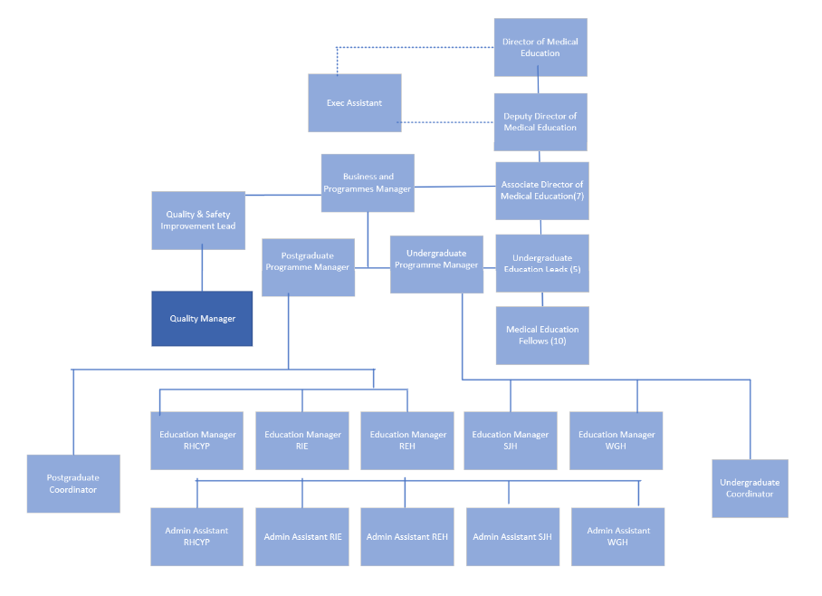

5. ROLE OF DEPARTMENT
The Medical Education Directorate has responsibility for ensuring that NHS Lothian provides education and training in line with the GMC standards in all aspects of undergraduate and postgraduate medical education and training. The directorate infrastructure has been aligned to the NHS Lothian general management structure and encourages close working relationships with clinical and non-clinical management. As the 2nd largest territorial Board in Scotland, NHS Lothian is one of the UK’s major Local Education Providers (LEPs). Through its Director of Medical Education, the Board influences Scottish and UK national training policies. The directorate acts as a conduit between service providers and relevant external agencies, e.g., University of Edinburgh Medical School, NHS Education for Scotland, and the General Medical Council. The Directorate ensures that appropriate systems and processes are in place to ensure NHS Lothian meets the requirements and standards set out by the General Medical Council (GMC), NHS Education for Scotland (NES) and the University of Edinburgh Medical School. The Directorate has responsibility for ensuring that NHS Lothian can demonstrate Medical Education programmes are delivering the standards as set and intervenes where standards are not being met through the development of improvement programmes with clinical and non-clinical managers in these areas.

6. KEY RESULT AREAS
Project management

- Responsible for supporting and where appropriate leading aspects of the Quality Programme within the Medical Education Directorate. Using formal QI planning methodology and appropriate data/intelligence to ensure that work is aligned to organisational and directorate priorities.

- Planning areas of improvement using data and intelligence and coordinating improvement projects to ensure successful completion. This may involve some or all of the following: establishing a steering group, background research, identifying or developing standards/guidelines to audit, identifying and resolving resource issues, developing robust data collection tools and data management systems, statistical analysis, evaluation and presentation of results, supporting change management and re-audit, keeping stakeholders informed throughout.

- Contribute to the successful development, implementation, and continual evaluation of the Medical Education Quality Management System ensuring all work adheres to NHS Lothian policies and procedures.

- Work closely with all teams across the directorate and support them in identifying and prioritising quality initiatives, accessing and appropriately using educational and experience evaluation data to inform quality planning, improvement and control activities.

- Support the Quality & Safety Improvement Lead with the organisation, promotion and delivery of improvement coaching, training and events within the sphere of Medical Education.

- Undertake administration and reporting relating to Deanery processes, visits and action plans and act as a source of advice and guidance for work required to understand the system and undertake improvements.

- Manage the recognition and approval of trainers across Lothian in keeping with the GMC Recognition of trainers policy.

- Collate, analyse and report Greatix/Datix data to recognise and celebrate the contribution of people working in NHS Lothian, and identify potential need for improvement across sites.

- Design and coordinate quality improvement projects to increase the likelihood of successful completion by ensuring the scope, aims, measures and key success factors of projects are clearly set out to optimise successful delivery, and quality improvement methodology and tools are utilised.

- Provide support for the development, implementation, and evaluation of data management systems.

- Provide analytical and statistical support and advice on a range of projects to ensure a high quality of project work. For example: through coaching, and creating charts (such as run charts, pareto charts) and dashboards in Excel from available data.

- Work in collaboration with the Quality and Safety Improvement lead to inform and establish standard operating procedures.

Financial management

- Support the Quality and Safety Improvement Lead in delivering against budget, including cost control, tracking and reporting as appropriate to local and national Project Boards of all local Project Costs.

- People management Deliver Quality Improvement coaching and training for staff to develop knowledge and skills and provide support throughout the life cycle of quality improvement projects within the context of a Quality Management System.

- Provide supervision and facilitation, using a range of quality improvement tools and techniques to enable Education Manager and other staff to progress quality improvement projects and programmes.

Communications

- As a key member of the Medical Education Directorate, responsible for compiling, co-ordinating and inputting (as appropriate) into regular reports, briefings and papers on the progress of all Quality workstream initiatives for sites, the board and the Deanery, identifying areas of risk which may impact on achievement of projects objectives and overall performance.

- Transform data gathered from the GMC National Training Survey, the Scottish Training Survey and University of Edinburgh into intelligence through analysis and engagement with the system and use this to inform priorities for improvement.

- Provide and constantly improve upon the quality, presentation and understanding of data and stories linked to internal initiatives and programmes to our network of internal and external contacts; DiTs and Faculty as our key service users.

- Engage with individuals and teams across sites utilising leadership skills and data to influence, inform and engage.

- On a regular basis, work with the Quality & Safety Improvement Lead to analyse the Quality workstream alongside other key MED workstreams and programmes, and convert this into relevant high-level management information reports (quantitative and qualitative) that will inform decision making.

- Responsible for supporting and where appropriate leading on a communications strategy for Quality within the Directorate and beyond, including managing relevant MED webpages and Teams channels ensuring there is a high level of awareness, that vital information is shared and that key learning points and good practice are disseminated effectively.

- To support NHS Lothian’s values of quality, teamwork, care and compassion, dignity and respect, and openness, honesty and responsibility through the application of appropriate behaviours and attitudes.

7a. EQUIPMENT AND MACHINERY
The following are examples of equipment which will be used when undertaking the role:

Personal Computer – for audio/visual presentations during meetings.
Laptop and projector– for audio/visual presentations during meetings.
Telephone.

Note: New equipment may be introduced as the organisation and technology develops, however training will be provided.

7b. SYSTEMS
The post-holder will use Microsoft Office 365 packages to: Create reports. Create, maintain, update databases and spreadsheets including for financial and performance monitoring. Analyse complex data using Excel and data dashboards. Carry out email communications and use the Internet. Manage an electronic diary. Devise and deliver presentations. Store data electronically. NES Turas. Jisc survey and Microsoft forms platform for surveys and evaluations.

8. ASSIGNMENT AND REVIEW OF WORK
The postholder will be required largely to manage their own day-to-day workload and priorities across a portfolio of projects to support various teams and priorities across the Medical Education Directorate.

The post holder will agree annual priorities with the Quality and Safety Improvement Lead and through close working with Business and Programmes Manager and senior leadership team prioritise projects accordingly.

Review of work will be with the Quality & Safety Improvement Lead on a bi-annual basis though eKSF and appraisal conversations. Specific objectives will also be agreed and reviewed on a regular basis and appraisal of performance will be undertaken formally on an annual basis.

The post holder will be expected to manage their own workload and to ensure the effective delivery of the Medical Education Directorates Quality framework and improvement strategy.

9. DECISIONS AND JUDGEMENTS
Problems and issues will need to be anticipated, addressed and resolved on a daily basis without being referred to the line manager. E.g.: managing competing priorities, balancing emergent work with cyclical activity such as medical staff rotation and deanery reporting processes.

The post holder is expected to lead, plan, prioritise and deliver upon Quality Improvement initiatives and support team members in gaining access to relevant data to inform decision making. They will be responsible for the assignment of work to team members including senior staff and tracking progress to ensure work is completed on time and to the correct specification.

The post holder will make judgements in the work they are leading or advising on informed by data and intelligence to make decisions in line with NHS Lothian and directorate priorities e.g. in the development, focus and prioritising of projects, identifying appropriate change ideas to test; and developing action plans both within the medical education team and in clinical areas.

The post holder delegates, agrees time-scales for, and supervises the work of Education Managers and Administration staff undertaking or supporting improvement in order to achieve expected results.

Responsible for reporting progress on specialised area(s) of work to senior clinicians, relevant committees and managers utilising data and intelligence to inform decision making. This could include signals for where improvements are required, insights about the issue in hand, and data indicating the impact of efforts to make improvements.

Requirement to anticipate, identify and provide solutions to a variety of complex operational issues E.g.: offering advice and coaching to a broad range of projects, including those where work is needed to fully understand why issues are occurring, where workstreams involve different services/organisations, or where previous efforts have not led to sustained improvement.

10. MOST CHALLENGING/DIFFICULT PARTS OF THE JOB
The post holder will be expected to challenge/review and support managers and clinicians and be confident in their ability to influence senior colleagues within the organisation. This may involve dealing with distressed members of staff and requires the post-holder to maintain respectful interactions while delivering unpopular decisions i.e. needing staff to engage with data regarding priorities across their site on top of existing workload.

The postholder will be responsible for managing a range of improvement projects from design stage through to implementation and reporting the final results, whilst in others it may be more appropriate to provide advice and influence the design. Decisions on methodology, including data collection, sampling, analysis and any resource issues which may be a shared responsibility or entirely that of the postholder, depending on the scale, impact, level of complexity and priority of the project. For example, some projects may require greater influencing skills and a complex measurement framework, requiring advice from the Quality and Safety Improvement Lead.
To make decisions within the overall framework of agreed objectives and in solving problems, but will know when to ask for help and support when needed.

11. COMMUNICATIONS AND RELATIONSHIPS
The post holder has to communicate effectively, both verbal and written, on matters relating to medical education quality improvement. Information communicated may be of a complex nature, which will require the post holder to have a good understanding of what they are communicating. The post holder will also be expected to attend quality improvement meetings with Universities/NES regarding issues raised in undergraduate and postgraduate training surveys to support the Associate Directors of Medical Education.
Director of Medical Education while writing the Medical Directors Report and Quality Improvement projects.
Deputy Director of Medical Education in the organisation of the Director of Medical Education reports and Quality Improvements projects.
Medical Education Service Manager regarding actions required from Educational Coordinators, as well as the rotational reports and updates to the training programmes.
Associate Directors of Medical Education Deanery Quality visits, Datix reports and meetings, termly quality reports, trainee focus groups, DME enquires, free text comments, and other site quality management processes.
Undergraduate leads to resolve issues raised by undergraduate RAG report.
NES Quality Improvement Managers in analysis of GMC Survey results, coordination of Deanery visits across Lothian and other quality management processes.
Scotland Deanery training department staff to update information on rotational doctor in training and updates on allocation of Educational Supervisors when not available on TURAS.
Clinical Directors to disseminate information regarding Deanery visits, discuss results from surveys and other quality management processes including writing the Director of Medical Education report.
General Managers, Heads of Service, Clinical Service Managers to request updates on corrective actions or improvements to service.
MED Fellows and Scottish Clinical Leadership Fellows in the implementation of quality improvement projects.
NHS Quality Managers nationally to agree new frameworks and processes in the management of quality improvement via the Quality Education Management Project.
MED administrators as first line support on issues raised with the implementation of new IT.
infrastructures to monitoring of induction, teaching and mandatory training compliance.
Doctors in Training to run focus groups, distribute invitations and important information for Deanery Visits and prompt learning from Datixes.
Educational Supervisors to prompt support for trainees involved in Datix.

12. PHYSICAL, MENTAL, EMOTIONAL AND ENVIRONMENTAL DEMANDS OF THE JOB
Physical Skills:

Standard keyboard skills for producing reports and project plans.

Physical Effort:

Transferring equipment required for presentations/training sessions across sites occasionally.

Mental:

Concentration required when assessing situations and evaluating data and information, for example manipulating large amounts of data from the GMC surveys and compiling databases of quality improvement data in spreadsheets.

Required to work with clinical staff and ensure effective and concise communication to meet tight timescales and monitor progress in actions agreed.

Prioritise workload to ensure delivery of requirements.

Influence and encourage clinicians to identify the service challenges and respond to them.

Negotiate realistic timescales and meet imposed deadlines whilst adapting to different work patterns of clinical staff.

Emotional:

Communicating sensitive issues or unwelcome information to stakeholders of the project.
Liaising between groups of colleagues in different organisations who may have conflicting agendas, and ways of working.
Exposure to the tensions that can exist when balancing training and service tensions.

Environmental:

Regular VDU use.
Requirement to travel between sites to attend project meetings.

13. KNOWLEDGE, TRAINING AND EXPERIENCE REQUIRED TO DO THE JOB
Training/Education:

Educated SCQF level 9 E.g. Degree in a clinical (healthcare practitioner) or non-clinical subject, for example business, healthcare management or science or be able to evidence equivalent professional qualification or significant project management experience.
Postgraduate qualifications or experience in Quality Improvement methodologies, which may include e.g. formal training/development in Quality Improvement, for example: Improvement Science in Action/Scottish Improvement Leader Programme, NHS Lothian’s Quality Academy. Proven ability to influence and support change management.

Skills and Experience:
Experience in coordinating and managing a portfolio of service improvement projects, using quality improvement methodology and applying formal project management principles.
Experience influencing peers, professional groups and senior staff to undertake improvement.
Knowledge of the organisational structure of the NHS.
Experience accessing, analysing and interpretating complex data sets and their appropriate use for informing decision-making.
Excellent communication, organisational and interpersonal skills.
A commitment to improving medical education provided within NHS Lothian Developed IT skills and experience of data analysis and reporting.
Excellent analytical, influencing and negotiating skills.

14. JOB DESCRIPTION AGREEMENT
A separate job description will need to be signed off by each jobholder to whom the job description applies.  Job Holder’s Signature:  Head of Department Signature: | Date:  Date:

