

**NHS Lothian Ward 21 St. John’s Hospital**

Exciting opportunities are available to join Ward 21 within one of the hospital sites across NHS Lothian. We have multiple Band 5 positions available for Registered Nurses and we are looking for passionate, caring, motivated people to join our highly skilled nursing teams.

We offer the opportunity to work with talented teams within multidisciplinary environments and impact positively on the lives of thousands of patients and their families.

Find out what our staff say about working in NHS Lothian at https://careers.nhslothian.scot/acute-specialist-nurses/who-we-are/

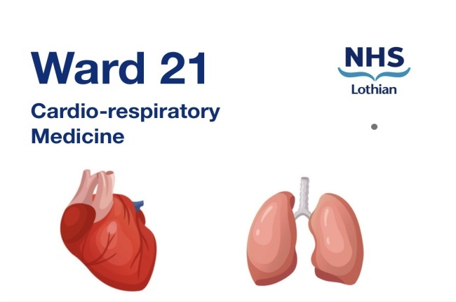

**What We Can Offer You**

We have a range of vacancies for experienced and newly qualified nurses to join our innovative and dynamic teams across NHS Lothian – providing you with the opportunity to gain a breadth of knowledge and exposure to multiple specialties.

**What we are**

Ward 21 is a 30 bedded Adult in-patient medical ward that strives to provide person centred care for a variety of patient who have respiratory, cardiovascular and or other complex medical needs.

**Training and development**

**Core Clinical skills -** The clinical skills you will gain in this position are, Venepuncture, Peripheral venous canulation, Administration of IV additives, Administration of IV bolus injections, Intravenous devises training (Alaris, BBraun, McKinley), Management of Midline catheters, Vascular access, Blood Glucose monitoring, Recording a standard 12 lead ECG (Adult) insertion of a female indwelling catheter (Male & Female)

**Cardiac Skills -** All Registered nursing staff are given the opportunity to attend NHS Lothian’s Cardiac Module. This is an 8 week course covering cardiac conditions such as Heart Failure, Cardaic Arrhythmias, and Acute coronary syndrome.

**Respiratory Skills** – in this role staff will be caring for patients who present with a variety of respiratory illnesses, such as Asthma, COPD and Type 1 & Type 2 respiratory failure. Asthmas care, Inhaler technique, Peak flow monitoring, Arterial blood gas analysis skills will be gained. Conditions such as Pneumothorax, Pleural effusion, Empyema and Haemothorax will be managed by ward staff trained in the management of intercostral chest drains and Thopaz chest drain suctioning.

**Career Progression**

Ward 21 are extremely proud to share our Nursing success stories. We have a number of staff who over recent years have went on to further develop and achieve their career goals within NHS Lothian. Example of these roles are:- Deputy Charge Nurse, Palliative care nurse specialist, Mesothelioma nurse specialist, Medical nurse practitioners, Lung cancer specialist nurse, Respiratory nurse specialist, Respiratory REACT at home team lead.

**Salary**

* Band 2 Range £23,362 – 25,362 (pro rata) per annum
* Band 3 Range £25,468 – £27,486 (pro rata) per annum
* Band 5 Range £30,229 – £37,664 (pro rata) per annum

**Benefits**

* A minimum of five weeks annual leave increasing with length of service
* A range of supportive employment policies including Flexible Working
* Full or part time hours considered
* We provide an extensive induction programme and excellent professional training and development opportunities.
* Access to the NHS Pension Scheme and Staff Benefits

**Check us out on social media**

@21_sjh

  