## e-Health Job Pack

**NHS GREATER GLASGOW AND CLYDE**

# Graduate Apprentice BSc (Hons) AI and Data Science



**Post**: Graduate Apprentice BSc (Hons) AI and Data

Science

**Tenure**: Permanent (upon completion of pre-requisites) **Directorate**: eHealth

**Grade**: Agenda for Change Band 6 (Pro Rata)

**Salary**: £39,912 - £48,635 (Fully Qualified)

## Salary During Apprenticeship:

Year 1: 60% of the top of a Band 6 pay scale = £29,181 Year 2: 65% of the top of a Band 6 pay scale = £31,613 Year 3: 70% of the top of a Band 6 pay scale = £34,044 Year 4: 75% of the top of a Band 6 pay scale = £36,476

**Hours**: Full time 37 hours per week **Location**: 1, Smithhills Street, Paisley, PA1 1EB **Closing Date**:

## Job Overview / Advertisement

An exciting opportunity is available to join NHS Greater Glasgow and Clyde as a Graduate Apprentice in Data Science and AI. This is a great opportunity for anyone with an interest in progressing a degree qualification and a career in the Business Intelligence / Data Analysis sector and is open to everyone who meets the entry qualifications.

In this scheme you will work as an integral member of one of the two sub-teams within the overall Business Intelligence team, within the e-Health directorate, and from day one you will be an active member working as part of the overall multi-functional team using a range of BI tools and techniques and utilising high quality data from various sources providing reports, analytics and insights to meet the organisations intelligence requirements.

You'll be involved in Data and Information management, developing, delivering and supporting reporting applications from start to finish and skilfully analysing data and developing dashboards to support the operational, strategic planning, and public health functions of the Board. As a graduate apprentice, you will be fully supported and mentored to grow into your new career and associated degree study.

As part of your career development with NHS Greater Glasgow and Clyde, you will study for a work-based university degree at Glasgow Caledonian University over a period of 4 years and on completion you will be awarded a BSc Hons degree in Data Science and AI.

Commencing in-house during summertime 2025, the combination of work-based experience and your course work will give you the Business Intelligence skills required to become an integral part of our team.

If you are interested in this opportunity, then we would be delighted to receive your application.

If you want to clarify any of the entry requirements or need more information, in the first instance please contact Jonathan Todd at Jonathan.Todd@nhs.scot

## Welcome from Jonathan Todd, Head of Information Management



Thank you for expressing an interest in our Graduate Apprenticeship programme for Data Science and AI within the Business Intelligence section. This post is an exceptional opportunity to further a career within Information Management and the Business Intelligence sector, and also incorporates opportunities to collaborate with front-line clinical teams, industry partners, academics, the West of Scotland Innovation Hub, and wider eHealth teams regarding their analytical and reporting requirements. I look forward to welcoming you as a member of our BI team.

.

## About NHS Greater Glasgow and Clyde Health Board

NHSGGC is the largest healthcare provider in Scotland, serving a population of approximately 1.3m, through the provision of a comprehensive range of Acute, Mental Health and Community Care services. The Board also provides cross-border and Regional services.

## About the Directorate

The eHealth Directorate has 1,640 staff of which about 30 work in the Business Intelligence section. The Directorate has a revenue budget of approximately

£70m, an annual capital budget of around £7m and other non-recurring budgets.

The eHealth Directorate comprises of the following departments:

* **Operations** – responsible for the overall IT and Telecommunication service delivery to NHSGGC including the delivery of the underpinning technical infrastructure and applications to support the health and corporate directorates across NHSGGC to agreed KPI’s and SLA’s. In addition, Information security and compliance.
* **Strategy and Programmes** - responsible for the development of the medium to long term eHealth Strategy and the delivery of a large number of highly complex programmes and projects including significant service reconfiguration and System development.
* **Innovations** – responsible for development and delivery of eHealth enabled Innovation Programmes, linking with Innovators such as clinicians, R&D, industry and SME's within NHSGGC, West of Scotland, and the broader Innovation community.
* **Information Management** – responsible for the collection and analysis of information, information governance and delivery of knowledge management

services. This service comprises Knowledge Services (Libraries), Clinical Coding and Business Intelligence.

* + **Health Records** - delivery of Health Records services across NHSGGC, including provision of outpatient clinics and ward clerk services
  + **Business and Resource Management** – responsible for financial management, procurement & contract management, audit, risk management, Programme Management Office (PMO), Information Governance, FOI responses and overarching aspects of staff governance and organisational development, Health

& Safety, general Directorate wide governance and facilities management activities.

The Directorate is fortunate to have in place strong governance structures to enable us to manage and effect change at pace and scale. The success of the Directorate is down to the way that teams work flexibly to deliver the support that’s required. A key element of the progress that we’ve been able to also down to the strong clinical leadership roles which are now embedded within the Directorate structure. Our clinical colleagues are aligned to key programmes and operate as a clinical reference group too.

Additionally, we place a big emphasis on staff development and retention and attracting new talent and we do this through a mature performance development framework, robust workforce and succession planning and role-based training which is pivotal overall.

# The Graduate Apprenticeship Programme

## What is a Graduate Apprenticeship?

Graduate Apprenticeships provide a way into degree-level study for individuals who are currently employed, or who want to go straight into work.

To apply for a Graduate Apprenticeship BSc Hons in Data Science and AI, the requirements are as follows:

- 4 Highers at Grade B or above, 3 of which must include Maths, English at SCQF 6 **and** a technical subject e.g. Computing / IT / Science / Finance.

If you have completed a Foundation Apprenticeship, this will take the place of one SQA Higher qualifications for the Universities standard entry requirements and will be treated as equivalent to a B grade at Higher.

All candidates must have a solid demonstrable interest in data and information technology, good communication skills, a commitment to a 4-year development programme and demonstrate motivated and enthusiastic behaviour coupled with a desire to learn and achieve.

The job description is enclosed as **Appendix 1** and reflects the qualification and experience you will have gained after your four years of study and work experience in the department. The person specification for the Graduate Apprenticeship is enclosed as **Appendix 2.** A summary of the course curriculum is **Appendix 3.**

## What is the recruitment and selection processes?

Apprenticeship places are limited so competitive interviews will be held to select the most focussed and willing candidates. Once selected, there will be a round of due diligence checks to ensure that candidates can evidence the minimum criteria needed for the role.

## When do I start?

Once pre-employment checks have been completed the aim is to have a start date with Business Intelligence that is at least 1 month before the start date for

your university course studies. This will give you an opportunity to get know the team and the department and generally settle in.

We are open to discussions on timings and handover for existing staff in other departments moving across to Business Intelligence.

## Who and what will I be working with?

Within the Information and knowledge management department you will be working with a dedicated and skilful team of data analysts, Information managers and Business Intelligence managers, clinical coders and library services. You will also be liaising with other Board departments, such as the Acute services, Interface Care, Planning, Health and Social Care Partnerships, Public Health, other eHealth colleagues and other national NHS services and departments.

You will be working with modern industry analytical software tools and both local and cloud-based technology platforms, creating high quality reports, documents, dashboards, and providing analytics to help the NHS deliver its operational and strategic objectives.

The current structure of the department is reflected in the diagram below and in the job description:

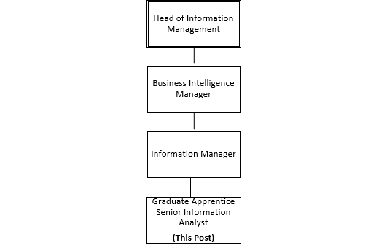

## Where and when will I be working?

We have a Hybrid Working policy in place where your working week will be split between:

* The eHealth offices at 1, Smithhills Street, Paisley, PA1 1EB,
* Caledonian University Campus, Cowcaddens Rd, Glasgow G4 0BA
* And working from home.

There may also be a requirement to work from any of our hospital and community sites depending on the project you’ll be working on.

The working pattern is Monday–Friday from 08:30 to 17:30 within a 37 hour working week.

Between September and December, you will attend University for a total of 1 day per week over 12 weeks and between January and April another 12 days over the 12- week period.

At University you will also have a summer project to complete which is mainly completed via a combination of remote teaching, seminars and tutorials. In the first 2 years there are two modules that require teaching over the summer months in order for the University to deliver the Programme at the same pace as full-time study.

## What happens when I start the Graduate Apprenticeship Programme?

Your university studies last 4 years starting from the September of your year of entry. Prior to your University studies start date, you will start work with NHS Greater Glasgow & Clyde and be issued with an NHS identity badge, building entry passes and an NHS network username and password. You will also be issued with a high specification development laptop.

In the first month you need to complete NHS induction and complete our Statutory and Mandatory training modules that are needed to be a permanent NHS member of staff. The modules you need to take are listed below: Additional modules may be added from time to time.

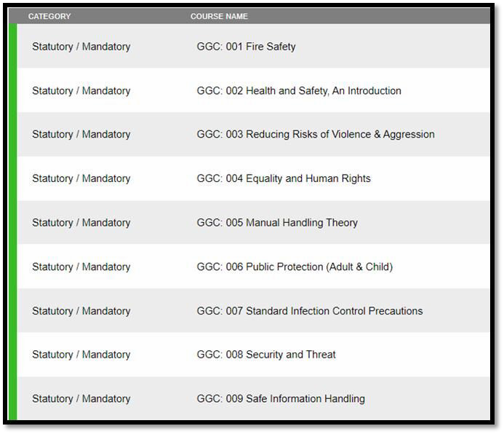

After induction and together with you mentor and line manager we will give you access to all the information and tools you’ll need to start developing your skills and start your journey and new career.

In addition to the NHS induction, you will also have a university induction in September where apprentices will attend the Induction Week to ensure they see themselves as members of the GCU student community and to ensure that they are aware of the University environment.

## Will I be working to a Job Description?

You will be working to the Job Description described in **Appendix 1.** This is the job description used to recruit fully qualified candidates. After your four year degree course you will be fully qualified and have been working on projects and programmes to provide you with skills and knowledge described in the Job Description.

## What skills will I learn and what will I be doing?

You will be working and learning alongside people with a wide range of experience from new graduates to senior information specialists with many years of experience in health-related disciplines and data analysis.

A representative high-level course curriculum for your university studies can be found in **Appendix 3**

In your first period of work, you will have the opportunity to familiarise yourself with our software and get to know the team, the nature of our work, our analytics tools and the wide-range of data, regular reports, and the sources of data.

You will also learn about our operating policies, procedures, and best practices to ensure that data information is understandable, trusted, visible, accessible, and interoperable. You will be given the opportunity to work with other analysts on developmental dashboards and documents which will go live for use throughout the organisation.

As part of the learning and mentoring process, your work will be overseen by another team member, and you will have the opportunity to get supportive feedback on your tasks.

As your knowledge and skills increase, you will have the opportunity to work on increasingly larger tasks with more challenging aspects and be given exposure of other areas of the business that will target your development on what you enjoy most and what suits you best.

## What are the most important skills required for the post?

Graduate Apprenticeship BSc Hons AI and Data Science at Glasgow Caledonian University entry requirements:

4 Highers at Grade B, 3 of which much include Maths, English at SCQF 6 and a Computing / IT / Science / Finance / Technical Subject.

All candidates will need to demonstrate:

* An Interest in information management and data analysis
* Good communication skills
* Commitment towards completion of the 4-year development programme
* Motivated and enthusiastic behaviour
* A desire to learn and achieve
* Flexibility to meet the business needs of the BI department

## Terms and Conditions of Employment

**Post**: Graduate Apprentice – Data Science and AI **Tenure**: Permanent (subject to completion of pre-requisites) **Directorate**: eHealth

**Grade**: Agenda for Change Band 6 (Pro Rata)

**Salary**: £37831 - £48635 The NHS Pay scale changes annually.

## Salary During Apprenticeship:

Year 1: 60% of the top of a Band 6 pay scale

Year 2: 65% of the top of a Band 6 pay scale

Year 3: 70% of the top of a Band 6 pay scale

Year 4: 75% of the top of a Band 6 pay scale

Where an existing employee moves to undertake the training role and this would result in a reduction in earnings, the individual will remain on their existing band and earnings level, including any incremental progression and pay award uplifts, until the conclusion of their training period or the Apprenticeship salary becomes greater.

**Hours**: Full time 37 hours per week

It is important to note that progression through each year of training is not automatic. Apprentices are required to meet the requirements for academic progression and skills acquisition at each stage before moving onto the next year

## Annual Leave

The annual leave entitlement in a full year commencing 1st April to 31st March is 27 days (202.5 hours), rising to 29 days (217.5 hours) after 5 years’ service and 33 (247.5 hours) days after 10 years’ service.

There are 8 (60 hours) Statutory and Public Holidays in each leave year (pro rata where applicable).

**Please note** that apprentices are full time NHSGGC employees who attend college during the academic year, therefore whilst attending college **it is expected that apprentices take their annual leave allocation during the college Easter and Christmas break and be available to work during the college summer holidays**.

## Superannuation Pension Scheme

If appointed, you will be automatically enrolled in the NHS Superannuation Scheme however on appointment you can chose to opt out of the scheme. Employee’s contributions to the NHS Scheme are tiered based on your earnings and the employer’s contribution equates to 13.5 % of salary. Employees in the NHS Scheme are “Contracted-out” of the State Earnings Related Pension Scheme and pay a lower rate of National Insurance contributions. You can find out more at www.sppa.gov.uk

## Right to Work in the UK

We are required to check the entitlement to work in the UK of all prospective employees, regardless of nationality or job category. Candidates appointed to a post will be required provide appropriate documentation verifying right to work in the UK prior to any commencing employment

## Healthcare Support Workers

You will be expected to comply with and complete the NHS Scotland Mandatory Induction Standards and Code of Conduct for Healthcare Support Workers in the first few months of starting in post.

As part of the Induction Process, you will be required to achieve Mandatory Induction Standards and Code of Conduct for Health Care Support Workers and these standards will be met through on the job induction programmes within NHS Greater Glasgow and Clyde that are core in supporting new staff.

## Smoke Free Policy

NHS Greater Glasgow and Clyde operates a NO SMOKING Policy on all premises and grounds for staff and visitors.

## Pre employment Checks

All offers of employment will be subject to the receipt of satisfactory References, Occupational Health Screening, Criminal Records Check (Disclosure Scotland) where applicable, Eligibility to Work in the United Kingdom and Verification of Qualifications.

## Car parking and travel to NHSGGC Sites

Like other NHS Boards across the country, demand for car parking on our sites far outweighs availability. As a result, access to on-site parking is extremely limited and you will therefore need to find alternative ways of travelling to work if you are selected for the post.

Staff are entitled to apply for the following benefits on appointment:

* Interest free loan to purchase a Zonecard which is a flexible season ticket for unlimited travel by rail, subway and some bus and ferry services
* Cycle to Work Scheme for staff to purchase a bicycle and any equipment needed and then repay those costs through their salary

Information on travel alternatives and travel loans can be found by visiting www.nhsggc.org.uk and select Transport and Parking on the home page

## Learning and education

NHSGGC has an on-going commitment to learning and development through competency based training and individual personal development plans informed by the Knowledge and Skills Framework (summary guidance can be accessed via www.nhsggc.org.uk go to Career and Jobs, click Agenda for Change and select Knowledge and Skills Framework).

For more information about the benefits and discounts available to NHS Greater Glasgow and Clyde staff, visit www.nhsstaffbenefits.co.uk and www.nhsdiscounts.com

**Appendix 1 - Job Description**

|  |
| --- |
| 1. **JOB IDENTIFICATION**  Job Title: Senior Information Analyst (Business Intelligence) **Responsible to: Business Intelligence Manager**  **Department: Business Intelligence**  **Directorate: eHealth** |
| **2. JOB PURPOSE** |
| Responsible for assisting in the development and delivery of business intelligence to exploit the corporate dataset(s) in support of the operational, planning, public health and performance monitoring requirements of NHS GGC and its operating divisions and corporate functions. Investigates highly complex enquiries providing assistance and specialist advice and contributes to corporate reporting providing strategic/business planning intelligence and insight. Manages a specialised team in the production of health information. |
| **3. ROLE OF DEPARTMENT** |
| The overall aim of the eHealth Directorate is to deliver and maintain a comprehensive integrated information, technology and record management strategy in order to ensure that the right information is provided in the right place at the right time, to support highest possible levels of diagnosis, treatment and care of patients and clients, to support continuous improvement of the health of the populations we serve and to achieve more effective integration between Health and the care services of our Local Authority partners.    This includes patients’ case notes and other information for clinicians working in the community and primary care, in outpatient clinics, on the point of admission for inpatients/day cases and for review after discharge: it includes developing and supporting electronic information systems for clinical and management use: and it includes collection and analysis of data required by the Scottish Government Health Department, for local monitoring of activity or performance, and for surveillance and protection of the health of our populations.    The eHealth Directorate has approximately 1,642 staff, a revenue budget of approximately £70.7m (inc. annual Scottish Government ring fenced funding), annual capital budget ranging between £7-8m and non-recurring eHealth budget of approximately £13.2m.  The eHealth Directorate comprises the following departments:   * **Operations** – responsible for the overall IT and Telecommunication service delivery to NHSGGC including the delivery of the underpinning technical infrastructure and applications to support the health and corporate directorates across NHSGGC to agreed KPI’s and SLA’s. In addition, Information security and compliance. * **Strategy and Programmes** - responsible for the development of the medium to long term eHealth Strategy and the delivery of a large number of highly complex programmes and projects including significant service reconfiguration and System development. * **Innovation** – responsible for development and delivery of eHealth enabled Innovation Programmes, linking with Innovators such as clinicians, R&D, industry and SME's within NHSGGC, West of Scotland, and the broader Innovation community. * **Information Management** – responsible for the collection and analysis of information, information governance and delivery of knowledge management services. This service comprises Knowledge Services (Libraries), Clinical Coding and Business Intelligence. * **Health Records** – delivery of Health Records services across NHSGGC, including provision of outpatient clinics and ward clerk services * **Business and Resource Management** – responsible for financial management, procurement & contract management, audit, risk management, Programme Management Office (PMO), Information Governance, FOI responses and overarching aspects of staff governance and organisational development, Health & Safety, general Directorate wide governance and facilities management activities. |
| **4. ORGANISATIONAL POSITION** |
|  |
| **5. SCOPE AND RANGE** |
| Business Intelligence is a constituent part of the eHealth corporate function within NHS GGC, including Information Management and Analytics, and delivers insights and intelligence to maximise the value of information to the organisation.  The department collects, collates and analyses patient data to provide a range of routine and ad-hoc information to support internal performance and operational management, ad hoc decision making and mandatory national reporting.  Internal customers are across the Acute and Partnerships operating divisions and corporate functions. External recipients include Scottish Executive Health Department, Public Health Scotland and local authorities.  Submissions and reports are required on routine, and as required, basis with frequency of reporting ranging from daily to annually.  To comply with requirements of Freedom of Information, Data Protection and Access to Health Records legislation, of NHS Scotland IT Security Manual and of relevant Codes of Practice or best practice within the NHS both in terms of access to information and in terms of sharing of information with third parties.  To comply with national legislation and Board policies in terms of Information Governance, IT Security, Information Handling, Records Management and Health and Safety for both themselves and for others. |
| **6. MAIN TASKS, DUTIES AND RESPONSIBILITIES** |
| To work closely with, and support the Information Manager in the provision of management information and business intelligence which is relevant to Management, Clinicians, Health and Social Care Partnerships (HSCPS), other partner organisations, the public and policy-makers.  Lead in the design of developing client-focused management reports. Production of accurate and timely regular and ad-hoc reporting.  Lead in the business intelligence requirements of work undertaken in the field including population health needs and inequalities research, epidemiology, and service management and redesign.  Provide expertise and advice in the development and understanding of highly complex and sensitive datasets and deliver Intelligence to support both clinical and corporate decision-making. For example, participate in and support the Planning function and Service redesign projects through access to information, expert advice, and complex data modelling support.  Key responsibility for adapting and designing information systems to meet specifications of users to support internal operational functions, performance management (e.g. key performance indicators), and external national NHS and partner agency reporting. For example, adapting current systems to capture and disseminate new data items.  Assist the Business Intelligence Manager in the development and implementation of the eHealth Strategy for NHS GGC in respect of the better use of information to support core and non-core health-related activities.  Participate in providing a culture of learning within the Business Intelligence Function, ensuring that staff are individually and collectively knowledgeable in relevant areas of NHS GGC business and deliver advice and training to team on their own specialist range of information subjects.  Initiate developments that consolidate and improve existing data capture and storage systems,  liaising with Health Records and eHealth colleagues, to expand the range, depth, quality and timeliness of information available for routine and ad-hoc analysis and reporting.  Lead in work relating to emerging information requirements, for example, to support new National requirements for unscheduled care, maternity data collection and waiting times.  Assist in the development of policy and procedures, to ensure consistency and quality of organisational data and information capture, analysis, and distribution processes.  Provide information support in Acute hospital sector, Partnerships (e.g. primary care), Mental Health, and Service Integration programmes ensuring a whole system approach to system implementation.  Represent NHS GGC on National specialist knowledge groups to influence the development of standards of data management that fully support NHS GGC in the execution of its role.  Deputise for Information Manager (BI) as and when required with responsibility for day-to-day management of a team of data analysts. |
| **7a. EQUIPMENT AND MACHINERY** |
| The post requires advanced use of computers and software including highly developed knowledge of data capture, analysis, business intelligence, and business support packages and products. For example, MicroStrategy, Business Objects, SQL, SPSS, PHS Data Marts, Excel, MS Project, Power BI, Patient Management Systems (TrakCare, EMIS etc.) |
| **7b. SYSTEMS** |
| Business Intelligence have implemented a data warehouse to enable more efficient analysis, data insights to enable informed decision making, and data governance.  Development, maintenance and management of a number of wider system and departmental databases.  Direct interrogation and operational reporting and report development from Partnerships and Acute patient and clinical management systems. E.g. EMIS Web, TrakCare, Badgernet, and various national and local datasets  Preparation and completion of select statutory NHS returns, ensuring work is completed accurately as part of Business Intelligence quality assurance protocols and in line with timescales, executive and legal requirements, interpreting these where necessary. E.g. data returns to Public Health Scotland / Scottish Executive scrutiny and validation.  Analytical input and modelling/scenario development to support Operational, Redesign and Capacity Planning within NHS GGC.  Development and completion of reports to assist and monitor inter-agency communications e.g. Collaborating with HSCPS. |
| **8. DECISIONS AND JUDGEMENTS** |
| The postholder acts as lead specialist without initial reference to manager and has the latitude to make informed decisions within departmental policies, working to the key results and outcomes to support the e-Health Strategy of NHS GGC.  Required to make clear and concise recommendations over a range of complex issues based upon analysing the information required. This requires frequent analysis and interpretation of multipart facts or situations, particularly in trend analyses, utilising specialist knowledge of data, definitions, standards and processes. e.g. the postholder must exercise judgement and determine the most useful data, form of analysis and presentation.  The postholder will also make specific recommendations to Project Boards or Management Teams e.g. on the data quality, completeness and veracity of various sources of information and the results of detailed analysis.  Responsibility for day-to-day management of staff including work allocation, checking and evaluation of work and identifying training needs and delivering specific training on own specialist range of information subjects. |
| **9. COMMUNICATIONS AND RELATIONSHIPS** |
| Out with the eHealth department and BI function, the main relationships are with senior Corporate and Service management in the Acute, Mental Health, and Partnerships operating divisions, in addition to regular interaction with Public Health, and Performance and Modernisation directorates, and national and other Partner agencies, and direct participation in clinically led redesign project boards.  Involves presentation and receipt of multifaceted, complex, specialist, and sensitive information on a regular basis by both direct and electronic communication. This requires communicating complex statistical issues to non-technical clinicians, managers and other users and therefore includes interpreting individual customer needs and the most appropriate way to present this.  Also provision of specialist advice, analysis, and interpretation of information and standards supporting management/clinical decision-making, planning and performance monitoring. This may involve situations where there is potential for conflict of opinion from clinicians and other service users but where the post holder will, using their specialist knowledge, have ultimate responsibility for the final information that is presented. |
| **10. PHYSICAL, MENTAL, EMOTIONAL AND ENVIRONMENTAL DEMANDS OF THE JOB** |
| Use of keyboard and VDU for majority of working day, paying particular attention to speed and accuracy.  Requires frequent prolonged levels of concentration when analysing and preparing complex data and information with the ability to switch to other detailed tasks with no notice.  Potential conflict situations where sensitive or contentious data or analysis is presented and discussed.  Frequent requirement to deal with staff performance issues and the initial stages of grievance and discipline.  Requirement to deal with end users/clinical staff in demanding environments. |
| **11. MOST CHALLENGING/DIFFICULT PARTS OF THE JOB** |
| Developing, adapting and implementing the Business Intelligence function to respond to the significant increasing demands for quality information to support decision making and planning.  The ability to be adaptable and to work under pressure to tight timescales, providing high quality accurate outputs.  To ensure that all analyses, irrespective of their complexity, are accurately presented in a format which enables ease of use and understanding by their target audience.  To develop and maintain competencies and skills, and learn new technologies, to fully utilise information resources.  Being aware and keeping abreast of National eHealth developments within the NHS in Scotland. |
| **12. KNOWLEDGE, TRAINING AND EXPERIENCE REQUIRED TO DO THE JOB** |
| * Degree with a high numerical and statistical content, or equivalent qualifications/experience * Skills gained through a mixture of internal and external formal training, e.g. graduate diploma qualification, or equivalent * Significant demonstrable experience of Information Management in a Health Care environment * Highly developed IT and information analysis skills are essential * Specialist knowledge and experience of application of NHS data definitions, information standards and policies is desirable * The postholder should have a theoretical knowledge base and practical experience of managing a skills based staff. * Effective and confident communication skills are required to present, advise and instruct analysis, procedures and standards to a senior audience. |

Continued…..

**Appendix 2 - Person Specification Job Title:** Graduate Apprentice in Data Science and AI

**Department:** eHealth Information Management

**Service:** Business Intelligence

|  |  |  |
| --- | --- | --- |
| **Criteria** | **Essential** | **Desirable** |
| **Qualifications & Training**  4 Highers at Grade B or higher, 3 of which much include:  Maths, English at SCQF 6 **and** a Computing / IT / Science / Finance or another Technical Subject.  OR evidence of equivalent knowledge, skills, and experience | Yes |  |
| **Knowledge, Skills & Abilities**   * Literacy and numeracy skills * Good keyboard and IT skills * Experience of using Office packages (M365, Excel, Word, Outlook, Teams). * Demonstrates Good communication and Interpersonal skills. * Demonstrates the Ability to understand and follow procedures and policies. * Demonstrates the ability to be an Effective team worker. * Ability to work accurately, paying attention to detail while working to deadlines. * Manual dexterity (relevant to duties) * Awareness of importance of confidentiality | Yes Yes      Yes Yes Yes  Yes Yes Yes | Yes |
| **Personal Qualities**   * Demonstrates a caring outlook. * Commitment to training & development, and a willingness to learn. * Enthusiasm –Demonstrates a genuine interest in and enthusiasm in analytics and software development. * Willingness to have a ‘hands-on’ approach to work allocated. * Demonstrates the ability to carry out duties in a safe confidential manner as instructed/trained | Yes  Yes  Yes  Yes  Yes |  |

|  |  |  |
| --- | --- | --- |
| * Demonstrates the ability to use initiative. * Demonstrates the ability to communicate well with colleagues and other service users within the workplace * Demonstrates understanding of the service need to have flexible approach to work. | Yes  Yes  Yes |  |
| **Other**   * The post holder is expected at all times to practice competencies that demonstrate insight, understanding and respect of patients and work colleagues. * The post holder is expected to progress through each stage of their University course education and Board training effectively, in a timely manner. | Yes  Yes |  |

Continued…..

## Appendix 3 – Course Curriculum

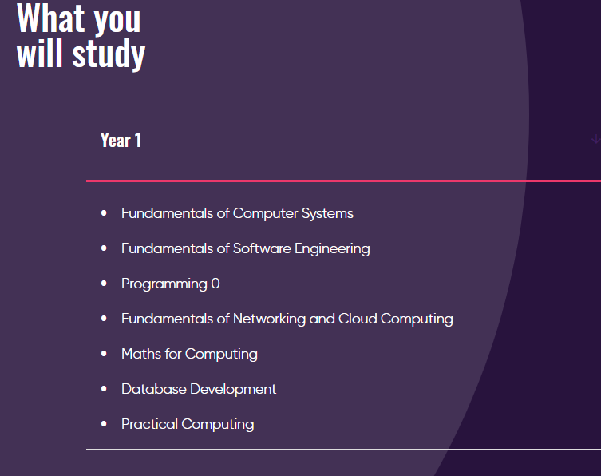

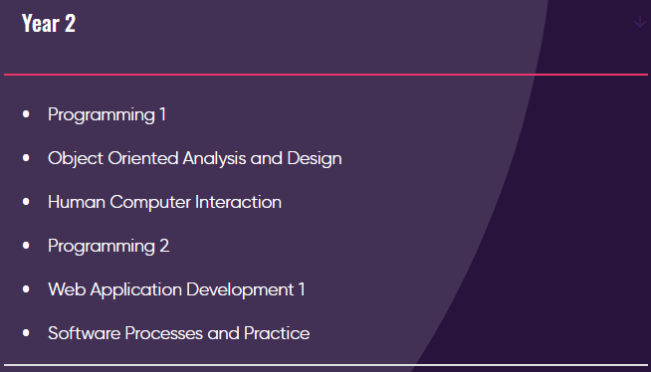

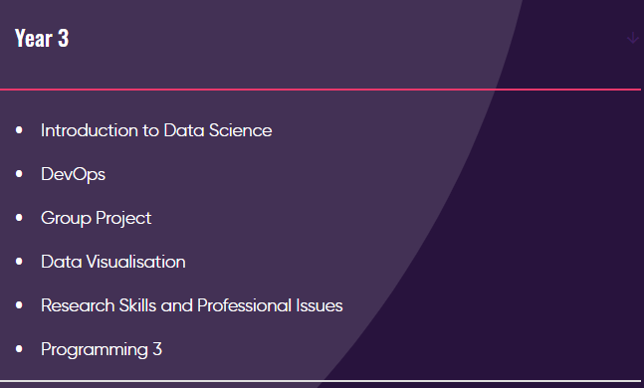

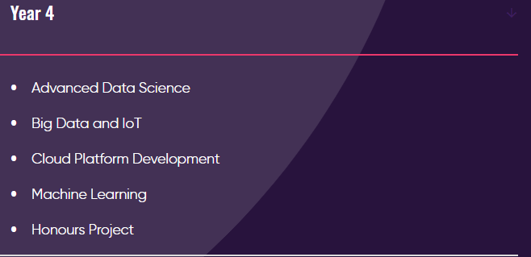

## Appendix 3 – Course Curriculum (cont.)

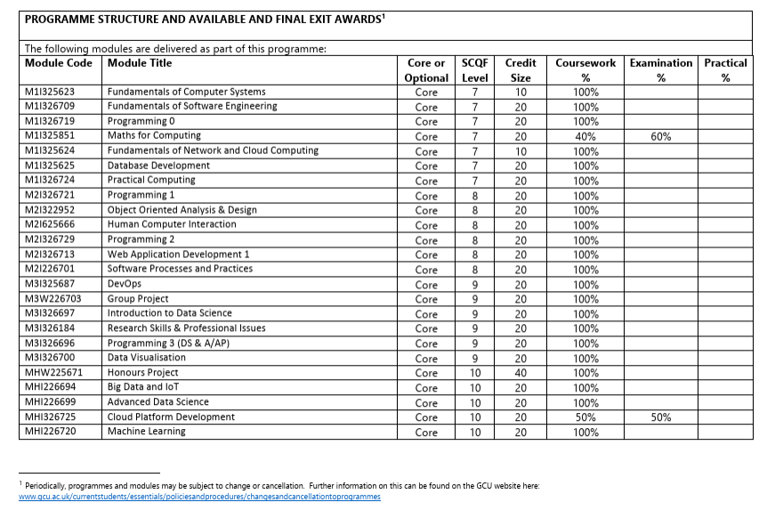

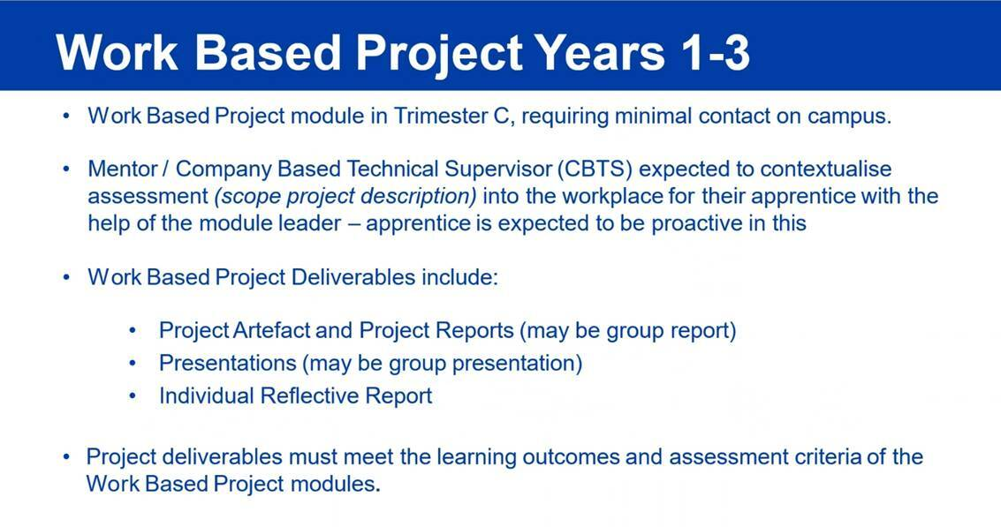

END.