**Department of Urology, Western General Hospital**

Exciting opportunities are available for Registered Nurses to join our Nursing Teams in the Urology Directorate at the Western General Hospital. We are looking for passionate, caring, motivated nurses to join our highly skilled surgical teams. This is a fantastic opportunity for Newly Qualified and experienced nurses to develop skills, knowledge and work as part of an innovative team.

The Western General is a modern teaching hospital that provides a comprehensive range of services for the people of Lothian and beyond. Ward 53 is a 24 bed Urology Surgical ward Monday to Friday reducing to 12 beds at the weekend. We admit a variety of patients of both genders and strive to provide the highest standard of person-centred care to our patients pre and post operatively. We provide emergency care for patients from our dedicated Surgical assessment unit and our emergency admissions ward or other sites. We also provide ongoing care and rehabilitation for patients stepping down from our intensive Care unit or Surgical High dependency Unit. We have 15 Urology consultants specialising in conditions and complaints of the Bladder, Renal system, Prostate and Andrology systems. We are also leading specialists in Robotic Prostate cancer surgery (working on reduce waiting times for patients and quicker recovery period). Our team are also highly specialised in bladder reconstruction surgery.

There is a vast number of opportunities to learn Surgical nursing skills and care of the deteriorating patient in ward 53. Due to reducing capacity at the weekends this means a better work life balance for our staff ensuring less weekend working. We have a robust induction and orientation in place for any successful candidates. We also have a dedicated Surgical Education Facilitator to support you in your new role.

The Western is based in the heart of Edinburgh and has a total of 596 inpatient beds in addition to our day case areas. We pride ourselves in being a professional, friendly, and supportive team who put high quality patient centred care foremost in what we do.

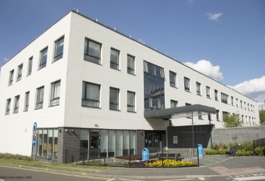**Senior Charge Nurse- Gemma Leitch - gemma.leitch@nhs.scot 0131 537 3553**

**Clinical Nurse Manager - Terri Ratcliffe Terri.ratcliffe@nhs.scot. 0131 5372320**



