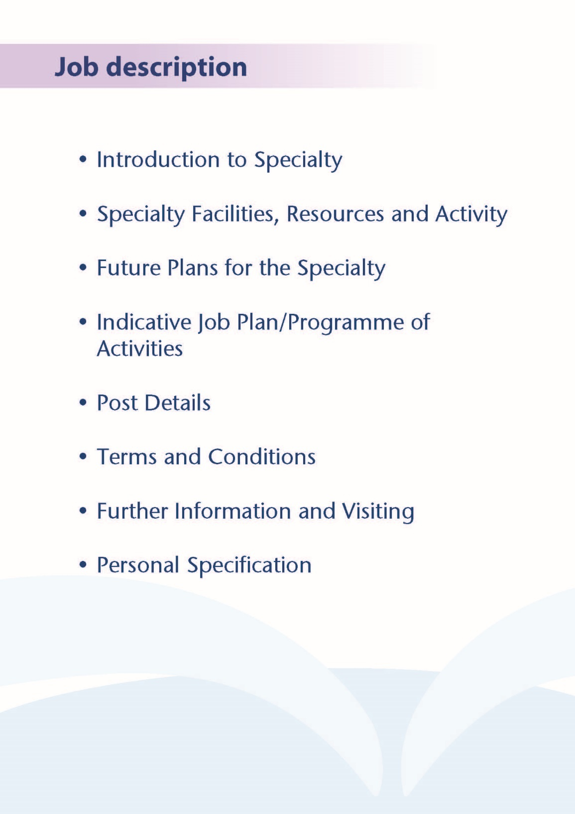



**Introduction**

NHS Ayrshire & Arran are pleased to invite applicants for the post of Locum Speciality Doctor Breast clinician for the South West Scotland Breast Screening Service. The initial term of service will be for 3 months with the option to extend this by mutual agreement. We currently have 1 vacancy and the successful applicant will join a friendly and dynamic team of 2 Consultant Breast Radiologists; 1 Associate Specialist; 1 Staff Grade Clinician and 2 Consultant Mammographers. The vacancies are available to those wishing to work solely as a breast clinician or also as a screening mammography reporter.

**THE REGION OF AYRSHIRE & ARRAN**

Ayrshire is a large county in southwest Scotland located on the shores of the Firth of Clyde. The overall population is approximately 370,000 with principal towns including Ayr, Kilmarnock and Irvine. Geographically the area is chiefly characterised by agriculture (with much of the inland county devoted to farming), but Ayrshire also has a beautiful coastline with the coastal Islands of Arran, Great Cumbrae and Little Cumbrae easily reachable. Most of Ayrshire is within easy reach of Greater Glasgow via the M77 and by rail. An international airport is also situated at Prestwick.

A wide variety of leisure activities are available in Ayrshire. The area is renowned for outdoor pursuits including fishing, cycling and hill-walking. Despite its relatively small area, more than a dozen golf courses are available including the prestigious Dundonald Links, Old Course at Royal Troon and Turnberry. The wider Greater Glasgow area affords further opportunities for travel and a wealth of culture, art, music, dining and sport.

Excellent Schooling is available within Ayrshire and the wider Greater Glasgow area with various highly-rated State and Independent Schools. University Hospital Ayr benefits from an on-site nursery with discounted staff rates.

**THE HOSPITAL**

The breast radiology service is primarily based at the South West Scotland Breast Screening Centre at Ayrshire Central Hospital in Irvine with some services provided at University Hospital Crosshouse. The hospitals are 9 miles apart, 15 minutes travelling time by car and easily accessible with ample free parking. Approximate journey times of 30 minutes each way from Glasgow are often faster than typical journeys to hospitals within Glasgow.

Ayrshire Central Hospital is home to the South West of Scotland Breast Screening Unit and the area-wide DEXA scanning service. Ayrshire Central Hospital is also county’s largest community hospital. NHS continuing care services are provided on-site along with a wide range of outpatient clinics and therapy services.

**WORKING AS A LOCUM BREAST CLINICIAN IN NHS AYRSHIRE & ARRAN**

The breast screening centre at Ayrshire Central Hospital has a friendly outlook and collaborative, collegial atmosphere. The department has excellent integration with clinical teams and there is frequent direct consultation with clinical colleagues face-to-instead or remotely by telephone.

NHS Ayrshire & Arran is accredited with the West of Scotland Deanery and receives Speciality Trainees on a rotational basis (ST1-ST5 level) for general and speciality attachments, with consistently high scores achieved on the annual GMC training survey. Medical students from University of Glasgow also rotate through the NHS Ayrshire & Arran hospitals for general and speciality attachments.

The South West of Scotland Breast Screening Centre screens eligible women aged 50-70 in Ayrshire and Arran and Dumfries and Galloway over a three year cycle. This totals approximately 86,000 women.

Women are screened with two view digital mammography. Viewing is via Carestream PACS with access to national PACS for any previous symptomatic studies.

Screening takes place at the South West Scotland Breast Screening Unit at Ayrshire Central Hospital and on two mobile screening units. Breast screening is now fully digital with recording of results onto the national breast screening IT system (SBSS). We perform double reading with arbitration within both the screening and symptomatic services.

Three breast screening assessment clinics are held each week to review patients with an equivocal/suspicious screening examination. All patients undergo clinical examination during the assessment clinic. We have large volume vacuum assisted biopsy on site within the breast screening unit at Ayrshire Central Hospital and three advanced practitioner radiographers who contribute to the biopsy service during assessment clinics. Approximately 200 women are diagnosed with breast cancer through our screening service annually.

We provide MRI breast for our screening, symptomatic and Family History Screening patients.

A weekly multidisciplinary meeting is attended by representatives of all relevant specialties.

Four breast team review meetings are held annually to review and plan services.

We are a forward thinking department and look to utilise new technologies and techniques as well as utilising effective skills mix to maximise efficiency. We have appointed two consultant mammographers who are now fully proficient in film reading, ultrasound, biopsy and localisation procedures.



**Facilities**

Two full field digital mammography units, both with stereotactic facilities and tomosynthesis capabilities are installed within the breast screening unit at Ayrshire Central Hospital. We have Encor large volume vacuum assisted biopsy at breast screening also. The breast screening service is now fully digital with 2 units within the screening centre and 2 on the mobile screening vans.

Dedicated breast ultrasound units are provided in 2 clinic rooms at ACH.

Stereotactic breast biopsies, large volume excision biopsies and image guided pre-operative localisations are performed on the Crosshouse site.

5 megapixel monitors are provided for mammography interpretation.

The breast service has encouraged skill mix and a non radiologist associate specialist participates in film reading and ultrasound, including biopsy procedures. A breast clinician also film reads and 3 further radiographers perform stereotactic core biopsies. Two consultant mammographers who are trained in the extended roles of film reading, ultrasound and biopsy.

**Medical Staff Resources**

The staffing of the Breast Screening Centre is as follows:

|  |  |
| --- | --- |
| **Consultant Staff** | **Specialist Interest** |
| **Dr Steven Henderson** | General and breast Radiology |
| **Dr Maret McHardy** | Breast imaging |



# Proposed Weekly Programme

An indicative weekly programme is shown below for a post which includes breast screening and screening mammography reporting.

**Proposed weekly programme (example)**

BSU = Breast Screening Unit at Ayrshire Central Hospital

|  |  |  |  |
| --- | --- | --- | --- |
|  | Work Timetable | Direct Clinical Care  (hours) | Supporting Professional Activities (hours) |
| Mon am |  |  |  |
| Mon pm |  |  |  |
| Tue am |  |  |  |
| Tue pm |  |  |  |
| Wed am |  |  |  |
| Wed pm |  |  |  |
| Thu am | Breast screening assessment clinic | 4 |  |
| Thu pm | Mammo reading (BSU) | 4 |  |
| Fri am | SPA | 1 |  |
| Fri pm |  |  |  |

The actual programme will be discussed with the appointee and will be agreed with the Clinical Director prior to commencement in post. This initial timetable will be reviewed three months following appointment and should therefore be regarded as an interim programme.

The weekly timetable will be as stable as possible and provides the basis for individual job plans. However, all staff are required to be flexible in relation to their agreed timetable in order to cover for colleagues absences and to meet varying service requirements.

**Notes on the Programme**

**Clinical Administration:**  This activity covers the management of individual patients including Out Patient administration, results reporting, letters/phone calls to patients, carers, GP’S and members of the wider multidisciplinary team involved in the patients care.

**Travel:** Any travel allocation will be included within the Total Programmed Activities and will be determined by location at which Direct Clinical Care and Supporting Professional activities are carried out.

**Supporting Professional Activities:** NHS Ayrshire and Arran recognise the important role Job Planning has in ensuring consultants are supported in delivering high quality, safe, sustainable clinical care to patients. It is therefore important to ensure there is an adequate balance between direct clinical care activities and activities which support both the personal and professional development of the consultant workforce and facilitates agreed contribution to activities including:

* Under and post graduate teaching/training
* Clinical Governance
* Quality and Patient Safety
* Research and Innovation
* Service management and planning
* Work with professional bodies

Appointed clinician will have 0.25 PA SPA as a minimum to support job planning, appraisal and revalidation. However the final balance of SPA and DCC activity will be agreed between the appointee and clinical manager prior to contracts being agreed.

One further SPA as described above will be available for:

* Teaching and training of any registrars who take up the breast module
* Optional attendance at consultant meetings, including monthly educational and clinical governance meetings.

There may be a requirement to vary the DCC outlined in the indicative timetable at section 4 when the final balance of DCC and SPA is subsequently agreed.

If the post-holder will be responsible for the formal training and supervision of post-graduates and under-graduates, a suitable additional allocation of SPA time will be made in accordance with national guidance.

**Job Plan Review**

New appointees will have an interim Job Plan review conducted at 3 months post commencement to review the balance previously agreed. The agreed job plan will include all the professional duties and commitments, including agreed Supporting Professional Activities.    Thereafter Job Planning will be carried out annually as part of the Boards Job Planning process.

**Research:** Research is encouraged and supported by an active Research and Development Committee. The appointee will be encouraged to develop research interests associated with their specialist interest.

**Teaching:** The post holder will be responsible for the training and supervision of post-graduates and under-graduates and will be expected as part of their SPA allocation to devote time to this activity on a regular basis. In addition he/she will be expected to ensure that Junior Staff and medical students receive adequate support and advice and may act as a contact as the person responsible for overseeing their training and as an initial source of advice.



The post holder will be accountable to the Clinical Director who will agree the Job Plan.

**Resources**

The staff resources of the Directorate are listed elsewhere. The post holder will have access to such general administrative support as is required for the discharge of his/her duties and responsibilities.

This will include the provision of adequate secretarial and clerical support and the availability of accommodation, equipment etc.

The post holder will receive support from such other professional staff as are employed within the organisation and are deployed to his/her area of patient care.

**Duties and Responsibilities**

The main duties and responsibilities of the post include:

* Responsible to the Clinical Director in matters concerning service provision.
* Providing clinical examination at breast screening assessment clinics.
* Provision of cover for colleagues during periods of annual and study leave.
* Participation in mutli-disciplinary team working as appropriate, including multi-disciplinary meetings.

The postholder will be required to comply with NHS Ayrshire and Arran’s Policies on Clinical Governance.

* The successful applicant will be encouraged to participate in research.
* Requirements to participate in medical audit and in continuing medical

education.

**Annual Appraisal & Job Planning**

You shall also be required to participate in annual appraisal. Job planning is linked closely with, but is separate to, the agreed appraisal scheme for consultants. The job plan review will take into account the outcome of the appraisal discussion and reflect the agreed personal development plan.



The terms and Conditions of Service Are those determined by the Terms and Conditions of the New Specialty Doctor grade (Scotland) as amended from time to time.



Applicants wishing further information about the post, or to arrange a visit, are invited to contact Dr S Henderson, Clinical Director of Breast screening, Tel. 01294 323 509, email steven.henderson@aapct.scot.nhs.uk or Dr Sudhakar Unnam, Clinical Director, Tel. 01563 826141, email :Sudhakar.Unnam@aapct.scot.nhs.uk.

**Personal Specification** 

# 

**Post of**: Speciality doctor breast clinician

**Location**: Ayrshire Central Hospital

## Qualifications:

|  |  |
| --- | --- |
| Essential | Desirable |
| Full GMC Registration with current Licence to Practice | Royal College Membership |
|  | Recognised qualification in mammography reporting |

**Skills/Knowledge/Competence**

|  |  |  |
| --- | --- | --- |
| **Requirements** | **Essential** | **Desirable** |
| **General Experience:**   * Expertise in sub-specialty field | * Knowledge of and skill relevant to the management of patients. * Ability to communicate effectively with all levels of staff and patients * Ability to work efficiently and timeously * IT literacy | * Ability to develop and maintain a   database of clinical practice |
| **Team Working** | * Ability to lead others, think strategically * Effective Team Player |  |
| **Development** | * Evidence of relevant Continuing Professional Development * Evidence of satisfactory compliance with appraisal requirements |  |
| **Teaching & Training** |  | * Proven ability to deliver high quality teaching * Interest in and knowledge of advances in medical education and training. |
| **Research & Publications** |  | * Evidence of publications of a high standard relating to specialty |
| **Clinical Audit** |  | * Evidence of interest and depth of experience in medical audit |
| **Management and Administration** | * Commitment to effective departmental management and management of a multidisciplinary group * Proven organisational skills | * Proven ability to lead a clinical team * Proven management experience * Understanding of resource   management and quality  assurance. |
| **Personal and Interpersonal Skills** | * A willingness to accept flexibility to meet the changing needs of the NHS in Scotland * Effective communicator and negotiator * Demonstrate effective leadership * A willingness to develop special interests which conform to the needs of NHS Ayrshire and Arran * Ability to operate on a variety of different levels * Open and non-confrontational | * Knowledge of recent changes in   the NHS in Scotland |