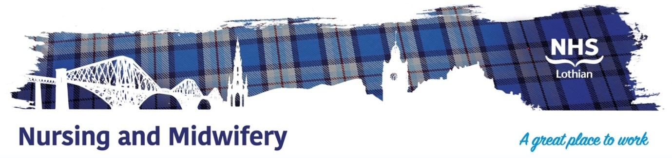

**NHS Lothian Royal Hospital For Children And Young People (RHCYP), Edinburgh**

Exciting opportunities are available for Registered Nurses (Child) to join our Nursing Teams at RHCYP. We have multiple Band 5 positions available and we are looking for passionate, caring, motivated people to join our highly skilled nursing teams. We offer the opportunity to work with talented teams within multidisciplinary environments and impact positively on the lives of thousands of patients and their families.

Our stand alone, state of the art hospital is located beside the Royal Infirmary and we pride ourselves in being a professional, friendly and supportive team who put high quality patient centred care foremost in what we do.

Find out what our staff say about working in NHS Lothian at https://careers.nhslothian.scot/acute-specialist-nurses/who-we-are/

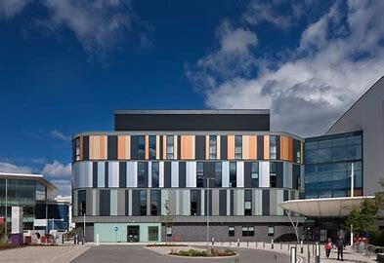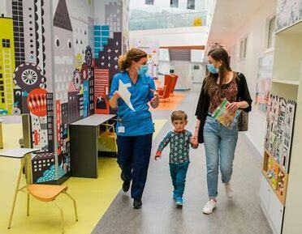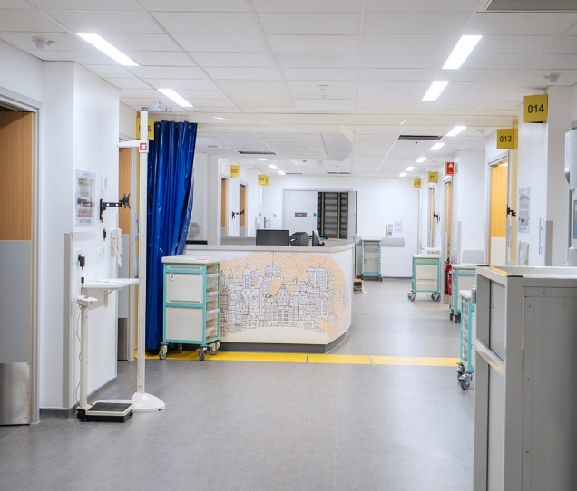

**What We Can Offer You**

We have a range of speciality vacancies for experienced and newly qualified nurses and theatre operating department practitioners to join our innovative and dynamic teams, providing you with the opportunity to gain a breadth of knowledge and exposure to multiple specialties.

**Specialities**

* Medical (Acute Receiving, Respiratory, Endocrine, Gastrointestinal, Renal, Neurology)
* Surgical (General, Orthopaedics, Major Trauma, Plastics, ENT, Neurosurgery)
* Theatres and Anaesthetics
* Paediatric Critical Care
* ED
* OPD
* Day Care (medical and surgical)

**Salary**

* Band 5 Range £30,229 to £37,664 (pro rata) per annum

**Benefits**

* A minimum of five weeks annual leave increasing with length of service
* A range of supportive employment policies including Flexible Working
* Full or part time hours considered
* We provide an extensive induction programme, education frameworks and excellent professional training and development opportunities.
* Access to the NHS Pension Scheme and Staff Benefits

**Contact**

**For informal enquiries and further information please contact Fiona McGovern, Clinical Nurse Manager, RHCYP on:**

**Telephone: 0131 312 0739**

**Mobile: 07816171714**

**Email: fiona.mcgovern@nhslothian.scot.nhs.uk**

 