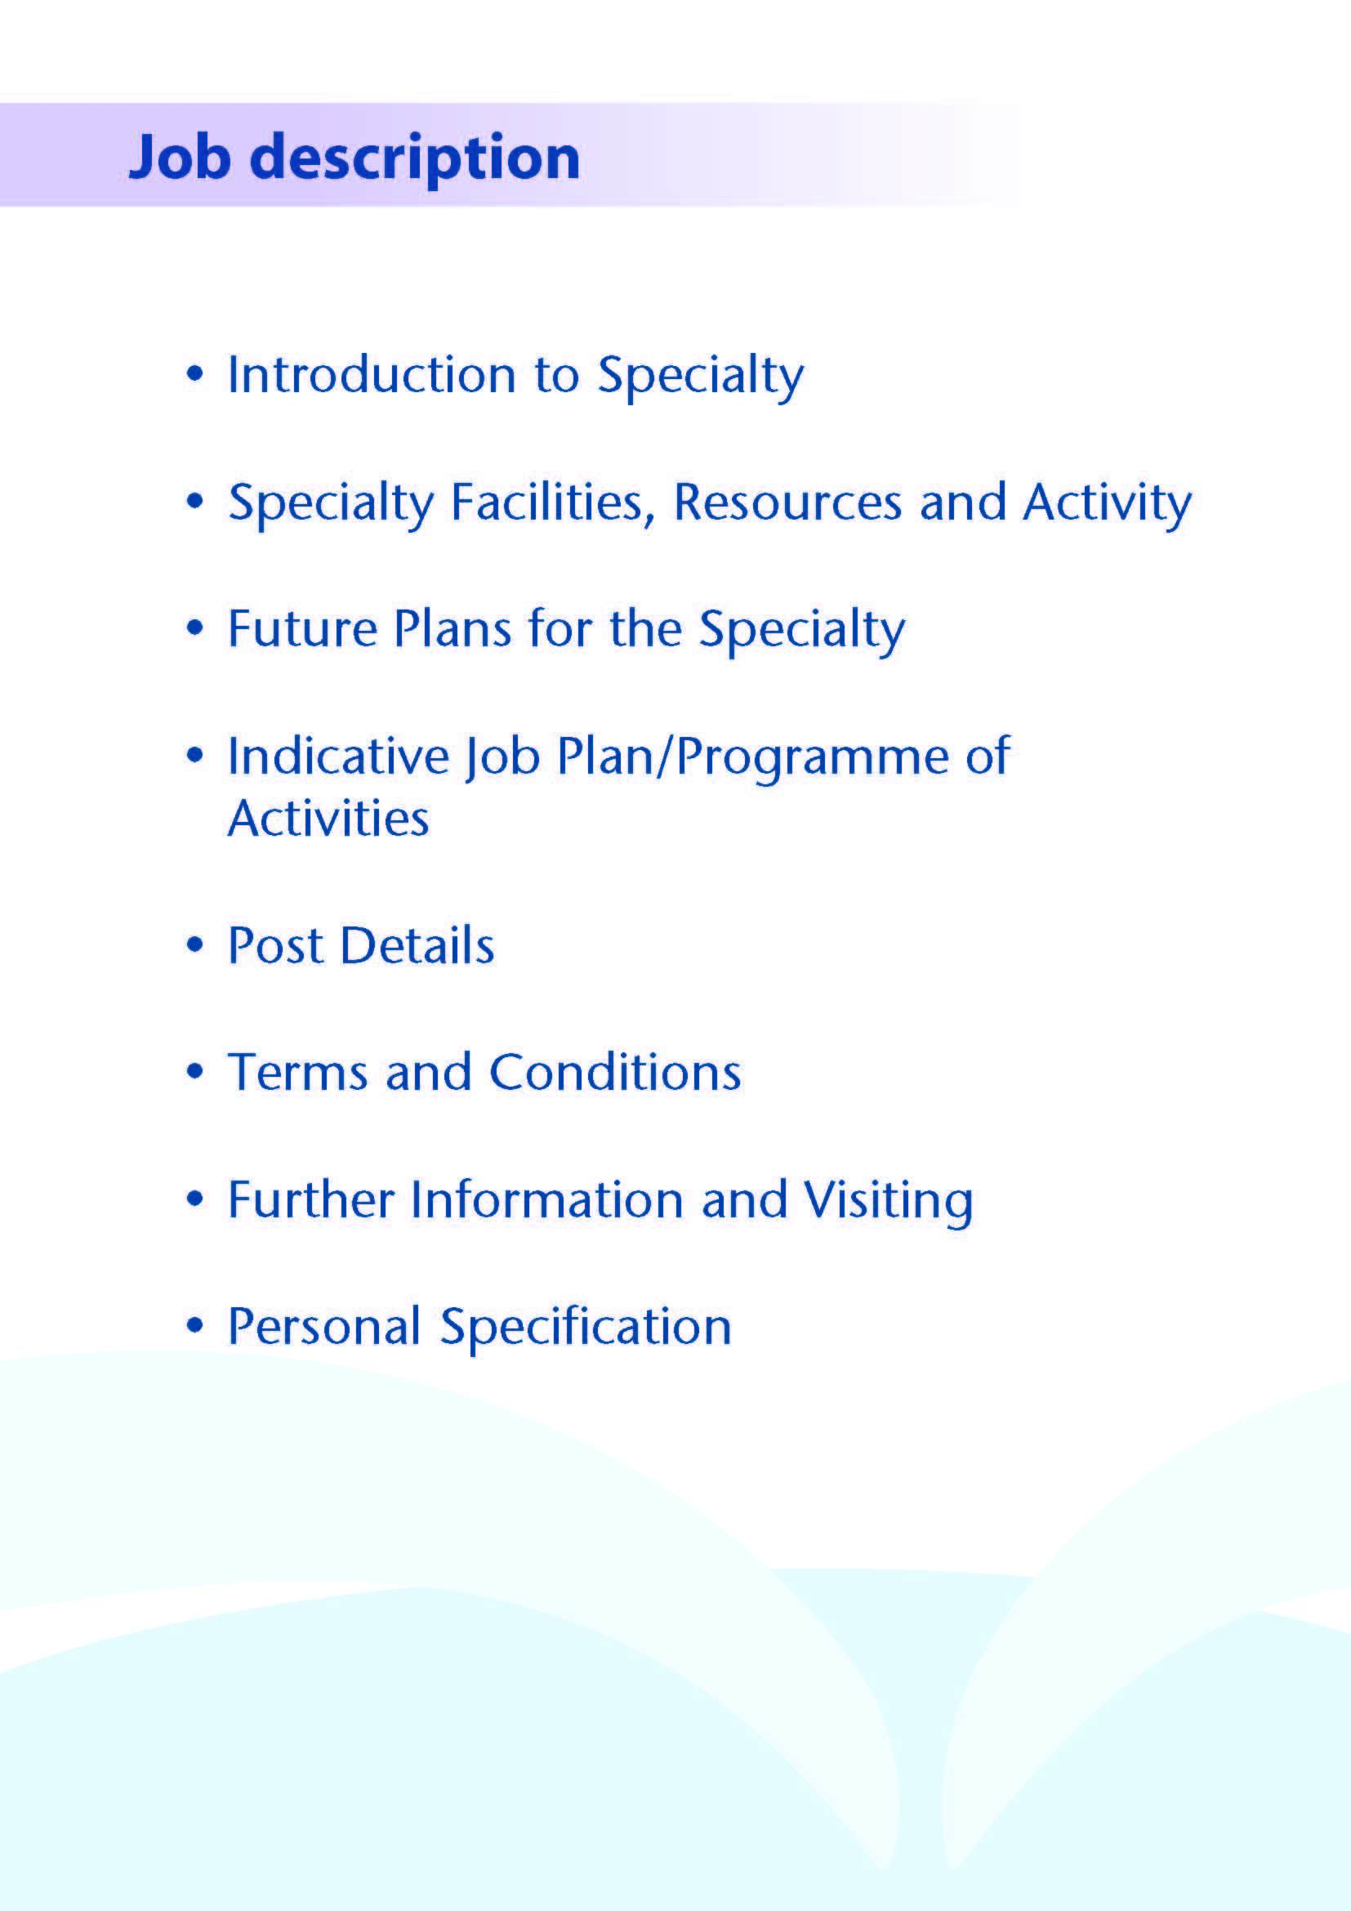



An opportunity exists to appoint a substantive Consultant in General Surgery with special interest in Colorectal Surgery. Experience in general and emergency surgery is essential.

This successful applicant will complement the current team of Consultant General Surgeons with sub-specialty interests and will participate in the emergency on-call rota for general surgery (currently 1 in 12) in University Hospital Crosshouse (UHC). The post-holder will join the current team of five consultant colorectal surgeons in UHC and three in University Hospital Ayr, and will be expected to provide some services across both hospitals.

The two main hospital sites within the health board are UHA and UHC, located in the picturesque West Coast of Scotland. Together they serve a population of 366,000.

UHC has 539 beds, was opened in 1982 and has been expanded and upgraded regularly since then. Services in the majority of major specialties are provided at the hospital, in addition to Ayrshire-wide services in Intensive Care Medicine, Trauma, Robotic Surgery, ENT, Maxillo-Facial Surgery, Paediatrics, and Gynaecology. The Ayrshire Maternity Unit resides in a state of the art building on the Crosshouse site.

UHA is a 343-bedded general hospital located to the south east of Ayr town and provides several area-wide services for NHSAA including Urology and elective Orthopaedic surgery. UHA is a referral center for Bariatric Surgery within NHSAA and receives referrals from other parts of Scotland for revision and primary surgery.

Both the UHA and UHC General Surgical units staff acute emergency surgery services. Recent changes to the provision of Critical Care services in NHSAA have meant all Level 3 care is now consolidated on the UHC site with Level 2 provision on both sites. This has necessitated some changes to emergency and elective general surgical pathways. We would envisage further service developments in future, including the optimization of UHA as a site for efficient, volume surgery.

Both Hospitals are easily accessed by road, with the M77 providing rapid access to Glasgow (30 minutes from UHC, 45 minutes from UHA). Rail services also link both Kilmarnock and Ayr to Glasgow and other surrounding towns. Prestwick International Airport lies midway between both hospitals, approximately a 15 minute drive to each. All clinical sites in NHSAA provide free parking.



.

* We provide a comprehensive colorectal service in NHSAA including minimal invasive surgery for all benign and malignant cancer surgery. For the benign disease, our services include surgery for pelvic floor disorder, inflammatory bowel disease, parastomal hernia, pilonidal sinus, proctology including fistuloscopy, and diverticular disease. We are hoping that we could expand our services to include surgery for complex endometriosis and multi-visceral resection for locally advanced malignant disease.
* For the pelvic floor disorders, we have facilities for anorectal manometry as well as endo-anal ultrasound scan. We also have a team of pelvic floor physiotherapists and a good working relationship with our gynaecology colleagues for the management of some of the more complex patients.
* For early cancer and polyp management, we have been running a bowel screening service in Ayrshire & Arran since 2005. We provide full range of colonoscopy procedures including EMR polypectomy for colonic lesions and trans-anal procedure such as TAMIS & TENS for rectal lesions.
* UHC has seen the recent addition of a DaVinci XI robotic system with dual consoles. This is currently being utilised by the colorectal, urology and gynaecology teams. Currently, 3 colorectal, 2 urology, and 2 gynaecology consultants are trained to use this system for our 5 full day theatre lists a week as well as some Saturday lists. We have already started robotic surgery for right and left hemi- colectomy, anterior resection, APR, rectopexy, and inguinal hernia repair. We still expect to expand the range of procedures for both general and colorectal procedures, but with time, it may become necessary to acquire additional robotic system and expand our current robotic team.
* General Surgical units at UHA and UHC have recently moved under the leadership of a single Clinical Director. In the future the units will deliver a single General Surgical service for NHSAA across the two sites with the expectation that clinicians will increasingly deliver clinical commitments on a cross-site basis.



**MULTIDISCIPLINARY TEAM STRUCTURE**

We run a weekly inflammatory bowel disease as well as a separate colorectal cancer MDT involving our radiology, oncology, pathology, and gastroenterology colleagues and MDT coordinators as well as dedicated audit staff. Our complex polyp cases, small bowel malignancy, and peritoneal malignancy are also discussed in our colorectal cancer MDT.

We also have similar arrangement for upper GI and breast cancer and they also meet on a weekly basis with tele-linking between NHSAA’s two acute hospitals and the Beatson Oncology Centre in Glasgow.

NHSAA Cancer MDTs play a major role in the West of Scotland Managed Clinical Networks for Cancer. The Surgical Directorate provides breast and bowel screening services for NHSAA and NHS Dumfries and Galloway.

**NURSE SPECIALIST SERVICES**

NHSAA has been proactive in developing enhanced nursing roles.

The organisation has nurse specialists in both colorectal and upper GI cancer care, stoma therapy, palliative care, and endoscopy. In addition, there are Advanced Nurse Practitioners who are Ward based and UHA has a Nurse Practitioner who undertakes minor surgery. We have trained Theatre Practitioners who can act as First Assistant in theatre on both sites.

**THEATRE / ENDOSCOPY FACILITIES**

The theatre facilities in NHSAA are equipped to a high level. There are designated CEPOD theatres available daily.

UHA is equipped with state of the art laparoscopic/ endoscopic 4K theatre with educational package linked to the education suite and the lecture hall.

UHC is equipped with a designated robotic theatre as well as 5 other theatres with facilities capable of providing all elective and emergency minimal invasive surgery.

NHSAA continues to invest in the purchase of up to date theatre equipment and has a well-established programme for the ongoing replacement of existing equipment.

The endoscopy suites provide a range of diagnostic and therapeutic procedures including, OGD, colonoscopy, ERCP, stenting, endoanal ultrasound, laser endoscopy and transnasal endoscopy. Currently the surgical department performs about 80% of endoscopic procedures, the rest being performed by 4 consultant gastroenterologists. In addition, there are 5 nurse endoscopists (4 surgical) and a GP endoscopist in UHC and a further 4 nurse endoscopists in UHA.

|  |  |  |
| --- | --- | --- |
| **No. of Facilities** | **UHA** | **UHC** |
| Main Theatres | 6 | 8 |
| Robotic Theatre | - | 1 |
| Integrated 4k theatre | 1 | - |
| Interventional Theatres | 1 | - |
| Day Surgery Theatres | 3 | 3 |
| DSU Treatment Room | 2 (diagnostic rooms) | 1 |
| Endoscopy Procedure Rooms | 4 | 4 |

**IMAGING**

An extensive range of imaging facilities are available including spiral CT with 3D reconstruction, MRI, MRA, nuclear medicine and digital subtraction angiography.

Interventional radiology is available at UHA.

**EMERGENCY DEPARTMENT**

Both UHC and UHA provide Emergency Departments with care led by consultants in Emergency Medicine.

**CRITICAL CARE**

Critical Care units are available at both UHA and UHC, however all ICU level 3 care is provided at UHC where there are 12 level 3 and 6 level 2 beds under the management of consultants in Intensive Care Medicine. There is an 8 bed level 2 critical care unit at UHA. This area is managed by the ICM team Monday to Friday, 9am -5pm. Outwith these times patients are cared for by their parent specialty (i.e. general surgery, urology, orthopaedics, medicine) with input from the anaesthetic team. A dedicated transfer rota is in place for those patients requiring transfer to UHC for level 3 care on an emergency basis.

**EDUCATION CENTRES**

Excellent post-graduate facilities are provided at both hospitals, with the MacDonald Education Centre based at UHA and the Alexander Fleming Education Centre based at UHC. Both centres include a full size lecture theatre, classrooms and a number of tutorial rooms. The facilities are supported with modern audio visual and information technology, including teleconferencing facilities and both centres incorporate an excellent up-to-date library with a resident librarian.

**MEDICAL STAFF RESOURCES**

**CONSULTANT SURGEONS**

|  |  |
| --- | --- |
| Subspecialty Interest |  |
| Colorectal Surgery | Mr S Alishahi  Mr R Muir (Deputy Clinical Director UHA)  Mr T Kallachil  Mr E Leung (Clinical lead for NHSAA bowel screening)  Mr C Ray (Clinical lead for NHSAA colorectal cancer)  Ms E Yeap (Clinical lead for UHC Clinical lead for IBD)  Ms H Koh (Clinical lead for UHC pelvic floor disease)  Mr I Felsenstein  Vacancy (this post) |
| UGI | Mr K Robertson (Clinical Director UHA & UHC)  Ms C Sharp (Deputy Clinical Director UHC)  Mr D Morran (Clinical lead for NHSAA Upper GI cancer & NHSAA endoscopy)  Mr L Velu  Mr A Hussain  Mr LJ Fon |
| General/ Paediatric | Mr M Khine (Clinical lead for NHSAA paediatric surgery) |
| General / Breast Surgery | Mr S Bhattachayra |
| General Surgery | Mr S Rajeev (Locum)  Mr V Manda (Locum)  Mr N Wickramesekara (Locum) |
| Breast Surgery | Ms S Elgammal  Ms S Tovey (Clinical lead for NHSAA breast cancer)  Ms J Reid  Ms L Ewan |

**SUPPORTING MEDICAL STAFF**

|  |  |  |
| --- | --- | --- |
|  | UHA | UHC |
| Associate Specialist (breast) | - | 1 |
| Staff Grade / Specialty Doctor | 6 | 6 |
| Specialty Trainee | 2 | 5 |
| Core Trainee | 2 | 1 |
| Clinical Development Fellow | 2 | 3 |
| Clinical Teaching Fellow | 1 | 2 |
| FY2 | - | 1 |
| FY1 | 9 | 10 |



This programme is based upon a core job plan of 10 programmed activities however opportunities may exist for Extra Programmed Activities to be undertaken subject to service requirements and in accordance with national terms and conditions of service.

|  |  |  |  |  |  |  |  |  |  |  |  |  |
| --- | --- | --- | --- | --- | --- | --- | --- | --- | --- | --- | --- | --- |
|  | | **Direct Clinical Care (hours)** | | |  |  | **Supporting Professional Activities (hours)** | | |  |  |  |
|  | Description | Theatre | OPC | Admin | Ward  Work | **Total** | Teaching | Audit | CPD | Research | Other | **Total** |
| Mon a.m. | Ward Work / Admin |  |  | 1 | 2 | **3** |  |  |  |  |  |  |
| Mon p.m. | Clinic |  | 4 |  |  | **4** |  |  |  |  |  |  |
| Tues a.m. | SPA  MDT |  |  |  |  | **4**  **1** | 1 |  | 2 |  | 1 | **4** |
| Tues p.m. |  |  |  |  |  |  |  |  |  |  |  |  |
| Wed a.m. | Clinic |  | 4 |  |  | **4** |  |  |  |  |  |  |
| Wed p.m. |  |  |  |  | ` |  |  |  |  |  |  |  |
| Thurs a.m. | SPA |  |  |  |  |  |  | 1 | 2 |  | 1 | **4** |
| Thurs p.m. | Endoscopy | 4 |  |  |  | **4** |  |  |  |  |  |  |
| Fri a.m. | Theatre | 4 |  |  |  | **4** |  |  |  |  |  |  |
| Fri p.m. | Theatre | 4 |  |  |  | **4** |  |  |  |  |  |  |
| **TOTALS** |  | 12 | 8 | 1 | 2 | **28** | 1 | 1 | 4 |  | 2 | **8** |
| **On Call** |  |  |  |  |  | **4** |  |  |  |  |  |  |
| **Total Hours** |  |  |  |  |  | **32** |  |  |  |  |  | **8** |

**The above job plan is a typical working week. All teams have been delivering sessions more flexibly following**

**re-mobilisation after the pausing of working during the pandemic. The actual days of delivery of each session**

**may therefore change.**

**PROPOSED WEEKLY PROGRAMME**

The core proposed weekly programme is shown at Section 4. Activities with current fixed time commitments will be carried out as detailed in the work programme e.g. clinics.

This timetable will be reviewed three months following appointment and should therefore be regarded as an interim programme.

The programme may be adjusted with appropriate recognition for Extra Programmed Activities depending on the needs of the department. Any change to the programme would be by mutual agreement between the post holder and Clinical Director.

**NOTES ON THE PROGRAMME**

**Patient Administration**. This activity covers the management of individual patients including Out Patient administration, results reporting, letters/phone calls to patients, carers, GP’s and members of the wider multidisciplinary team involved in the patients care.

**Ward Rounds**: the time allocated is indicative and will be discussed with the appointee. Ward work will include teaching ward rounds as required.

**Travel:** Any travel allocation will be included within the Total Programmed Activities and will be determined by location at which Direct Clinical Care and Supporting Professional activities are carried out.

**ON CALL ARRANGEMENTS**: On Call is on a 1:12 basis initially.

**Supporting Professional Activities**: The agreed job plan will include all of the consultant’s professional duties and commitments, including agreed supporting professional activities (SPA). It will be requested that SPA is delivered at the normal place of work, unless there are mutual advantages to it being performed elsewhere. The exact timing and location of SPA, and flexibility around these, will be agreed during the 1:1 and included in the prospective job plan.

**Research:** The unit is supported by an active Research and Development Committee. The appointee will be encouraged to develop research interests.

**Teaching**: The post holder will be responsible for the training and supervision of post-graduates and under-graduates and will be expected as part of their SPA allocation to devote time to this activity on a regular basis. In addition he/she will be expected to ensure that Junior Staff and medical students receive adequate support and advice and may act as a contact as the person responsible for overseeing their training and as an initial source of advice.



The post holder will be responsible for the provision of inpatient, day case and outpatient surgical care. Specific to the subspecialty interest the post holder will also be expected to:

* Work with colleagues to further develop services across NHSAA.
* Support West of Scotland Managed Clinical Network activity regionally.
* Provide training and support to Foundation Doctors and Specialist Trainees.
* Support multidisciplinary team delivery of care.

The post holder will be accountable to the Clinical Director for General Surgery who will agree the Job Plan.

He/she will work with local managers and professional colleagues in the efficient running of services and will share with Consultant colleagues in the medical contribution to management.

Subject to the provisions of the Terms and Conditions of Service, he/she is expected to observe the Organisation’s agreed policies and procedures, drawn up in consultation with the profession on clinical matters, and to follow the standing orders and financial instructions of NHSAA. Where they formally manage employees on behalf of NHAA, the post holder will be expected to follow the Local and National Employment and Personnel Policies and Procedures.

It is expected that the post holder will make sure that there are adequate arrangements for hospital staff involved in the care of patients to be able to make contact with the post holder when necessary.

The post holder is required to comply with the Organisational Health and Safety Policies.

The post holder will be responsible for the training and supervision of Junior Medical Staff who work with the post holder and will be expected to devote time to this activity on a regular basis.

In addition, they should foster a supportive environment for colleagues and help ensure Junior Staff have access to advice and counselling. If appropriate, the post holder will be named in the Contracts of Doctors in training grades as the person responsible for overseeing their training, and as the initial source of advice to such Doctors on their career.

**RESOURCES**

The staff resources of the Directorate are listed elsewhere. The post holder will have access to such general administrative support as is required for the discharge of his/her duties and responsibilities.

This will include the provision of adequate secretarial and clerical support and the availability of accommodation, equipment etc.

The post holder will receive support from such other professional staff as are employed within the Division and are deployed to his/her area of patient care.

**DUTIES AND RESPONSIBILITIES**

The main duties and responsibilities of the post include:

* Responsibility for day case, inpatient and outpatient care at the UHC and other sites throughout NHSAA as agreed within the Job Plan.
* Provision of cover for consultant colleagues during periods of annual and study leave.
* Professional supervision and management of Junior Medical Staff.
* Responsibilities for carrying out teaching, accreditation and examination duties as required, and for contributing to undergraduate andpostgraduate medical education. The post holder will be expected to comply with College recommendations on Continuing Medical Education.
* The post holder will be required to comply with Organisation’s Policies on Clinical Governance.
* The successful applicant will be encouraged to participate in research and to develop a subspecialty interest to complement the department, subject to resources and local priorities.
* Requirements to participate in medical audit and in continuing medical education.
* The successful applicant will participate in the Managed Clinical Network as appropriate within Ayrshire and Arran and other hospitals in the West of Scotland.
* Managerial, including budgetary, responsibilities (where appropriate).

**ANNUAL APPRAISAL AND JOB PLANNING**

You shall also be required to participate in annual appraisal. Job planning is linked closely with, but is separate to, the agreed appraisal scheme for consultants. The job plan review will take into account the outcome of the appraisal discussion and reflect the agreed personal development plan.



Are those determined by the Terms and Conditions of the New Consultant Grade (Scotland) as amended from time to time. The distance that a consultant can reside from the principal base hospital, where travel time is seen as more important than mileage, is subject to the agreement of the Medical Director.



Applicants wishing further information about the post, or to arrange a site visit, are invited to contact:

Potential candidates may also wish to contact Mr Kevin Robertson, CD for General Surgery, Miss Catherine Sharp, Site CD for General Surgery UHC or Mr Cameron Sharkey, Divisional General Manager, 01292 616899/ Cameron.Sharkey@aapct.scot.nhs.uk



**PERSONAL SPECIFICATION** 

**POST OF**: CONSULTANT GENERAL/ COLORECTAL SURGEON

**LOCATION**: UNIVERSITY HOSPITAL CROSSHOUSE, WITH COMMITMENTS ACROSS NHSAA

***QUALIFICATIONS:***

|  |  |
| --- | --- |
| **ESSENTIAL** | **DESIRABLE** |
| * Full GMC Registration * Inclusion on the GMC Specialist Register for General Surgery,   OR, at time of interview, be within 6 months of the anticipated award of a CCT for General Surgery  OR, at time of interview, for CESR Combined Programme candidates be within 6 months of anticipated award of CESR for General Surgery. | * Royal College Membership/Fellowship * Post-graduate medical degree |

**SKILLS/KNOWLEDGE/COMPETENCE**

|  |  |  |
| --- | --- | --- |
| **REQUIREMENTS** | **ESSENTIAL** | **DESIRABLE** |
| **General Experience/ Training:** | * Specialist training in the diagnosis and management of patients presenting to the general surgical department. * Knowledge of and skill relevant to the management of patients. * Ability to communicate effectively with all levels of staff and patients * Ability to work efficiently and timeously * IT literacy * Experience and training in Colorectal surgery. | * Experience of consultant working * Interest in IBD * JAG accreditation |
| **Team Working** | * Effective Team Player | * Willing to do cross site work |
| **Development** | * Evidence of service development and quality improvement. |  |
| **Teaching & Training** | * Proven ability to deliver high quality teaching | * Interest in and knowledge of advances in medical education and training * Experience in undergraduate teaching * Experience in supervisory roles for trainees and junior doctors |
| **Research & Publications** |  | * Evidence of publications of a high standard relating to specialty |
| **Clinical Audit** | * Evidence of previous audit relating to surgical services | * Peer reviewed publications and presentations |
| **Management and Administration** | * Commitment to effective departmental management and management of a multidisciplinary group | * Proven ability to lead a clinical team * Proven management experience * Understanding of resource management and quality assurance. * Proven organisational skills |
| **Personal and Interpersonal Skills** | * Effective communicator and negotiator * Demonstrate effective leadership * A willingness to develop special interests which conform to the needs of NHS Ayrshire and Arran * Ability to operate on a variety of different levels | * Knowledge of recent changes in the NHS in Scotland * A willingness to accept flexibility to meet the changing needs of the NHS in Scotland |

# 