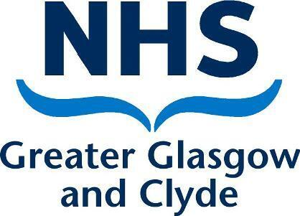

**Title: Consultant in Geriatric Medicine (Flexible Subspecialty)**

**Location: Inverclyde Royal Hospital**

**Job Reference: 173981**

**Closing Date: 23rd January 2024**

**Interview Date: 7th February 2024**

**OLDER PEOPLE A**

**Welcome to Inverclyde Royal Hospital**

**Inverclyde Royal Hospital is embarking on an exciting time of service redesign along with commitment to staff and patients and are recruiting across the specialties.**

**Inverclyde Royal Hospital is a district general in Greenock, on the beautiful west coast of Scotland and is part of Greater Glasgow and Clyde Healthboard, the largest in Scotland.**

**Through the pandemic period, the team working ethos and drive for service development at the site was an absolute priority and we are delighted to be taking this forward into the future.**

**We are looking for Consultant colleagues to work in a small but dedicated consultant team, where work life balance is encouraged and teamwork is a priority. Supporting service improvement, supporting clinical and non-clinical interest and attractive job plans are key.**

**Above all, the teams at Inverclyde Royal Hospital are comprised of friendly and empathetic colleagues, where all the teams work together for our patients and a smile is always present.**

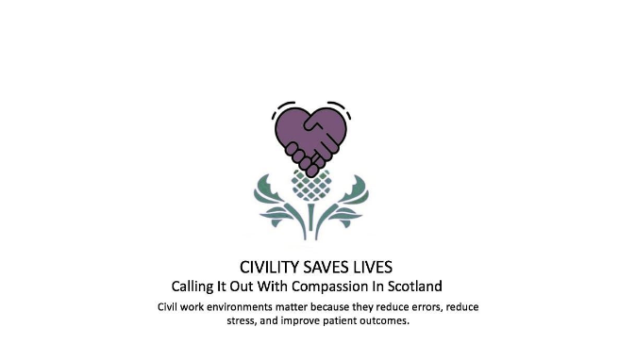

**Consultant in Geriatric Medicine (Subspecialty flexible)**

**10 sessions, 8 DCC, 2 SPA**

**Inverclyde Royal Hospital**

# Summary of the Post

We are now seeking to appoint, on a permanent basis, a Consultant in Geriatric Medicine. This post is based within a specialist Older People and Stroke Unit at the Inverclyde Royal Hospital (IRH) Greenock. IRH provides a full range of District General Hospital Specialties with excellent support facilities. We also have a major commitment to education and close links with Glasgow University and there is an active undergraduate and postgraduate teaching programme.

We are seeking a highly motivated, innovative, experienced and enthusiastic consultant to join a well-established and friendly Older People and Stroke Service, providing acute assessment and rehabilitation across the Clyde area which comprises both urban and rural populations. This post provides an exciting opportunity to deliver and develop Older Peoples Services within an expert multi-disciplinary team. The post holder should ideally have a passion for service development and quality improvement.

Within this role you will be one of a team of Consultants supported by a dedicated team of specialist nursing staff who are committed to improving the patient pathway to promote and deliver high standards of patient care, outcomes, experience, safety and quality. Your application and interview will demonstrate the skill set needed to join us in delivering, developing and teaching expert care within this exciting and challenging specialty.

Successful candidates will be able to demonstrate a high level of clinical experience in all aspects of geriatric medicine including additional evidence of their subspeciality interest.

# Duties of the Post

## This is an exciting opportunity to join a team of consultants providing a needs-

## led comprehensive Geriatric Medicine service and Stroke service based within

## Inverclyde Royal Hospital.

## The successful candidate will be expected to undertake a subspecialty interest – the exact nature will depend on candidate preference. We are able to offer opportunities within the Movement Disorder, Orthogeriatric or Frailty services, either both within IRH and across Clyde Sector.

## Suggested job plan

This post has no mandatory on call or out hours of work, however this can be incorporated to the job plan if desired.

This job plan is negotiable with a view to supporting interests and helping the individual achieve their potential. It will be agreed between the successful applicant and the Clinical Director.  Older People and Stroke Services would initially allocate new appointments to the consultant team 10 PAs made up of 8 Direct Clinical Care (DCC) PAs and 2 Supporting Professional Activities (SPA) for service development and development of specialty interest. The precise allocation of SPA time and associate objectives will be agreed with the successful applicant and will be reviewed at annual job planning. EPAs for additional activities of interest are available.

The job plan will be tailored to the successful candidate’s interests and the following should only be taken as guidance.

|  |  |  |  |  |  |
| --- | --- | --- | --- | --- | --- |
|  | **Monday** | **Tuesday** | **Wednesday** | **Thursday** | **Friday** |
| **A.M.** | Acute assessment ward round (10 patients) | SPA | Rehabilitation ward round and MDT (10 patients, shared with AHP Consultant) | Acute assessment ward round (10 patients) | Subspecialty interest session |
| **P.M.** | Acute assessment MDT meeting | Outpatient clinic | Admin | Subspecialty interest session | SPA |

Cover for study leave and holidays will be provided from within existing consultants. OPSS is strongly supportive of family life and can accommodate flexible working arrangements.

# An overview of the sites and ethos

## IRH

The Inverclyde Royal Hospital is situated in Greenock and provides acute health care services to Inverclyde, North Ayrshire and the Cowal peninsula. The Hospital is a 220 bedded, modern District General Hospital which opened in 1979 and is one of the busiest teaching DGHs in Scotland. In addition, the hospital is currently the base for provision of Emergency Medicine, Surgery, Endoscopy, Orthopaedics, Critical Care, Dialysis satellite unit Gynaecology and Maternity Services. A stabilize and transfer model for level 3 care and other acute presentations is well established in a hub and spoke model.

The hospital provides a wide range of District General Hospital specialties with excellent support facilities. The hospital has a first class modern radiology department and services. All departments participate in undergraduate teaching and there is an active postgraduate educational program, specializing in General Internal Medicine and supporting International Medical Graduates. IRH benefits from links with the larger central hospitals in Glasgow and is well supported by the Department for Medical education along with a good medical library service.

### IRH Older People & Stroke Services

The Older People and Stroke Service (OPSS) is situated within the Larkfield Unit which is a modern facility attached to the main IRH building by a link corridor. The Larkfield Unit has five wards, three of which belong to the OPSS. The other two house the Neurological Rehabilitation Unit and inpatient Psychiatry service. The Larkfield Unit also hosts our Day Hospital, outpatient clinics and allied health professions services.

There is an educational programme both within our unit and the wider medical unit and we have bimonthly morbidity and mortality meetings within each ward. We are a teaching hospital and the Larkfield Unit hosts medical students at various points during the academic year and there are opportunities for junior doctor supervision.

Assessment and Rehabilitation

Ward 2 provides 30 beds for the assessment of frail, elderly inpatients. It receives most of its patients from the acute medical unit, with a smaller number from the downstream medical and surgical wards. Flow into the unit is controlled by our Elderly Care Assessment Nurse and Frailty Practitioner. The aim is to provide comprehensive geriatric assessment by the multidisciplinary team with early discharge, with or without follow-up, where appropriate. Medical unwell patients remain within ward 2 and those requiring a longer period of rehabilitation are transferred to Ward 3.

Ward 3 is our combined rehabilitation ward with 10 general rehabilitation/complex care beds and 10 orthogeriatric rehabilitation beds. The orthogeriatric rehabilitation is supported by our Allied Health Professional (AHP) Consultant.

We are supported by an Advanced Nurse Practitioner, who is also an Independent Prescriber. All our wards have dedicated physiotherapy and occupational therapy teams with support where required from the wider AHP services including speech and language therapy, podiatry, tissue viability, dietetics and orthotics.

Acute Stroke Unit (patients of all ages)

Ward 1 is the 17 bedded Acute Stroke Unit which accepts direct admissions from the ED and Acute Medical Unit. Thrombolysis for patients from the IRH catchment area is delivered by the South Glasgow Stroke Service at the Queen Elizabeth University Hospital and patients repatriated thereafter. There is a neurology liaison service to the IRH both for inpatients and outpatients.

Rapid access TIA clinics are undertaken, with the number of clinics required to achieve national performance targets recently being agreed following review. The Stroke service is represented on the Greater Glasgow & Clyde Stroke Managed Clinical Network.

Movement Disorders

Movement Disorder services at IRH is provided by one consultant, supported by a Parkinson’s Disease Nurse Specialist (shared with the Vale of Leven). There are 2 outpatient clinics per week and inpatients are cared for in wards 2 and 3 wherever possible/appropriate. The team provides liaison support to other specialties within the hospital and our PDNS provides domiciliary visits, where possible, to our local nursing homes.

Orthogeriatric Liaison

Orthogeriatric Liaison is currently undertaken by a consultant, supported by an Elderly Care Orthopaedic Nurse (ECON). There is a weekly Falls outpatient clinic.

The unit is enhanced by the ‘Rainbow Garden’, an award winning initiative on site that allows our most vulnerable patients the chance to be outside, relax with visitors and enjoy the peaceful surroundings. It is also available to staff.

# The Team

There is very much a Clyde team approach. The post will be hosted within the Clyde Sector, Older People and Stroke Service. The Consultant appointed will be expected to participate fully in the work and aims of the Sector.

The Chief of Medicine is Dr Claire Harrow, Clinical Director for Older People across Clyde is Dr Lucy McCracken and the Lead Consultants are Dr Julie McManus, Dr Oona-Mary Lucie and Dr Janice Murtagh.

The General Manager for Older People and Stroke in Clyde is Victoria Cox, supported by Heather Lapsley and Heather Kinnon, Clinical Service Managers.

Consultant Team

Dr J Murtagh Movement Disorders

Dr J Martin Frailty/Stroke

Dr L McCracken Orthogeriatrics/Frailty

Dr A Gunn Stroke/Acute Medicine

Dr C Harrow Stroke/Acute Medicine

Dr S Muir Stroke/Acute Medicine

Trainees

FY1 x 3, FY2 x 6, GPST x 1

IRH feeds into the Clyde acute governance framework with monthly M&M meetings and a commitment to duty of candour and transparency in clinical working.

An Appraiser will be automatically appointed to the successful applicant to ensure straightforward revalidation.

There is secretarial support for consultant appointments, as well as input from a newly appointed Service Improvement Manager and Clinical Governance team.

# Postgraduate and Undergraduate Training

Clyde Sector has an active undergraduate and postgraduate education program and has excellent educational facilities including a clinical skills area equipped with a simulator suite.

# Further information

We would be delighted to hear from any candidates that wish further information about our recent quality improvement work and proposed job, and to arrange a visit to the department, either virtually with Teams or in person.

|  |  |  |  |
| --- | --- | --- | --- |
| **Informal enquiries and details of arrangements to visit the department regarding this post will be welcome by:** | | | |
| **Name** | **Job Title** | **Email** | **Telephone** |
| **Victoria Cox** | **General Manager** | **Victoria.Cox@ggc.scot.nhs.uk** | **07970317043** |
| **Dr Lucy McCracken** | **Clinical Director** | **Lucy.McCracken@ggc.scot.nhs.uk** | **0141 887 9111** |
| **Dr Janice Murtagh** | **Lead Clinician IRH** | **Janice.Murtagh@ggc.scot.nhs.uk** | **01475 505078** |
| **Heather Lapsley** | **Clinical Service Manager** | **Heather.Lapsley@ggc.scot.nhs.uk** | **01475 505119** |

# Candidate Specification: Consultant in Geriatric Medicine

|  |  |  |  |
| --- | --- | --- | --- |
| **Qualifications** | | | |
| **Essential** | * Full GMC Registration and a licence to Practice. * Those trained in the UK should have evidence of higher Specialist Training leading to a CCT in Geriatric Medicine or eligibility for specialist registration (CESR) or be within six months of confirmed entry at the date of interview.  Non UK applicants must demonstrate equivalent training. | | |
| **Desirable** | * Training/Clinical Supervision qualification | | |
| **Experience** | | |
| **Essential** | * Experience of selected ‘needs related’ emergency admissions in older people. * Experience of multidisciplinary assessment and rehabilitation in older people. * Experience in Day Hospital. * Experience of teaching undergraduates. * Involvement in clinical audit. * Experience in relation to applicants declared subspecialty interest | |
| **Desirable** | * Experience of teaching medical and non-medical postgraduates. * Involvement in research. * Leadership of an audit or quality improvement project. * Experience in quality improvement projects | |
| **Knowledge and Skills** | | | |
| **Essential** | | * Ability to undertake comprehensive medical assessment and evaluate rehabilitation potential in older people. * Knowledge of clinical governance issues. * Evidence of training in the applicants declared subspecialty interest | |
| **Desirable** | | * Ability to perform assessment on medical trainees. * Knowledge of key policy issues relevant to Older Peoples Medicine in Scotland. * Familiarity with future service priorities in Glasgow and service integration with Community Health and Social Care Partnerships. * Record of contribution to service change and redesign. | |
| **Disposition e.g. Personal (transferable) skills** | | | |
| **Essential** | | * Excellent communication skills and empathy. * Ability to work in multi-disciplinary team. * Flexibility to respond to changing patterns of work in line with service change. | |
| **Desirable** | | * Evidence of time management. | |

# Discover Inverclyde

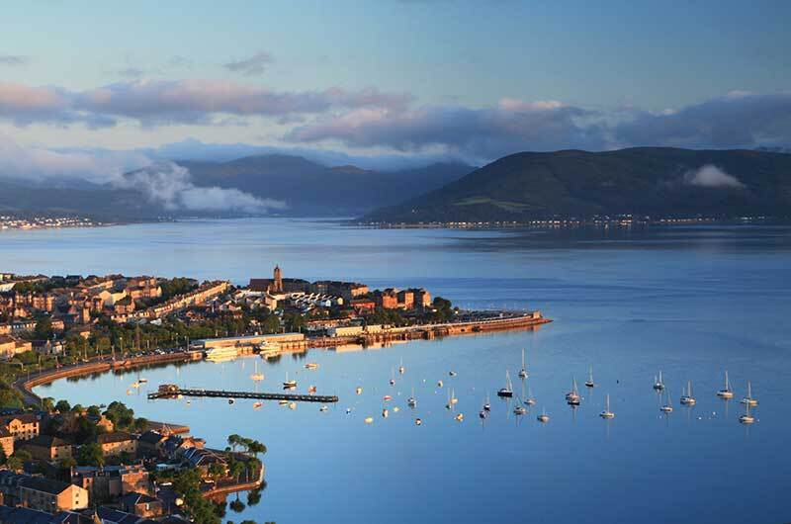

**Inverclyde is located on the beautiful west coast of Scotland**

It is one of the most attractive places in Scotland to live, work and visit, with breath-taking scenery, excellent transport links to Glasgow and Edinburgh, a wide range of sporting and leisure opportunities and some of the best schools in Scotland.

The area includes the main towns of Greenock, Port Glasgow, Gourock, Inverkip and Wemyss Bay, and the rural villages of Kilmacolm and Quarrier’s Village. Offering spectacular views and scenery, unique waterfront sporting and leisure opportunities all accessible easily by car, rail, ferry and air links from the city of Glasgow and beyond. Many of the staff live locally in Inverclyde, Renfrewshire and Glasgow.

The area has a history and heritage rich in shipbuilding and seafaring dating back to the 1500’s which has left its mark throughout the region.

These days, it offers a broad range of sports and leisure facilities, both indoors and outdoors, a great variety of arts and culture activities and wide open spaces to enjoy and explore.

There are many recreational activities; for lovers of the outdoors, with excellent local golf courses, sailing in the Clyde, outdoor swimming at Gourock, hill walking and mountain biking in Argyll & Bute. There are 6 golf courses alone in the area with outstanding views of the Firth of Clyde.  Wild swimming, sailing and rowing are all popular activities. This makes the area is an attractive one to live in. It offers good access to the Highlands and to Glasgow with its many cultural and recreational attractions.

Inverclyde’s estimated population in 2017 was 78,760, which is 1.5% of the total population of Scotland.

87% of the population live in the towns of Greenock, Port Glasgow and Gourock with the remainder of the population living in the villages of Inverkip, Wemyss Bay, Kilmacolm and Quarriers Village.

* 16.2% of Inverclyde’s population is aged 16 years or younger,
* 20.46% is aged 65 years or older.
* 63.3% of Inverclyde’s population is aged between 16 and 64 years old.

Despite the attractiveness of many parts of Inverclyde there are a number of communities, similar to other parts of the West of Scotland, in Inverclyde that continue to suffer from high levels of poverty and disadvantage. The areas suffering from the highest levels of deprivation include parts of Greenock and Port Glasgow. Within Greenock in particular, there are communities that have consistently been placed amongst the top 5% most deprived in Scotland since 2004. This has manifested itself in poorer health, lower levels of employment, higher levels of child poverty, lower levels of attainment and higher levels of drug and alcohol misuse in these areas.

The differences in social and economic circumstances in communities across Inverclyde mean that tackling inequalities is key priority for NHS Greater Glasgow and Clyde, and the Team at Inverclyde Royal Hospital are committed to driving forward change and advocating for our patients.

**Education**

In Inverclyde there are currently 6 Secondary State Schools, 20 Primary Schools and 2 Independent Schools along with Early Years Establishments and Additional Support needs units.

Find out more about schools in Inverclyde via www.inverclyde.gov.uk/education-and-learning/schools

As a place to live, the Greater Glasgow and Clyde area has many attractions. The West of Scotland combines cosmopolitan charm, lush countryside and soothing seaside. Culturally diverse, architecturally stunning and historically rich, this vibrant region is home to innovation, celebration and the largest city in Scotland – Glasgow.

As Scotland’s most populous region, the West of Scotland is home to approximately two million people. In addition to the city of Glasgow, East and West Dunbartonshire, Inverclyde, Ayrshire, North and South Lanarkshire, Renfrewshire and East Renfrewshire make up this captivating and eclectic part of the country.

This is a region of striking contrast. Larger areas like Glasgow are within easy reach of picturesque towns, villages and some of Scotland’s most scenic beaches, captivating wildlife and tranquil countryside.

Multicultural, magnificent and brimming with personality, Glasgow is Scotland’s largest city and is home to nearly 600,000 people. Offering a rich history, stunning architecture and the best shopping in the UK outside London. The community spirit and friendliness of the locals led to the creation of the commonwealth games phrase ‘People make Glasgow’.

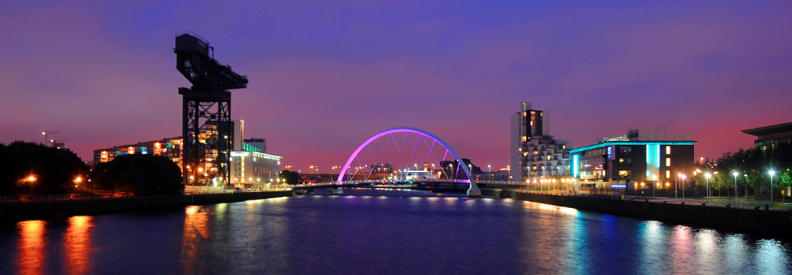Offering the best of both worlds, Glasgow is close to breath-taking countryside offering up nearby hill walking, sailing, and cycling. Some of the world’s greatest golf courses are all within an hour’s drive of the city. And this bustling city’s arts and culture, nightlife and food are hard to surpass.

Home to over 133,000 students from around the world, this vibrant city has five world-renowned universities and seven colleges.

## Lots to see and do

No matter what your age or interest, the West has something for you. Be dazzled by Charles Rennie Mackintosh’s iconic architecture in Glasgow or satisfy your appetite with mouth-watering produce at the farmers’ markets in Renfrewshire and Inverclyde.

You also have your choice of impressive year-round events and festivals, attractions or some of the best leisure facilities in the country. And as a UNESCO City of Music, Glasgow offers an impressive range of musical delights.

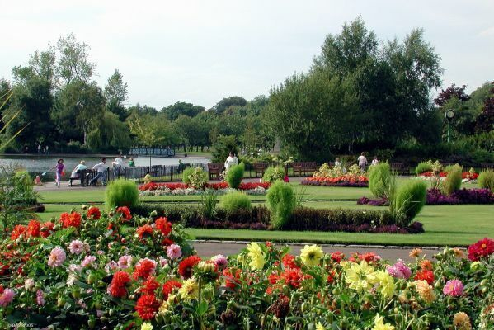Experience the award-winning wonder of Kelvingrove Art Gallery and Museum and the awe-inspiring Glasgow Science Centre, or enjoy international musicians, sporting events and more.

The West loves its sports – evident in its numerous outstanding leisure centres and facilities. Glasgow is one of the world’s top 10 destinations for sports events and in 2014, Glasgow hosted the 20th Commonwealth Games. The newly built Commonwealth Arena and adjoining Sir Chris Hoy Velodrome in the East End of Glasgow hosted badminton and cycling events for the 2014 games.

In Ayrshire you can celebrate the national poet at the Burns and a' that Festival, admire the spectacular scenery at the Ayr Flower show or try your luck at the races at the Scottish Grand National.

## Housing

Whether you are renting or buying, the West offers a superb selection of housing. Here you’ll have your choice of apartments on the River Clyde, country cottages and rural manor houses in rural Renfrewshire, spacious Victorian flats in the West End and family homes in leafy suburbs conveniently located near to schools. Rightmove and Zoopla searches for the council areas display the wealth of choice and advice can be given by local colleagues if applicants are relocating- we want to ensure that transitions are as smooth and well supported as possible.

## Getting around

The Hospital itself has plenty of free parking, including a staff car park and overflow car park. It is supplied by the rail line from Glasgow Central Station.

The M8 motorway connects the West with the rest of Scotland, taking just under an hour to drive between the country’s major cities Glasgow and Edinburgh, a well-used commuter route. Major rail lines travel out of Glasgow, North and South, with a direct train to London taking just 4.5 hours, or if a more exciting rail journey is wanted, a trip on the steam train to the famous Glenfinnan viaduct featured in Harry Potter. Glasgow has the UK’s largest suburban rail network outside London.

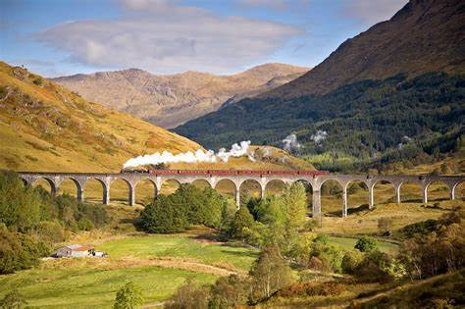

The bus is an effortless way to get around because it’s inexpensive and widely available across the region – even in remote locations.

From Ardrossan, Gourock and Wemyss Bay you can also travel by ferry to many of Scotland’s islands, or further afield from one of the cruise ships that dock at Greenock harbour.

Glasgow’s two international airports connect the region with the rest of the UK and beyond. Pre Covid there were approximately 200 flights per day from Glasgow international airport alone, ready to fly you to over 90 destinations like London, Dubai and New York.

The best of the city-living, magnificent countryside and an opportunity to work in some of Scotland’s most exciting industries means this region is a hugely popular place to live, play and work.

Further information

To find more information about living and working in Scotland please visit:

www.visitscotland.com

www.scotland.org

www.talentscotland.com

www.moverdb.com/moving-to-glasgow

# Terms and Conditions of Service

Terms and Conditions of Service are those determined by the Terms and Conditions of the New Consultant Grade (Scotland) as amended from time to time. For an overview of the terms and conditions visit **http://www.msg.scot.nhs.uk/pay/medical**

|  |  |
| --- | --- |
| **TYPE OF CONTRACT** | **Permanent** |
| **GRADE AND SALARY** | **Consultant**  The whole-time salary will be a starting salary of:-  £96,963 - £128,841 per annum (pro rata if applicable)  Progression of salary is related to experience.  New Entrants to the NHS will normally commence on the minimum point of the salary scale, (dependent on qualifications and experience). Salary is paid monthly by Bank Credit Transfer. |
| **HOURS OF WORK** | **Full-Time** |
| **SUPERANNUATION** | New entrants to NHS Greater Glasgow and Clyde who are aged sixteen but under seventy five will be enrolled automatically into membership of the NHS Pension Scheme.  Should you choose to "opt out" arrangements can be made to do this via: www.sppa.gov.uk |
| **REMOVAL EXPENSES** | Assistance with removal and associated expenses may be given and would be discussed and agreed prior to appointment. |
| **EXPENSES OF CANDIDATES FOR APPOINTMENT** | Candidates who are requested to attend an interview will be given assistance with appropriate travelling expenses. Re-imbursement shall not normally be made to employees who withdraw their application or refuse an offer of appointment. |
| **SMOKEFREE POLICY** | NHS Greater Glasgow and Clyde operate a No Smoking Policy in all premises and grounds. |
| **DISCLOSURE SCOTLAND** | This post is considered to be in the category of “Regulated Work” and therefore requires a Disclosure Scotland Protection of Vulnerable Groups Scheme (PVG) Membership. |
| **CONFIRMATION OF ELIGIBILITY TO WORK IN THE UK** | NHS Greater Glasgow and Clyde (NHSGGC) has a legal obligation to ensure that it’s employees, both EEA and non EEA nationals are legally entitled to work in the United Kingdom. Before any person can commence employment within NHSGGC they will need to provide documentation to prove that they are eligible to work in the UK. Non EEA nationals will be required to show evidence that either Entry Clearance or Leave to Remain in the UK has been granted for the work which they are applying to do. Where an individual is subject to immigration control under no circumstances will they be allowed to commence until the right to work in the UK has been verified.. You will be required provide appropriate documentation prior to any appointment being made. |
| **REHABILITATION OF OFFENDERS ACT 1974** | The rehabilitation of Offenders act 1974 allows people who have been convicted of certain criminal offences to regard their convictions as “spent” after the lapse of a period of years. However, due to the nature of work for which you are applying this post is exempt from the provisions of Section 4 of the Rehabilitation of Offenders Act 1974 by virtue of the Rehabilitation of Offenders Act 1974 (Exceptions Orders 1975 and 1986). Therefore, applicants are required to disclose information about convictions which for other purposes are “spent” under the provision of the act in the event of employment, failure to disclose such convictions could result in dismissal or disciplinary action by NHS Greater Glasgow and Clyde. Any information given will be completely confidential. |
| **DISABLED APPLICANTS** | Job Interview Guarantee Scheme  As a Disability Symbol user, we recognise the contribution all individuals can make to the organisation regardless of their abilities. As part of our ongoing commitment to extending employment opportunities, all applicants who are disabled and who meet the minimum criteria expressed in the job description will be guaranteed an interview. A disability or health problems does not preclude full consideration for the job and applications from people with disabilities are welcome. All information will be treated as confidential. You will note on our application form that we ask for relevant information with regard to your disability. This is simply to ensure that we can assist you, if you are called for interview, to have every opportunity to present your application in full. We may call you to discuss your needs in more detail if you are selected for interview. |
| **FLEXIBLE WORKING** | NHS Greater Glasgow and Clyde operates flexible staffing arrangements whereby all appointments are to a grade within a department. The duties of an officer may be varied from an initial set of duties to any other set, which are commensurate with the grade of the officer. The enhanced experience resulting from this is considered to be in the best interest of both NHS Greater Glasgow and Clyde and the individual. |
| **EQUAL OPPORTUNITIES** | The postholder will undertake their duties in strict accordance with NHS Greater Glasgow and Clyde’s Equal Opportunities Policy. |
| **NOTICE** | **The employment is subject to 3 months’ notice on either side, subject to appeal against dismissal.** |
| **MEDICAL NEGLIGENCE** | In terms of NHS Circular 1989 (PCS) 32 dealing with Medical Negligence the Health Board does not require you to subscribe to a Medical Defence Organisation. Health Board indemnity will cover only Health Board responsibilities. It may, however, be in your interest to subscribe to a defence organisation in order to ensure you are covered for any work, which does not fall within the scope of the indemnity scheme. |



**Making your Application**

From the 3rd of June 2019 candidate applications for Medical and Dental posts within NHS Greater Glasgow and Clyde (NHSGGC) will only be accepted via the completion of an online application form. NHSGGC utilise a third party recruitment system called JobTrain and when you complete and submit the online application form your submitted application will be imported into JobTrain and any emails will be sent via the JobTrain Recruitment System.

If this is the first time you have applied for an NHSGGC vacancy via our eRecruitment system (JobTrain), you will be asked to create an account. You can do this via an email address or social media account. Please make sure the email address submitted is correct as this will be our primary method of contact during each stage of the recruitment process. You will receive emails from our eRecruitment system throughout the process, you can reply to these and they will be received by our Medical Recruitment team member managing the vacancy. Please ensure you check the email account (including junk/spam boxes) from which you apply regularly as we will use this to contact you regarding your application.

NHS Scotland does not accept CV’s in addition to/instead of a completed application form. Your CV will not be provided to the interview panel for shortlisting.

Please remember when using the online application system you will time-out after 30 minutes of inactivity. Please regularly save your application.

NHS GGC is unable to accept written applications; all applications must be submitted via eRecruitment system, JobTrain. Please visit

**https://apply.jobs.scot.nhs.uk**

**Contact Us**

For any additional information about this post, guidance in completing your application or if you have any personal requirements that will enable you to participate in our recruitment process please contact a member of our NHS Greater Glasgow and Clyde’s Medical and Dental Recruitment team via:

Tel: +44 (0)141 278 2700

Email: nhsggc.recruitment@nhs.scot

Thank you for your interest in NHS Greater Glasgow and Clyde, we look forward to receiving your application.