JOB IDENTIFICATION
Job Title: Digital Services Service Asset Configuration Manager

Responsible to: Digital Services Head of Service Delivery

Department: Digital Services

Directorate: Infrastructure & Support Services

Job Reference:

CAJE No: 800-3281

No of Job Holders: 1

Last Update: June 2024

JOB PURPOSE
Driving and implementing Service Asset Configuration Management (SACM) initiatives to improve Healthcare delivery and improve patient outcomes in NHS Ayrshire & Arran.

Responsible for ensuring continued support, improvements, and communication of the SACM provision to all NHS Ayrshire & Arran users through appropriate Digital Services teams.

The Service Asset Configuration Manager (SACM) will be responsible for the design, delivery, population, and ongoing maintenance and continual improvement of the Configuration Management Database (CMDB) and all the assets contained within this. This role and the CMDB are central to improving the Digital Service’s IT Service Management capability and interfaces with other ITSM processes, such as:

Role is focused on Service Asset Configuration Management in support of current local Digital Services delivery and requirements to contribute to the development of support processes for new and changing NHS Ayrshire & Arran, West of Scotland, and National Initiatives. The role will support continuous improvement of the Digital Services whilst minimising the risk to business services, all activities will be recorded for auditing purposes.

DIMENSIONS
Direct responsibility for monitoring, developing and improving the quality of Service Asset Configuration Management and ensuring all CIs are recorded and are updated when any changes have taken place by monitoring to develop and improve the quality of the CMDB. This supports the Digital Services Service Desk provision to 14,000 + users across NHS Ayrshire & Arran through providing accurate and up to date information on all CIs. Identification of areas for improvement and the implementation of new processes and procedures to meet client expectations in line with organisational requirements.

Escalation point for all Digital Services teams and Service Desk staff in relation to assets and CIs across the entirety of NHS Ayrshire & Arran.

ORGANISATION
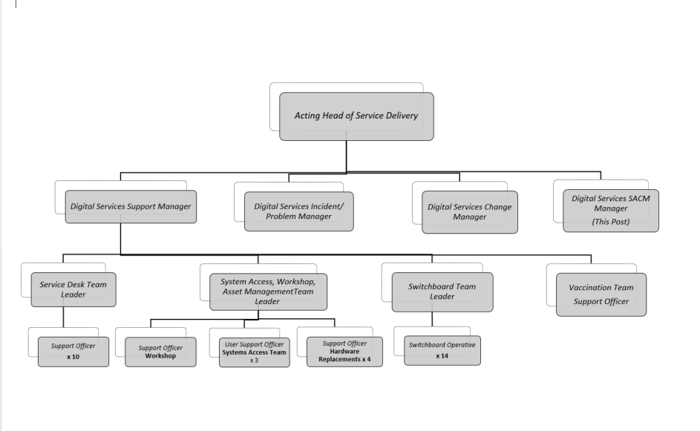

The Service Asset and Configuration Management Manager will report directly to the Acting Head of Service Delivery and will work alongside peers including the Digital Services Support Manager and the Digital Services Change Manager and the Digital Services Incident and Problem Manager.

ROLE OF DEPARTMENT
The Department is responsible for delivering the following services on an organisation wide basis across NHS Ayrshire & Arran:
- Cost effective Digital services to drive Transformational Change and the delivery of effective and safe patient care.
- Developing and maintaining the technical IT infrastructure (servers, desktops, local and wide-area networks) to enable the sharing of information and knowledge across NHS Ayrshire & Arran in a secure managed environment.
- Providing support and professional advice on Digital technology, Voice, and Data Networks.
- Delivering safe, effective, and efficient Digital Services to provide the highest possible standards and quality of care to patients.

KEY RESULT AREAS
Service Asset and Configuration Management
- The development, agreement, implementation, management and maintenance of Service Asset & Configuration Management policies, standards, processes, and the continual improvement of Service Asset & Configuration Management function. Driving the adoption and adherence of Service Asset & Configuration Management policies, standards and processes throughout NHS Ayrshire & Arran Digital Services. Addressing and escalating issues of non-compliance of policy, standards and processes.
- Train, guide and advise all Digital Services staff as required in SACM process, policy and procedures. Act as an escalation point for all SACM activities through the SACM process.
- The design and delivery of a ServiceNow CMDB using both a mix of automatic discovery and manual mapping considering; functional and non-functional requirements, the scope and depth of information held and phasing of the implementation plan. Planning and executing the population of the asset register and configuration management database (CMDB), ensuring that the data held is complete and accurate.
- Monitor and review software licenses and ensure compliance with licensing agreements.
- The identification of any CIs not recorded in the CMDB or incorrectly recorded and adding or correcting such records; taking corrective action if a physical audit identifies any deficiency in the accuracy or completeness of the records in the CMDB and for coordinating regular audit reviews.
- Coordinate with procurement and finance teams to track and manage hardware and software assets throughout their lifecycle, including acquisitions, deployments, disposals, and renewals.
- Analyse asset and configuration data to identify opportunities for optimisation and cost savings.
- Conduct verification, auditing, and reporting activities of IT infrastructure to ensure that information contained in the CMDB is an exact representation of the Configuration Items (CIs) actually installed in the live production environment and to identify any unauthorized CIs.
- Ensuring that internal controls are established, monitored for effectiveness, and reported. Regularly audit the SACM process to ensure validity and the process is being adhered to.
- Establish key performance indicators (KPIs) and provide reporting on all areas of SACM to senior leadership team and respond timeously to requests for information relating to all SACM activities from all areas.
- Ensuring that the IT assets or Configuration Items (CI’s) required to deliver IT services are properly controlled and accurate, and reliable information about those CI’s is accessible when and where it is needed. This information includes details of where assets are located, how those assets have been configured and the relationships between CIs. As such, the postholder is the custodian and guardian of all assets, documentation and CIs registered within the CMDB. They will develop, implement, and manage the processes and procedures required to maintain accuracy of the CMDB.
- Creation and production of monthly management reports where required on the CMDB to report to all levels of key stakeholders up to and including CXOs. Develop, prepare, agree, and communicate procedures to all relevant parties across NHS Ayrshire & Arran.

Service & Client Management

- Directly responsible for delivering best practice SACM processes providing efficient and effective support to internal Digital Services teams and the wider organisation.
- Develop and maintain good working relationship with ability to communicate with Digital Services Staff and key suppliers if required. Liaising with Digital Services Head of Service Delivery to facilitate required information provision or review of 3rd Party Vendor reporting on Service Level Agreements.
- Ensure that customers' issues are addressed timeously by all Digital Services staff and identify opportunities for improvements, keeping abreast of organisations best practice.
- Resolving conflict or contention for service within defined priorities, escalating actions to the Digital Services Head of Service Delivery as necessary.
- Proven track record in the management of ITIL Service Operations processes and experience of driving through service improvement activities.
- Excellent organisational skills including attention to detail and multitasking, as well as excellent written, verbal communication and leaderships skills.
- Strong stakeholder management and interpersonal skills, interfacing/presenting to director level.
- Awareness and understanding of Change, Problem, and Incident Management, maintaining Service Levels, ITSCM (IT Service Continuity Management), Business Continuity and Disaster Recovery.

The above is not exhaustive, and the post-holder may be required to fulfil any other reasonable requests for support on other digital related matters.

7a. EQUIPMENT AND MACHINERY
The post holder will use a range of standard office machinery & equipment, including: -
- Scanners / Photocopiers or Multi-Function Devices
- Telephony
- Tele conferencing
- Video Conferencing
- Personal Computer
- Printer
- Audio Equipment
- Mobile Phone
- Other office equipment including smartboard, projector and photocopier.

7b. SYSTEMS
The post holder will use and ensure maintenance and services in support of a complex range of computer equipment and systems, including:
- Servers, network equipment, PCs, printers, and other computer peripherals.
- Microsoft operating systems, Microsoft 365 Applications, Adobe Applications, and other network systems.
- Service Desk Software Application and Reporting Tools.
- Business Support systems such as SSTS, eExpenses, ePayroll and eESS.
- There will be a requirement to support single user systems, applications, and multiuser departmental systems, with operational awareness required, even if not a frequent user.
- Specialist knowledge and understanding of Acute, Primary Care and Community Digital Clinical Systems throughout the organisation.
- Access to Turas for appraisal and staff development.

The post holder will use a range of electronic and manual recording and reporting systems, including but not limited to 3rd party contracts, technical, legislative & supplier literature.

8. ASSIGNMENT AND REVIEW OF WORK
Work is assigned and assessed by the Digital Services Head of Service Delivery in line with local, West of Scotland and National initiatives.
The post holder operates with a high degree of autonomy and has significant authority to determine how objectives should be met.
The post holder identifies and initiates items for consideration by the client groups.
Interaction and relationships with the very diverse range of service users, stakeholders and professional groups will be critical and will necessarily determine the overall direction and priorities of the department.

The review of work is undertaken by the Digital Services Head of Service Delivery on a regular and informal basis, and formally through yearly Personal Development Plan meetings.

9. DECISIONS AND JUDGEMENTS
- Key areas of responsibility and agreed priorities & objectives will be agreed with the Head of Service Delivery in keeping with NHS Ayrshire & Arrans Digital & Data Strategy.
- The majority of the post holder’s activity will be self-initiated and proactive in response to meeting objectives of the job with freedom to act / autonomy in the following Key Areas: -
- Individual issue resolution of Configuration Items (CIs) or complex communication to the rest of the Digital Services Directorate and customers as appropriate (proactive and responsive).
- Interpretation, communication, and submission of information to Digital Services relating to Service Asset and Configuration Management (SACM).
- Interpretation and communication of information to and from 3rd party suppliers in relation to SACM.
- Decisions, directions, and communication to External Suppliers (proactive and responsive).
- Frequent interaction and joint working on key projects or pieces of analysis or Service and Quality Improvement.

10. MOST CHALLENGING/DIFFICULT PARTS OF THE JOB
- Providing service improvements necessary to meet the aspirations of Digital users through the management of the Configuration Items (CIs) which may affect patient care while ensuring all interested parties are kept updated with progress.
- Developing, implementing, embedding, and communicating SACM processes for all Digital systems.
- Ensuring the Configuration Items (CIs) are accurately recorded, routinely updated when CIs are altered, e.g. retired, introduced etc by different areas of Digital Services.
- Delivering all elements of role with a changing and growing NHS Ayrshire & Arran and West of Scotland, ensuring correct recording of all Configuration Items (CIs) in the CMDB.
- Concluding the resolution of SACM with Digital teams and resources to whom the post holder has no authority, with high and conflicting demands on resources, to the benefit of end users.
- Working within a highly technical and changing environment.
- Frequent periods of concentration required when analysing complex technical issues with the CMDB, writing reports and knowledge-based resolution.
- Dealing with aspects of patient confidentiality and data protection.

11. COMMUNICATIONS AND RELATIONSHIPS
Communication is a key element to this role with the ability to communicate complex technical information effectively to individuals or large groups at all levels and stakeholders in a clear and understandable manor being an absolute requirement. Other than obvious inter departmental communication, all NHS Ayrshire & Arran users of Digital equipment or services are able to converse with the post holder at any time, whether junior or senior, clinical or clerical. The nature of communication is wide ranging from basic to complex Digital issues, technical to supportive, informative to emotive.

Create communications for all NHS Ayrshire & Arran staff related to the Changes being implemented and the Digital Services which will be affected. Issue agreed communication to all Digital users and close collaboration with Heads of Service, Service Desk Team Leader and other Digital Management teams.

Close collaboration with executive team members, senior clinical and medical staff, General Managers, Service Managers, Departmental managers or Heads of Departments and a wide range of users of Digital systems and services.

Building effective working relationships with all areas of Digital Services is extremely important to allow them to gain an understanding of the importance of SACM and in particular the CMDB and ensuring all CIs are recorded accurately and updated when changes have taken place to maintain the integrity of the CMDB.

12. PHYSICAL, MENTAL, EMOTIONAL AND ENVIRONMENTAL DEMANDS OF THE JOB
Physical Effort/Skills:
- High level of dexterity and precision occasionally fixing equipment.
- Sitting for prolonged periods of time.
- Occasionally moving and handling equipment.
- Frequent advanced keyboard skills.
- Occasional travelling between sites.
- Driving licence/driver.

Mental Effort/Skills:
- Ability to deliver initiative, proactiveness and subjectivity at times of high demand or pressure.
- Knowledge that major impact on clinical and medical services can be affected by initiative, decisiveness, and promptness of reactions to loss of Digital services can create high levels of stress, often requiring additional effort.
- Lengthy periods of concentration are required analysing Digital issues whilst balancing frequent interruptions by Digital Services staff or department staff, and multi-tasking.
- Maintaining knowledge in area of expertise including managerial, technical & legislative advancements, whilst continuing to carry out day to day activities.
- Physical demands on time management and ability to diversify due to team of staff with varying responsibilities & skills, ensuring performance measures are met & improved upon.

Emotional Effort/Skills:
- Excellent interpersonal skills.
- Exceptional customer service orientation.
- Empathy with colleagues and users.
- Dealing with stressful, angry users.

Environmental Working Conditions:
- Mainly office based but can be subject to agile working and working from home.
- Travelling between sites.
- Occasionally unpleasant conditions, exposure to dust and noise.
- Server rooms within hospitals and clinics.

13. KNOWLEDGE, TRAINING AND EXPERIENCE REQUIRED TO DO THE JOB

Essential

- Significant experience of working in a Service Asset Configuration Management, Digital service or support function.
- Educated with degree in IT, Business Management, or related field, or holds equivalent level of professional IT qualifications.
- In depth knowledge of Digital Support is essential as is competence in troubleshooting, root cause analysis and problem solving.
- High level of familiarity of the concepts, standards, technology, tools, procedures, hardware, software, and services in use for delivering Digital services is required.
- Proven ability to understand the business aspects of information systems and applications supported, and specialist knowledge of technical aspects of information and application systems, hardware, and software environments in which they run, business continuity process and procedure to ensure impact is known for loss or interruption to services.
- High levels of analytical, problem solving, and numeric skills are essential to be able to identify and resolve configuration management issues.
- Familiarity with software licensing and compliance requirements.
- Highly developed & fine Keyboard skills are required.
- High level of communication and negotiating and influencing skills and the ability to diplomatically deal with all levels of users and senior management must be demonstrable.
- High level of knowledge of legislation, best practices and procedures surrounding Digital.
- Demonstrated capability to manage own workload and make informed decisions, working independently and using own initiative.
- Excellent report writing skills and able to articulate complex information to a range of key stakeholders at all levels.
- Experience with configuration management tools and systems, such as ServiceNow.
- Advanced level IT Skills including Excel, Word and PowerPoint.
- Able to design, implement and embed documented procedures and policies with staff at all levels.
- Able to deal, analyse and present technical information to a non-technical audience.
- Practical approach to problem solving, and excellent ability to understand technical issues.
- The ability to work under pressure and multitask, maintaining quality output.
- Exceptional relationship building skills, including extensive experience of working collaboratively with stakeholders at all levels.
- Full driving license and car is essential.

Desirable

- Qualified in ITIL Foundation level is desirable and good working experience of IT Service Management processes, in particular those relating to Service Asset Configuration Management.
- Experience of the NHS is desirable.
- In-depth knowledge and understanding of NHS primary care, community and secondary care services, systems, and infrastructure.

14. JOB DESCRIPTION AGREEMENT
A separate job description will need to be signed off by each jobholder to whom the job description applies.  Job Holder’s Signature:  Head of Department Signature: | Date:  Date:

