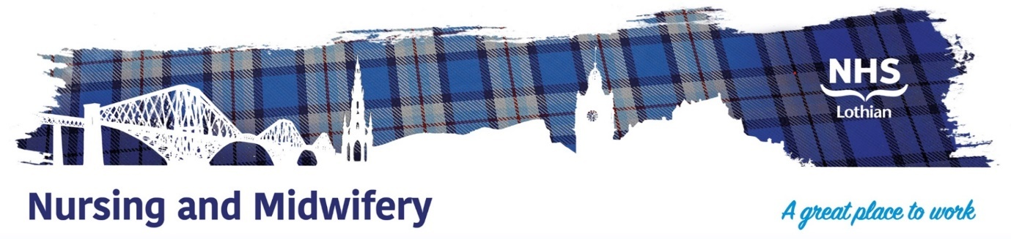

**NHS Lothian : The Robert Fergusson Unit**

Exciting opportunities are available to join The Robert Fergusson Unit (RFU) Team. The RFU is based at the Royal Edinburgh Hospital and is the Scottish National inpatient unit for treatment of the Neuropsychiatric Sequelae of Acquired Brain Injury.

Are you passionate, caring, motivated come join our highly skilled nursing team, we currently have Band 5 positions available for Registered Nurses, either Learning Disability or Mental Health Trained.

Our nurses lead on shaping and delivering care and treatment approaches, including behavioural management plans. We therefore offer a unique opportunity for you to work within a specialist, supportive, and talented team in a multidisciplinary environment, and to impact positively on the lives of our patients and their families.

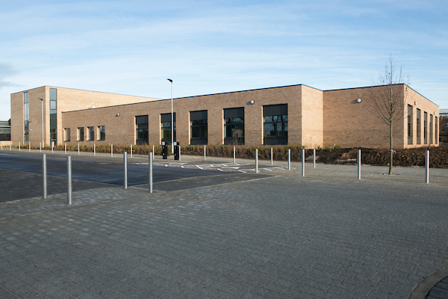

**What We Can Offer You**

You will be joining an ambitious, innovative, and dynamic team. You will learn and develop skills that are transferable into a range of different roles and tasks, gaining a breadth of knowledge through exposure to multiple specialties within a specialist national service.

**Roles**

* Staff Nurse (Learning disability/Mental Health (Band 5 Salary (£30,229 - £37,664 (pro rata) per annum (pending agreed uplift for 23/24)
* Clinical Support Workers (Band 3 Salary (£25,468 – £27,486 (pro rata) per annum (pending agreed uplift for 23/34)

**Benefits**

* An extensive induction programme.
* Excellent professional training and development opportunities.
* A minimum of five weeks annual leave increasing with length of service.
* A range of supportive employment policies including Flexible Working.
* Full or part time hours considered.
* Being a part of a supportive and enthusiastic team.
* Being part of a national behavioural rehabilitation service.
* Access to the NHS Pension Scheme and Staff Benefits.

**Staff Testimonials**

We are fortunate to have a very experience team here. We asked them why they have stayed at RFU this long – they said:

“The RFU is a good place to work, there is loads of opportunities for learning skills to help take care of people with complex needs and challenging behaviour”.

“It’s a really unique place to work, you use skills you wouldn’t pick up anywhere else, and because of the kind of work we do, if you can work here, you can work anywhere!”

“The team is filled with different disciplines with lots of different experiences, you get to work closely with people like OT’s and SLT’S”.

“Working with a big MDT, can be really helpful it feels more person centred”.

“It is a supportive team – one of the best that I have ever worked in, which you need because it is a very demanding job”.

“No two days are the same, it’s not a boring place to work you are always kept busy”.

“You feel appreciated for the work you do and for your own individual skills and what you bring to the team.”

“It is a fun place to work even on the hardest days, the team you work with become a great support system,”

“Once you have been here a while, you feel valued in your opinion, and you are taken seriously as a nurse”.

“Good options for courses and further training”

“You get extra training alongside your job, helps you with the skills needed to work here”.

