NHS

JOB DESCRIPTION

JOB IDENTIFICATION
Job Title: Assistant Finance Manager
Responsible to: Senior Finance Manager/Finance Manager
Department: Finance
Directorate: Finance
Job Reference: 160948
No of Job Holders: 12
Last Update: 27 April 2017

JOB PURPOSE

To support development of the Financial Plan and Lothian’s redesign and service modernisation plans and strategies though provision of financial expertise, advice and analysis (both financial and non-financial) ensuring the financial impact of proposed changes affecting services are robustly assessed and communicated, and financial risks identified.

To deputise for manager where appropriate.

3. DIMENSIONS

The post holder has responsibility for accurately and fairly representing performance on NHS Lothian’s budget, and ensuring Heads of Service, Clinical Directors, Service Managers and Chief Nurses can present an appropriate position to their local management teams. The post holder will support services through attendance at management team meetings.

Day to day management of a team of staff including Accountant(s), Assistant Accountant(s) and Accounting Assistants(s)

The postholder is employed within NHS Lothian and there may be a requirement to work flexibly across Lothian to meet service demands.

4. ORGANISATIONAL POSITION
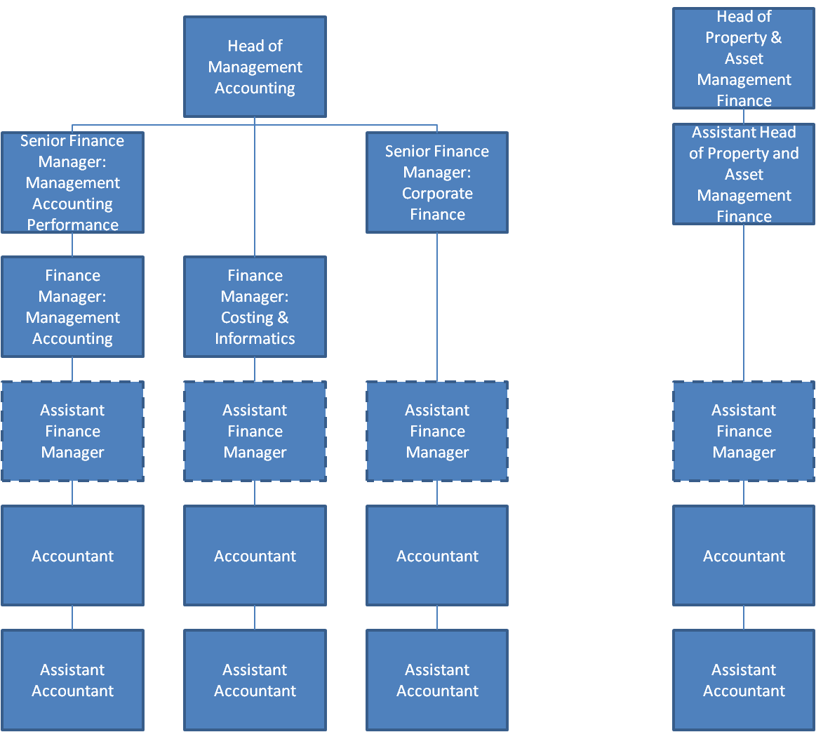

5. ROLE OF DEPARTMENT
Guide and support NHS Lothian to achieve year on year Financial Balance.
To provide the financial advice and guidance required for effective corporate management, strategic and operational decision-making in both the short and medium term.
Prepare and account for the information underpinning NHS Lothian’s public accountability for stewardship of funds.
Provide advice and information to secure effective planning and delivery of investments in service improvement and organisational change.

6. KEY RESULT AREAS
- To contribute to the Financial Plan through provision of costing information, financial advice on potential developments and their implications to Heads of Service, Clinical Directors, Service Managers and Chief Nurses to ensure delivery of financial targets.
- To support the appraisal of alternative options for service developments and transfers though provision of detailed financial advice and modelling to ensure that all costs are included and risks minimised to enable NHS Lothian to make best use of its resources, giving due consideration to service implications from advice given. This may require liaison across a number of services affected.
- To investigate complex financial enquiries through the analysis of data from a variety of sources, providing meaningful performance management information for use at clinical and board level and articulate the implications of the data to managers.
- To ensure value for money is achieved within NHSL provide effective support to Heads of Service, Clinical Directors, Service Managers and Chief Nurses in the understanding of the financial issues, assisting them by explanation of and education in financial matters to ensure that financial targets are delivered, both at 1:1 and wider management team meetings.
- Responsible for setting up Service Level Agreements, working with external bodies, e.g. the Blood Transfusion Service and other Health Boards to ensure maximisation of income.
- To develop and maintain a detailed knowledge of the organisation and the various interactions to support the provision of accurate financial information.
- Develop effective partnerships with operational managers and clinical staff, and with finance colleagues across the various finance functions, to enable effective communication of finance developments eg improvements in reporting and benchmarking data in support of service management.
- Day to day management responsibility for a team of staff including managing and motivating staff in order to achieve objectives within agreed timescales. Participate in recruitment, appraisal, initial stages of grievance and continuing professional development.
- To ensure implementation of finance policies, procedures and standards and contribute to their ongoing development, seeking opportunities for change and improvement at all times, ensuring consistency with the aims, objectives and values of the organisation.

7a. EQUIPMENT AND MACHINERY
- Essential user of Personal Computer and networked systems as part of the core Single System Finance Team within NHS Lothian. Use of office equipment: PC photocopier, printer, telephone
- New systems may be introduced as the organisation and technology develops, however training will be provided.

7b. SYSTEMS
- Frequent day-to-day user of MS Office suite of software including Excel, Word, Access, PowerPoint and Project. Use of Internet for research purposes.
- Use of finance systems including financials/NSI and BOXI reporting
- Design and manipulate spreadsheets for the maintenance of records required within the department - data is shared with other internal users.

8. ASSIGNMENT AND REVIEW OF WORK

The post holder is managerially accountable to a Finance Manager and is expected to make autonomous decisions on a daily basis including advice to operational and clinical staff regarding financial matters. The control environment predetermines a number of the time-scales e.g. monthly and annual reporting cycles.

The post holder will be required to determine the priorities for their role and to manage their own workload to achieve daily, weekly and monthly deadlines.

Objectives will be agreed annually with the manager of the post holder. The post holder is responsible for ensuring delivery of those objectives within the statutory obligations of the post. Formal review will take place at mid-year and year-end. Update of objectives and review of progress will also take place through regular 1:1 meetings with the post holder’s manager.

Decisions will be made within broad departmental policies and procedures without reference to manager.

9. DECISIONS AND JUDGEMENTS

Analysis and interpretation of complex financial and non-financial data, identifying errors and trends, providing advice as to where and why material variances are occurring recommending corrective actions where appropriate.

Provides the financial input into business cases / option appraisals relating to service change ensuring that the impact of the service change on all departments under the various scenario’s is accurately costed, conveyed to, and understood by service management providing recommendation on the most appropriate way forward applying financial expertise and experience.

Provide forecasts on directorate financial performance, identifying and quantifying risk as required, and provide a professional opinion.

10. MOST CHALLENGING/DIFFICULT PARTS OF THE JOB

Developing and motivating the team particularly during periods of significant organisational change that will affect both individual members of staff and front-line patient services.

Lead, develop and implement a continuous improvement culture within the department whilst managing a diverse and complex portfolio.

Ensure that all External and Internal audit recommendations, which identify control weaknesses within department are addressed.

The communication of financial issues to a wide range of financial and non-financial staff. Presentation of financial information in a manner that is easy to comprehend so as to aid the understanding of financial management and good practice.

Developing and maintaining effective working relationships with managers and clinicians over a range of sites who have competing priorities in order to convey the importance of focusing on achieving financial targets and at the same time strive to be regarded as an integral part of their service delivery team.

Keeping abreast of changing business priorities.

Some discussions with staff or managers will be sensitive and post holder must be prepared to have discussions which could be received badly.

11. COMMUNICATIONS AND RELATIONSHIPS
The following working relationships are maintained through verbal contact, written correspondence, electronic communication and formal/informal meetings: -

Internal NHS Lothian: -
- Finance Department
- NHS Lothian Senior Management
- General Managers
- Patient Services Directors
- Operations Managers
- Heads of Service
- Senior Clinicians
- Chief Nurses
- Trade Union and Staff Organisations

External: -
- NHS Education Scotland
- Other Health Boards
- Suppliers
- National Services Scotland
- Scottish Executive Health Department.

Relationships: -

Discuss with non-financial budget holders financial performance ensuring that factors affecting the performance are fully understood and exploring possible options when financial targets are not being achieved.

Discuss complex financial queries and non-financial implications with non-financial budget holders and the wider Finance Department.

Provide monthly financial written reports to budget holders in a timely manner.

There is also a requirement to negotiate with NHS and non-NHS bodies in relation to service issues and related costs to ensure full recovery. Information must be delivered in a timely manner to strict, externally driven deadlines. Where financial targets are not being achieved the post holder is required highlight the situation to management and support Heads of Service, Clinical Directors, Service Managers and Chief Nurses in action planning and implementing solutions.

Provide finance training to groups of non-finance staff.

12. PHYSICAL, MENTAL, EMOTIONAL AND ENVIRONMENTAL DEMANDS OF THE JOB

Physical Skills and Demands
- On a regular basis sit at a desk using a keyboard and Visual Display Unit for long periods of time. There is a requirement for speed, accuracy and attention to detail.
- The post holder is required to be an effective communicator; both written and spoken.

Mental Effort
- Prolonged concentration is required when completing highly complicated financial calculations, analysing and reconciling figures, using complex financial spreadsheets, and when prioritising tasks and identify problem areas
- Concentration required when interpreting, preparing and presenting complex financial information to a variety of end users.
- Working in a pressured environment taking all necessary steps to achieve goals.

Emotional Demands
- High degree of personal resilience, especially in relation to the interpretation and application of complex policies and decisions, often at times of significant organisational change and in a turbulent and politically driven environment
- Required to build trust with Service Managers and be able to challenge actions and negotiate solutions to sometimes-difficult situations.
- Management of staff.

Environmental Demands
- Multi-tasking is required, with frequent interruptions from telephone, colleagues and e-mail. Often need to reprioritise work and prepare information at very short notice.
- Frequently spend long periods of time using PC.

13. KNOWLEDGE, TRAINING AND EXPERIENCE REQUIRED TO DO THE JOB

Qualifications and Experience

Qualified Accountant with membership of one of the bodies recognised by the Consultative Committee of Accounting Bodies (CCAB) eg CIMA, CIPFA plus in depth experience in a management accounting role within a complex organisation and specialist knowledge of relevant legislation, accounting procedures and financial aspects of NHS policy.

Experience of managing a range of staff.

Experience of financial aspects of service redesign, change management, scenario costings.

Continued professional development should have been undertaken since qualification.

Skills

Ability to communicate complex financial information to financial and non-financial managers.

Advanced IT skills, including advanced use of Word and Excel.

Organisational skills to ensure competing priorities are achieved to agreed timescales.

Excellent inter-personal and an ability to deal with employees at all levels.

Highly developed analytical skills.

Communication, report writing and presentational skills.

14. JOB DESCRIPTION AGREEMENT
A separate job description will need to be signed off by each jobholder to whom the job description applies.  Job Holder’s Signature:  Head of Department Signature: | Date:  Date:

