

**NHS Lothian PREGNANCY SUPPORT CENTRE**

Exciting opportunities are available to join Pregnancy Support centre within one of the hospital sites across NHS Lothian. We have one Band 5 position available for Registered Nurses and we are looking for passionate, caring, motivated people to join our highly skilled nursing teams.

We offer the opportunity to work with talented teams within multidisciplinary environments and impact positively on the lives of thousands of patients and their families.

Pregnancy Support Centre is a nurse led early pregnancy unit which provides care for couples experiencing early pregnancy problems, primarily miscarriage and ectopic pregnancy.

This role combines emergency clinical care with the need for excellent communication with patients who are frequently very distressed. This is an opportunity to develop expertise in early pregnancy care and to develop the multiple skills necessary for working within a nurse led service.

A background in Gynaecology/Women’s health would be an advantage, although those with transferrable skills are welcome to apply.

The role we currently have available is a staff nurse band 5 – 32 hours per week 4 x 8 hour shifts over 7 days with no night duty.

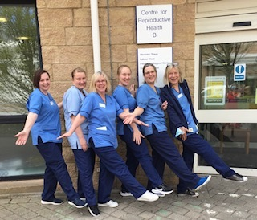

**For further information or to arrange an informal visit please contact:**

**Lisa Starrs, Centre Manager, Pregnancy Support Centre 0131 242 2428**

Find out what our staff say about working in NHS Lothian at https://careers.nhslothian.scot/acute-specialist-nurses/who-we-are/

**What We Can Offer You**

We have a range of vacancies for experienced and newly qualified nurses to join our innovative and dynamic teams across NHS Lothian – providing you with the opportunity to gain a breadth of knowledge and exposure to multiple specialties.

**Salary**

* Band 5 Range £30,229 – £37,664 (pro rata) per annum

**Benefits**

* A minimum of five weeks annual leave increasing with length of service
* A range of supportive employment policies including Flexible Working
* We provide an extensive induction programme and excellent professional training and development opportunities.
* Access to the NHS Pension Scheme and Staff Benefits

  