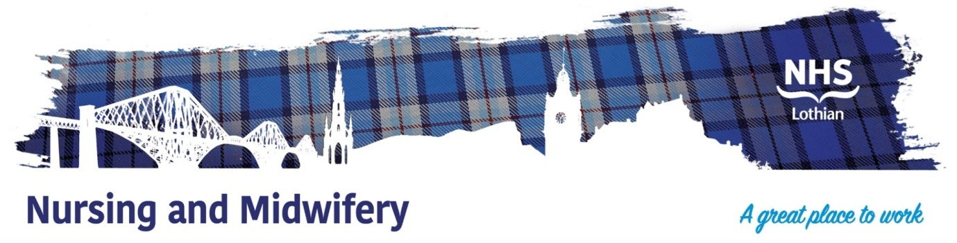

**Working for NHS Lothian**

**Introduction to NHS Lothian**

Thank you for your interest in applying to work within NHS Lothian. As an organisation, we are responsible for providing health services and improving the health for the population of Lothian and beyond.

NHS Lothian is Scotland’s second largest health board and provides a comprehensive range of primary, community based and acute hospital services, employing over 24,00 staff providing healthcare services to 800,000 people in Edinburgh, Midlothian, East Lothian and West Lothian.

Further information about NHS Lothian and the services we provide can be found at our website http://www.nhslothian.scot.nhs.uk .

Edinburgh is an exciting place to live and work; a historic hive of culture with breathtaking landmarks, atmospheric festivals and awe-inspiring architecture. Yet just a few miles away, you couldn’t feel further from the city in the beautiful Pentland Hills or in one of the many picturesque seaside towns of East Lothian. Add to this great shopping, leisure and arts facilities and cinemas plus a healthy dose of fresh air with plenty of opportunities for hillwalking, golf, cycling and even skiing!

To find out more about local attractions and things to do in Edinburgh, take a look at the Visit Scotland website http://www.visitscotland.com

Transport links are second to none with excellent rail services and a motorway network to all major cities, which accesses Glasgow within an hour and brings stunning scenery beyond within easy reach. The area is also noted for excellent schools, both state and independent, and for the friendliness of its people.

NHS Lothian offers a huge range of exciting career prospects. Come and join our dynamic teams in the Capital City of Scotland. We offer a wide variety of specialities with great learning opportunities including Theatres, Transplant, Critical Care, Children’s Services, Community and Mental Health Services. We actively recruit people of all ages, backgrounds and levels of experience. Visit our website for more information http://www.careers.nhslothian.scot

**Terms & Conditions Overview**

Terms and Conditions

The terms and conditions of service are those laid down by the **Agenda for**

**Change Handbook**.

Salary Scale

The Agenda for Change salary scale for the post will be contained in the

recruitment advertisement. The salary scale is based on working full-time, 37.5

hours per week and will be pro-rata for part-time.

Staff taking up a new appointment with NHS Lothian will normally enter the scale at the minimum of the pay Band/ Range. Any appointments above the lowest point of the pay Band/ Range will be subject to verification of previous NHS service, or experience outside the NHS, which is given in recognition of relevant complete years of experience.

Hours

The hours for the post will be contained in the recruitment advertisement.

Employees may be required to vary the pattern of their working week subject to the exigencies of the service.

Annual Leave

27 days rising to 29 days after 5 years service and to 33 days after 10 years service

plus 8 public holidays (pro rata) OR

202.5 hours rising to 217.5 hours after 5 years service and to 247.5 hours after 10 years service plus 60 hours public holiday (pro-rata).

Superannuation

The post is superannuable under the Scottish Public Pensions Agency Scheme

and your remuneration will be subject to deduction unless you choose to opt out of

the scheme.

Occupational Health

No appointment can be confirmed until a satisfactory Occupational Health Check

has been completed.

Confidentiality

In the course of your duties you may have access to confidential information

concerning patients or staff. Unauthorised disclosure or removal of information

may lead to consideration of disciplinary action.

Equality in Employment

NHS Lothian fully supports the principle of equality in employment and

opposes all forms of unlawful and / or unfair discrimination which cannot be shown

to be justified. NHS Lothian is committed to ensuring equality of treatment for

both present and potential employees.