

**NHS NATIONAL SERVICES SCOTLAND**

# JOB DESCRIPTION

|  |  |  |
| --- | --- | --- |
| **1. JOB DETAILS** | | |
| Job Title | | **Senior Stakeholder Engagement Manager – National Programmes** |
| Immediate Senior Officer/ Line Manager | | Head of Communications |
| Department | | Strategy, Performance, Communications |
| Directorate | | Strategy Performance and Service Transformation (SPST) |
| Location | | Edinburgh/Glasgow |
| CAJE Reference | |  |
|  | | |
| **2. JOB PURPOSE**  The role will lead the development and implementation of stakeholder management and engagement activities and provide subject matter expertise in the development of engagement strategies for specific programme stakeholders. The role will work collaboratively with key programme stakeholders to promote programme goals and messages while maintaining and aligning with NSS corporate key messages and image.  The post holder will support the Programme Director and workstream leads by encompassing both reactive and proactive stakeholder engagement and management functions, dealing with the national and regional stakeholders, and support and manage programme engagement events.  The post holder will play a pivotal role in executing and refining NSS’ credibility in regard to the programme and build communities to create integrated campaigns ensuring engagement with consistency in voice and brand.  Support the delivery of a national programme of work including any media and social media activities for the programme, building NSS’ reputation, and ensuring effective media and online coverage. | |

|  |  |
| --- | --- |
| **3. DIMENSIONS** |  |
| The post holder will develop and deliver frequently complex stakeholder engagement and communication programmes of work that support the delivery of national programmes across the NHS in Scotland. The programmes have a high profile among NSS stakeholders and the impact to service delivery of any delays or problems with related programmes of work is potentially large, especially if individual services were put at risk as a result. All national programmes delivered by NSS come with degrees of reputational risk for NSS as an organisation, the postholder will be expected to support the mitigation of these risks throughout the lifecycle of the programme.  The postholder has responsibility for the direct line management of communications staff supporting programmes and is fully accountable for the delivery of business objectives, management of performance and quality of deliverables in their area.  The postholder does not hold a budget, however, is responsible for the monitoring and management of ongoing expenditure, taking corrective action to ensure that spend remains within agreed levels and programme objectives are met. | |

**4. ORGANISATION CHART**

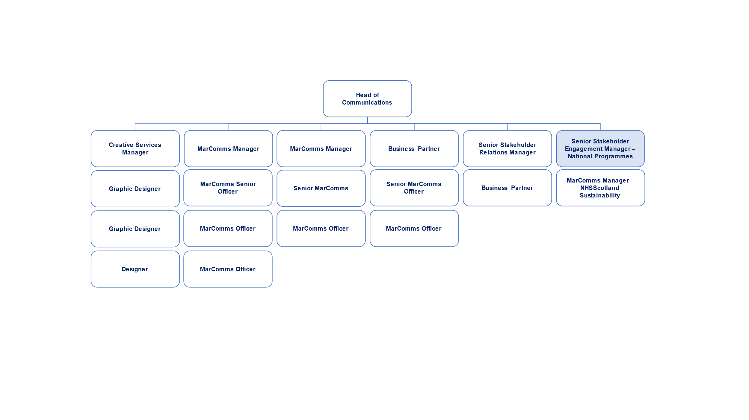

|  |
| --- |
| **5. ROLE OF THE DEPARTMENT**  NHS National Services Scotland delivers a range of national services through its Directorates. The role of the Strategy, Performance and Service Transformation (SPST) Directorate is to lead the development of the NSS strategy and to drive forward its implementation in order to deliver and embed the purpose and vision; to maximise the performance of NSS and our impact on the Scottish Government, NHS Scotland, Health and Social Care IJB’s and to support the delivery of the transformation agenda in NSS and across Health and Social Care. The SPST Directorate has a substantial role in enabling the delivery of the National Health & Social Care Delivery Plan across a range of National Programmes through a “Once for Scotland” approach. |

|  |
| --- |
| **6. KEY RESULT AREAS**   1. Lead the strategic approach, implementation and delivery of the stakeholder management approach covering national programmes which impact across all NHS Scotland Health Boards, ensuring the approach is aligned to wider programme objectives and delivery plans and operates effectively within the agreed performance, quality and governance targets and frameworks. 2. Support the Programme Director, Senior Responsible Officer (SRO) and Sponsor by developing and implementing an approach to programme stakeholder management and communications that ensures the delivery of the marketing and communications requirements of the programme. 3. Lead the development and standardisation of stakeholder engagement, communications processes, and systems across the programme. Initiate, develop and implement appropriate policies and associated standard operating procedures to ensure adoption of best practice and consistency of approach and monitor compliance. 4. Manage performance across the programme, ensuring that appropriate mechanisms are in place for monitoring activities and performance indicators, reporting progress against targets and identifying and addressing issues/gaps. 5. Promote, facilitate, and enable adoption of a range of quality and continuous improvement initiatives for the programme to improve efficiency and enhance service delivery; this will include analysing and redesigning business processes, as required, to make best use of the people involved and enabling this with new technology as appropriate. 6. Embed all improvements into operational processes effectively through excellent design and delivery, ensuring knowledge and skills transfer to business users to allow sustained benefits realisation. 7. Lead the Stakeholder and Communications workstream within the programme, providing clear and strategic direction to both the team and stakeholders on where Marketing Communications can add strategic value. Lead and direct staff/teams across the programme ensuring that staff have the skills and competencies required to deliver high quality services and are adaptable to the significant technological and cultural changes taking place within NHSScotland as a result of the programme. 8. Line manage project communications staff and ensure that staff are guided, supported and mentored through processes of change, such as new ways of working, ensuring effective engagement in partnership to successfully embed change. 9. Lead specific projects for the communications and engagement activities within the programme including, monitoring and managing progress against timescales, identifying issues and managing risks and adjusting plans as required to avoid problems that may adversely impact project delivery. 10. Establish, and maintain deep and effective partnerships with customers and programme stakeholders (e.g., NHS users of the marketing and communications services and outputs, NSS senior leaders, clinical colleagues, health, communications and policy contacts at Scottish and local Governments, communications colleagues across NHS Scotland and other boards, media contacts etc.) to ensure that the functions of the service area/department are recognised and that stakeholders are playing a key role in evolving and improving services. 11. Prepare and obtain agreement for all income funded budgets (circa £1m and likely to grow) in line with the Stakeholder Engagement and Communications workstream, monitor and control ongoing expenditure, taking corrective action to ensure that spend remains within agreed levels and programme objectives are met. 12. Develop and embed an organisational culture that promotes effective behaviours and demonstrates a clear commitment to NSS values. |

|  |
| --- |
| **7. ASSIGNMENT AND REVIEW OF WORK**  Work will be self-assigned and generated in accordance with the objectives set out and measured by the Programme Director. The post holder is expected to prioritise and manage their own workload in accordance with the objectives and timescales of the programme. The post holder will be a key core member of the programme team and must demonstrate considerable initiative.  The postholder develops plans ensuring alignment and collaborative planning with other national initiatives that coincide either through people, financial, technological or service delivery communities. Defines, develops and establishes contingency activities to cope with fluctuating scopes driven by political, regulatory, external Stakeholder and environmental considerations. Engages stakeholders who will ultimately manage the services, ensuring supporting people, financial and technological structures are established and organised for long term ownership and improvement of outcomes.  Nationally, the postholder works with Scottish Government sponsors and NSS Directors and peers, Health Board Senior Management teams and across a substantial range of disciplines such as Clinical, Medical and Management teams representing the programme, to define the strategic engagement outcomes regarding service wide implementations.  While day to day work will be agreed with the Programme Director, the postholder will be line managed by NSS Marketing Communications to ensure consistency in the NSS approach and where appropriate engage with specialist communications teams and agencies to develop materials and events on behalf of the programme.  **Decisions & Judgments**  The post holder will demonstrate leadership skills and display effective decision making and problem-solving skills, including resource management when required to ensure programme delivery. This will be allied to an ability to facilitate idea generation in the context of meeting identified business requirements and to foresee risks and issues and take appropriate corrective action.  The post holder will be expected to demonstrate the ability to identify pragmatic solutions using quality improvement techniques and methods to support colleagues deliver strategic and business goals.  Works across multiple delivery streams and with programme stakeholders to ensure that interdependencies are recognised and managed to enable successful delivery and achievement of best value across a range of projects. |

|  |
| --- |
| **8. COMMUNICATIONS AND WORKING RELATIONSHIPS**  The post holder must be able to effectively and efficiently manage stakeholder communications at all levels. The right information must get to the right person(s) in a timely fashion. Effective conflict management through effective communication is seen as an essential element of this post and the post holder is responsible for establishing and developing close relationships with Programme stakeholders.  The post holder is required to produce and deliver a variety of reports in several formats depending on the target audience. These reports may be written and/or verbal depending on the situation.  The post holder is required to give presentations on proposals, plans and progress across the organisation and external parties associated with the programme. There will be a frequent need to chair meetings between programme, business, and external staff.  The post holder must be able to effectively inform and instruct programme staff on all aspects of delivery and provide expert advice as required.  The post holder must also be an effective listener in order to provide the support and appropriate direction for individual members of the programme team(s).  Typical working relationships may be built with a substantial range of disciplines such as clinical, medical and management teams, for example:   * Board Members, Executive/Senior Management Teams * Programme Sponsors & Governance Groups * Programme and Project Teams * Partnership Forums & Organisational Development Teams * Patient/User Groups * External Suppliers/Contractors * External/Internal Auditors |

|  |
| --- |
| **9. MOST CHALLENGING PART OF THE JOB**   * Maintaining and improving the high quality of service delivery standards expected within an environment of decreasing resources, revenue budgets, changing organisational culture and new technology. * Building and maintaining effective relationships across a diverse range of stakeholders all with different expectations and demands, some of which it will not be possible to meet. * Balancing priorities and activities within the programme to ensure timely delivery of services. * Ensuring the service is sufficiently robust and effective to deliver consistent quality to end users and customers. * Training, coaching, mentoring, and managing staff to maximise potential and increase efficiency and effectiveness. * Developing new/innovative solutions to meet the requirements of the programme, reducing bureaucracy, and overcoming resistance to change in the new environment. |

|  |
| --- |
| **10. SYSTEMS**  Advanced knowledge of use and practical application of MS office software, and other marketing, communications, and digital engagement software tools.  In order to develop and present business plans and performance reports the postholder requires advanced knowledge of use and practical application of MS office software, and other bespoke software tools used for communications management, performance analysis and reporting and resilience reporting. The postholder will also use:   * Service Now * Reporting and performance analysis tools * PRgloo * Office 365 * Meltwater media monitoring * HR and Payroll systems such as eESS, TURAS, Crown Flexi-time system, SSTS, eExpenses * Biteable * Content Management System (CMS)   The postholder will have a good understanding of how to analyse complex data and data trends.  The postholder is responsible for ensuring that all staff managed enter, store, and transmit data in accordance with data protection, freedom of information and confidentiality policies/legislation. |
|  | |
| **11. WORKING ENVIRONMENT AND EFFORT** | |
| **Physical Effort** | |
| A significant part of the working day will be spent at the workstation, dealing with operational management issues.  Good keyboard proficiency required.  Workshops/training sessions require the programme delivery roles to stand for long periods, either in the form of presenting to the group, or walking between individual groups. Frequency and duration will be dependent upon stage of the programme. | |
| **Mental Effort** | |
| The post requires ability to concentrate for long periods of time, e.g. when resolving complex operational or staff related problems, analysing data performance, calculating budgetary spend. despite occasional interruptions with critical and urgent matters such as requests for responses for ministerial briefings, media enquiries and rapid response requests.  Concentration is also required when attending meetings (1-2 hours) with staff, stakeholders etc., when undertaking such activities as e-mail correspondence or telephone conversations and when drafting standard operating procedures, developing PowerPoint presentations, business plans and reports.  Due to the nature of the programme, there will be a significant element of unpredictability in the working day in terms of telephone calls or unexpected work requests/issues and there is a requirement for the postholder to make sound judgements in dealing with interruptions, changing from one task to another, if required, prioritising effectively, and adjusting plans accordingly.  The postholder will frequently be required to work to tight time constraints in relation to team and operational performance and meeting project deadlines. | |
| **Emotional Effort** | |
| There may be exposure to staff issues when undertaking line management responsibilities. Some staff will be resistant to changes in working practices and the postholder will need to deal with these in a diplomatic and sensitive manner. The postholder will guide and support staff in their teams during times of change and uncertainty in order to provide reassurance and help maintain emotional stability. In situations like this, the postholder is required to maintain composure and emotional resilience.  There will be occasional exposure to distressing or emotional circumstances in relation to staff management issues such as formal conduct and capability proceedings or in providing support to staff in relation to sensitive personal matters. | |
|  | |
| **12. ENVIRONMENTAL / WORKING CONDITIONS & MACHINERY AND EQUIPMENT** | |
| * Standard shared/open plan office conditions and equipment, as well as working from home on a regular basis. * Exposure to unpleasant working conditions is rare. * The postholder may be required to travel to other sites throughout Scotland. | |
|  | |

|  |  |  |  |  |
| --- | --- | --- | --- | --- |
| **13. QUALIFICATIONS AND/OR EXPERIENCE SPECIFIED FOR THE POST** | | | | |
| Educated to degree level with an appropriate postgraduate qualification in either stakeholder management/marketing//public relations, business or equivalent corresponding level of experience.  **Experience**   * Extensive demonstrable experience at a senior managerial level within a communications and engagement setting. * Specialist knowledge in project management acquired through experience and able to delegate, manage performance and ensure high levels of customer satisfaction. * Proven skills of the management and development of staff in the delivery of a high-quality stakeholder management and communications service. * Experience of managing an operational service, with a focus on operational excellence and continuous improvement. * Experience of forging effective relationships with internal and external stakeholders. * Experience of driving change and managing successful service redesign programmes.   **Skills and knowledge**  The person demonstrates the following:   * Effective communication, influencing and facilitating skills. * Excellent interpersonal and relationship building skills. * Evidence of leadership qualities and people management skills. * Ability to analyse complex data and use findings to better manage demand and deployment of resources. * Performance management expertise. * Strong and sound decision making and problem-solving abilities. * A good understanding of information governance. * Ability to reprioritise in line with a fast-moving marketing environment. * Good knowledge of budgeting and resource allocation procedures. * Able to demonstrate a sound knowledge and understanding of the broad framework within which the NSS operates. * Excellent planning and organisational ability.   The post holder is expected to lead by example at all times, demonstrate the highest standards of personal and professional conduct that support the NSS Values and Behaviours and respect the diversity that makes up a complex multi-disciplinary workforce. | | | | |
|  | | | | |
| **14. JOB DESCRIPTION AGREEMENT** | | | | |
| A separate job description will need to be signed off by each postholder to whom the job description applies. | | | | |
| Postholder Signature: |  | Date: |  |  |
|  |  |  |  |  |
| Postholder Print: |  |  |  |  |
|  |  |  |  |  |
| Manager Signature: |  | Date: |  |  |
|  |  |  |  |  |
| Manager Print: |  |  | | |
|  |  |  |  |  |
| Manager Title: |  |  | | |
|  |  |  |  |  |
|  |  |  |  |  |