**Psychological Therapies Service**



**Clinical, Counselling, Psychologist**

**(Band 8a)**

## APPLICANT INFORMATION

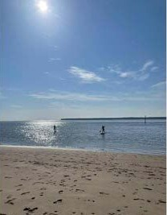

**Contents**

Psychological Therapies Service 3

Living in Tayside 4

Spotlight on Staff 5

Current Vacancies 8

Benefits of NHS Working 9

**NHS TAYSIDE**

#### Psychological Therapies Service

We have a number of exciting opportunities available in one of the UK’s most up and coming and rapidly developing Cities.

NHS Tayside is seeking to appoint Clinical and Counselling, Psychologists to allow expansion of an already thriving service. Opportunity exists to combine different specialist posts to reflect career interests of suitable applicants. Applications are welcomed from people looking to work on a full-time or part-time basis.

NHS Tayside Psychological Therapies Service already has a complement of around 160 clinical and applied staff with an additional 18 trainees. The Service provides a friendly, supportive and stimulating environment in which to work. Opportunities exist for involvement in teaching and research, taking advantage of close links with the Universities of Dundee and Stirling. Members of the Service also contribute to the supervision and training of trainees on the Edinburgh/East and South of Scotland Clinical Teaching Course and the Universities of Stirling and Dundee MSc Course. We have recently appointed a Clinical Psychologist with a special remit to promote and support research within the service, both with qualified staff and trainees.

You will be joining a forward thinking Service with excellent links and working relationships with Dundee, Perth & Kinross and Angus Health & Social Care Partnerships and the acute services of NHS Tayside. Our Eating Disorder and Forensic Medium Secure services are part of North of Scotland Regional Services. Together, we serve a population of 416,090, with approximately 67,100 of these being children under 16. The Service is hosted within Dundee Health & Social Care Partnership.

We are committed to authentic leadership and have a strong leadership team of 15 Consultant Psychologists. The leadership team meets regularly, making time to address operational issues and professional development and this model is mirrored in each speciality for clinical staff. We are able to support training and professional development from our core budget, having invested significantly in schema focused therapy and EMDR in recent years.

We have streamlined the application process for our jobs to enable candidates to apply and be interviewed once, regardless of now many jobs they wish to be considered for. To apply for a post please visit NHS Scotland Job Train website (link given at the end of this document) and state clearly within your application form which position(s) you wish to be considered for. Please ensure you have the appropriate level of qualification – or are due to graduate with the appropriate qualification – for the posts you wish to be considered for.

 Living in Tayside

When choosing somewhere to work and live, quality of life is key. Tayside is one of the few locations in the UK which combines the best of both worlds – city facilities in Dundee and Perth on a friendly community scale, and easy access to some of the most stunning countryside in Scotland. Set on the spectacular Tay Estuary, Dundee, the principal city in Tayside and the sunniest city in Scotland, sits in a landscape of wild beaches, championship golf courses, quaint coastal villages and beyond them, Scotland’s famous mountains and glens.

Dundee is conveniently located within easy reach of three other large cities in Scotland – Edinburgh, Glasgow and Aberdeen and within a 90 minute drive from 90% of Scotland’s population. There are excellent road, rail and bus links to all 3 cities and London is six hours by rail and just over an hour by air from Dundee airport, flying direct to London City Airport. There are also regular flights to Belfast. There is a vibrant arts scene in Dundee and beyond. Scotland’s first design museum, The V&A Museum of Design, opened in 2019 as part of significant ongoing investment and redevelopment of Dundee waterfront including the forthcoming development of the Eden Project, Dundee. Dundee is the UK’s only UNESCO City of Design. Within Dundee, in addition to the new waterfront development, there are a number of attractions to suit all ages including Discovery point, the Dundee Contemporary Arts centre and the Dundee Science Centre.

Beyond Dundee, the River Tay and its estuary, the coasts of Angus and Fife and the nearby hills and mountains of Perthshire offer scope for almost any outdoor activity. Furthermore, St. Andrews, home to a number of world famous golf courses, picturesque town and beach, is only a short drive away. Whether you want to live in the rural countryside, a seaside village or one of Tayside’s vibrant cities or towns, there is a variety of housing choices to suit all budgets. The salaries of employees in Dundee currently go further on the property ladder than almost any other city in the UK. There are a good variety of primary and secondary schools. There is also the option of private schooling with schools to choose from in Dundee City, St Andrews and Perth and Kinross



**SPOTLIGHT ON TEAM WORKING - Dundee Adult Psychology**

“I am the Consultant Psychologist for Dundee Adult Psychological Therapies Service and Clinical Psychology to CMHT. I moved to Tayside in 2006 initially working in the Older People Psychology Service before moving to the Adult Psychology Service. The department and the job drew me to Tayside but the people and the lifestyle Tayside and the surrounding areas offers as well as career opportunities is what keeps me here. I have benefited from so much support and mentoring from peers and colleagues in the department as well as the wider mental health community, with opportunities to be involved in training, research, teaching at several universities and local and national initiatives. The department continues to grow and there is a genuine desire to collaborate, to create and support opportunities which allow us all to deliver great patient care. The work is challenging but I think we have so much potential and opportunity to be creative and innovative. I would encourage clinicians looking for the right place to really flourish professionally and have a great work-home life balance to join us here in Tayside.”

***Dr Helen Nicholson-Langley, Consultant Clinical Psychologist***

*Some of the staff working at Dundee Adult Psychology (DAPTS)*

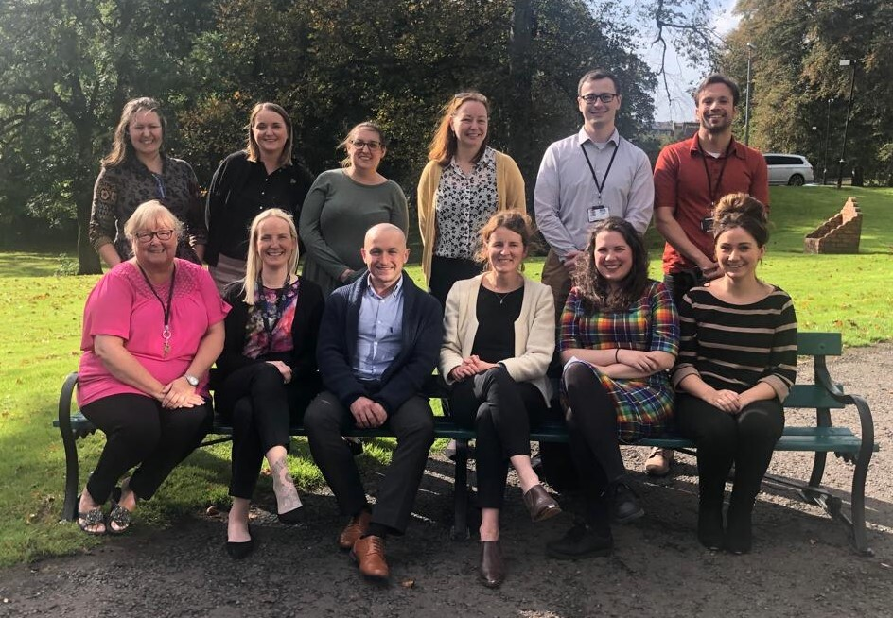

Here’s what some of the team say about living and working in Tayside:

“The DAPTS team have been very welcoming and supportive in my first year of post-qualified work. I've gained a lot of valuable clinical experience and I've also had the opportunity to engage in continued professional development that has proved beneficial for my skills, and confidence in this post. I've also been able to contribute to service development which is a great opportunity at this early point in my career.”

**C*arl McNelis, Clinical Associate in Applied Psychology***

“I'm a Clinical Psychologist working in one of Dundee's Community Mental Health Teams (CMHTs).  I really enjoy working as part of a team, and it definitely feels like the CMHT is my niche!  My role is very varied, which is one of the things that keep it interesting.  Alongside working directly with adults experiencing severe and enduring mental illness, I provide supervision and consultation for colleagues. Consultation means working collaboratively to figure out what approaches might work best clinically but also routinely contributing to team discussions and decisions, where we can bring all our knowledge and experience together.  There are a number of developments underway within our CMHTs and being able to be part of the service development, helping to shape how we deliver the best service we can is something I really enjoy.  Ultimately though, my colleagues are what make the CMHT such a nice place to work, and knowing we can rely on each other makes all the difference.”

***Dr Katy Mitchell, Clinical Psychologist to CMHT***

“I chose to work for NHS Tayside because my husband and I had decided to settle here to raise a family.  We live on the outskirts of a beautiful little town and former fishing village, with a really interesting heritage.  We’re a 20-minute walk from the beach, where I take the dog every weekend and the local shops are great for just about anything you need.  However, also being part of Dundee, there’s always something to do with the kids over the School holidays or at the weekend (lovely local walks, cinema, soft play, ice-skating, visiting a really old ship...!), and the rest of Scotland isn’t too much of a drive away either - Pitlochry for instance, is only an hour away. I love where we live!”

***Ashley Cochrane, Clinical Associate in Applied Psychology***

“I have worked in the Psychological Therapies Service since 2007 as a Psychological Therapist.  I returned to Tayside having moved around for many years. I have been supported in a number of training opportunities throughout the years which has been instrumental in my personal and professional development. As a staff team we have been exploring ways to develop the service in new and innovative ways especially since the pandemic and looking at ways to build a service where staff have a wide range of opportunities.  Our main role is providing psychological therapy but we recognise the importance of continued professional development with opportunities for reflective practice, journal club, research and ongoing team development (in work and socialising out of work... we need to make sure all the local businesses are thriving too!)  It is great to be living near the coast, and Tayside does not disappoint on this front, especially if you enjoy water sports, swimming, paddle boarding. Tayside has a balance of peace and tranquility and bustle. There are also lots of green belts, parks, hills for walking and upgrading of cycle routes underway. The City of Dundee has been expanding, and has lots of good bars and restaurants to cater for all tastes and regular concerts at venues such as the new Slessor Garden Area and Caird Hall.”

***Amanda Thomson, Accredited Person Centred Psychological Therapist***

“I have been working for NHS Tayside for 17years, in the role of Forensic Psychologist.  NHS Tayside were one of the first NHS employers in Scotland to recruit a Forensic Psychologist and to set up a dedicated local Court assessment and treatment on diversion service.  My employment in Tayside has allowed me to pursue special interest placements in secure settings and more recently, to develop my therapeutic skills in adult non-forensic services.  Further professional development via additional training opportunities has always been supported, as have opportunities to develop skills in other clinical areas.  Tayside itself offers excellent and diverse living opportunities, from the city centre, to beach front living, to more rural settings.  It is close enough to Edinburgh, Glasgow and Aberdeen to enjoy what they have to offer whilst itself being a great place for culture, to pursue many social and sporting interests and to raise a family.”

***Vicky Orme, Forensic Psychologist***

“I came to this department as a newly qualified Counselling Psychologist in November 2019. Within my role in the Primary Care Adult Psychology Service, I have had opportunities to work with a varied case load to consolidate my skills post qualification, seeing a wide variety of presenting issues including, Anxiety, Depression, OCD, PTSD, Body Dysmorphia, Self-esteem, and FND. The department has supported me to develop my knowledge and therapeutic skill-set, including new therapeutic modalities through training and opportunity to consolidate learning with protected time. I have also been supported to develop as a Clinical Supervisor which is a part of my role I very much enjoy. Most of all, I have benefitted from a fantastic team of colleagues who are supportive, from a wide range of psychological practitioner backgrounds, who are always happy to have a chat - not to mention help make for great staff nights out!”

***Dr Matilda Nordqvist, Counselling Psychologist***

“I returned to Scotland 3 years ago with my Husband and our children after spending several years living abroad. I joined NHS Tayside again just over a year ago and I currently work in a full-time post across two adult services in Primary Care and the CMHT.  Working in adult mental health has always appealed to me and I really enjoy the variety of experience that both NHS Tayside services offer.  I am particularly drawn to working in the CMHT which offers diversity in role as well as a stimulating challenge and constant opportunities to learn.  Since returning, I have been well supported in my role and the CPD opportunities have been excellent.  At home, we are a very active family and being based just outside of Tayside offers a wide range of sporting activities from hill walking to visiting the Tentsmuir forest and the beautiful coastline.”

***Dr. Maria Dempster, Clinical Psychologist***

**Vacancies Currently Available**

The following vacancy information is intended to spotlight the main opportunities we have available at the present time.

We welcome applications for full-time and part-time employment for all posts.

**Dundee Adult Psychological Therapies Service – 4.3 wte Band 8a**

Dundee Adult Mental Health Services including Psychology are currently undertaking significant redesign as part of the Tayside Mental Health & Wellbeing Strategy ‘*Living Life Well’*. We want to hear from enthusiastic and committed clinicians interested in being part of the transformation. We have exciting opportunities for qualified Clinical and Counselling Psychologists, Psychological Therapists and Clinical Associates in Applied Psychology (CAAPS) to work with Adults across a range of services in Dundee City. Full or part time hours will be considered and, for suitable candidates, there are opportunities to combine sessions or posts tailored to individual clinicians’ special interests and career objectives. Clinicians may opt to work across the Dundee Adult Psychology Services or combine Dundee Adult Psychology sessions with additional posts across Tayside.

Dundee Adult Psychological Therapies Service - a Primary Care Psychology Service offering 6-12 sessions of evidence based psychological therapy to adults experiencing *mild-moderate* psychological disorders.

Clinical Psychology in the Community Mental Health Teams **-** provides specialist psychological services to Dundee’s two Community Mental Health Teams with both direct delivery of individual and group psychological therapies to adults experiencing severe and enduring mental illness as well as indirect consultation, training and supervision roles within the wider multidisciplinary setting.

***Informal enquiries considering the above post may be made to Dr Helen Nicholson-Langley on (01382) 346556 or*** ***helen.nicholson-langley@nhs.scot***

Short-listed applicants will be contacted by email.   Please check your emails regularly, including your junk/spam folder.

We hope that the above information will inspire you to apply to work with us.

If you need more convincing, here are some of the many additional benefits of

joining us in the NHS and in Tayside.



**Employee Benefits**



**Child Care Voucher Scheme**

**Career Break Opportunities**

**Flexible Working**

**Relocation Package**

* Assistance with relocation costs

**Continuous Personal Development Opportunities**

**Health Service Discounts**

* Access to the UK’s biggest NHS staff discount website
* Eligibility for blue light membership, a discount service for NHS staff
* Access to Tayside Recreational Events Activities Team Surprises (TREATS)

**NHS Pension Scheme**

* Access to generous

NHS pension scheme

**Holidays and Leave**

* Generous annual leave
* Maternity/paternity leave
* Paid paternal leave for each child
* Paid sick leave entitlement

**Staff Recognition**

* Long Service Awards
* NHS Tayside’s Staff Appreciation and Recognition (STAR) Awards

**Health and Wellbeing**

Access to Occupational

Health, free counselling

and wellbeing services

* Cycle to work scheme
* www.cyclesolutions.info/nhstayside