**NHS Lothian**

**Community Vaccination Team**

Exciting opportunities are available to join Community Vaccination Team at Musselburgh Primary Care Centre. Due to expansion of our service, we have multiple Band 5 positions available for Registered Nurses and we are looking for passionate, caring, motivated and dynamic people to join our highly skilled nursing team.

We offer the opportunity to work with our team, vaccinating school aged children from Primary One to S6 across Lothian. Please note this is a Pan-Lothian post and a driving license is essential.

Have a look at our video to see what our staff have to say!

Find out what our staff says about working in NHS Lothian at https://careers.nhslothian.scot/acute-specialist-nurses/who-we-are/

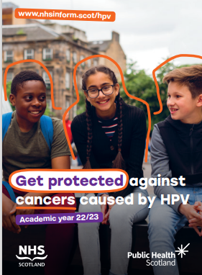 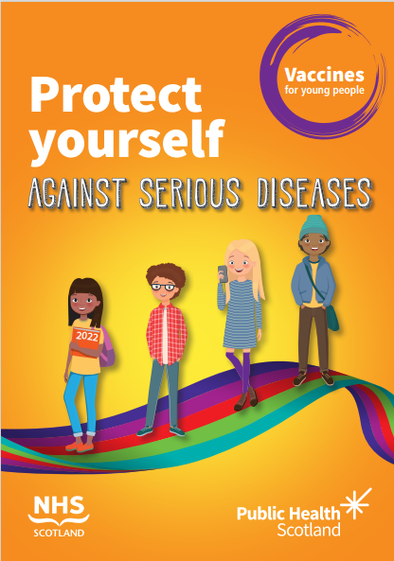 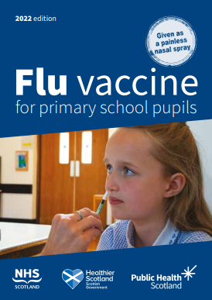

**What We Can Offer You**

We have a range of vacancies for experienced and newly qualified nurses to join our dynamic team in NHS Lothian – providing you with the opportunity to gain a breadth of knowledge and understanding of routine vaccines provided for children and young people in Lothian.

**Roles**

* Working with children and young people across East Lothian, Midlothian, West Lothian, and City of Edinburgh
* Providing intranasal/injectable/intradermal vaccination – full training will be given.

**Salary**

* Band 5 Range £26,104 – £32,915 (pro rata) per annum

**Benefits**

* A minimum of five weeks annual leave increasing with length of service
* A range of supportive employment policies including Flexible Working
* Full or part time hours considered
* We provide an extensive induction programme and excellent professional training and development opportunities.
* Access to the NHS Pension Scheme and Staff Benefits

Community Vaccination Team offer vaccination to school age children across Lothian. We offer seasonal ‘flu vaccination for children aged from Primary One up to S6. We offer HPV vaccination for S1 and above, and we offer booster vaccinations of diphtheria, tetanus, and polio along with Meningitis ACWY vaccination for S3 and above. We provide BCG vaccination for neonates and also support the Health Protection Team in the event of community outbreaks.

As part of your role, you will be allocated schools with the expectation that you work alongside the staff and pupils to provide information which supports the uptake of vaccination in line with Scottish Government requirements.

You will work to identify and promote the health care needs of the local population in partnership with colleagues, clients and the local community and promote an excellent vaccination service to service users throughout Lothian while delivering a robust Clinical Governance Framework across the service.

There is no maximum caseload size – some of our smallest schools have less than 50 pupils while some have in excess of 1500 pupils requiring vaccination in one day!

The team display clinical leadership and are key role models for new members joining. Each person supports staff promoting values and beliefs of the nursing profession as well as that of the organisation. Professional development is nurtured in a supportive environment ensuring competency and proficiency. There is a breadth of clinical statutory, mandatory and role specific training in line with policy and personal development needs, supported by the Team Managers.

If this sounds like a good fit for you, we encourage you to get in touch and would look forward to welcoming you into our team!

Please contact Lyndsey Lynch for further information: lyndsey.lynch@nhs.scot

