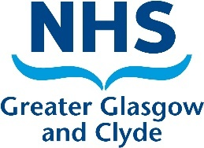

**Additional Information**

**Post: Specialist Fellowship – Neuro-oncology (Neurosurgery), 12 months**

**Specialty: Neurosurgery**

**Role: Senior Clinical Fellow**

**Base: The Institute of Neurological Sciences, Queen Elizabeth University Hospital, Glasgow**

The post provides a structured educational experience for suitable candidates who have completed, or are about to complete their training curriculum. It provides a comprehensive training program in the neuro-oncology subspecialty.

The Fellow will be exposed to a high number of neuro-oncology cases, and would hold responsibility for the preparation of cases for MDT discussion and will have the opportunity to participate on-going clinical or laboratory research within the Institute of Neurological Sciences.

This post offers a wide range of clinic, ward-based and surgical experience. The successful candidate will also contribute to the training of pre-CCT Trainees.

The post-holder will be supervised by the lead neuro-oncology consultant and the neuro-oncology consultants.

The successful candidate would participate in the 16-person rota (2-resident on call).

We would encourage academic interest during their time within the department.

**Informal contacts:**

**Mr Athanasios Grivas, Consultant Neurosurgeon**

**Athanasios.Grivas@ggc.scot.nhs.uk**