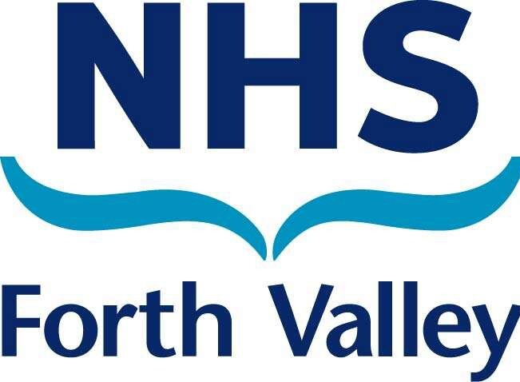
NHS FORTH VALLEY JOB DESCRIPTION

- JOB DETAILS

Job Title: Oral Health Training Officer

Responsible to: Dental Nurse & Oral Health Improvement Manager Dental Action Plan Team Lead

Department(s): Public Dental Service Job Reference: G-N-D-5a

JOB PURPOSE

Take a delegated responsibility for driving forward the Scottish Government’s Dental Action Plan Programmes (DAPs) that includes Paediatric Oral Health Programmes.
These are national programmes implemented within all 14 NHS Boards to improve oral health.

Under the DAP Team Lead’s guidance visit establishments such as schools, Care Homes, independent contractors and NHS Forth Valley Primary Care Departments across the Board area, to deliver awareness and training sessions for children and adults designed to improve oral health.

To provide support to establishments to enable set up and operate DAPs, in accordance with best practice guidelines, relating to health promotion and clinical care.

Responsible for the operational activity, implementation, smooth running and co- ordination of all DAPs, these include:
  - Caring for Smiles (Elderly)
  - Mouth Matters (Prisons)
  - Smile 4 Life (Homeless)
  - Open Wide (Adults with Additional Care Needs)
  - Paediatric Oral Health Service
All of these programmes are delivered throughout NHS Forth Valley.
Assist in the planning, development and implementation of DAPs working towards targets set by the Scottish government.

Provide solutions for individuals and groups by trouble-shooting when issues arise reassuring clients within DAP programmes.

Take part in clinical audits and trials as appropriate to the DAPs and involved with clinical effectiveness and clinical governance colleagues as required.

DIMENSIONS
  - There is no responsible for budget spend or as an authorised signatory.

  - There is no supervision of other staff members however may be asked to mentor less experienced staff.

- KEY DUTIES

Responsibilities
  - Patient Client Care
Deliver awareness and training sessions in schools, independent contractors, care homes and prisons to children, adults and staff designed to improve oral health. Provide 1:1 support as appropriate in care homes and domiciliary home visits

Whilst working in prisons, working with the dental team by triaging dental referrals and processing outcomes appropriately

  - Policy and Service
Monitor compliance to infection control guidelines in accordance to current General Dental Council guidelines and NHS Forth Valley Infection control policy
Monitor & Maintain Health & Safety Procedures to include clinical risk management In conjunction with the Dental Nurse & Oral Health Improvement Manager and DAP
Team Lead, develop, implement, and evaluate protocols within the department relating to the DAPs putting in place evaluation measures to enhance service delivery for example annual programme evaluation.

Ensure compliance to policies of NHS Forth Valley

  - Finance and Physical Assets
To understand, follow and adhere to the Standing Financial Instructions with support & guidance from Senior Managers when ordering using the Pecos system.

  - Staff Management/Supervision, Human Resources, Leadership and/or Training

Working closely with the DAP Team Lead to develop educational programmes for General and Dental Nurses and in doing so co-ordinate arrangements with external bodies.

Deliver training to Dental Care Professionals (DCP’s) and Dental Health Support Workers across Forth Valley

Deliver train the trainer sessions relating to the DAPs to staff to enable them to train staff in their area in order that the relevant DAP targets are being met.

Provide advice, guidance and training relating to the key DAP initiatives on an ongoing basis to a variety of groups of clients.

Deliver oral health promotion information to target groups to meet the objectives of the FV Oral Health Strategy.

Support and facilitate the ongoing development of Oral Health Improvement programmes within establishments.

Provide professional support to the dental health staff group on a daily basis relating to DAPs.

Undertake health education and clinical oral health support on a one-to-one basis with adults and children in a variety of settings.

The post holder maybe expected to work out with normal working hours to meet the demands of the service
The post holder is required to cover colleagues during periods of leave or absence and so will be required to work at sites throughout Forth Valley

  - Information Resources
Maintain up-to-date records using set systems, allowing linkage across the various elements of the programmes and report back to the DAP Team Lead as required. This includes handling of sensitive information relating to family circumstances.

In the course of work there will be access to confidential information regarding patient and staff details so confidentiality and discretion is required at all times and in accordance with the Data Protection Act and Caldicott legislation.
.
Complete local statistical returns as appropriate to work.

  - Research and Development
.
Participate in Quality Assurance programmes conducting Clinical Audit as requested by the Dental Action Plan Team Lead

Take part in clinical audit and other quality initiatives when required.

Skills
  - Communication
Liaise with staff of NHS Forth Valley and other external bodies on a daily basis.

Develop and maintain effective communications and good working relationships with all of the key stakeholders to help facilitate the uptake of DAPs.

With the use of skills to encourage engagement with the DAPs advise and guide children, adults, carers regarding oral hygiene practices including individuals or groups that do not readily understand or wish to be involved. This will also involve clinical 1:1 support with those with challenging behaviours

Provide support to individuals and groups to achieve improvements in oral health across the Board area.
Provide guidance based support to other dental/nursing students or professionals as part of on-going learning.

Attend local and national meetings as appropriate to inform DAP work.

Facilitate communication across all programmes including the production of formal written reports and regular feedback and progress reports to DAP Team Lead.

Overcoming barriers to understanding for example social, learning difficulties, special needs and where English is not the main language spoken.

Provide oral health information in a tactful, persuasive and non-judgmental way.

  - Analytical and Judgements
Assist in the, monitoring, assessment and evaluation of activities related to the DAPs within the timescales set by the Scottish Government.

Co-ordinate problem solving initiatives within establishment where there is a reluctance to participate in the programmes.

The post holder will work within the parameters set by DAP Programmes, Dental Nurse & Oral Health Improvement Manager, and the DAP Team Lead

  - Planning and Organising

Assist in the planning and evaluation of oral health initiatives in other settings as appropriate. Liaise with other staff in the planning of these to ensure that target groups and individuals are made available.

Arrange training and information sessions on an ongoing basis and develop and deliver presentations as required to this work

Implementation and assignment of programmes will be driven through Dental Action Plan Implementation Group.

Plan day to day workload with others when required.
  - Physical
There is a daily requirement to use computerised and manual systems some of which are specific to the DAPs as well as the use of:

Scanners
Intranet & Internet E mail
TURAS (eKSF)
Data collection systems
Microsoft Office (Powerpoint, Excel, Word) Microsoft Teams (Training & Meetings) R4/MORSE/HIC Systems
Desk top computer, lap-top, projector, and printer Photocopier
VW Caddy Van Telephone
Mobile display board Childsmile resources

Effort and Environment
  - Physical
Frequent driving and travel to locations both within and out with the NHS Forth Valley area.

Requirement to transport, carry and utilise medium loads of project materials, sundries and display materials.

Driving to unfamiliar destinations within time restraints

  - Mental

Using skills of persuasion and influencing to achieve outcomes. Independent decision making (risk assessment).
Concentration required when listening and responding to questions from staff, parents, children and Service Users.

Dealing with frequent interruptions that require the post holder to respond to requests for specific information and focus on a different task or activity.

Time management and prioritisation of work to meet deadlines.
  - Emotional
Potential exposure to distressing situations within the family setting.

Resolution of staffing issues, including supporting team members in personal crisis.

Emotional demands confronting staff regarding performance or behaviour when working with other staff members – during peer review or working with staff at a lower level.

Exposure to individuals with challenging behaviour.
  - Working Conditions
Exposure to foul smells, head lice, body fluids and contaminated materials in care homes, educational establishments and peoples own homes on a regular basis.

FREEDOM TO ACT WITHIN THE JOB

Responsible to the DAP Team Lead, taking part in the TURAS (KSF) review process, objectives will be agreed, performance monitored, and personal development needs discussed.

Working autonomously, ensure that deadlines are met, and work is in line with the requirements of the National DAP targets organising and planning the delivery of the work.

Co-ordinate activity with the DAP Team Lead asking for advice and guidance as required receiving professional support as required.

Working within NHSFV Values and behaviours

To act responsibly in respect of own and colleague’s health, safety, and welfare, following safe working practices and complying with NHS Forth Valley health and safety policies; this includes attending mandatory health and safety training.

KNOWLEDGE, TRAINING AND EXPERIENCE REQUIRED TO DO THE JOB

Qualified Registered Dental Nurse (National Examination Board for Dental Nurses Certificate or equivalent SVQ level 3 in Oral Health Care)

Possession of or willingness and ability to undertake Post Qualification in Oral Health Education/Promotion – NEBDN, BETEC or Royal Society of Health or PDA in Delivering Oral health Interventions

Experience –

  - 3 years post qualification in Dental Nursing
  - Specific knowledge and understanding of the principles of oral health promotion is essential

  - Up-to-date working knowledge or experience of DAP Programmes
  - A recent proven track record of working in partnership to successfully effect change.

Skills – essential & desirable – On job training given
  - Excellent communication and organisational skills. (E)
  - Evidence of the ability to plan, prioritise and manage time to meet deadlines (E)
  - Proof of having developed, delivered, and evaluated training and information sessions to a variety of individuals and groups. (D)
  - Ability to engage with others and motivate them in changing their practices (E)

  - Full current driving licence (E)
  - Quality Improvement Training (D)

- DEPARTMENT ORGANISATIONIONAL CHART
Oral Health Training Officers
(This post)

Clinical Director (Public Dental Service)

Dental Health Support Workers (Childsmile)
Childsmile Dental Nurses
Public Health Practitioners

Community Health Partnerships

Scottish Prison Service
Childsmile Development Officer
Team Leader (DAP)
Department Manager (Public Dental Service)

