JOB DESCRIPTION

JOB IDENTIFICATION
Job Title: Job Title: Assistant Practitioner- Podiatry

Responsible to: Podiatry Team Leader

Department: Podiatry

Directorate: Renfrewshire HSCP

Last Update : 03.02.22

2. JOB PURPOSE
To provide podiatric care in a variety of settings where the postholder is either directly or indirectly supervised whilst remaining part of a wider team. Providing a high level of care both palliative and corrective as part of an agreed care plan whilst liaising with or referring to other Health Care Professionals (HCPs) or Agencies as appropriate. To plan and organise own workload to ensure effective caseload management of a diverse range of patients

3. DIMENSIONS
To provide podiatric care in a range of settings

- Community clinics
- Patients own homes
- Nursing/ residential homes
- Ward rounds
- Day care centres

Range of service provision

- Assessment, diagnosis and treatment of foot pathologies
- Maintain tissue viability and foot function
- Nail surgery
- Advise line manager/ supervising podiatrist of service changes required and risk involved
- Diabetic clinics in GP practice

4. ORGANISATIONAL POSITION
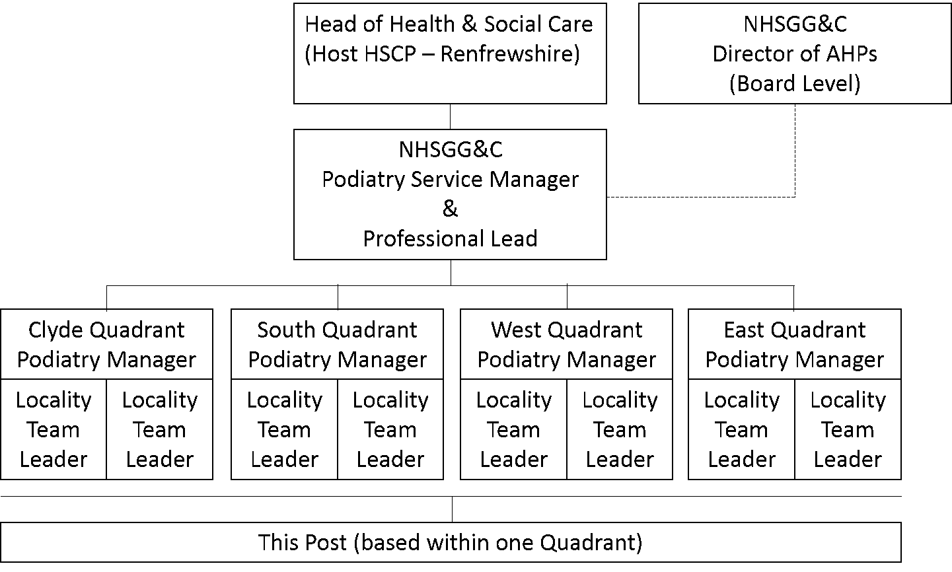

5. ROLE OF SERVICE
The Podiatry Service aims to deliver high quality care to patients and their carers.
The key responsibilities of the service are to provide triage, assessment, diagnosis and treatment to a diverse range of conditions and patient types in a variety of environments. There is also a key role in health promotion.

Podiatry focuses on supporting patients to remain independently mobile and pain free while promoting self care wherever possible. The aim is to provide Podiatry care and foot health education to those who need it most by a team of skilled practitioners who are constantly learning and developing.

Podiatry services are patient centred and needs led with clinical assessment and diagnosis leading to patient management plans tailored to meet the needs of individual patients. There is a focus on rehabilitation with a self care element included in treatment plans where appropriate

As part of skill mixed service this role will be fulfilled by graduates who have not yet gained HCPC registration and for Podiatrists who have been out of practice for a significant period of time and require to undertake the supervised return to practice framework (RtP). In normal circumstances this would be for a period of 30 or 60 days dependent on the level of support and learning required.

If competence in not demonstrated within a maximum of 90 days (RtP) the Bank contract will be terminated. For new graduates the Bank contract will be terminated on receipt of HCPC registration nd based on vacancy position can apply for a Bank Band 5 post or a permanent Band 5 post

The service is provided by a range of practitioners as follows

- Podiatry Assistants
- Pre reg Podiatrists
- Podiatrists
- Specialist Podiatrists in specific specialist area
- Advanced Podiatrists
- Principal Podiatrists

6. KEY RESULT AREAS

CLINICAL:

The post holder:

- Will have achieved a level of theoretical knowledge to core competency/skills level acquired through formal or training equivalent experience.

- Will prioritise and manage a clinical caseload on a day to day basis without direct supervision.

- Will plan and progress treatment programmes, applying knowledge of Podiatry techniques.

- Will take responsibility for delegated tasks and report back any concerns to the senior Podiatrist.

- Will take responsibility for parent/relatives education on a one to one basis and in a group setting.

- Will ensure that patient/parent/carer has given informed consent to intervention and that this is documented.

- Will be required to achieve an understanding of specialised work procedures and practices.

- Use analytical and judgement skills to assess clinical/non clinical situations and decide on appropriate actions, e.g. modifying intervention depending on clinical presentation.

- Will work in a variety of different clinical settings

- As a member of the Podiatry Service will be required to respond to the needs of the service all localities covered by the Board.

PROFESSIONAL:

The post holder:

- Will maintain Professional Standards as outlined by HCPC

- Will adhere to the Quality Standards for Practice Learning (QSPL) Return to Practice as outlined by NES. (if appropriate ie return to practice)

- Will attain an understanding of specialised work procedures and practices through training, Continuing Professional Development (CPD), staff appraisal and taking part in in-service programmes by identifying and highlighting areas of training needs.

- Will assist in Research and Development (R&D) including audit and clinical trials by implementing treatment packages and information gathering in order to maintain a high level of care in the Podiatry service in relation to patients, treatment and interventions.

- Will liaise and work collaboratively with colleagues and other members of the multidisciplinary team to ensure effective communication and reporting of patient progress and treatment.

- Will contribute to and attend staff meetings and in-service training programmes.

- Will attend internal/external courses, presentations and training sessions.

- Will record and maintain accurate patient data and clinical records

- Will be actively involved in the collection of appropriate data and statistics for use of the department.

- Will adhere to infection control policies.

- Will be aware of Health and Safety aspects of work and implement policies. Will promptly record and report any accidents, incidents and near misses to line manager.

7a. EQUIPMENT & MACHINERY
Use and upkeep of medical devices for carrying out treatments for example – nail drill, syringes, podiatry instruments, domiciliary case and machinery for the production of orthoses/insoles i.e. vacuum formers, ovens, industrial grinders, and Ultrasound.

7b. SYSTEMS
- Internet and email access
- TRAKCARE electronic patients management system
- Utilising and updating other electronic systems eg. Sci diabetes, PECOS
- Maintain and update patients records at each clinical intervention
- Corporate, Departmental Policy and Procedures and Guidelines e.g. clinical waste
- Provide monthly statistical returns reporting on activity and waiting times by appropriate use of TRAKCARE outcomes

8. ASSIGNMENT AND REVIEW OF WORK
- The post holder will be responsible to Podiatry staff who are nominated as part of an agreed process and to the appropriate Team Leads.

- Clinical caseloads will be generated by the specific needs of service users within the specialty - these will be designated by Podiatry staff.

- Assessment will be through TURAS, ongoing clinical supervision and CPD.

- As a member of the Podiatry Service, the post holder will be required to respond to the needs of the service at all localities within the Board.

- To undertake any other duties that may be considered appropriate by the Team Leads

9. DECISIONS AND JUDGEMENTS
- To ensure a high standard of clinical treatment for patients under your care.

- Plan and prioritise caseload on a daily basis and work autonomously following procedures and protocols for patients as defined within scope of practice.

- Independently assess, treat, progress and discharge patients from defined clinical group using clinical reasoning skills

- Be able to recognise when a patient is deviating from the clinical pathway and know when to refer back to a senior Podiatrist for reassessment.

- Uses judgement to ensure safety when rehabilitating patients by continuous risk assessment throughout the day in all environments.

- The post holder will be required to organise and prioritise their own time and caseload

- Formal supervision will be from a nominated and more senior member staff as part of an agreed process

10. MOST CHALLENGING/DIFFICULT PARTS OF THE JOB
- Ability to adapt to the variable and unpredictable demands of a clinical caseload.

- To maintain and continually develop clinical knowledge in Podiatry

- Requires to attain highly developed physical skills for Podiatry treatment eg use of scalpel and for local anaesthesia injection.

- To work independently without direct supervision of colleagues.

- To be aware of potential risks in lone working and vulnerable situations and to comply with current Health and Safety Guidelines.

- The post demands a high level of multi-disciplinary team work/ co-operation to deliver an effective service to service users.

- A mentally and physically demanding job, which requires ability to safeguard own safety as well as that of colleagues and patients.

11. COMMUNICATIONS AND RELATIONSHIPS
The post holder will be required to use communication skills effectively with regard to:

- Routine information e.g. discussion within the multidisciplinary team or in the organisation of daily timetable
- Complex information e.g. contribution to the evaluation of interventions and treatments
- Sensitive information e.g. discussion of wound prognosis where this is not favourable

This may require tact or persuasive skills where there may be barriers to understanding e.g. parents or carers with learning difficulties or hearing impairment.
It will include communication with education staff; medical staff and other agencies. However, communication of more contentious issues should be deferred to qualified staff.

The post holder will be required to:
- Work collaboratively with the families/carers to ensure effective intervention and reporting of patient progress and treatment.
- Participate in formal/informal peer review.
- Raise any concerns in relation to your supervised practice experience in a timely and appropriate manner
- Provide feedback about their supervised practice experience
- Make a professional decision as to whether the period of supervised practice undertaken is enough to allow safe and effective practice

12. PHYSICAL, MENTAL, EMOTIONAL AND ENVIRONMENTAL DEMANDS
OF THE JOB
- Requirement for prolonged concentration to carry out podiatric treatments which can be frequently interrupted e.g. phone calls
- Required to administer local anaesthetic as and when necessary under supervision.
- When treating patients in Care homes/domiciliary circumstances postholder will be required to work for long periods in cramped awkward positions
- Bending to aid some patients with removal/putting on hosiery/footwear
- Sustaining weight of patient’s feet on knee for approx. 20 minutes during each Domiciliary visit, up to 13 visits per day at least once per week. These limbs are often swollen and overweight.
- May be required to carry large amounts of equipment to domiciliary/nursing homes in excess of 5kg up to 13 times per day at least once per week.
- Travel between clinics, domiciliary visits and nursing homes throughout the year in differing weather conditions
- Exposed to wounds which may have offensive smells and poor foot hygiene; blood, pus and serum daily
- May be exposed to aggressive and challenging patients/carers occasionally
- Exposure to nail dust on a daily basis
- Moving and handling patients
- Exposed to the risks of Lone Working
- Exposed to the possibility and be aware of the risk of sharps/ needlestick injury
- Work on domiciliary visits where environment is not clinically sound, and may carry risk e.g. poor lighting, poor hygiene, and pets
- Perform intricate clinical procedures on a regular basis to treat/manage foot disorders of low and high risk patients
- Fine manual dexterity and a high degree of concentration - frequently
- Dealing with terminally ill patients, death and bereavement – occasionally
- Dealing with patients and their relatives who have long term illness and debility occasionally
- Dealing with complaints occasionally
- Working in potentially threatening situations occasionally

13. KNOWLEDGE, TRAINING AND EXPERIENCE REQUIRED TO DO THE JOB

Education and Qualifications | Degree or diploma in Podiatry (or within 3 months of expected degree award)  Local analgesia certificate
Skills and Abilities | Demonstrate Podiatry specific CPD portfolio
Knowledge and Experience | Demonstrate evidence based clinical knowledge
Personal Qualities | Ability to work on own and as a team member  Ability to prioritise, plan and organise workload
Other requirements | This post is a training post and requires the post holder to commit to learning and education processes to achieve HCPC registration

