NHS TAYSIDE – AGENDA FOR CHANGE

JOB DESCRIPTION

1. JOB IDENTIFICATION | Job Title | HMFUS pregnancy loss bereavement counsellor
 | Department(s)/Location | Hydatidiform Mole Follow Up Service (HMFUS)
 | Number of Job Holders | 1 (0.2wte)
2. JOB PURPOSE
To maintain and provide a confidential bereavement counselling service for families in Scotland who have suffered a molar pregnancy loss. The bereavement counsellor will provide specialist advice to healthcare professionals, other agencies, carers, clients and relatives about bereavement and loss issues associated with molar pregnancy, both within a community setting and clinical setting

To provide training and education for staff to develop their skills in supporting and communicating with parents/families experiencing a molar pregnancy loss.

- ORGANISATIONAL POSITION

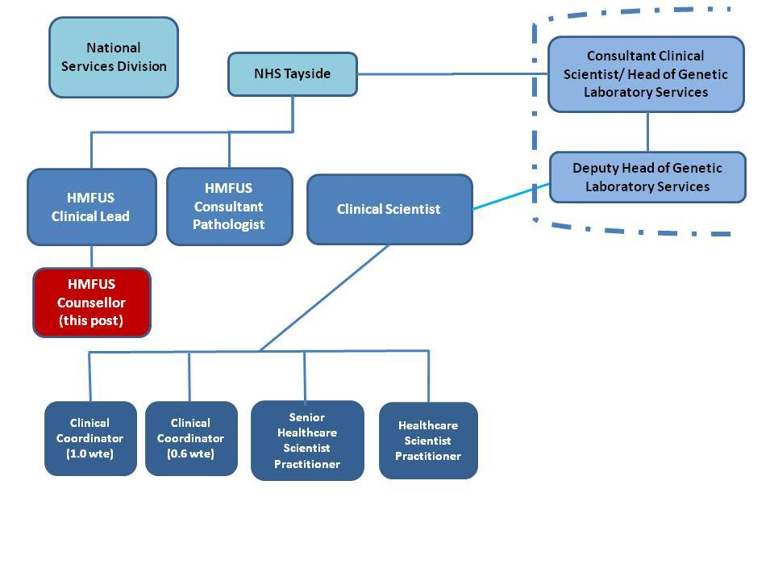
4. SCOPE AND RANGE
To provide a high quality bereavement support and counselling service for parents and families who have experienced a molar pregnancy loss

Environment of Care

- Outpatient Departments within Ninewells Hospital, Tayside
- Individuals homes across Scotland using remote technology and telephone consultation

To include:
- Liaison with other statutory and non-statutory agencies. Provision of specialist advice to others.
- Training and education of medical, nursing staff and students, in formal and clinical settings, carers/relatives, and other services staff.
- Individual risk assessments

Supervisory Responsibility
No direct supervisory responsibility

Budgetary Responsibilities
The post holder has no direct budgetary management responsibilities. However they are required to be aware of the need to work within budgets and their responsibility to assist in effective use of resources, highlighting cost pressures with respect to bereavement work to the Clinical Director for the Scottish Hydatidiform Mole Follow-Up Service (HMFUS).

- MAIN DUTIES/RESPONSIBILITIES

- Care Delivery
Responsible for the management of a caseload within a defined field of practice, ensuring that care needs are assessed and programmes developed, implemented and evaluated for patients whose needs may be predictable or unpredictable to ensure delivery of a high standard of counselling/bereavement support.
Work in partnership with/client/carers/ relatives and other Health Professionals in the planning and delivery of individualised care to ensure best practice in bereavement care

Act as a clinical expert to develop comprehensive counselling programmes to meet psychological needs to enable people to develop effective coping mechanisms and self care strategies to enhance quality of life.

To provide individual and couple counselling for bereaved families at outpatient facilities at Ninewells Hospital and home environment through remote and online platforms

Maintain and develop bereavement support group in collaboration with service users

To provide consultation and undertake assessment procedures for the bereaved requesting counselling, offering a referral service, or ongoing counselling where appropriate

To establish contact and liaise with hospital staff and primary healthcare teams together with other agencies in the voluntary sector

To act as a resource to families and healthcare professionals in relation to bereavement and associated issues (eg organ retention, post mortem and funeral arrangements, if appropriate)

Regularly attend patient information drop-in sessions with consultant medical staff to support bereaved parents/families when discussing sensitive issues

Undertake autonomous assessment of need for counselling and subsequent progress by identifying and initiating appropriate steps for effective care, exercising higher levels of judgement and decision-making

To ensure and appropriate confidential record system is maintained, documenting care plans, assessments and outcomes of counselling of individual counselling episodes

Work at all times within the ethical framework of the British Association of Counsellors (BAC)

- Management/Leadership

Take a leading role for developing molar pregnancy loss bereavement services within the Scottish HMFUS and UK-GTD service

Identify opportunities and contribute to processes influencing change to enhance practice

Provide appropriate support to nursing/midwifery and medical staff, acting as a role model and a source of advice

Foster an environment that encourages staff development, supporting and counselling staff as required

Develop and maintain procedural documents and guidelines to support the HMFUS in conjunction with referrers and service users

Develop, maintain and update information and supporting documentation and information for parents/families who experience molar pregnancy loss.

Represent the Scottish Hydatidoform Mole Follow-Up Service when required by attending meetings in relation to bereavement and molar pregnancy loss.

Recognise and report adverse incidents using Datix /IT system

Demonstrate the ability to effectively use physical, human and financial resources, promoting awareness amongst staff of the cost implications of their actions

- Education/Continuing Professional Development
Participate in personal/career development plan to maintain and develop attitudes, skills and knowledge, facilitating personal and professional growth in order to maximise contribution to service delivery

Design, facilitate and actively participate in teaching programmes including post basic education university programmes for nursing and medical colleagues and learners using mentorship and preceptorship, induction and orientation, appraisal and clinical supervision

To provide training for professional in counselling and communication skills related to bereavement and loss, both to reduce stress and promote good practice

Organise, facilitate and evaluate courses and conferences for staff focusing on bereavement and loss and associated topics

Access and maintain appropriate personal supervision in line with the British Association for Counselling guidelines.

Maintain own personal and professional development

- Quality/Research & Development

Maintain workload monitoring data and provide an annual report of activity to the Clinical Director for the Scottish Hydatidiform Mole Follow-Up Service (HMFUS).

Monitor, evaluate and review the service as appropriate

Develop and continually review clinical guidelines to achieve best practice in molar pregnancy loss and bereavement support

Lead practice development initiatives through participation in clinical working groups

Develop, implement and evaluate strategies to improve service design and delivery of specific care programmes

Work within an ethical and legal framework utilising defined policies, procedures, standards and protocols of the department, organisation and the NHS Tayside to promote safe and effective care and report quality issues to senior staff

Actively participate in Clinical Governance, clinical effectiveness and risk management, be proactive in implementing organisational agendas and strategies

Your performance must comply with the national “Mandatory Induction Standards for Healthcare Support Workers 2009” and with the Code of Conduct for Healthcare Support Workers.

6. COMMUNICATION AND RELATIONSHIPS
Communicates continuously with nursing, medical staff and others in the multidisciplinary team about activities associated with bereaved parents, necessary to maintain a high standard of bereavement support

Establish relationships and communicate sensitively and effectively with parents/families during one of the most distressing times of their lives. Support others in the team to communicate in sensitive and appropriate manner

Communicates continuously on routine, complex and potentially stressful matters with a wide range of health care workers and other relevant departments/agencies utilising a wide range of media such as telephone, verbal and written communications. Overcomes any difficulties in communication, identifying and negotiating appropriate actions

- KNOWLEDGE,TRAINING AND EXPERIENCE REQUIRED TO DO THE JOB
  - Diploma in counselling or willingness to undertake
  - Experience of personal therapy and counselling related to child bereavement/pregnancy loss
  - Evidence of ongoing professional development
  - Ability to work using own initiative as part of a multiprofessional team
  - Work experience within a healthcare setting preferred
  - Ability to work using own initiative and demonstrable ability to make autonomous decisions
  - Demonstrable ability to communicate effectively in sensitive situations
  - Leadership training or commitment to undertake
  - Knowledge and expertise acquired through in-depth experience and theoretical study of a range of techniques / processes relating to the area of practice.
  - Ability to lead and manage a specific field of practice or more than one area, ability to support continuous quality improvement, professional development and educational activity, work effectively as part of a multi-professional / multi-agency team

ESSENTIAL ADDITIONAL INFORMATION

- SYSTEMS AND EQUIPMENT

The molar pregnancy loss counsellor is expected to have knowledge and skills necessary to use all equipment required for the provision of a high quality bereavement support service

Information Technology
Accessing electronic guidelines/protocols
Word processing
Maintaining databases
Use of powerpoint and projectors

Responsibility for Records Management
All records created in the course of the business of NHS Tayside are corporate records and are public records under the terms of the Public Records (Scotland) Act 2011. This includes email messages and other electronic records. It is your responsibility to ensure that you keep appropriate records of your work in NHS Tayside and manage those records in keeping with the NHS Tayside Records Management Policy and with any guidance produced by NHS Tayside specific to your employment.

- PHYSICAL DEMANDS OF THE JOB

Physical Skills:
- Sitting in close proximity to distressed clients for lengthy periods
- Organising and prioritising own work and caseload.
- A lone worker, covering large geographical area.
- Work flexible hours

Physical Demands:
  - Preparing environment for bereavement service

Mental Demands:
  - Concentration required when communicating
  - Concentration required to prioritise workload and manage allocated work time in a service with peaks and troughs in activity
- Facilitating and supporting staff under stressful conditions
  - Concentration required when organising and facilitating events
  - Concentration required to assess progress of individuals receiving bereavement counselling therapy

Emotional Demands:
- Communicating with distressed/anxious/worried parents/carers and other relatives
- Supporting parents/families/staff who will be emotionally vulnerable and distressed
- Communicating with bereaved individuals regarding sensitive issues such as post mortem

Working Conditions:
- Lone working

- DECISIONS AND JUDGEMENTS
The bereavement counsellor will be responsible to the Clinical Director for the Scottish Hydatidiform Mole Follow-Up Service (HMFUS) for guidance and professional support, work review and appraisal of performance. Counselling supervision will be undertaken by a recognised trained counsellor according to BAC standards

The bereavement counsellor is autonomous and has continuing responsibility for quality of clinical practice and ongoing management of molar pregnancy loss liaison service

The bereavement counsellor has responsibility to reflect upon and review their own decisions in relation to bereavement support and the effectiveness of support/counselling programmes

- MOST CHALLENGING/DIFFICULT PARTS OF THE JOB

- Effective management and prioritisation of competing demands
- Balancing the demands of all stakeholders to provide an efficient, safe and effective service
- Lone working.
- Matching expectations and needs to the resources available.
- Continued exposure to distressing circumstances
- Provide independent consultation.
- Lead complex discussion that requires analysis, interpretation and comparison
- Responsible for decision making at specialist centre or regional level.
- Fulfilling the role as a change agent.
.
- JOB DESCRIPTION AGREEMENT

The job description will need to be signed off using the attached sheet by each postholder to whom the job description applies

JOB DESCRIPTION AND ESSENTIAL ADDITIONAL INFORMATION FORM – SIGNATURE OF AGREEMENT

Post Title | HMFUS pregnancy loss bereavement counsellor
Reference Number | SCO6-TN111-a

The attached job description and essential additional information will be used as part of the Agenda for Change assimilation exercise and therefore the job matching panel may wish to seek further clarification on any issues contained within the documents. Should this be necessary please identify an appropriate Manager and Staff representative who can be contacted.

Responsible Manager | Refaat Youssef Clinical Director HMFUS and Consultant Obstetrician and Gynaecologist
Contact No. | Ext: 54568
Staff Representative

Contact No.

