Physiotherapy Job Description: Additional Specialism information
Add the information below that is specific to the specialist work area. There may be more than 1 additional information form needed per specialism at the same grade e.g. Adult MH / Elderly MH / Forensic MH. This information will enhance expectations of role to jobholders/applicants.
Specialism: Ward 1 (part of Douglas Grant Rehabilitation Centre & Ward 1 Team) Grade: Band 6
Job description linked to: Specialist Physiotherapist
Organisational position (including chart) | 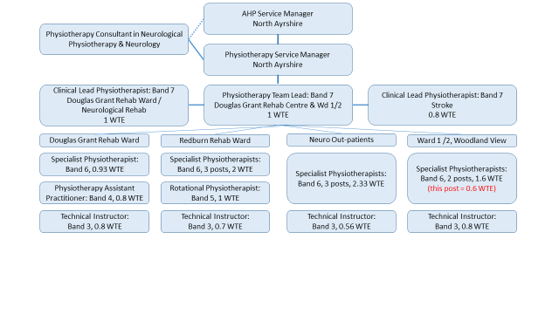  - The Douglas Grant Rehab Centre (DGRC) and Ward 1 Physiotherapy Team is based in the North Ayrshire Health & Social Care Partnership (HSCP) and comprises four clinical teams: Douglas Grant Neuro Rehab Ward, Redburn Stroke Rehab Ward, Ward 1 (Older Adults and Amputee Rehab), Neuro Out-patients  - This post is one of 2 Specialist Physiotherapist posts in the Ward 1 team  - The Ward 1 team also has sporadic input to Ward 2, a long term care ward
Job Purpose | - Ward 1 is a rehabilitation ward for older adults and patients who have undergone lower limb amputation. The majority of patients in Ward 1 have ongoing rehabilitation needs and are transferred directly from University Hospitals Ayr / Crosshouse following a period of illness or orthopaedic surgeries/injuries or are repatriated from Hairmyres Hospital as part of the vascular pathway.  - The aim of physiotherapy rehab in Ward 1 is to help patients become as active and independent as possible with the minimum level of ongoing therapy support and home care needs as possible on discharge  - Work as a Specialist Physiotherapist in Ward 1  - Assess and treat older adults with reduced mobility and provide senior support to junior team members as detailed in above chart  - Conditions treated include, but are not limited to: frailty; falls; dementia; delirium; multi-morbidity; lower limb amputation; traumatic orthopaedic injuries; elective orthopaedic surgery; arthritis; COPD; heart failure; alcoholic liver disease; Parkinson’s disease; stroke  - Treatments for reduced mobility will include, but are not limited to: gait and balance re-education; provision of walking aids; use of hoists and standing and walking aids such as Arjo Sara Plus ® / Taurus ® / Stedy ®; upper and lower limb strengthening; stair practice; access to a therapy room with rehab equipment including a rehab plinth, stairs and parallel bars; referral to Orthotics  - Attend MDT whiteboard meetings and contribute to discharge planning including attendance at discharge planning meetings (DPM)  - Deliver practical and theoretical training to members of the MDT  - Lead local service improvement projects  - Engage at a local and national level with relevant clinical interest, policy development and service development groups which may include Falls; Frailty; Rehabilitation
Key Result Areas | - Treat adults with reduced mobility in Ward 1  - Promote a rehabilitation ethos and encourage physical activity to improve / maintain functional independence while in Ward 1 and on discharge  - Empower individuals to be as active and independent as possible  - Facilitate discharge from the rehab setting and make onward referrals to other services and teams as required to ensure ongoing rehab needs are met  - Contribute to MDT discharge planning
Other relevant information

