JOB DESCRIPTION

JOB IDENTIFICATION
Job Title: Senior Innovation Research Administrator

Responsible to: Innovation Sponsor Co-ordinator & R&I Systems & Operations Manager

Department(s): Research & Innovation

Directorate: Corporate

Operating Division: Research & Innovation Management Office

Job Reference:

No of Job Holders: 2

Last Update (insert date): 09/11/2023

2. JOB PURPOSE
Develop and implement comprehensive support systems and processes that include tracking and supporting NHS GG&C Sponsored (and co-Sponsored) Innovation activities, including research. The post holder will ensure that regulatory and governance requirements are adhered to, for research activity supported by the R&I activities in the West of Scotland Innovation Hub, hosted in NHS GGC. A key aspect of this would be to work closely and support the Sponsor’s representatives in the development and implementation of a robust system to review and issue approval for a range of study types, including medical device trials (including AIaDM).

Support the R&I WoSI team in making sure that deadlines and timelines are visible and that researchers and collaborators expectations are managed.

Responsible for guiding researchers and collaborators through the Innovation review process, including Sponsor, eHealth and R&I review process, keeping in contact so they feel informed of where they are in the review process. Managing the Innovation teams diaries where helpful and keeping track of the team’s priorities.

3. ORGANISATIONAL POSITION
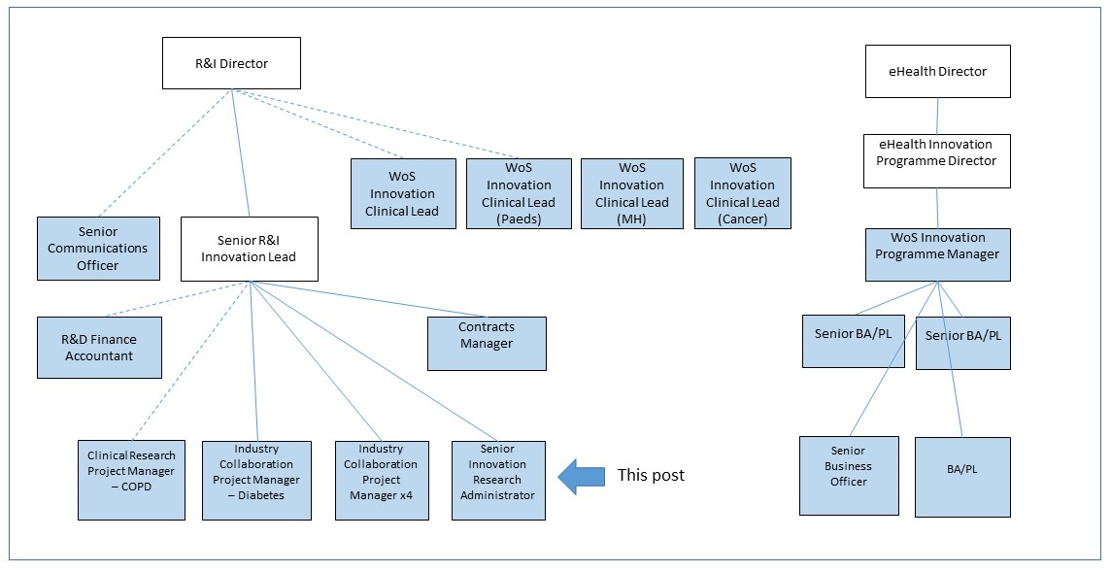

4. SCOPE AND RANGE
The purpose of the WoS Innovation Hub is to provide a co-ordinated, supported environment and infrastructure for investigators undertaking innovation projects, according to Scottish Government, CSO and board priorities, in the West of Scotland.

As part of the Innovation team the post holder will be expected to work unsupervised and
autonomously and will:

- Be responsible for the set up, ongoing development and implementation of robust administrative systems and processes necessary to meet the complex regulatory and governance requirements surrounding Innovation validation and research,
- Acting as a point of contact for Innovation enquiries along with the eHealth administrator. The post holder will manage priorities and deadlines, manage tracking systems for the R&I Innovation to make sure that agreed deadlines are met
- Where required, manage the Innovation Research Co-ordinator’s diary and respond to requests for scheduled time
- Help collate costs for funding grant application deadlines
- Review and sign off Research Passport applications in order for researchers to gain NHS letters of access or Honorary Research Contracts with the Health Board
- Review some types of Sponsor amendments, escalating to Sponsor Innovation Co-ordinator if needed
- Advise and support researchers to help them through the sponsor review and R&I participating site approval processes, including completing submissions to the Ethics Committees, PBPP, CRF, LPAC, biorepository & Support Departments through online applications i.e. IRAS, Amendment tool portal etc
- Liaise directly with external agencies involved in research including for example The University of Glasgow and different pharmaceutical companies to ensure that essential Innovation documentation is processed correctly and within appropriate timelines and through the Innovation Governance Group (IGG)
- Develop close working relationships with internal departments ensuring that all departments impacted upon by research projects are fully informed of future and current research activities involving WoSI Hub
- To be aware of your own strengths and development needs, taking personal responsibility for your own actions, continuous learning and personal development. Accepting and embracing change.
- Taking a longer term, broader perspective on issues. Seeking, using and interpreting information to generate solutions and recommendations. Drawing on diverse sources of information. Using a combination of precedents and innovation/initiative

5. KEY RESULT AREAS
The post holder is a key member of the WoS Innovation Hub team in Glasgow and will closely with the Research Co-ordinator staff group, R&I Systems manager and the wider R&I management team.

Innovation review support

- The post holder will have responsibility for delivery against robust national approval timelines and will issue approval letters (for the Innovation Sponsor Research Co-ordinator) for research projects on behalf of the Board for sponsored submissions and their amendments.
- In conjunction with the Innovation Sponsor Research Co-ordinator and R&I Innovation Lead, produce and develop relevant department SOPs, policies and procedures, clinical trial/research project activities as part of the Quality Management Systems.
- Ensuring version control of documents reviewed
- Keep a robust Sponsor tracker for Innovation team but also for the wider team to access to have a clear idea of where we are with our studies and liaise with the eHealth administrator and team
- Know when to submit a research study for NIHR adoption/extended review and do so without prompt
- Ensure effective systems are put in place for circulation of information, policies, procedures, NHS Circulars and Consultations within R&I relevant to the projects under review by the sponsor team
- The post holder is guided by the principles of Good Clinical Practice (GCP) and departmental procedures and has the autonomy to decide the most effective way to apply administration and when projects require to be escalated for a more detailed review.
- Implement and monitor quality standard systems to ensure that a comprehensive and efficient secretarial and general office administrative service is in place to support service delivery.
- The Innovation Project Managers manage a large portfolio of Sponsored research studies. Using tracking tools; knowing the status and how far a project has progressed to keep the team moving with approvals
- Participate in R&I-wide working groups set up to address specific working practices and policies.
- The postholder will be required to manage competing priorities and deal directly with Senior Clinical staff in relation to their project submissions.
- Ensure that workload is prioritised on a daily basis in order to meet critical timescales.
- Co-ordinate leave across their portfolio to ensure that adequate resource is available to meet national timelines.

Communication
- Ensure that systems are in place so that the R&I Innovation department meets its legal and regulatory obligations specifically in terms of Data Protection/GDPR, Access to Health Records Act, Freedom of Information (Scotland) Act, Research Governance, ICH GCP
- Manage and respond to constant change due to increasing legislation while promoting a culture of quality and transparency
- Responsible for the administration and co-ordination of a number of stages within study approval process, deal with any queries relating to the CRF, Ethics and the management of applications. To deal with enquiries from applicants i.e. Principal Investigators (PI), Chief Investigators (CI) with multidisciplinary backgrounds, data managers, researchers and to take a role in organising submissions and informing applicants of the outcome of their applications
- Responsible for reviewing and liaising with the researchers to make sure the documentation submitted is gathering the correct and gathers the right information
- Working closely with the research teams to make sure they have considered and given all the relevant information required for R&I review and approval
- Develop and implement electronic documents and records management systems to meet the needs of the R&I Innovation Hub and its associated research documentation/protocols
- Develop robust relationships with similar post holders in other Operating divisions to ensure uniformity of approach in relation to research quality indicators
- Facilitate the implementation of agreed action plans to reflect the issues and challenges resulting from meetings
- Participate in relevant working/steering groups/meetings to take forward issues which have a direct bearing on the WoS Innovation Hub and wider R&I department
Organisational
- The Post holder will prepare, plan, organise and attend Innovation meetings themselves or on behalf of the Hub and be responsible for the dissemination of all relevant information from these meetings
- Work alongside the Hub team making sure that deadlines are managed by tracking and setting reminders for the team so expectations as met
- The post holders will maintain SReDA (R&D Research Database) and will respond to regular requests for project and timeline related enquiries by collating information for review by Senior Management committees and PCS via the eHealth admin post. This requires working with a meticulous approach to detail to ensure the quality and integrity of data
- Along with day-to-day tasks the job holder works unsupervised and autonomously
- Where required will manage the Hub diaries and manage requests for time for researchers, project managers etc

Education and Training.
- Responsible for the development of robust administrative systems to approve projects within short, government-led timelines
- Support and train and help colleagues gain similar experience and skills
- Assist study teams to comply with GCP encourage training and courses needed to meet gaps
- Actively establish links and share good practice with external agencies and organisations to develop and promote research governance, supporting the benchmarking of good research practice within the organisation.
- Monitor systems, data capture and procedures within the Sponsor team in relation to Research Governance indicators and UK directive legislation.
- Ensure relevant information and documentation is available, in various formats and modes, to support all research active professionals. This will include written materials and web based information
- Have a working knowledge of GCP and be able to provide advice and guidance where required

Personal Development
- Actively seek out learning opportunities appropriate to the role and lifelong learning
- Identify gaps and ask the right questions to learn for experience
- Ensure the post holder’s Personal Development Plan is up to date
- Complete reflective practice for each learning event attended
- Update IT skills required to meet changes in technology to manage clinical trials
- Update and maintain knowledge of legislation surrounding clinical trials

6. SYSTEMS & EQUIPMENT
- PC/laptop equipment: Advanced keyboard skills to enable the production of often-complex documents
- Work with a range of Microsoft programmes including MS teams, word, excel, access, PowerPoint and outlook (to an advanced level)
- Update and maintain Web-based database SReDA, and have a working knowledge of IRAS application systems
- Online software programmes: Turas system for management of appraisal and learning tools (learning modules online)
- Office equipment: PC, photocopier/scanner/printing equipment, telephones for team
- The post holder will oversee the maintenance of their office equipment and their sponsor team colleagues

7. DECISIONS AND JUDGEMENTS
The postholder :
- Responsible for supporting the timely review and approval of Sponsor and IGG submissions and any amendments to these projects
- Works autonomously and is expected to time manage and prioritise their own workload
- Required to read detailed and complex research documents to help review Sponsor amendments for simpler changes. Knowing when to pass to the Sponsor research co-ordinator when their knowledge is required
- Being able to extract the relevant details for inclusion on the database, to fulfil all data returns and to maintain information for the current annual budget
- Ability to determine the category of funding in place for each research study being guided by Government guidelines
- Self generate further work to meet the needs of the service offered by the R&I Department. This will include responding to requests from study teams and external personnel.
- On a daily basis, be responsible for managing a programme of work in relation to competing priorities
- Will have the ability to anticipate problems and develop solutions with little or no supervision.
- Required to solve any problems which may arise in relation to approval timelines for new submissions and amendments. If these problems cannot be resolved the job holder may need to seek guidance and direction from the Research Co-ordinator lead for the Sponsored Research
- Advise others within R&I matters relating to development of policy and compliance with statutory and regulatory provisions and for making recommendations on the development of Standard Operating Procedures.

8. MOST CHALLENGING/DIFFICULT PARTS OF THE JOB
- Keeping on top of an ever-changing varied workload which consists of competing and altering priorities, all of which in themselves, present complicated project management challenges
- Operating within complex and conflicting organisational requirements.
- Keeping up to date with all current legislation and appropriate regulatory documents.
- Provide administration support to researchers, R&I colleagues and key project stake holders
- Pacifying agitated researchers.
- Sensitive staff issues such as managing poor performance of delegated tasks.

9. COMMUNICATIONS AND RELATIONSHIPS
- Good communication is a crucial element of this job. The post holder will provide and receive complex, sensitive information from a range of staff internally and externally across the organisation.
- Internal working relationships with all members of R&I staff, professional contractors, Glasgow CRF Management, Nursing and Administration Team, Scientific Steering Committee and Senior members of the NHS GG&C and various Universities and engage in communication at all levels on a regular basis.
- External working relationships with colleagues from the Local Authority, the Scottish Executive Health Department, Chief Scientist Office, Scottish Enterprise, Glasgow-based Universities, pharmaceutical companies, MHRA, external independent contractors will be required on a regular basis.
- The post holder spends a large amount of their time corresponding by email and telephone with all grades of staff from students to professors involved in clinical research. It is important that they are able to communicate clearly and relevant advice is delivered in a helpful and friendly manner. Communication involves using medical and scientific terminology. It is important the job holder deals with all individuals in a friendly, courteous and pleasant manner.
- Team working is a critical and integral element to the successful running of the R&I department. The postholder will be required to engage effectively with all staff within R&I and with partner agencies, both formally and informally.

10. PHYSICAL, MENTAL, EMOTIONAL AND ENVIRONMENTAL DEMANDS OF THE JOB

The post holder is required to review and approve projects which are open to patient recruitment across all GG&C sites and affiliated Universities. This may require travel from base as and when an activity demands and subsequently workload is adjusted accordingly. Frequent use of a VDU is recognised as a necessity of the post. Depending on the activity, this can range from short periods, interrupted by other commitments to up to two days of prolonged periods for document review.

The post holder will undertake periods of intense concentration during any given activity. This may be interrupted by telephone calls, colleagues requiring advice/assistance, or visits to the office. Acknowledging that delivering evidence of quality systems in academic trials can be interpreted and viewed as a bureaucratic exercise, having little significant impact on overall trial management.

Accommodating and responding to personal dynamics and the politics of working in a complex open office environment. Dealing with portfolio performance issues, dissatisfied stake holders (e.g. Principal investigators, Research Nurses, affiliated Health Board departments and external stakeholders).

Required to be involved in difficult complaints which may require direct contact with research teams in
circumstances where emotions are high and there is a need to respond to challenging behaviour quickly.
The post holder will ensure that a sensitive and proportionate response is provided.

11. KNOWLEDGE, TRAINING AND EXPERIENCE REQUIRED TO DO THE JOB
- Demonstrable experience of Research administration in NHS, HEI or equivalent.
- Degree in business administration, Bio medical science or working towards Degree or equivalent experience.
- Good knowledge and understanding of NHS administrative and governance systems in practice.
- Demonstrate a high level of communication skills, both oral and written in addition to interpersonal skills gained through experience.
- Excellent working IT knowledge of Microsoft Word, Excel, Access, PowerPoint, Email & internet-based systems, as is the ability to gain competence with in-house software packages. Demonstrate a good track record in developing Office Systems
- Demonstrable experience of Clinical Research / Healthcare environment and networks, working in multidisciplinary Teams and experience of team working on new development issues.
- Excellent organisation and communication skills and ability to multi-task and prioritise workloads. (essential)
- Ability to perform effectively and co-operatively as an individual and as a team member
- Familiarity and understanding of medical & research terminology
- Evidence of continual professional development
- Setting clear objectives, communicating priorities, time management skills, monitoring progress and getting results. Promoting change and making improvements that help the organisation achieve its overall goals. Taking responsibility for making things happen.
- Ability to work under pressure in an environment that can lead to frequent interruptions.
- Operating with awareness and of sensitivities. Building networks and partnerships to enhance organisational credibility.
- Building and maintaining good working relationships with colleagues and contacts at all levels. Working with individuals and in groups. Sharing knowledge and resources.

12. JOB DESCRIPTION AGREEMENT
Job Holder’s Signature:  Head of Department Signature: | Date:  Date:

PERSON SPECIFICATION FORM

Job Title: Senior Innovation Research Administrator (Band 5)

Department: Research & Innovation, West of Scotland Innovation Hub

Qualifications | Essential | Desirable
HND or equivalent in an administrative/ statistical subject | Yes
Medical terminology | Yes

Experience | Essential | Desirable
3 years experience in a similar role, NHS or other public service experience would be an advantage. | Yes
Working knowledge of MS Office to an advanced level in particular Excel and Access. | Yes
Experience of information management in the NHS |  | Yes
Experience of clinical research and GCP requirements |  | Yes

Behavioural Competencies | Essential | Desirable
Good written and oral communication skills | Yes
Ability to work under pressure | Yes
Ability to follow direct and precise guidelines | Yes
Adaptable and self motivated |  | Yes
Good time keeping and responsible attitude. | Yes

Other | Essential | Desirable
Excellent ability to work within a team | Yes

