

**NHS Lothian Ward 8 St John’s Hospital**

Exciting opportunities are available to join Ward 8 within one of the hospital sites across NHS Lothian. We have multiple Band 5 positions available for Registered Nurses and we are looking for passionate, caring, motivated people to join our highly skilled nursing teams.

We offer the opportunity to work with talented teams within multidisciplinary environments and impact positively on the lives of thousands of patients and their families.

Find out what our staff say about working in NHS Lothian at https://careers.nhslothian.scot/acute-specialist-nurses/who-we-are/

 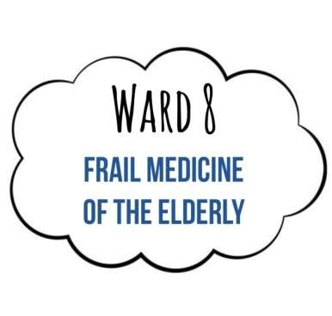 

**What We Can Offer You**

We have a range of vacancies for experienced and newly qualified nurses to join our innovative and dynamic teams across NHS Lothian – providing you with the opportunity to gain a breadth of knowledge and exposure to multiple specialties.

**Ward 8 is a 29 bedded, adult in-patient Frailty Ward that provides care for elderly patients who have complex medical conditions or are at risk of functional decline. Our team is dedicated to focusing on comprehensive assessment, management and rehabilitation to optimize the health and well-being of our patients.**

**Training and Development**

Core Clinical Skills

The clinical skills you will gain in this position are

* Venepuncture
* Peripheral Venous Cannulation
* Administration of IV Additives
* Administration of IV Bolus Injections
* Intravenous Devices Training (Alaris, Braun, McKinley)
* Management of Midline Catheters
* Vascular Access
* Blood Glucose Monitoring
* Recording a Standard 12 Lead ECG (Adult)
* Insertion of Male and Female Catheters
* Higher Level Dementia Training

**Salary**

* Band 5 Range £30,229 – £37,664 (pro rata) per annum

**Benefits**

* A minimum of five weeks annual leave increasing with length of service
* A range of supportive employment policies including Flexible Working
* Full or part time hours considered
* We provide an extensive induction programme and excellent professional training and development opportunities.
* Access to the NHS Pension Scheme and Staff Benefits

  