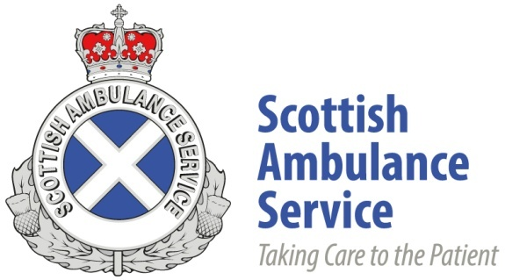

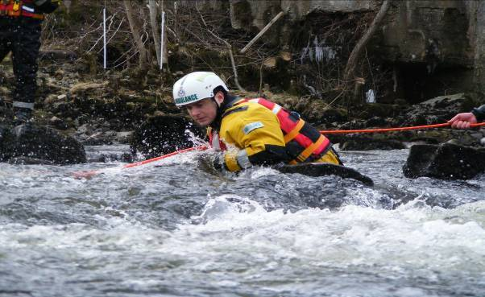**SPECIAL OPERATIONS PARAMEDIC INFORMATION PACK**

Scottish Ambulance Service

SPECIAL OPERATIONS PARAMEDIC

Information Pack

Thank you for your interest in the Scottish Ambulance Service.

This pack gives you all the information on the recruitment and selection process for the post of Special Operations (SORT) Paramedic. It covers:

|  |  |
| --- | --- |
| The Role of SORT Paramedic | |
| The Recruitment and Selection Process | |
| Stage 1 | Advertising & Self-Assessment Stage |
| Stage 2 | Application Stage |
| Stage 3 | Shortlisting Stage |
| Stage 4 | Physical Competency Assessment |
| Stage 5 | Competency & Values based Interview |
| Stage 6 | Pre- Employment Checks |
| Recruiting applicants with disabilities | |
| Core Competencies and NHS Values | |
| Physical Competency Assessment | |
| Occupational Health Standards | |
| Self Assessment Form | |
| Interview Preparation Guide | |
| SORT Training Programme | |

**SORT PARAMEDIC**

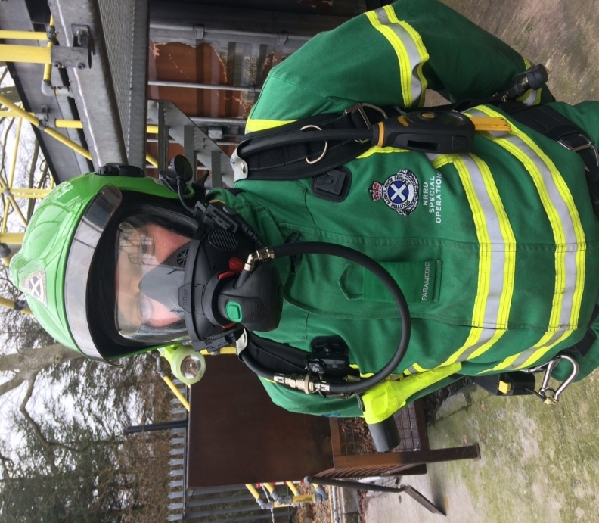

The Scottish Government Health and Social Care Directorates (SGHSCD) require the Scottish Ambulance Service (SAS) to maintain an on-going, national specialist operational response capability to provide patient care in hazardous environments on behalf of NHS Scotland.

The purpose of SORT is to save life, increase survival, improve clinical outcomes and enhance patient and staff safety through the provision of specialised paramedical care.

Special Operations work within hazardous areas to deliver the highest standards of prehospital specialised clinical care using personal protective equipment within the inner cordon. We identify and manage risks appropriately; operating in environments where no other responding agency can provide clinical care and no other professional health care intervention is available. This allows us to provide safe and effective, person-centred care, 24/7/365, where and when needed by the patient. We provide leadership, advice, training and exercising, geared to improving critical decision making, interoperability and improving outcomes.

Following specific terrorist incidents in September 2001 and in subsequent years, the SAS developed Specialist Operational Response Teams to provide patient care in hazardous environments, based on the ability to respond to specific threats as outlined in the UK National Risk Assessment (NRA).

Designed as a supernumerary national specialist capability for Scotland, the Special Operations Response Teams (SORT) were funded by the Scottish Government in a number of incremental steps to develop a specific range of skills and capabilities so as to be able to provide patient care in response to accidental, environmental and malicious threats and hazards to the health of the population of Scotland.

Such threats have included the deliberate release of hazardous chemical, biological, radiological and nuclear (CBRN) material; including scenarios detailed in the Home Office Model Response to a CBRN attack; environmental hazards such as the consequences of severe weather; and the immediate patient care consequences of a marauding terrorist attack (MTA).

Within the SAS, SORT operates as a Division of the National Risk and Resilience Department (NRRD), responsible for emergency planning, risk management, infrastructure security, business continuity and other similar functions.

**SORT PARAMEDIC - Recruitment and Selection Process**

The recruitment and selection process is made up of six stages:

**Stage Two – Application Stage**

Application Form and competency Statement

**Stage Three – Shortlisting Stage**

Assessment of application against person specification and competencies

**Stage Four – Physical Competency Assessment Stage**

Assessment of fitness against relevant standards for role, Written Assessment and Swim Test

**Stage Five – Interview Stage**

interview based around competencies and values

**Stage Six – Pre-employment Stage**

Qualifications / OHS / PVG / References

**Stage One – Advertising Stage**

Adverts are placed on our web site, SHOW, My Job Scotland and social media

Stage 1 - Advertising and Self-assessment

Stage 2 – Application

Stage 3 - Shortlisting

Stage 4 – Physical Competency Assessment

Stage 5 – Competency and Values Interview

Stage 6 - Pre- Employment Stage

**Stage 1 - Advertising and Self-Assessment Stage**

This information pack is designed to help you decide whether this post is for you.

As part of the application process we would expect you to make efforts to find out more about the Scottish Ambulance Service and whether this is the right role for you.

To become a SORT Paramedic, you must satisfy all our minimum entry requirements, but this role also calls for a range of personal attributes that will enable the team member to operate effectively within this environment.

*There is a self-assessment questionnaire at the back of this pack and we encourage you to answer this honestly and candidly before deciding whether to apply. This will help you determine for yourself whether this is the right role and working environment for you.*

**You can learn more about the Scottish Ambulance Service, our visions and values by visiting our website** **www.scottishambulance.com**

**Stage 2 - Application Stage**

We use an on-line candidate management system for applications and this will guide you through the process, prompting for the information we need as you go.

As part of your application, you will need to complete a set of standard questions, an equality monitoring section and a section detailing how you think you meet the minimum competency requirements of the role. This is an important part of the application and before completing you should make sure you understand what these are so that your answers reflect them.

**Minimum Eligibility Requirements**

2 year post registration frontline experience

C1 Driving licence

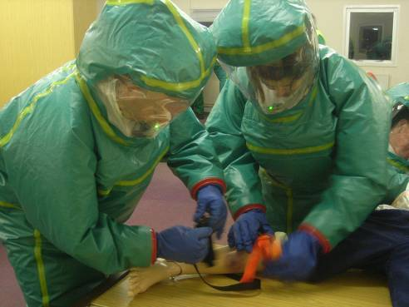

**Physical restrictions and other disqualifiers**

Prospective candidates should read the following information carefully. Unless all the criteria below are met candidates should not apply as they may put themselves at undue risk of incurring or exacerbating an injury or condition and will have difficulty completing the Physical Competence Assessment centre and training. They would therefore not be eligible to undertake the role**.**

The following criteria will be confirmed through the Occupational Health Screening and Assessment stage of the recruitment process.

* Candidates must not suffer from any skin allergies and irritants, including eczema and heat/sweat rash as the wearing of Personal Protective Equipment (PPE) may adversely affect these conditions.
* Candidates must not suffer from any lung function difficulties or breathing conditions, including asthma, which is inhaler dependent for treatment. This is because the conditions in which this role operates, such as dust, fumes etc may adversely affect these conditions.
* Candidates must not suffer from claustrophobia or experience any other confinement -related difficulties
* Candidates must be able to operate at heights and not suffer from vertigo
* Glasses are acceptable provided all vision requirements are met wearing the same pair of glasses.

You must also be able to comply with the following requirements for your own safety when undertaking the role.

* Facial hair must be maintained in such a condition as to enable you to wear the service issue breathing apparatus and other Respiratory Protective Equipment (RPE) and to maintain the integrity of the seal.
* Fall within the minimum and maximum shoe size for specialist PPE equipment. (Typically size 5-15). Variations will be considered subject to risk assessment.
* Be prepared where necessary to respond to national incidents in other areas of the country which may involve being away from home for protracted periods.

**Staff with insulin dependent diabetes**

There are strict guidelines surrounding the driving of emergency vehicles and the Service has a policy relating to the employment of staff with diabetes. This is very much a case by case policy as every individual is different.

You are advised to speak to your GP about how your diabetes may affect your ability to meet Group 2 driver standards.

**Stage 3 - Shortlisting**

All applications will be reviewed by an operational manager against the person specification and the core competencies. They will also assess whether you have met the minimum entry criteria and correctly completed all sections of the application.

Your answers will be scored and then a final overall decision made on whether your application should progress to the next step.

Managers will be looking for how you have demonstrated your previous experience in relation to the competencies and what additional and different experience you can bring to the role.

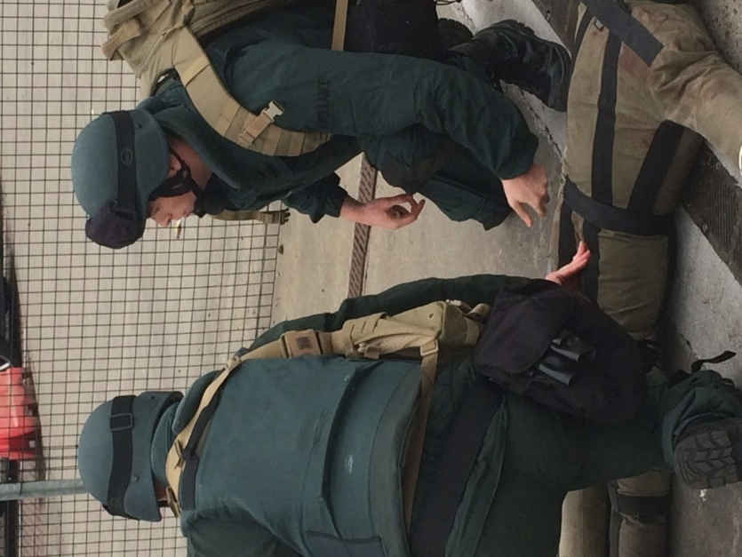**Information on the core competencies can be found later in this pack.**

**Stage 4 – PHYsical COMPETENCY ASSESSMENT (PCA)**

The role of SORT Paramedic is continually evolving and the demands of the role require you to have a good level of physical fitness.

SORT Paramedics are required to operate alongside Fire & Rescue and Police colleagues within the “inner cordon” of hazardous incidents. It is recognised that for them to perform their normal duties safely, whilst wearing high level of PPE, the physical demands and stresses of their role will be substantially increased.

Ensuring there is a match between the capabilities of the individual and the inner cordon by implementing physical selection criteria will help to optimise safe operating procedures for the workforce, whilst ensuring a minimum standard of operational effectiveness.

The PCA standard has been designed by a multi-disciplinary panel of subject matter experts, who have extensive experience in this field and has been used as a benchmark by the Hazardous Area Response Teams (HART) in England for a significant number of years. An authentic trial circuit was conducted under strict conditions: the results of which have set the standard of performance for selection to the role. The standards have subsequently been reviewed and are subject to ongoing evaluation and validation on a regular basis.

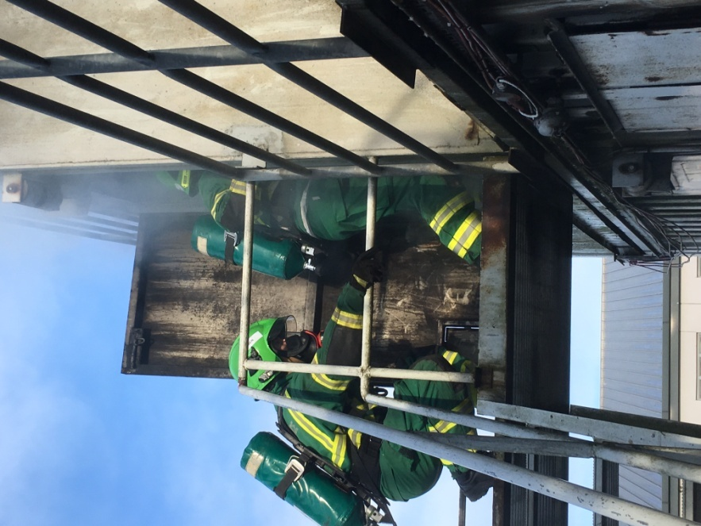The exercises simulate a cross section of realistic tasks expected of the role. It determines your ability to carry out the physical elements and is designed to ensure that if successful you will be able to carry out the roles safety, both for yourself and for the safety of our patients.

**Full details of what is involved in the test and how you can prepare for it can be found at the end of this pack.**

**Stage 5 - Competency and Values Based Interview**

If you successfully complete the fitness test you will be invited to attend a competency based interview which involves 3 elements.

1. Command Task
2. Objective Structured Clinical Examination (OSCE)
3. Formal Interview

At the interview you will be required to give examples of situations in which you have demonstrated behaviours relevant to the core competencies considered critical for effective performance in the role.

The interview will also allow interviewers to further assess you against the essential and desirable criteria of the person specification.

The interview is likely to last about 40 minutes and will use a template structure.

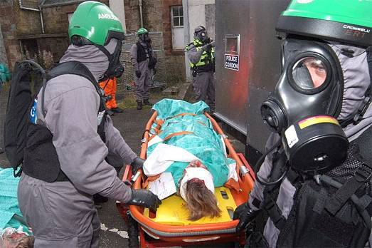

**More information on the core competencies can be found later in this pack.**

**An interview preparation guide and example questions can also be found at the end of this pack**

**Stage 6 - PRE-EMPLOYMENT STAGE**

**Pre-Employment Screening**

All employment offers are subject to pre-employment criteria being satisfactorily completed. You will not be able to start in post until all these have been completed. These are detailed below:

**Referencing Process**

As part of the application process you will be asked to provide the names of two referees, one of which must be your current or most recent line manager. Your referees will be contacted once an offer has been made.

*Remember it is good practice to make sure your referees know you have put their name down, before we contact them. This avoids embarrassment and speeds up the process*.

**Protecting Vulnerable Groups (PVG)**

The Protection of vulnerable groups ensures that people whose behaviour makes them unsuitable to work with children and/or protected adults, cannot carry out regulated work with these vulnerable groups. In applying for the scheme, you will confirm that you are not barred from the type of regulated work which we require you to do

The scheme is regulated by Disclosure Scotland and there are strict rules governing the handling of information. The Service will only be advised of any relevant criminal conviction that may affect your ability to be employed.

**Should you believe that you cannot become a member of the PVG scheme, you should consider carefully whether to apply.**

**Occupational Health Screening (OHS)**

Before taking up employment, all new starts must complete an Occupational Health Screening form and attend a medical assessment.

This is a confidential process and we will only be notified if there are possible implications for your employment or when additional support measures might need to be put in place.

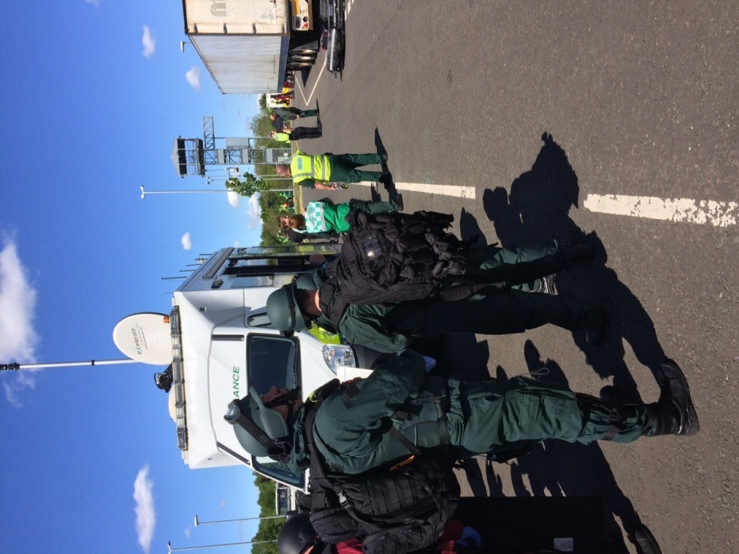**If you have any health conditions that you think might prevent you from successfully passing this, you should consult your GP before thinking about applying.**

**Full details of the health standards that you will be required to meet can be found at the end of this pack**

**APPLICANTS WITH DISABILITIES**

The Service is committed to equality and diversity, and we welcome applications from candidates who consider themselves to have a disability.

The SORT Paramedic role is a physical role and therefore to ensure that we are fairly considering those with disabilities, we work closely with applicants and our OHS partners to ensure that all reasonable adjustments are made throughout the selection process and then into employment.

If you believe you have a disability, please consult our website. If called for an interview, please make sure you talk to the recruitment team, so we can talk to you about any necessary adjustments.

Details relating to the nature of the applicant’s disability will not be disclosed to the managers conducting the shortlisting. This information will be supplied, if required, when interviews are being arranged.

**Further information regarding our commitment to equality and diversity can be found on our website** **www.scottishambulance.com**

**CORE COMPETENCIES AND VALUES**

**The Scottish Ambulance Service Core Competencies**

Our selection process is based on the core competency dimensions (called KSF dimensions) and the NHS values required for the role. These are the basis for the application, shortlisting and interview stages and they are the standards that will be used throughout your career with the Service

These standards ensure that the recruiting managers are being consistent across all roles and geographical areas.

**There are 6 core competencies**

**Core Competency 1 – Communication**

This job relies very heavily on your ability to communicate with others often in extremely difficult circumstances. Excellent communication skills are essential as you will communicate with a range of internal and external contacts. You will also often be the lead clinician at a scene and as such you will be responsible for ensuring that any barriers to communication are recognised and that there are effective mechanisms to overcome these.

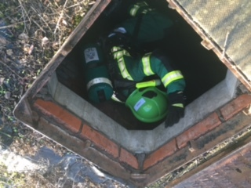As well as communicating directly with patients, you will also need to communicate in other ways such as producing written reports, completing patient forms, handling radio communications and working with multi agency partners.

Team work is clearly very important and an ability to work within a team is one of the most important skills needed.

**Core Competency 2 - Personal and People Development**

In this role you will be expected to identify your own areas personal development and take responsibility for developing your own skills and knowledge to ensure that you maintain the required clinical skills and knowledge to ensure you undertake your duties effectively.

You will also have a role in mentoring less experienced colleagues both within Special Operations and across the wider Service.

**Competency 3** – **Health, Safety and Security**

In this role you have responsibility for the personal health and safety of yourself and others including patients, the public and colleagues. Risk management is key in this role and you will need be able to identify and manage this every day.

**Core Competency 4 - Service Improvements**

We are always trying to improve our service to the public. As a result, the role of the Specialist Operations Paramedic is constantly evolving to try to provide this improved service. It is also expected that you will play a part in working towards this by working with your team and line manager to continually improve the service which we provide.

**Core Competency 5 – Quality**

Attention to detail is critically important and this role requires the post holder to act consistency within both our own process and legislation. You will take ownership for how resources are managed, making sure they are efficiently used and making sure your colleagues do the same.

**Core Competency 6 - Equality and Diversity**

It is the responsibility of all staff to act in ways which support equality and diversity. This role requires you to be able to identify and act where others behaviour undermines equality and diversity.

**NHS Core Values**

The Scottish Government recognises that working to a shared set of values in the work that we do is key to the success of NHS Scotland and the people it employs. It has set out 4 core and shared values for NHS Scotland staff.  The values are;

* care and compassion
* dignity and respect
* openness, honesty and responsibility
* quality and teamwork

We use these values throughout our recruitment process and the interview to ensure that we select the right people to provide the best care for our patients.

**More information on the NHS values and the Scottish Government’s, “Everyone Matters” strategy can be found at** **www.staffgovernance.scot.nhs.uk**

**THE PHYSICAL COMPETENCY ASSESSMENT (PCA) TEST**

SORT Paramedics work within the inner cordon of hazardous incidents and therefore will be required to perform their normal clinical duties within these environments, wearing high levels of Personal Protective Equipment, as a result the physical demands and stress of their role will be substantially increased.

The PCA is intended to afford a degree of personal protection and assurance that the individuals are physically capable of performing their duties without endangering themselves, their colleagues or the public.

The most important priority is your safety and as such you will be provided with a full safety brief prior to commencing each activity and a qualified paramedic with a fully kitted response bag and defibrillator/shock box will also be in attendance during the assessments.

The activities will be facilitated by qualified instructors in each discipline and take place on the premises of external providers who are very experienced in these specialities. They will be carried out under the provider’s site and training risk assessments which will be validated by the Scottish Ambulance Service’s Health & Safety Department.

The assessment is made up of 5 tests.

|  |  |
| --- | --- |
| **Test 1** | **Circuits** |
| **Test 2** | **Enclosed Spaces** |
| **Test 3** | **Ladder climb and descent** |
| **Test 4** | **Swim Assessment** |
| **Test 5** | **Clinical OSCE** |

**TEST 1 – CIRCUITS**

**Test Details**

* Distance = 1200 meters
* Weight carried = 35kg
* Initial stair climb of one flight of stairs (15 steps)
* 9 circuits including one flight of stairs (15 steps), duck under (1.5m), step over (42cm and 58cm) and walk between 2 benches (31cm apart).
* Manikin drag at the end of 9 circuits (75kg, 15m around 2 cones.
* Manual dexterity.

**Test Standard**

24 minutes:

* Candidates completing the circuit between 24 and 25 minutes may be able to enter the training as risk candidates. The decision to allow these candidates to enter the training would lie with the facilitators once they have conducted the next round of testing and have evidence of the distribution of scores.

**Criteria for failure:**

* Candidate is deemed unsafe to continue by the safety staff
* Candidate is not able to finish within the time limit
* Failure to stand up at the end of the manual dexterity task
* Self-withdrawal

**Test Core Tasks**

* This test partially reflects the physical demands of a reasonable worst case scenario – e.g. walking 3.2 km in an underground tunnel to rescue casualties whilst wearing Self Contained Breathing Apparatus (SCBA) and Gas Tight Suit (GTS), with obstacles to navigate.
* The manual dexterity reflects the ability to perform fine motor skills when tired and stressed. eg. triage and treatment (applying tourniquets, blast dressings and inserting an oro-pharyngeal airway) once the casualty was reached, following penetration into the cordon area to the incident, whilst wearing PPE.

**TEST 2 - ENCLOSED SPACE**

**Test Details**

* Distance = 80 m.
* Negotiate at least 6 obstacles including small apertures, enclosed tunnels and shapes to climb through.
* The candidate uses their head torch to half way point, when the light must be turned off and the candidate must retrace their route to the start.

**Test Standard**

* Maximum 12 minutes.

**Test Core Tasks**

* This test reflects the ability to work in dark, enclosed spaces.

**TEST 3 - LADDER CLIMB AND DESCENT**

**Test Details**

* Climb 13.5 m ladder to the fourth floor.
* No specified size for the aperture to climb through.
* Descend a rope from the third floor.
* Perform confidence test half way down.

**Test Standard**

* No time limit but candidates are scored on a three point scale;

0 = fail

1 = pass but lacked confidence

2 = passed with confidence.

**Test Core Tasks**

* This test assesses the candidates’ ability to work at height

**TEST 4 – SWIM ASSESSMENT**

**Test Details**

* 8 x 25 metre length warm-up (any swim stroke)
* 2 x 25 metre length front crawl
* 2 x 25 metre length back stroke
* Recover simulated patient from bottom of the pool to the surface

**Test Standard**

* No time limit but candidates are scored on a three point scale;

0 = fail

1 = pass but lacked confidence

2 = passed with confidence.

**Test Core Tasks**

* This test assesses the candidates’ ability to work in or beside water

**Test Safety**

Your safety during the test is very important and we recognise that many people may not have undertaken these types of exercise before. A qualified member of staff will talk you through each stage and will be on hand to ensure your safety. If at any time the assessor has any concerns over your well-being, they will suspend or stop the test immediately. They will then talk through their concerns with you.

Participants are also advised that should they experience discomfort, breathlessness, dizziness or pain they must stop immediately and notify the assessor.

**If you have any concerns regarding your health and your level of fitness to undertake this test, you should seek advice from your GP**

**Annual Marauding Terrorist fitness training**

As part of the ongoing commitment to ensure the physical competency required for the role,SORT Paramedics are required to undertake an annual fitness test as part of their MTA training.

You will therefore need to commit to maintain your current levels of fitness throughout your time with Specialist Operations Response Team. **OCCUPATIONAL HEALTH STANDARDS**

All staff at the Scottish Ambulance Service are put through a pre-employment Occupational Health Assessment. This looks at the role being undertaken and whether the individual has any health issues that may preclude them from undertaking the role or which we may need to be aware of to enable us to put measures in place to help them undertake the role.

Applicants already employed within the Service, will still need to undertake an occupational health assessment, to ensure that the additional standard required of a SORT Paramedic are assessed.

If there are any queries in respect of your responses these will be picked up by the Occupational Health Advisor in your medical assessment, so they can assess the significance in relation to your application.

You will also need to participate in an immunisation programme, with relevant bloods being taken where necessary. This programme covers; Hepatitis B; Varicella, Measles, Tuberculosis, Rubella, Polio, Tetanus. Due to the nature of the job, staff must be non-infectious from diseases such as HIV, HepB, HepC. Therefore, as part of your medical you will be required to undertake blood tests to confirm this. Testing positive would not preclude you from working with the Service, but you would not be able to undertake the role until further tests have been satisfactorily completed.

As the role requires you to drive an emergency vehicle, you will also need to satisfy the DVLA Group 2 medical standard for driving. Full details of these can be found on www.gov.uk

**If you believe you will not be able to meet any of these health standards, you should speak to your GP for further guidance**.**SELF ASSESSMENT**

As part of the application process we would expect you to make efforts to find out more about SAS and think carefully about whether this is a role for you.

You can learn more by visiting the SAS website www.scottishambulance.com. We also encourage you to complete this Self-Assessment Questionnaire, honestly and candidly before deciding whether to apply.

**Self-Assessment Guidance**

This self-assessment is designed to allow you as a prospective candidate the opportunity to evaluate your own suitability. The aim of this questionnaire is to help you to think about aspects of the Special Operations Paramedic role that you may not have initially considered. It is therefore important that you respond honestly to the statements.

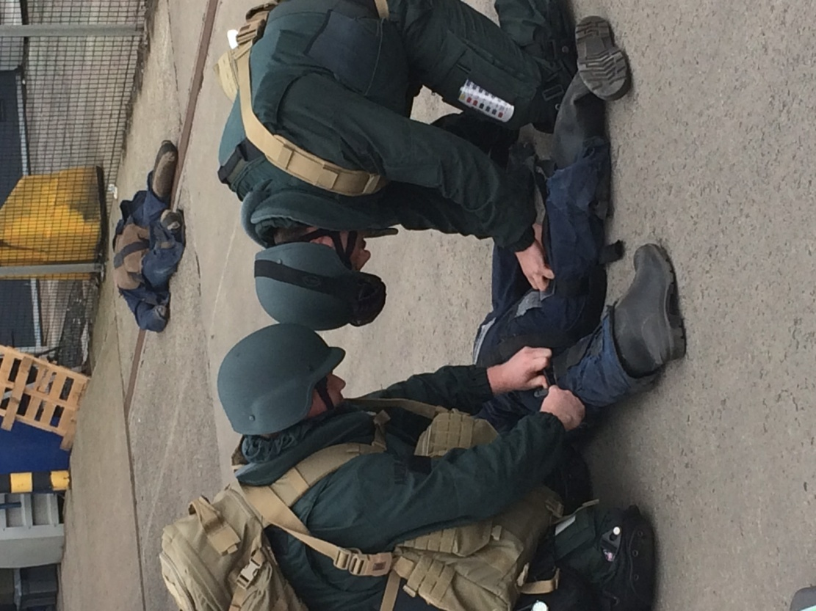

If you answer “No” to any of the statements, you need to consider seriously whether working for the Service and Specialist Operations is the right decision for you**.**

**SCOTTISH AMBULANCE SERVICE SELF ASSESSMENT FORM**

|  |  |  |
| --- | --- | --- |
|  | **Yes** | **No** |
| I can comply with all the physical restrictions and other eligibility criteria found in this information pack |  |  |
| I am willing and consider myself able to become a member of the Protecting Vulnerable Groups Scheme |  |  |
| **I am proficient in driving and I can attain the C1 driving category** |  |  |
| I recognise that, on occasion, I may be required to work from other locations |  |  |
| I recognise that it may be necessary for me to be away from home for extended periods in response to national incidents |  |  |
| I understand that I may have to work for extended periods throughout a protracted incident |  |  |
| I have the physical fitness to deal with the demands of the role – and will endeavour to maintain that level on an ongoing basis |  |  |
| I believe I have the mental fitness to deal with the demands of the role |  |  |
| I do not suffer any phobia or other conditions that would prevent me from carrying out the duties of this role as per the job and person specification |  |  |
| I do not suffer any phobia that would prevent me from working in the dark |  |  |
| I do not experience any difficulties that would prevent me from working in confined spaces |  |  |
| I do not suffer any phobia that would prevent me working at height |  |  |
| I would be prepared to have vaccinations and boosters if directed by/on advice from Occupational Health |  |  |
| I am prepared to undertake any training required that might take me away from home |  |  |
| I recognise the heightened risks associated with undertaking a Special Operations role |  |  |
| I am prepared to undertake the training programme, which may involve self study, outside of working hours in order to successfully qualify as a SORT Paramedic |  |  |
| I recognise that I will be interacting with people who are extremely distressed |  |  |
| I recognise that some of the circumstances I could experience will be highly unpleasant |  |  |
| I am a team player and can work with a range of people |  |  |
| I believe I can stay calm in a crisis |  |  |
| **I believe I can be respectful towards people in need and help them maintain their dignity** |  |  |

**INTERVIEW PREPARATION GUIDE**

To help you prepare for a potential interview, these are the types of questions you might get asked. You will need to be able to demonstrate actual examples to show that you understand the requirements of the role.

You will be scored depending upon the depth and relevance of your answer. These are the types of questions that you might get asked.

|  |
| --- |
| **Example Question 1 – Communication** |
| Tell us about a situation where your listening skills proved crucial to the outcome of a situation?  What happened? / What was the outcome? / Was it a successful outcome? |
| **Example Question 2 – Quality Improvement** |
| Tell us about a time when you discussed an idea you had with a line manager?  Why did you think this change was necessary? / What made you think that your way would be better? / Was it implemented? |
| **Example Question 3 – Equality and Diversity** |
| Tell me about a time when you found yourself on unfamiliar territory or a new situation at work?  How did you approach this situation? / How did it make you feel? / How did you cope with the situation? |
| **Example Question 4 – Care and Compassion** |
| We all find ourselves in stressful situations at work when keeping a positive or compassionate attitude is most useful. Tell me about a time when you were under extreme pressure and remained calm, compassionate and focused at work? |
| **Example Question 5 – Dignity and Respect** |
| Tell me/us about a situation when you had to speak up to get a crucial point across |
| **Example Question 6 – Quality and Teamwork** |
| Quality is not just one person’s job. Describe a time when you identified a potential quality concern and addressed it personally before it became an issue? |

**SPECIAL OPERATIONS TRAINING PROGRAMME**

**Foundation and Incident Response Unit Training**

The Special Operations Teams (SORT) comprises of specially recruited and trained Paramedics who provide the ambulance response to hazardous or challenging incidents which in some cases where there is a mass casualty incident.

These incidents may involve Chemical, Biological, Radiological or Nuclear (CBRN) or other hazardous materials, Teams can also attend incidents such as train crashes, large scale vehicle accidents; building collapses, significant fires, working in water and support to Police firearms operations

SORT teams work alongside the Police and Fire & Rescue Services within what is known as the ‘inner cordon’ or ‘hot zone’ at a major incident. The job of the SOR teams is to triage and treat casualties and to help save lives in very difficult circumstances. They are also there to look after other emergency personnel who may become injured whilst attending these difficult and challenging incidents.

The Foundation IRU course is designed to provide staff with the required knowledge, understanding and practical skills in order to perform SORT duties within an inner cordon.

**Course Objectives**

* Demonstrate an understanding of the background to SORT.
* Demonstrate an understanding of the threat from terrorism in the UK.
* Define the social and health protection impact of a SORT event.
* Define multi-agency organisations that would influence SORT deployment.
* Demonstrate an understanding of the roles and interactions with partner agencies.
* Demonstrate operational competency whilst wearing SORT PPE.
* Demonstrate competence in the deployment and use of SORT vehicles and equipment.
* Demonstrate competence in JRCALC procedures relevant to SORT deployments.
* Demonstrate understanding of SORT operational procedures.
* Demonstrate an understanding of command and control protocols.
* Demonstrate an understanding of incident log keeping.

**Course Assessment**

Ongoing assessment is conducted by a number of theory based question papers, presentations, formative and summative assessment of safe systems of working in non-permissive and semi permissive environments.

**Course Administration**

The course is 7 weeks in duration, on completion SORT Paramedics will declared ‘Fully Operational Competent’ within Inner Cordon working before being assigned to a operational duties. Further specialist training will be conducted in technical disciplines such as Swift Water Rescue, Safe Working at Heights and Urban Search and Rescue.

Course delivery is a mixture of discussions, presentations and immersive training activities based on the practical application of SORT SOPs focusing on patient triage, treatment and extrication.

Candidates will be expected to undergo practical assessments of their competency whilst wearing PPE (Breathing Apparatus, PRPS, CBRN QD PPE, Ballistic PPE etc). It is essential that candidates have a level of fitness to manage the physical demands involved in the course.  The minimum fitness requirements are those identified in the physical competency assessments (PCA) conducted during the recruitment and selection process.

This is a residential course delivered at number of Emergency Services and Ministry of Defence locations across Scotland.

**Robust Training**

The purpose of the Foundation IRU course is to deliver ‘Robust Training’ that progressively develops individuals’ mental and physical resilience in preparation for SORT operational duties. Training will be delivered safely with appropriate supervision to a defined standard and include calculated risk. To condition and immunise SORT personnel to the rigours of inner cordon working ‘Robust Training’ includes both Psychological and Physical pressures such as frequently changing priorities, incomplete or extra information, reduction in time for allocated tasks, dislocation of expectation, significantly increased responsibility, environmental factors – heat/cold/wet/darkness, exertion and tiredness.

**Post Course – Ongoing Training & Recertification**

Post Foundation Inner Cordon Working training includes the following elective training disciplines

* Swift water Rescue Technician in support of Inland Water Operations
* Safe Working at Heights in support of difficult patient access.
* Urban Search and Rescue in support of rescue activities associated with damaged or collapsed structures
* Ongoing PPE training and refreshers; Reflective practice; CPD.
* 3 Year statutory recertification requirements; Reflective practice; CPD