#### **JOB DESCRIPTION**

|  |
| --- |
| JOB IDENTIFICATION |
| Post Holder:  Job Title: Buyer  Responsible to (insert job title): Lead Buyer  Department(s): Procurement  Directorate: Finance  Operating Division: NHS Lothian  Job Reference L-FIN-PROC-B  No of Job Holders: 6  Last Update (insert date): December 2022 |

|  |
| --- |
| 2. JOB PURPOSE |
| To utilise the procurement journey and procurement tools across the commodity area to control spend and deliver best value.  By engaging on a day-to-day basis with stakeholders to understand their needs, operate within a customer focused approach to ensure queries, complaints, sourcing requests and product availability is communicated efficiently and effectively across the category area.  Have a working knowledge of the standing financial instructions and EU procurement regulations to provide procurement support to stakeholders to ensure governance of spend and minimise risk. |

|  |
| --- |
| **3. DIMENSIONS** |
| The role requires the post holder to liaise and work with staff at all levels and disciplines within NHS Lothian, other Health Boards and the Scottish Government.  Non-Pay spend influenced £331m  National BPI Expenditure influenced £1bn  Contracts 1038  Supplier Base 4500  Customer Base 3486 |

|  |
| --- |
| 4. ORGANISATIONAL POSITION |

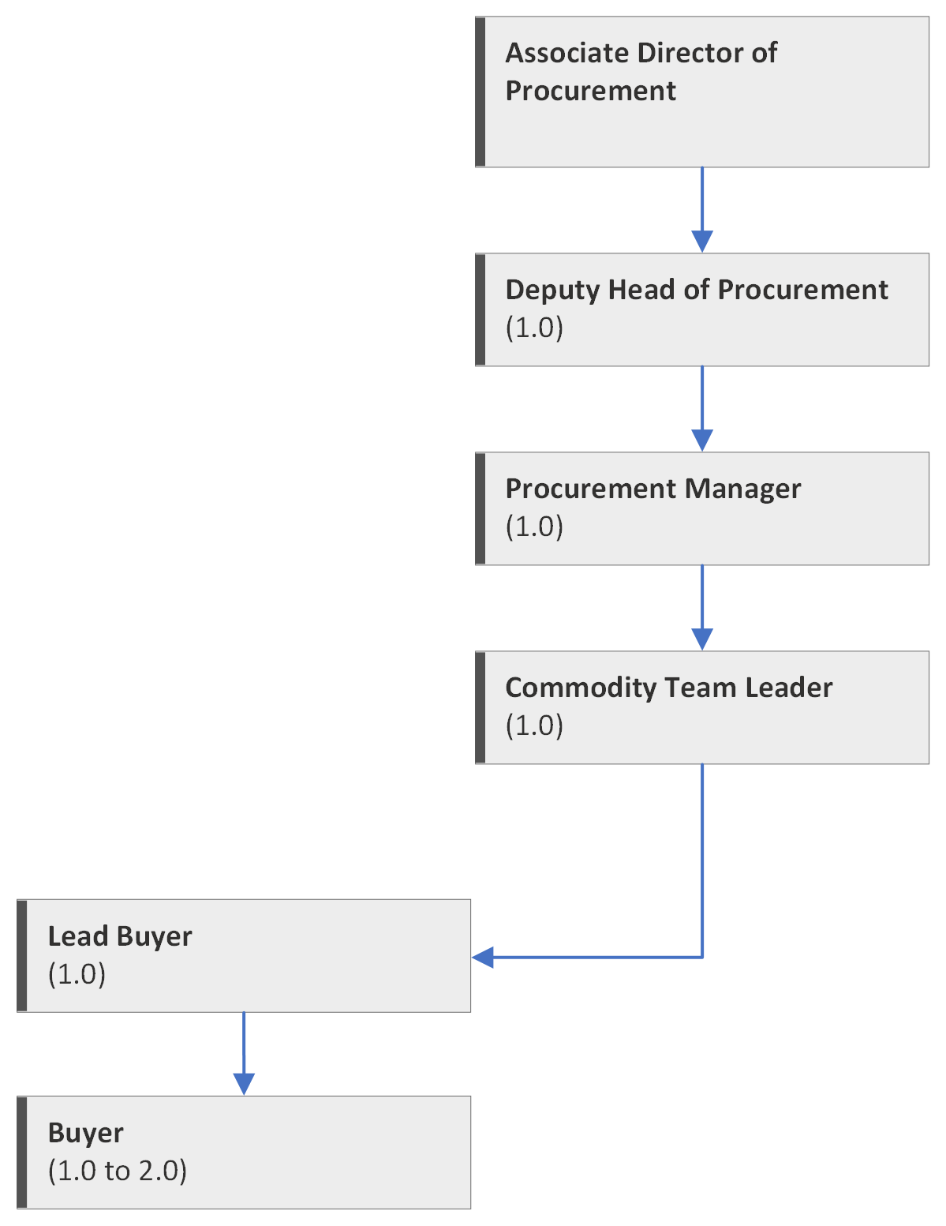

|  |
| --- |
| 5. ROLE OF DEPARTMENT |
| To support the objectives of NHS Lothian through the provision of leadership, technical expertise, project management and operational support providing professional best value procurement, contracting and supplies service in compliance with SFI’s, national and EU regulations and directives.  The department has a number of responsibilities:   * Developing and implementing NHS Lothian’s Procurement Strategy * Selecting and authorising suppliers within national and local policies * Advising, researching sourcing and assisting in the development of specifications and monitoring quality of all goods and services * Monitoring value for money to establish a system for monitoring and driving cost savings * Leading supply chain design, strategies and system implementation * Management of equipment capital and maintenance contracts * Participate in the development and implementation of national procurement strategies * Provide support and advice to the organisation in all relevant areas of Corporate Governance |

|  |
| --- |
| 6. KEY RESULT AREAS |
| * Utilise the procurement journey and procurement tools to deliver effective control of spend across the category. Work with the lead buyer to identify contracting opportunities through review of non-contract spend via supplier catalogues and support the development of the category work plan. * Update and review supplier catalogues via the PCM system, ensuring compliance to contract, identify price movements and highlight ordering efficiencies to ensure the best value supply chain route is utilised. * Challenge compliance to contract and governance of spend, liaising with stakeholders to minimise the use of non catalogue ordering and assist with the control of the supply base across the category. Where appropriate utilise quick quote to control the spend in line with the standing financial instructions. * Process non stock requests within agreed time limits and work to minimise processing of non stock requests by adding products to supplier catalogues, challenging request, routing demand via existing products and working with the team leader to develop improved ordering routes. Utilise the catalogue management approach to deliver control of spend, variety reduction, standardisation of product and reduction of stockholding. * Provide administrative support in order to identify, establish and implement sourcing strategies, quick quotes and supplier management across the category. Support the work of the Technical User Groups by issuing meeting invites, sample requests, issue of papers. * Have working knowledge of all appropriate Standing Financial Instructions (SFIs), Standing Orders, VAT legislation and EU Procurement Directives in relation to procurement issues. * Through day to day communication with key customers maintain a focused customer service function, responding efficiently to complaints and enquires regarding requests for product availability, product costing and sourcing information. Expedite orders and highlight delivery issues to the team leader. * To liaise with Accounts Payable department to ensure continuous improvement across the complete P2P process with particular emphasis on invoice mismatches. * Liaise with other team members on both an informal and formal basis to share ideas and suggest improvements to ways of working. * Support the process of Safety Alerts and Consumer Advisory Notices, completing data requests accurately and effectively to ensure the safety alert team are provided with the required information. * Support a comprehensive contract register, covering local, regional and national contracts within the category, quick quotes and tender waivers to ensure spend via these routes are maximised. * Provide data as requested in agreed formats to feed into the dashboard reporting tools, KPI reporting and balanced scorecard to highlight to stakeholders demand, utilisation of supplies, savings and the delivery of best value contracting * Working with the lead buyer liaise with the systems team, accounts payable and supply chain to ensure continuous improvement across the complete P2P process with particular emphasis on invoice mismatches, receipting and catalogue accuracy. * Working across the team participate in open and frequent communications and work to develop knowledge and skills of the wider procurement process. |

|  |
| --- |
| 7a. EQUIPMENT AND MACHINERY |
| The post holder will be required to use a desktop and/or lap top computer in locations around NHS Lothian. Will be expected to use and be conversant with network systems and all technology in day-to-day use in the office environment and all external web based applications relevant to delivery of the provisions identified above.  Multi Functional Device |

|  |
| --- |
| **7b. SYSTEMS** |
| Knowledge of all relevant computer systems including eFins, PECOS, Spikes Cavell Business Objects, Email, Intranet, MS Word and MS Excel is essential to performance of duties. |

|  |
| --- |
| 8. ASSIGNMENT AND REVIEW OF WORK |
| * The post holder will, to a degree, be self-directing and motivated with an ability to work within established procedures and supervision is available. * Formal appraisal will be undertaken annually and in line with the performance appraisal schedule. Individual managers will undertake more frequent, informal reviews of progress on current developments and issues to ensure corporate objectives are being met. |

|  |
| --- |
| **9. DECISIONS AND JUDGEMENTS** |
| * Work is assigned by wards, departments, suppliers, e-Procurement, Finance Management and Supplies Management. * Prioritise workload as required. * Communicate/negotiate with suppliers and customers to resolve complaints or other associated problems. * Work on own initiative but refer to Lead Buyer as required. |

|  |
| --- |
| 10. MOST CHALLENGING / DIFFICULT PARTS OF THE JOB |
| * Ensuring all customers receive the agreed level of service while following procurement guidelines and regulations. * Ensuring strict deadlines and timescales for projects are met. * Prioritisation of tasks at peak periods. |

|  |
| --- |
| **11. COMMUNICATIONS AND RELATIONSHIPS** |
| * Work closely with other Procurement staff members, ward/department staff, Finance Department staff, etc., to ensure procurement objectives are met through meetings, by letter, email, telephone, video conferencing etc. * Communicate with Procurement Lead Buyers and Team Leaders re deadline requirements and workload prioritisation. * Demonstrate tact, diplomacy and a high level of knowledge when dealing with demanding customers or situations, e.g., supplier problems, etc. * Regular meetings with Lead Buyer re procurement matters. * Liaise on a day to day basis with suppliers and/or representatives, respond to enquiries and gather information. |

|  |
| --- |
| **12. PHYSICAL, MENTAL, EMOTIONAL AND ENVIRONMENTAL DEMANDS OF THE JOB** |
| * Physical Effort * Keyboard duties ongoing throughout the day, typing data, sending and responding to electronic messages and making and answering telephone calls. This can be for up to 6 hours per day with breaks. * Light physical effort involved in occasional loads handling, e.g., packages of paper, files, etc. * Mental Effort * Management of a wide variety of tasks from various sources, meet deadlines on a wide range of issues, e.g., management of workload, staffing issues, Key Performance Indicator returns, answering queries face to face or by telephone from both internal and external sources. * Concentration to deal with supplier and customer queries and complaints etc. * Emotional Effort * Tact and diplomacy required in handling different people and demands on a daily basis. * Working Conditions * Normal office conditions. * Continuous use of VDU. |

|  |
| --- |
| 13. KNOWLEDGE, TRAINING AND EXPERIENCE REQUIRED TO DO THE JOB |
| * Post holder should have sufficient relevant experience preferably in a large complex organisation. * Show initiative and excellent personal, written and verbal communication skills and be computer literate. * Excellent organisational skills and attention to detail. * Knowledge of computerised systems. * Reliable Team Player. |

|  |  |
| --- | --- |
| **14. JOB DESCRIPTION AGREEMENT** | |
| A separate job description will need to be signed off by each jobholder to whom the job description applies.  Job Holder’s Signature:  Head of Department Signature: | Date:  Date: |