

JOB DESCRIPTION

1. JOB IDENTIFICATION
Job Title: Specialist Clinical Pharmacist

Responsible to (insert job title): REAS Lead Pharmacist

Department(s): Child and Adolescent Mental Health Services (CAMHS)

Directorate: Child and Adolescent Mental Health Services (CAMHS)

Operating Division: REAS

Job Reference: 157651

No of Job Holders: 4.0

Last Update (insert date): May 2022

2. JOB PURPOSE
To provide specialist pharmaceutical service within individual CAMHS Multidisciplinary Teams to ensure safe, appropriate and cost effective use of medicines in line with local and national guidelines.

To support and facilitate the delivery of strategic and operational prescribing priorities within CAMHS.

To provide education, advice and support to the CAMHS multidisciplinary team on medicine related issues.

To provide advice for patients and/or carers regarding medicine related issues and health promotional material so that patients are treated holistically.

3. DIMENSIONS
NHS Lothian provides services for the second largest residential population in Scotland – circa 800,000 people.

NHS Lothian CAMHS provides specialist assessment/intervention as part of a tiered system, which can include consultation and advice prior to referral, and assessment appointment to establish clinical need and delivery of mental health treatment.

The clinical pharmacist is designated to provide prescribing support in specified CAMHS Teams and will primarily be based within locality level(s) across one of the five CAMHS Tier 3 Outpatient Locality Teams with job planned time to provide named professional pharmacy support Tier 4 and Specialist Teams.

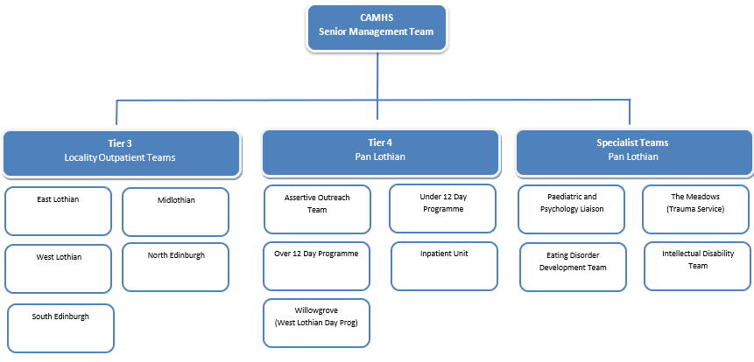

The postholder will routinely deal with pharmaceutical care issues and queries from other members of the CAMHS multidisciplinary team and will routinely interact with consultant psychiatrists, nurses, administrative staff, community pharmacists and general practitioners.

Staffing
There are no direct line reports for the postholder, thought the postholder may be identified to provide professional supervision to less experienced pharmacists as well as supporting non-medical prescribers in training.

Budget
There is no delegated budget. The postholder will provide advice on medicines utilisation and expenditure within CAMHS and will influence and contribute to the management of the CAMHS prescribing budget (circa £300, 000 per annum).

The postholder is employed within NHS Lothian and there may be a requirement to work flexibly across Lothian to meet service demands.

4. ORGANISATIONAL POSITION
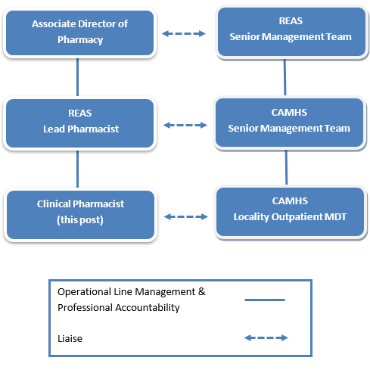

5. ROLE OF DEPARTMENT

Lothian CAMHS provides a Tiered service approach and a comprehensive range of community outpatient, day patient, in-patient and specialist mental health services for young people and their families up to the age of 18 years.

NHS Lothian CAMHS outpatient services are organised into 5 multi-disciplinary locality teams strategically managed by the CAMHS Senior Management Team.

The role of the locality CAMHS multidisciplinary teams are to

deliver assessment and mental health treatment to children and young people in the locality.
work in partnership with the locality local authority and other children’s services to support child and young person mental wellbeing.
support health and social care practitioners with training resources, practice placement and continuing professional development.

The Tier 4 Intensive Treatment and Day Programme services support outpatient teams to reduce the need for admission or to support the admission process and reduce the length of stay where possible.

The Inpatient unit is a regional unit and there is a consortium arrangement between Lothian, Borders and Fife in regard to admission to CAMHS Inpatient unit.

The CAMHS department also provides an important training resource and placement for CAMHS career development across all professional disciplines. In addition, the department has an ongoing commitment to research and has a fully equipped research base.

6. KEY RESULT AREAS
- To support NHS Lothian’s values of quality, teamwork, care and compassion, dignity and respect, and openness, honesty and responsibility through the application of appropriate behaviours and attitudes.

Provision of Pharmaceutical Advice and Care to Patients
- Responding to medication and medication review requests from patients, community pharmacies and other healthcare professionals, assessing appropriateness in light of medical history, current medication, relevant monitoring and generating prescriptions where appropriate.

- To contribute to decision making in individual patients’ care by discussion of therapy with the prescriber and provision of advice on appropriate selection of medication to ensure that treatments are evidence based.

- As part of the medication review process, changes will be documented in patients’ electronic notes and patient’s blood results will be monitored to ensure that medicines are prescribed at the most appropriate dose in order to minimise adverse side effects.

- Ongoing relevant monitoring will also be documented and carried out by the pharmacist or by another healthcare professional as part of the follow up from medication review e.g. weight, height, blood pressure, bloods and urinalysis.

- Facilitate communication and liaise across a patient’s pharmaceutical care pathway e.g. across primary care, secondary care and social care.

- Assess the pharmaceutical care needs of individual patients (urgent and non-urgent) and contribute to, implement and monitor medicine related decisions for individual patients as part of the multidisciplinary team.

- To provide clinical pharmacy advice to medical and nursing staff on the most appropriate selection of medication to ensure that treatments are evidence based, cost-effective, rational and safe.

- To provide counselling and advice on medicines to patients and carers (verbal and written) to help patients use their medication to obtain greatest benefit. This is particularly important if they are young, confused or distressed, if their medication regime is complex or if they have multiple disease pathologies.

Pharmacist Independent or Supplementary Prescriber
- As an independent or supplementary prescriber initiate and assess an episode of patient contact independently including assessment, determining prescription and dosage (diagnosis may already be known) and treatment, acting at all times within the limits of the individual’s confidence and competence and refer to other appropriate professionals whenever the scope of an episode patient care exceeds the individual’s level of competence.

Provision of Specialist Pharmaceutical Education, Training and Audit
- Utilising prescribing information to prepare, publish and deliver advice and training to doctors, nurses and the wider multidisciplinary team responsible for the care of patients.

- Identifying, planning, implementing and evaluating cost saving and quality strategies at practice level to directly impact prescribing budget and other performance and prescribing indicators and to evaluate the impact of these.

- Provide training and ongoing support for post-graduate pharmacists, student pharmacists other non-medical prescribers.

- Contribute to the development and delivery of clinical education and training sessions for the wider CAMHS team.

- In collaboration with CAMHS colleagues, plan, develop, organise and undertake complex uni- and multi-professional quality and cost-effective clinical audits to monitor the quality of medicines prescribed, ensuring recommendations are discussed and actioned.

Service Development

- To provide information, on request to the CAMHS Senior Management Team and REAS Lead Pharmacist to assist in business planning, service development and budget setting exercises.

7a. EQUIPMENT AND MACHINERY
The postholder will be expected to be responsible and knowledgeable in the safe use of all clinical and non-clinical equipment used within the area ensuring this is checked and maintained and where problem are identified these resolved so that all equipment is fit for purpose.

The following are examples of equipment which will be used when undertaking the role:

This list is not exhaustive:

Mobile phones
PC and laptop
Scales
BP machine

Note: New equipment may be introduced as the organisation and technology develops, however training will be provided.

7b. SYSTEMS
The following are examples of systems which will be used when undertaking the role:

Microsoft Outlook, Word, Excel and PowerPoint – for communication, reports, data analysis, presentations.
PRISMS (Prescribing Information System for Scotland) which is a complex web-based database of prescribing information is regularly used for analysing prescribing data from ISD.
NHS Lothian internet and intranet - for accessing relevant medical and pharmaceutical information, including local and national guidelines and for access to e-library.
TRAK for medicines management and updating patient records
DATIX for recording adverse events.
SCIStore - laboratory results system
The post-holder must also maintain their own Personal Development Plan, Training Record, Continuing Professional Development.
Records of the work carried out are maintained and information provided to the CAMHS Senior Management Team and REAS Lead Pharmacist.

Note: New systems may be introduced as the organisation and technology develops, however training will be provided.

8. ASSIGNMENT AND REVIEW OF WORK
The post holder works autonomously as part of the wider CAMHS Multidisciplinary Team, within established operational, strategic and policy guidelines.

Problems or enquiries of a wide-ranging nature, which arise on a daily basis are addressed and resolved or answered without the need for supervision or managerial input. Advice can be sought from the REAS Lead Pharmacist, other Clinical Pharmacists, or from other specialist sources, for more highly complex queries.

The post-holder’s workload is predominantly self-directed within the bounds of the agreed work plan. The post holder will work independently within this structure.

Annual objectives will be agreed jointly with the REAS Lead Pharmacist as part of the performance management process.

The post-holder is subject to regular performance appraisal.

Formal clinical peer-review is undertaken with other clinical pharmacists on a 6-monthly basis.

9. DECISIONS AND JUDGEMENTS
The post-holder is an independent professional who is accountable for their professional and clinical decisions. All pharmacists must work within the Code of Ethics and Standards from the General Pharmaceutical Council.

The pharmacist has a high degree of autonomy and independent working regarding prescribing advice and clinical judgments that are made on an individual patient basis to routine CAMHS multidisciplinary team enquiries. The pharmacist is accountable for recommendations made and information provided.

The pharmacist will have to explain the evidence base for any medicine information provided and justify and reply to opinions where the advice differs or where is a lack of published evidence.

10. MOST CHALLENGING/DIFFICULT PARTS OF THE JOB
The post requires frequent period of prolonged concentration for 3-4 hours at a time for issuing acute prescriptions, interpreting prescribing data and for service development. The post holder is required to respond to queries from a variety of sources in a timely fashion. They may be interrupted by urgent requests for advice, interrupting planned workload.

The post holder must:

Take responsibility and be accountable for independent clinical decisions and being able to justify the decisions made.

Be able to explain the benefits, limitations and cost-effective use of medicines and treatment for patients with multiple morbidities and complex medicine regimens, to patients and carers with the ability to reach agreement the best outcome for the patient.

Ensure that the most cost-effective prescribing choices are made within the prescribing budget resource available.

Be able to respond to rapidly changing evidence base which requires constant mental effort to remain up to date with current practice.

11. COMMUNICATIONS AND RELATIONSHIPS
The postholder will have well developed communication and influencing skills as part of their contact with a wide range of individuals including; patients, doctors, nurses, AHPs, pharmacists from across primary and secondary care, admin staff, community pharmacists, social work and the pharmaceutical industry.
The pharmacist as a member of the wider REAS Clinical Pharmacy team and will represent the profession on designated working groups and committees across both primary and secondary care as requested by the REAS Lead Pharmacist, in order to provide safe and cost effective advice relating to the use of medicines.
Communication with secondary care colleagues and community pharmacy colleagues to facilitate continuation of seamless appropriate treatment after discharge or as part of a process to any resolve prescribing and pharmaceutical care issues.
Communication with patients and carers to explain detailed information about medicines and for underlying illness. The pharmacist must provide advice in a professional and empathetic manner and assess patient/carer perception and understanding in order to provide motivation and reassurance regarding any changes in treatment.
Excellent communication, negotiation and influencing skills are required to discuss medicines use primarily with patients, carers and healthcare professionals.
The pharmacist must have the ability to resolve differences of opinion relating to medicines use with other clinicians to a mutual satisfaction or compromise.

12. PHYSICAL, MENTAL, EMOTIONAL AND ENVIRONMENTAL DEMANDS OF THE JOB
Physical
Standard keyboard skills.
Light physical effort when undertaking pharmacy duties, including:
Working in restricted position (using PC at desk).
Carrying lap-top, projector and clinical equipment.
Moving folders and work around to different places.

Mental
Accuracy in writing reports to range of senior personnel both clinical and non clinical. These include CAMHS senior management team, CAMHS clinicians and GPs regarding complex prescribing issues and queries.
Clinical work requires a high level of concentration, characterised by assessment of information, sometimes conflicting, from a variety of sources and forming a clinical opinion. Such work is often
conducted under time pressure and subject to frequent interruptions.
Critical appraisal and analysing skills are required, including the management of conflicting opinions and evidence (e.g. choice and clinical use of drugs).

Emotional
Provides advice and guidance to patients on medication regimens that require explanation and reassurance.
Frequent contact with patients and relative which can be emotionally demanding.
The post holder is required to integrate and work as a team member in the CAMHS teams; this can involve handling sensitive information and difficult discussions with other healthcare staff with tact and diplomacy.
Investigate and deal with medication incidents that may have had serious consequences.
Deal with complaints in relation to the pharmacy service.

Environmental
Potential exposure to episodes of verbal and physical aggression from patients/relatives/carers.

13. KNOWLEDGE, TRAINING AND EXPERIENCE REQUIRED TO DO THE JOB
Qualifications and Knowledge

Masters degree in pharmacy or equivalent.
Annotated as an independent prescriber on the General Pharmaceutical Council register Member of the GPhC (General Pharmaceutical Council).
Relevant post-registration Primary Care, community or hospital pharmacy experience.
Completion of the NES Post - Registration Pharmacist Foundation Programme or documented evidence of equivalent competency.
Sound clinical and therapeutics knowledge.
Evidence of Continuing Professional Development (CPD)/PDP.

Skills and Experience

Excellent communication skills (verbal and written).
Excellent influencing and negotiation skills.
Knowledge of clinical governance and the implications this has on daily practice.
Understanding and use of critical appraisal skills.
Effective time management skills.
Proficient level of IT competency in Microsoft Office, Word and Excel etc.
Good problem-solving skills.
Ability to plan, deliver and report audit and research projects.
Experience of planning delivering and assessing teaching.

14. JOB DESCRIPTION AGREEMENT
A separate job description will need to be signed off by each job holder to whom the job description applies.  Job Holder’s Signature:  Head of Department Signature: | Date:  Date:

