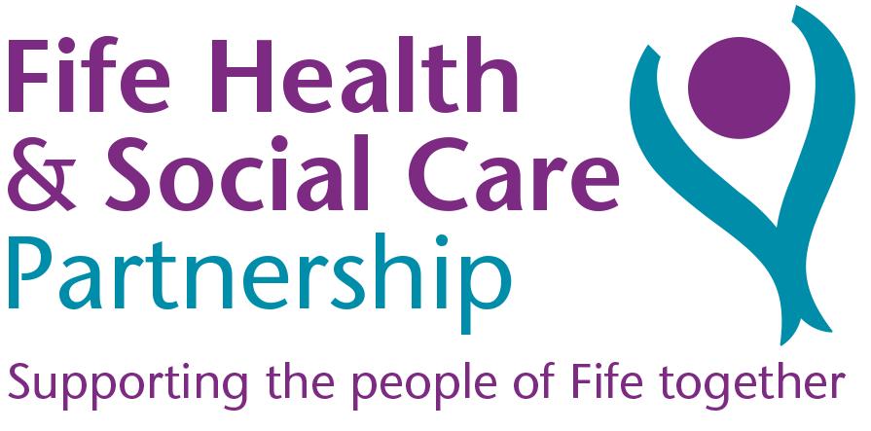
JOB DESCRIPTION

JOB IDENTIFICATION
Job Title: Staff Nurse

Responsible to: Nurse Team Leader

Department Child Development Centres

Directorate: Children and Young Peoples Community Nursing Service

Operating Division: Preventative and Primary Care

Job Reference: SN/CDC

No of Job Holders: 4

Last Update: 19/11/21

2. JOB PURPOSE
- To support the CDC Team Leader in managing a diverse caseload of children under 3 years with developmental and complex health needs in the community.
- To support the child's nursing, social, educational and emotional needs, and work with parents to deliver a plan of support to promote their child’s optimum development.
- To liaise closely with the multi-agency team to coordinate assessments and individual support plans.
- To work across different sites in the service and provide care and support in homes and the community.

3. DIMENSIONS
- Based within a Child Development Centre for pre-school children with additional support needs and their families, you will be a member of a multi-disciplinary team.
- You will support the Team Leader and the wider team in delivering individual support plans for children on the CDC caseload in the centres or the community.
- You will act as a mentor for student nurses and participate in the teaching of all learners in accordance with their objectives.

- You will facilitate less experienced and/or more junior staff to develop their professional skills, and perform as key worker to a group of children.

4. ORGANISATIONAL POSITION
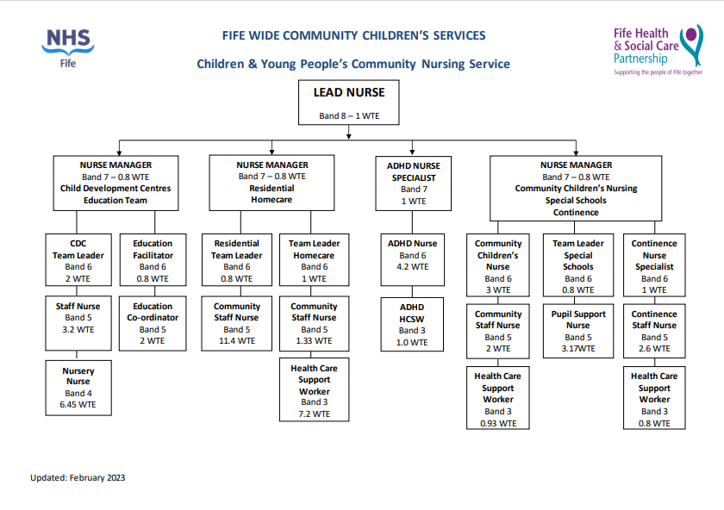

5. ROLE OF DEPARTMENT
- To provide a safe, supportive environment for pre-school children with additional support needs.
- To support and empower parents to be an advocate for their child and help them to reach their optimum health and development.
- Carry out assessments and deliver support and specific strategies to enable the family to support their child’s developmental goals.
- Offer support for children with a high complexity of needs and work closely with other services to coordinate care.
- To provide a learning environment for Student Nurses, other learners and volunteers.

6. KEY RESULT AREAS

Fulfil the role of key worker for allocated children and their families, and to manage a caseload under the direction of the Team Leader.

- Recognise and record the significance of the observations that contribute to the ongoing assessment, planning, implementation and evaluation of the care the child is receiving.

- Work within and support the work of staff within the team in accordance with:

-NMC Code of Conduct
-Local and National Guidance
-Infection Control Policy

- Deliver nursing care procedures as required in line with local and national guidance and ensure competencies are maintained.
- Work within the Scottish Governments GIRFEC framework.
- Communicate information effectively and maintain clear and concise documentation.
- Review and evaluate the efficiency of policies and report to the relevant line manager matters affecting best practice and clinical governance issues.
- Maintain own professional development and training in accordance with professional requirements and Turas appraisal.
- Act as a mentor to students and contribute to an effective learning environment.
- Support the induction of new staff.
- Support clinical governance measures and participate in engagement and audit processes.
- Administration of medicines as prescribed in line with SSUMP.
- Promote effective Risk Assessments and Risk Management and work within Health and
Safety legislation.

7a. EQUIPMENT AND MACHINERY
- Safe use and working knowledge of all the equipment being used within a children and young people’s community setting.
- To be responsible for the safe use of client related equipment.
- To teach parents and families in the use of specific pieces of equipment in the home in accordance with approved guidelines and manufacturing instructions.
- Laptop / computer use in line with DSE regulations.
- Use of height adjustable trolley, tables, and weighing scales, hoists and moving and handling equipment.

7b. SYSTEMS
- Recording personally generated observations in child’s nursing records.
- Liaising with multi-disciplinary/agency teams & parents to compile agreed shared information, assessments and care plans.
- Communication with parents & professionals in person and by letter writing, telephone and e-mail, MS Teams and Near Me.
- Assist in meeting the nursing needs of the children and their families in the centres, home or other community setting.
- Develop and implement therapeutic programmes for each child in consultation with other disciplines and agencies.
- Use a range of development assessments with the children
- To promote and develop effective team working and parent participation in the coordination of care given.

8. ASSIGNMENT AND REVIEW OF WORK
- The post holder will work autonomously within the CDC team under the direction of Team Leaders and is accountable for their own professional actions.
- The standard and quality of work is reviewed through own professional codes of conduct and Division Policies.
- Personal and professional development is undertaken annually through objective setting and PDP process.
- Work is assigned by the Team Leader but is generated by the family and child’s needs on a day-to-day basis.
- Personal & professional development is undertaken through objective setting and annual Turas appraisal by Team Leader.
- To attend courses, seminars and conferences to meet the requirements of professional registration and ongoing development and learning..

9. DECISIONS AND JUDGEMENTS
- Take the lead in addressing situations that may be detrimental to the child’s health
and wellbeing.
- Advise on the promotion of health and prevention of accidents and illness.
- Prioritising care & nursing needs of each child and implementing these as effectively
as possible on a day-to-day basis.
- Report all accidents/incidents to your line manager, completing the relevant forms.
- To depute for Team Leader in their absence.

10. MOST CHALLENGING/DIFFICULT PARTS OF THE JOB
- Working with children who display challenging behaviour.
- Being a key worker for allocated children and providing support, information and counselling to parents can demand a lot of time and be mentally and physically exhausting.
- Recognition of parameters in an uncertain and changing role
- Unpredictability of children and behaviour.

11. COMMUNICATIONS AND RELATIONSHIPS
- To utilise strategies to communicate effectively with children with complex needs and learning difficulties at their level of understanding and support their parents in methods of communication.
- To develop and maintain good working relationship with parents/carers and other family members.
- Facilitate good communication and team working in the CDC service.

- To communicate effectively within the multi-disciplinary/agency team, demonstrating a high level of interpersonal skills.
- Communicate to Team Leader regarding service improvement and areas for development.
- Daily communication within the core team.
- Communicate with external agencies Social Work and Education and third sector organisations.

12. PHYSICAL, MENTAL, EMOTIONAL AND ENVIRONMENTAL DEMANDS OF THE JOB
Physical
- A combination of standing, walking and kneeling for several periods per shift. Examples being wound dressings, changing medical devices, and floor play activities.
- Moving and handling spending time on the floor, on low stools, and handling children of varying weights.
- Use and handling of equipment and supplies where required.

Mental
- Concentration on assessments with children and families, observations, meetings and Multi-disciplinary communication.
- Planning workload and activities within geographical area.
- Teaching student Nurses and other learners.
- Problem solving within the CDC team and deputising for the Team Leader as required.
- Concentration on clinical procedures.
- Updating nursing documentation and writing up assessments, support plans and reports.

Emotional
- Communicating with and supporting children / young people and their families who are distressed/anxious/worried.
- Dealing with complex family situations, such as parental learning disability/ mental health issues and social difficulties and wellbeing and child protection concerns.
- Potential exposure to verbal aggression due to client group.

Environmental
- Exposure to body fluids PPE and cleaning materials.
- Lone working in the community.
- Demands and intensity of working with children requiring a high degree of medical and nursing needs.
- Unpredictable environments and situations – home visits.
- Requirement to travel in the community and across different sites in the CDC service.

13. KNOWLEDGE, TRAINING AND EXPERIENCE REQUIRED TO DO THE JOB
- Registered Nurse (RN) Child Branch / Learning Disability or Registered Sick Children’s Nurse (RSCN)
- Evidence of acute or community post registration experience.
- Excellent communication and interpersonal skills.
- Ability to work on own initiative and prioritise own workload
- Time management skills.

- IT skills
- NMC Registration: - RSCN, RNC, RGN, RNLD
- Consolidation period in a clinical/childcare setting following registration.
- Knowledge of child development with a keen interest in learning disabilities and behavioural management.
- Awareness of current issues in health care children’s nursing and evidence of continuing professional development.
- Ability to work within a multi-disciplinary/agency team and be flexible and support change management and service improvement.

14. JOB DESCRIPTION AGREEMENT
A separate job description will need to be signed off by each jobholder to whom the job description applies.  Job Holder’s Signature:  Head of Department Signature: | Date:  Date:

