

**NHS Lothian CAMHS Willowgrove over 12’s day service**

**Located in a community setting in Livingston, West Lothian.**

An exciting opportunity is available for a band 5 registered nurse and a band 3 clinical support worker to join CAMHS Willowgrove over 12’s day service which is based in a community setting in Livingston. This team is dedicated to delivering a specialist mental health day service to young people from 12 to 18 years old. CAMHS Willowgrove day service operates a bespoke service within our day service building but also on an outreach basis and therefore a full drivers licence is essential to the role.

The service provides intensive assessment, formulation and intervention to children, young people and their families and is open Monday to Friday.

NHS Lothian offer the opportunity to work with talented teams within multidisciplinary environments and impact positively on the lives of thousands of patients and their families.

Find out what our staff say about working in NHS Lothian at https://careers.nhslothian.scot/acute-specialist-nurses/who-we-are/

**Band 5 – 14.5 hours**

**Band 3 – 29.5 hours**

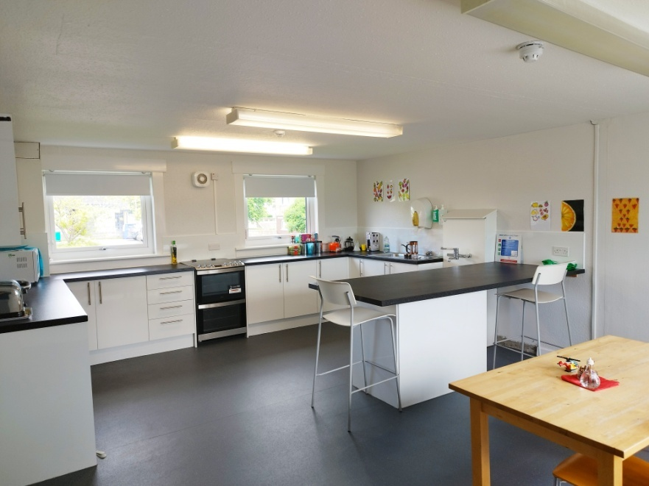

**What We Can Offer You**

We have a vacancy for a for experienced or newly qualified nurse (band 5) and a clinical support worker (band 3) to join our innovative and dynamic teams – providing you with the opportunity to gain a breadth of knowledge and exposure to children and adolescent mental health.

**Roles**

* Providing intensive support to children and young people and their families in order to reduce the need for admission to inpatient services.
* Work alongside the multidisciplinary team to ensure that patient care needs are met.
* Assessment and formulation of patient difficulties which is then used to make informed decisions about ongoing care pathways.
* Ensuring that robust risk assessments are completed and up to date.
* Carrying out home visits to further inform assessment and to help those young people who might struggle to engage.
* Supporting junior members of staff and students to provide safe and holistic care for the patient group.
* Take on a small caseload of patients both within day service and on an outreach basis.
* Working in conjunction with social work and other agencies to support patients and their carers.
* Provide evidence-based therapeutic interventions to patients experiencing moderate to severe mental health difficulties.
* To participate in audit systems to monitor the delivery and standards of care given to patients and their families.
* To maintain effective written and verbal communications with patients, relatives and other members of the multidisciplinary team to ensure patient needs are met and appropriate information is shared and documented.
* To develop within the post by expanding knowledge and skills to ensure continuous professional development and the delivery of evidence-based practice.

**Salary**

* Band 3 Range £25,468 – £27,486 (pro rata) per annum
* Band 5 Range £30,229 – £37,664 (pro rata) per annum

**Benefits**

* A minimum of five weeks annual leave increasing with length of service
* A range of supportive employment policies including Flexible Working
* Full or part time hours considered
* We provide an extensive induction programme and excellent professional training and development opportunities.
* Access to the NHS Pension Scheme and Staff Benefits

  