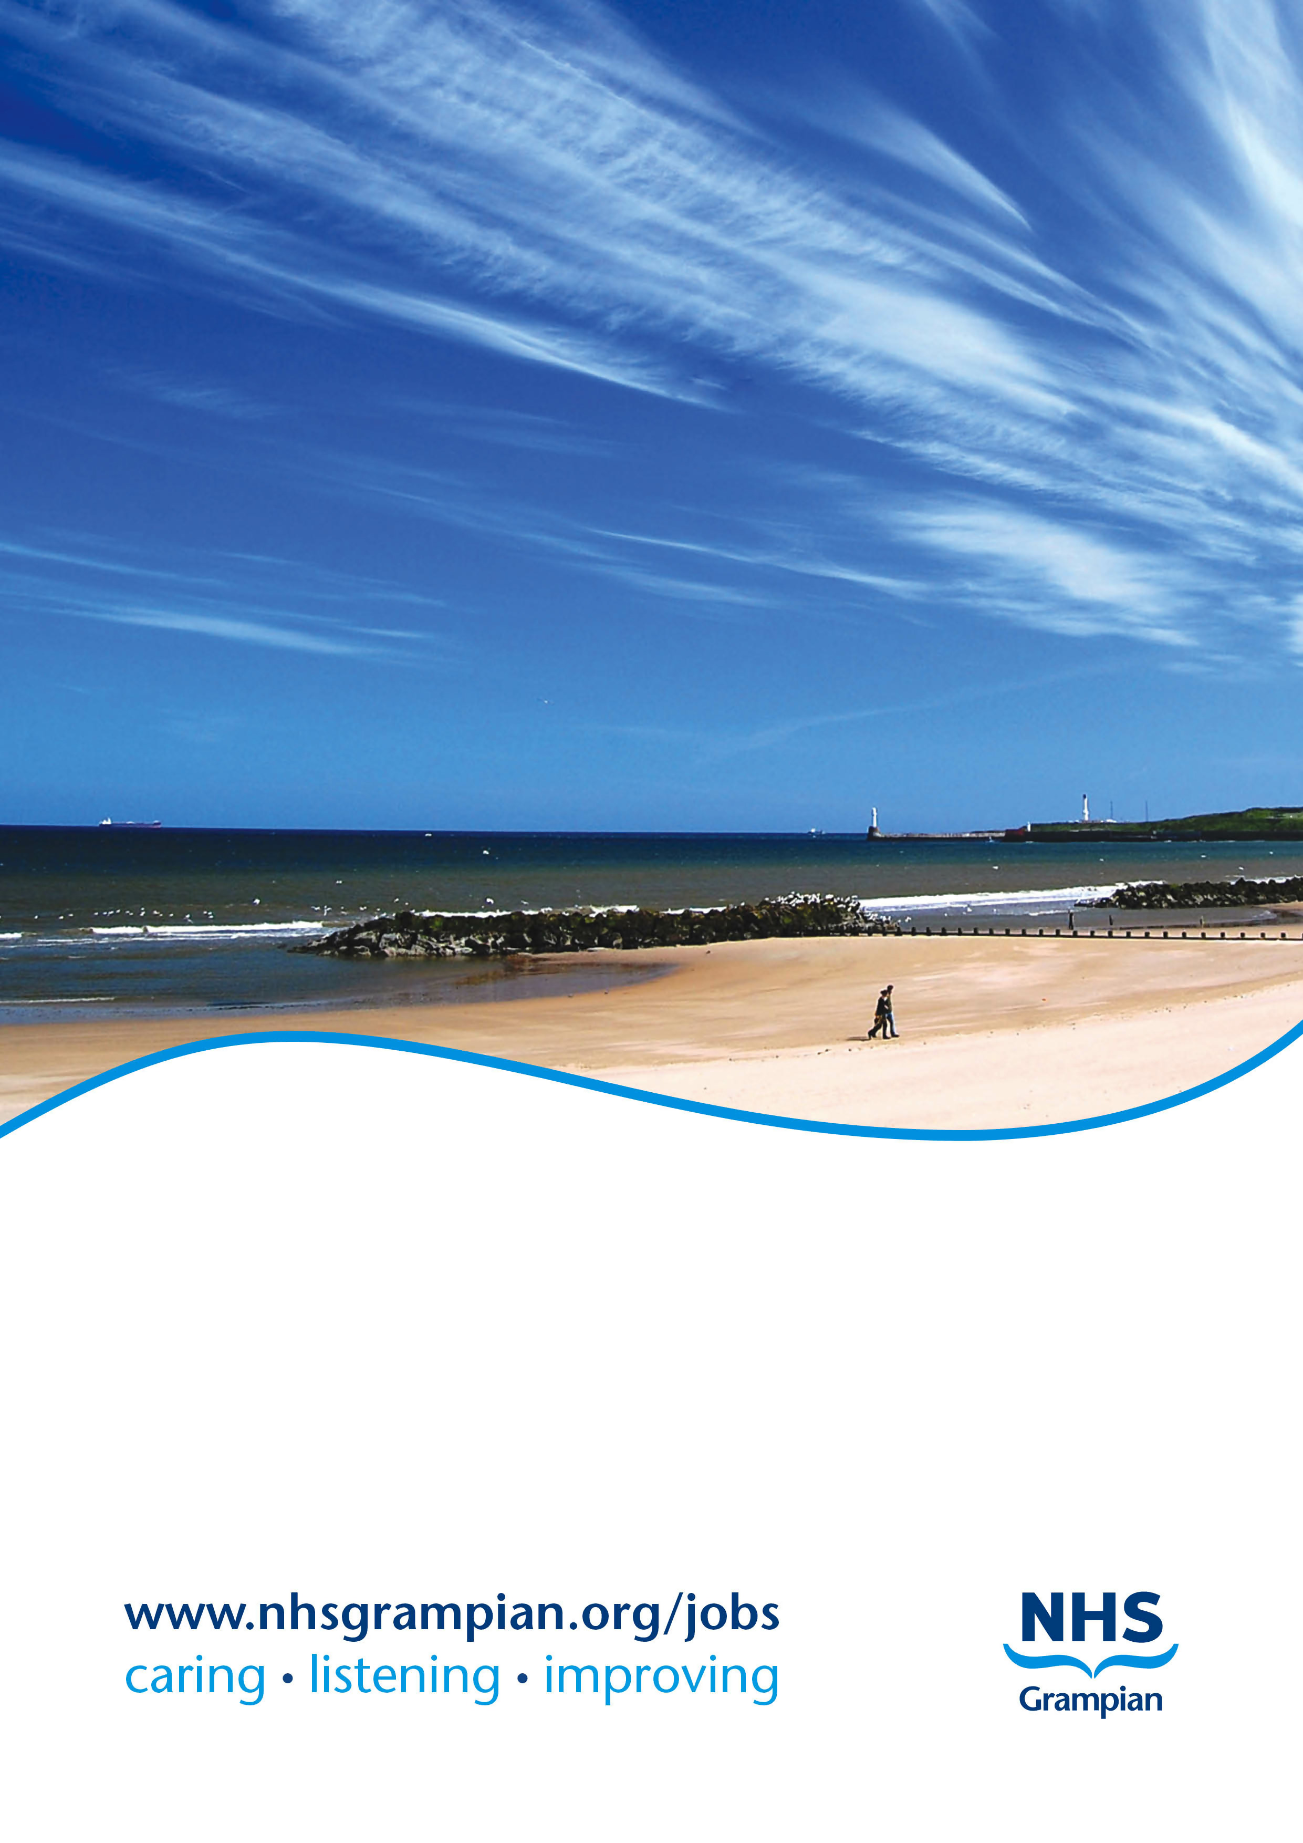

**Job Title: Locum Consultant Paediatric Anaesthetist**

**Location: Royal Aberdeen Children’s Hospital**

**Ref No: CI03083**

**Closing Date: Sunday, 18 August 2019**

**NHS GRAMPIAN**

**LOCUM CONSULTANT PAEDIATRIC ANAESTHETIST**

**ROYAL ABERDEEN CHILDREN’S HOSPITAL**

**REF: CI03083**

***NHS GRAMPIAN*** *www.nhsgrampian.org*

NHS Grampian Acute Sector comprises, Aberdeen Royal Infirmary (ARI), Royal Aberdeen Children’s Hospital (RACH), Aberdeen Maternity Hospital (AMH), Woodend Hospital, Cornhill Hospital, and Roxburghe House, and Dr Gray’s Hospital, Elgin

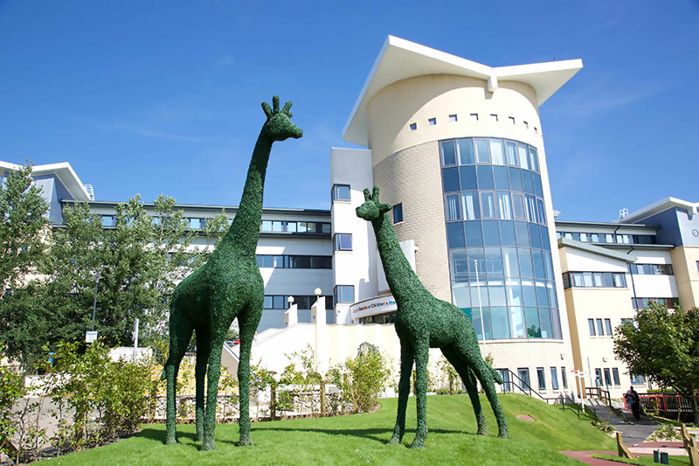

***ROYAL ABERDEEN CHILDREN'S HOSPITAL***

Royal Aberdeen Children’s Hospital (RACH) is an 85-bed facility that provides high quality, acute and comprehensive care for children up to the age of 16 years from the Grampian region in the north-east of Scotland, and from the Orkney and Shetland Islands. Additional clinical networks enable children from other parts of Scotland to receive their specialist care at RACH. The theatre caseload at RACH equates to over 5000 cases per year and includes approximately 40 neonates per year.

Built in 2004, RACH has been carefully designed with the children’s operating theatres located in close proximity to the Day Case Unit, Medical and Surgical Wards, High Dependency Unit and Emergency Department. There are three spacious operating theatres, one of which is retained for unscheduled work. A dedicated dental theatre is co-located within the children’s theatre suite.

RACH theatre has a proven track record of efficiency in operating theatre throughput, attributable to a well-motivated theatre team. Good communication and relations exist between the theatre team, anaesthesia and other specialities to ensure the delivery of safe, high quality care for all infants and children. Both first and second stage recovery of patients takes place within the post anaesthetic care areas of the children’s theatre suite.

RACH is built adjacent to Aberdeen Royal Infirmary (ARI), which has approximately 800 beds. It is the principal adult acute teaching hospital for the Grampian area providing a complete range of medical and clinical specialties. It is a comprehensive facility and houses all major surgical and medical specialties in one hospital. A link bridge connecting the two hospitals enables easy access to additional services such as CT, MRI, Nuclear Medicine, adult operating theatre facilities and the adult intensive care unit.

The Neonatal Unit is currently located in the nearby Aberdeen Maternity Hospital (AMH). A new development, the “Baird Family Hospital”, due to be opened by 2020, will include a brand new Neonatal Unit. This new hospital will have a direct link bridge connection to RACH, permitting easy access to neonates requiring surgery.

***PAEDIATRIC ANAESTHESIA SERVICES AT RACH***

There are currently twenty-seven consultant sessions in paediatric anaesthesia and pain management at RACH, which are covered by 5 consultants; Drs G Byers, K Davies, Z Kusnirikova, G Wilson and Professor T Engelhardt.

Anaesthetic support is provided for a range of paediatric surgical specialities, including general surgery (major GI, urology and thoracic cases), orthopaedics, ENT, ophthalmology, plastic surgery and maxillofacial surgery. There is a variable neurosurgical caseload that is accommodated within the unscheduled theatre activity. Close cooperation and anaesthetic support exists with all medical paediatric specialities, particularly oncology and gastroenterology. Anaesthetic support is provided for a paediatric dental service, as well as for imaging and other procedures, including MRI, CT, isotope and PET scans, lumbar punctures and long term venous access.

The paediatric anaesthesia service is frequently involved in the delivery of critical care to children in RACH. The eight-bedded High Dependency Unit has the capacity to provide level 3 intensive care for short periods. All patients requiring longer-term level 3 intensive care are retrieved to the Paediatric Intensive Care Units in Glasgow or Edinburgh via the ScotSTAR retrieval service, which we retain close links with.

The Paediatric Pain Service provides acute and chronic pain support to hospital in-patients and out-patients. This service is provided by the Archie Foundation Specialist nursing team, along with involvement of Dr G Wilson.

The paediatric anaesthesia team at RACH has a well-established commitment to teaching and research. Professor Engelhardt leads an active group pursuing a variety of clinical research topics, including paediatric airway management and the pharmacology of anaesthesia. He is also closely involved with a number of major studies reviewing anaesthetic practice across Europe (https://www.abdn.ac.uk/people/t.engelhardt/)

***NORTH OF SCOTLAND MAJOR TRAUMA CENTRE***

In October 2018, Aberdeen became the first Major Trauma Centre in Scotland and will play a key role in leading the way in delivering specialist trauma care for adults and children. The North of Scotland Major Trauma Centre (NoS MTC) www.nosmtc.co.uk is part of an inclusive and collaborative North of Scotland Trauma Network spanning five health board areas. The NoS MTC and Network will be developed as part of an inclusive Scottish Trauma Network which reflects the needs of the population across Scotland. The development of the NoS MTC and NoS Trauma Network is a key national, regional and NHS Grampian priority which will seek to enhance patient clinical and functional outcomes (across the whole pathway from prevention to rehabilitation and on-going care), in addition to improving the experience of patients, their families and staff across the Network.

***DESCRIPTION OF THE POST***

This is a whole-time equivalent locum post based at Royal Aberdeen Children Hospital. The post is available with immediate effect for a fixed term of six months. Although, this is mainly intended as a paediatric anaesthetist post, interests in adult anaesthesia could also be accommodated. Applications from candidates wishing to work on part time basis will be considered, and it will also be possible to accommodate more flexible working arrangements including annualised job plans.

It is anticipated that we will be advertising a number of substantive posts in the very near future and hence this locum post would provide an excellent opportunity for candidates wishing to explore working and living in Aberdeen before considering a long-term commitment.

The appointed consultant will be encouraged to develop an interest out-with direct clinical care such as in teaching, research, or clinical management. In addition, the successful candidate will be expected to regularly audit clinical practice as well as participate in appraisal and revalidation as specified by national bodies.

The appointee will participate in the paediatric anaesthesia on call out of hours’ rota as one of 6 whole time equivalent colleagues. The on-call frequency will therefore be approximately 1:6 with prospective cover. The on-call commitment averages 5 hours per week and attracts a 5% availability supplement. Consultant on call cover is on a non-resident basis. The private residence of the appointee should not normally be more than 10 miles (or 30 minutes) by road from RACH, unless otherwise agreed.

Indicative job plan will include the following sessions:

|  |  |  |
| --- | --- | --- |
|  | ***AM*** | ***PM*** |
| **Monday** |  |  |
| **Tuesday** | Theatre session | Theatre session |
| **Wednesday** | SPA/ admin | Theatre session |
| **Thursday** | Theatre session | SPA/ admin |
| **Friday** | Theatre session | Theatre session |

***The detailed Job Plan will be agreed with the successful candidate at the time of the appointment, taking account of the experience, skills and interests of the candidate and how they can best function within the Consultant team***

Up to two of the above theatre sessions will be flexible and may be worked on different days of the week subject to 6 weeks’ notice and agreement by the successful candidate. Flexible theatre sessions may also be calculated on an annual basis, resulting in periods when a higher sessional workload may arise.

**DIRECTORATE OF ANAESTHESIA, THEATRES, AND PAIN SERVICES - NHS GRAMPIAN**

Unit Clinical Director Dr Amr Mahdy

Chairman of the Senior Staff Committee Dr Karen Cranfield

TPD for Anaesthesia Dr Alastair McDiarmid

Clinical leads:

Theatres (service clinical director) Dr Andrew Bayliss

Cardiac Anaesthesia Dr Zeljka Knezevic-Woods

Obstetric Anaesthesia Dr Luna Saqr

Paediatric Anaesthesia Dr Graham Wilson

Chronic Pain Dr Sarvanakumar Kanakarajan

Acute Pain Dr Andrea Harvey

Pre-assessment Dr Paul Bourke

Woodend Hospital Dr Karen Cranfield

The Department of Anaesthesia in Aberdeen is one of the largest single departments in the UK with 70 Consultants, 40 Trainees, 1 Associate Specialist, and 1 specialty doctor. The main anaesthetic department is located close to the main theatre suite in Aberdeen Royal Infirmary. It consists of offices, a tutorial room, a computer room for trainee anaesthetists, a coffee room and on call accommodation. The consultant paediatric anaesthetists have offices within the children’s theatre suite in RACH.

Continuing medical education (CME) for Consultants is enthusiastically encouraged and supported. Meeting appraisal and revalidation requirements is mandatory. Video-conferencing between sites for educational meetings and some teaching activity is facilitated. The anaesthesia department organizes half day educational meetings on a monthly basis during the academic term. These involve speakers from within the department, from other departments in the hospital and from elsewhere in the country and cover a spectrum of topics. The appointed consultant paediatric anaesthetist will also have additional access to many CME opportunities that take place in RACH on a weekly and monthly basis.

Professor Helen Galley is the head of the Academic Department of Anaesthesia and Intensive Care. A number of postgraduate staff and students completes the academic team.

The Anaesthetic Department provides Anaesthetic services to the hospitals in and around Aberdeen including General, Maternity, Paediatrics, and Psychiatric units. It also provides cover for some peripheral hospitals in the area.

For more information, please visit Aberdeen Anaesthesia on https://www.aberdeenanaesthesia.org/.

**CONSULTANT ANAESTHETISTS**

|  |  |  |  |
| --- | --- | --- | --- |
| Dr L Allen | Dr S Friar | Dr Z Kusnirikova | Dr C Reid |
| Dr G Anderson | Dr P Gururaj | Dr M Lamont | Dr A Ronald |
| Dr J Austin | Dr A Harvey | Dr J MacBrayne | Dr P Sasidharan |
| Dr A Bayliss | Dr M Hendrie | Dr J Macdonald | Dr I Scott |
| Dr R Bloomfield | Dr P Holder | Dr D M Macleod | Dr N Scott |
| Dr P Bourke | Dr A Hunter | Dr A Mahdy | Dr D Seath |
| Dr W Brampton | Dr F Ismail | Dr A McDiarmid | Dr K Sim |
| Dr G Byers | Dr Graham Johnston | Dr C McDonald | Dr B Stickle |
| Dr R Carmichael | Dr Gwen Johnston | Dr J McDonald | Dr S Stott |
| Prof W A Chambers | Dr A Kamat | Dr J Moore | Dr L Strachan |
| Dr A Clarkin | Dr S Kanakarajan | Dr R Nagaraja | Dr R Subramaniam |
| Dr D Coventry | Dr C Kaye | Dr N Nagdeve | Dr J Szygula |
| Dr R Coventry | Dr N Kirodian | Dr S Narasimhula | Dr A Thomson |
| Dr K Cranfield | Dr Z Knezevic-Woods | Dr B Niazi | Dr A Wake |
| Dr K Davies | Dr L Knox | Dr C Patterson | Dr F Warrick |
| Prof T Engelhardt | Dr A Kumar | Prof R Patey | Dr G Wilson |
| Dr P Faber | Dr M Kumar | Dr R Pratap |  |
| Dr K Ferguson | Dr N Kumar | Dr J Read |  |

**RESEARCH AND DEVELOPMENT AT NHS GRAMPIAN**

NHS Grampian aims to maintain the tradition of clinical excellence and to encourage clinical staff to work in an environment where people are looking to innovate and are aware of, and contribute to, developments within their specialties and are excited by the prospect of involvement in the exchange of ideas within the national and international research community. NHS Grampian's Research & Development Strategy has been developed to prioritise and stimulate research and development within the Trust’s fields of interest, complementing the research strategies of the Universities and Research Institutes in the area.

The Research and Development (R&D) Department exists to support and facilitate research within NHS Grampian. Candidates with potential research interest should contact Prof. Maggie Cruickshank, R&D Director, NHS Grampian, on 01224 (5) 51118, to discuss their particular research area of interest.

**ABERDEEN AND GRAMPIAN**

With a population of approximately 220,000, the city stands between the Rivers Dee and Don. This historic city has many architectural splendours and the use of its sparkling local granite has earned Aberdeen the name of the Silver City. Recognised as the oil capital of Europe, Aberdeen nevertheless retains its old-fashioned charm and character making it an attractive place in which to live. http://en.wikipedia.org/wiki/Aberdeen

Aberdeen enjoys excellent communication services with other European cities - e.g. flying time to London is just over one hour with regular daily flights. There are direct air links to London (City, Gatwick, Heathrow, and Luton), Manchester, Birmingham, Leeds, Southampton, Belfast and East Midlands within the U.K. There are also flights to international hub airports: Amsterdam (Schiphol) and Paris (Charles De-Gaulle) as well as flights to other European destinations. http://www.aberdeenairport.com Road and rail links are also well developed.

Many new housing developments have taken place in surrounding villages providing a wide choice of housing within easy commuting distance by car. Education facilities are excellent and in addition to Regional Education Authority schools, there are two fee-paying schools for girls and one co-educational college. All three cater for primary and secondary pupils. Aberdeen College www.abcol.ac.uk is one of Scotland's largest colleges of further/higher education and vocational training. Last year it had over 30,000 student enrolments.

The Grampian Region which took its name from the Grampian Mountains has a population of approximately 545,000. It is made up of five districts – Aberdeen, Banff & Buchan, Gordon, Kincardine & Deeside and Moray. The city and the surrounding countryside provide a variety of urban, sea-side and country pursuits. Aberdeen has first class amenities including His Majesty's Theatre, Aberdeen Music Hall, The Lemon Tree, Aberdeen Art Gallery, Museums, the Beach Leisure Centre, the Lynx Ice Arena and Curl Aberdeen. A new Aberdeen Exhibition and Conference Centre is currently under construction. Within a short time, beach pursuits, equine activities, salmon, trout and sea fishing, hill-walking, mountaineering, golf, sailing, surfing and windsurfing can be reached. The city and the surrounding countryside are repeatedly given high ratings for quality of life in surveys.

*The following outdoor pursuits are available in and around Aberdeen:*

Skiing - 3 ski centres within 2 hours drive of Aberdeen. The nearest centre only one hour away. There is a good dry ski slope in the city.

Water sports - Aberdeen has one of the best surf breaks on the east coast of Scotland with further good surfing at Fraserburgh. There are numerous inshore and offshore windsurfing opportunities. Excellent sea kayaking off the local coastline with river kayaking in River Dee and North Esk. Power kiting / surf-kiting in Fraserburgh.

Cycling - There are three local road cycling clubs and there is a wealth of excellent road cycling routes out, particularly to the west and north, from the city which are within very easy reach. Due to the relatively compact nature of Aberdeen it is possible to very quickly escape the city and enjoy a wonderful network of quiet country roads.

Mountain Biking - There are local official trails at Kirkhill Forest on edge of the city with many unofficial mountain biking opportunities within an hour of the city. There is a downhill mountain bike course at the Lecht (90 min).

Walking - ranging from the forests around the city and the Deeside Way to long-distance footpaths to more difficult routes along Deeside, Glen Muick (leading to Lochnagar), Glen Tanar culminating in challenging high level routes into the Cairngorms, the largest National Park in the UK.

Climbing - There is indoor climbing at Transition Extreme and RGU sports centre in the city and outdoor and winter climbing on Lochnagar and the Cairngorms.

Golf - many excellent links and parkland courses both public and private including Royal Aberdeen which hosted the 2014 Scottish Open and the 2011 Walker Cup. Trump International Scotland is only 20 minutes from the city boundary

Country pursuits - fishing on the Rivers Dee, Don and Spey and shooting estates in the East Cairngorms.

There are 4 National Nature Reserves within an hour's drive of Aberdeen - Sands of Forvie, Muir of Dinnet, Glen Tanar, St Cyrus and 3 RSPB reserves (Fowlsheugh, Meikle Lodge and Loch of Strathbeg) and one SWT reserve (Montrose Basin) – all within an hour's drive.

As well as having excellent schooling, Aberdeen is a university town and is home to two of the UK’s oldest and most successful universities.

The University of Aberdeen www.abdn.ac.uk

The University of Aberdeen is a fusion of two ancient universities: Kings College founded in 1495 and Marischal College, which dates from 1592. http://en.wikipedia.org/wiki/University_of_Aberdeen The University maintains an outstanding record in scholarship and supports a high level of teaching and learning underpinned by a first class portfolio of research programmes and currently has 13,500 matriculated students.

*Aberdeen University Medical School*

The Medical School is located on the Foresterhill site along with the majority of NHS Grampians clinical services. The majority of non-clinical teaching takes place in the Suttie Centre, a joint University and NHS Grampian centre for postgraduate and undergraduate education, opened in 2009. http://www.abdn.ac.uk/suttie-centre

*The Institute Of Medical Sciences* *www.abdn.ac.uk/ims*

The IMS is adjacent to the University Suttie Centre and brings together medical scientists and clinicians in a fully integrated research facility. The institute has the mission to become an acknowledged centre of excellence in Medical Science Research. The University believes this can only be achieved by the optimal integration of both medical and scientific research.

*Robert Gordon University* *www.rgu.ac.uk*

The Robert Gordon University has earned wide recognition for its pragmatic approach to higher education both in Scotland and internationally. For generations it has produced qualified professionals across a broad spectrum of careers in the arts, management, engineering, sciences, pharmacy, health and the professions allied to medicine.

Nearly 16,000 students study almost 145 full-time and part-time courses at undergraduate, post-experience and postgraduate levels. The University is actively involved in applied research in a variety of fields and many short course programmes are being formulated to meet the growing needs of the community.

*Others*

The Health Services Research Unit of Scotland (HSRU) www.abdn.ac.uk/hsru and the Health Economics Research Unit (HERU) of Scotland www.abdn.ac.uk/heru are located on the Foresterhill campus.

The Rowett Institute of Health and Nutrition has also been recently relocated to the Foresterhill site. The Institute was founded in 1913 and between the two world wars the research staff led many landmark studies of diet and health, both in humans and in animals. www.abdn.ac.uk/rowett

**NHS GRAMPIAN**

**LOCUM CONSULTANT PAEDIATRIC ANAESTHETIST**

**REF: CI03083**

**CONDITIONS OF APPOINTMENT**

1. The appointment will be made by the Board on the recommendation of an Advisory Appointments Committee, constituted in terms of the National Health Service (Appointment of Consultants) (Scotland) Regulations, 1993 - NHS Circular 1993 No 994 (S.140) which will include University representatives. Any person suitably qualified and experienced who is unable for personal reasons to work full-time, will be eligible to be considered for the post.

2. (a) The whole-time salary, exclusive of any distinction award, will be a starting salary of £78,304 to £105,570 progression of salary is related to experience. Appendix 8 of the contract sets out the code of conduct for private practice which applies to all interested parties. In general consultants will be free to undertake private practice as long as this is undertaken out-with the agreed job plan and employers are informed, in writing, of private commitments. While employers have discretion to allow some private practice to be undertaken alongside a consultant’s NHS duties, such provisions of private service should not prejudice the interests of NHS patients or disrupt NHS services.

(b) Job plans must be agreed in association with the appropriate General Manager and Clinical Managers; for signature on behalf of the Chief Operating Officer. Changes will be discussed and agreed by these officers and yourself in line with Clinical Grouping service needs and changes in service requirements as well as at annual review.

3. The person appointed will be expected to take part in undergraduate and postgraduate teaching programs. You will therefore be awarded appropriate Aberdeen University Honorary Status. To be allocated as part of job plan.

4. Consultants are expected to undertake research and development in their own field and to link with the University research areas. To be allocated as part of job plan.

5. Day to day arrangements for undertaking the specified duties of the post will be made in consultation with the Head of Service, other consultants in the department and with the Board.

6. The person appointed will have a responsibility for the care of patients in his or her charge and an appropriate share in the running of the clinical department.

7. The person appointed will act as an adviser to the Board in Anaesthesia.

8. You may exceptionally be required to undertake duties at other hospitals in the Grampian Area or other Health Board areas and at hospitals in Orkney, Shetland and elsewhere for which service agreements would be arranged.

9. The person appointed may undertake the diagnosis and treatment of patients occupying accommodation made available under Sections 57(1), 57(2) and 58 of the National Health Service (Scotland) Act 1978 at the above hospitals insofar as the patients have not made private arrangements for such treatment.

10. The Board, in partnership with the BMA Local Negotiating Committee has a study leave policy for all Career Grade Medical and Dental staff Policy available on request from the Human Resources Department.

11. The appointment will be superannuable if the person appointed so chooses. He or she will be subject to the regulations of the National Health Service Superannuation Scheme and the remuneration will be subject to deduction of contributions accordingly, unless he or she opts out of the Scheme.

12. The private residence of the person appointed should not normally be more than 10 miles by road from their principal place of work unless otherwise agreed locally. They must be contactable by phone.

13. NHS Grampian is legally liable for the negligent acts or omissions of employees in the course of their NHS employment. Medical staff are however advised to ensure that they have defence cover for activities not covered by the Board’s indemnity.

14. The officer appointed will be required to be registered with a licence to practise with the General Medical Council.

15. All posts within NHS Grampian are subject to pre-employment screening which OHS undertake in accordance with the guidelines/policy below:

Protecting Health Care Workers and Patients from Hepatitis B” (1993; Health Clearance for Tuberculosis, Hepatitis B, Hepatitis C and HIV for new healthcare workers with direct clinical contact with patients http://www.gov.scot/Resource/Doc/221201/0059484.pdf;

Hepatitis B infected healthcare workers and antiviral therapy. Department of Health 2007;

Management of HIV infected healthcare workers who perform exposure prone procedures; updated guidance January 2014 Public Health England.

16. Termination of the appointment is subject to three months' notice on either side.

17. The Board is required to instigate a PVG (Protecting Vulnerable Groups) Scheme Check, to be made with Disclosure Scotland, for any convictions recorded before an offer of appointment can be made (Rehabilitation of Offenders Act 1974 (Exclusions and Exceptions) (Scotland) Amendment Order 2015)

**NOTES TO CANDIDATES**

Canvassing in connection with appointments is not permitted but this does not debar candidates who wish from visiting the hospitals concerned.

**Further information can be obtained and an appointment to view the Department arranged by contacting Dr Graham Wilson, Clinical Lead for Paediatric Anaesthesia or Dr Amr Mahdy, Unit Clinical Director on (01224) 553144.**

Mr Paul Bachoo Dr N Fluck

Medical Director – Acute Services Medical Director

NHS Grampian NHS Grampian

3rd Floor West Wing, Ashgrove House Summerfield House

ARI Site Eday Road, Aberdeen

Contact: Gavin Davidson Lyndsay Cassie

Personal Assistant Personal Assistant

Direct Line: 01224 554299 Direct Line: 01224 558577

***Apply for this post by visiting*** ***www.nhsgrampian.org/jobs*** ***and search for the above Ref No. Closing date: Sunday, 18 August 2019.***

NHS Grampian has a process of induction for all newly appointed Consultants. You will have a local department induction and orientation led by your Head of Service. In addition we believe it important that you have an opportunity to meet with key personnel in NHS Grampian. This allows them to explain their role in the organisation and to discuss key information on the organisation and strategic planning processes we operate. We believe it important that all newly appointed Consultants even if they have previously worked in Grampian should have this opportunity once appointed to a Consultant post. Your Head of Service along with you will be responsible for ensuring this is undertaken. Heads of Service are supplied with the names of those you should meet.

NHS Grampian are obliged to bring to your notice that the Rehabilitation of Offenders Act 1974 provides for many people who have been convicted of certain criminal offences, the opportunity to have no need to refer to any conviction or circumstances relating to it in the course of daily lives. Certain convictions can, therefore, be regarded as “spent” after the lapse of a period of years under the terms of the Act. The National Health Service employment for which you are applying, however, has been excluded from the provisions of the Act and you are, therefore, required no withhold information about convictions which for other purposes are “spent” under the provisions of the Act. In the event of employment, any failure to disclose such convictions could result in dismissal or disciplinary action by the Board. Any information given, however, will be completely confidential and will be considered only in relation to the post to which this job description refers.

There is a Day Nursing facility for children of staff employed by NHS Grampian. ‘Little Acorns Day Nursery’ which has been specially designed can accommodate 24 children between the ages of 6 months and 5 years. Please contact the Nursery Manager on (01224) 557828 for further details.

In The Interest of Health Promotion, We Operate a No Smoking Policy

MODEL JOB PLAN FORMAT

***(For 6 months starting Day/Month/2019)***

**Name: ................................................................... Specialty: Anaesthesia**

**Principal Place of Work: Royal Aberdeen Children’s Hospital**

**Contract: Whole Time**

**Programmed Activities: 10 Indicative PA Split: DCC 8.0, SPA 2.0, EPAs (by agreement)**

**Availability Supplement**: **Level 1 Time allocated for on call duties: 5 hours**

**Premium Rate Payment Received: 5 % On call frequency: 1 in 6**

**Managerially Accountable to: Dr Amr Mahdy (Unit Clinical Director)**

**Responsible for: Anaesthesia, Theatres, and Pain services (Acute Services, NHSG).**

**a) Timetable of activities which have a specific location and time**

|  |  |  |
| --- | --- | --- |
| **DAY** | **From - To** | **TYPE OF WORK** |
| **Monday** |  |  |
| **Tuesday** | 0800-1300  1300-1800 | Theatre Session  Theatre Session |
| **Wednesday** | 09:00-13:00  1300-1800 | SPA/ Admin  Theatre Session |
| **Thursday** | 0800-1300  13:00- 17:00 | Theatre Session  SPA/ Admin |
| **Friday** | 0800-1300  1300-1800 | Theatre Session  Theatre Session |
| **Saturday** |  |  |
| **Sunday** |  |  |

On call commitments as per paediatric on call rota

***NB: the detailed Job Plan will be agreed with the successful candidate at the time of the appointment, taking account of the experience, skills and interests of the candidate and how they can best function within the Consultant team.***

**NHS Grampian**

**Person Specification Form- Locum Consultant Paediatric Anaesthetist**

|  |  |  |
| --- | --- | --- |
| **REQUIREMENTS** | **ESSENTIAL** | **DESIRABLE** |
| **Qualifications** | MBChB or equivalent  Full GMC Registration  FRCA | Higher Degree in an area relevant to teaching hospital consultant practice (e.g. MD, PhD)  Other qualifications relevant to anaesthesia. |
| **Experience** | Minimum of 6 years in recognised training post. Ability to undertake the clinical work and supervisory medical work expected of a consultant in NHS practice in Scotland.  Advanced Paediatric Anaesthesia fellowship training or equivalent experience. | Wide experience of paediatric anaesthetic practice, including critical care and acute and chronic pain. |
| **Ability** | Competence in a wide range of techniques in paediatric general and regional anaesthesia e.g. neonatal, epidural and other pain management techniques. | Specialist techniques particularly appropriate to the work of a paediatric teaching hospital and instruction of post-graduate trainees e.g. fibreoptics, TIVA. |
| **Personality** | Able to cope with acutely stressful situations on recurring basis.  Enthusiasm, warmth and ability to work as part of a small, friendly team.  Willingness to be flexible in working patterns.  Prepared to cover for colleagues on leave. | Leadership qualities. |
| **Audit** | Evidence of participation in audit and implementation of results.    Enthusiasm and willingness to initiate and / or supervise audit projects. | Commitment to QI process |
| **Research** | Evidence of supporting or participation in research work. | Interest in and enthusiasm for research work in paediatric anaesthesia or a relevant field.  Published research in paediatric anaesthesia |
| **Management Ability** | Sensitivity to management issues.  Understanding of the organisation of the NHS. | Practical experience, course attendance, or qualification. |
| **Other requirements** | Sensitivity to professional issues, adherence to clinical standards and ethics.    Ability and willingness to participate in teaching of under-graduates and post- graduates, nurses and other health-care professionals.    Ability to communicate with clarity and intelligibility in written and spoken English and ability to produce legible notes.    Ability to build rapport, listen, persuade & negotiate widely.  Uses a non-judgmental approach to patients and colleagues. Experience of, and enthusiasm for, under-graduate and post-graduate medical teaching.  This post requires PVG clearance | Experience of teaching non-medical staff.    An interest in medical information technology and its application to anaesthesia, theatres and critical care. |
| **Prepared by** | Dr Amr Mahdy | 04/08/2019 |