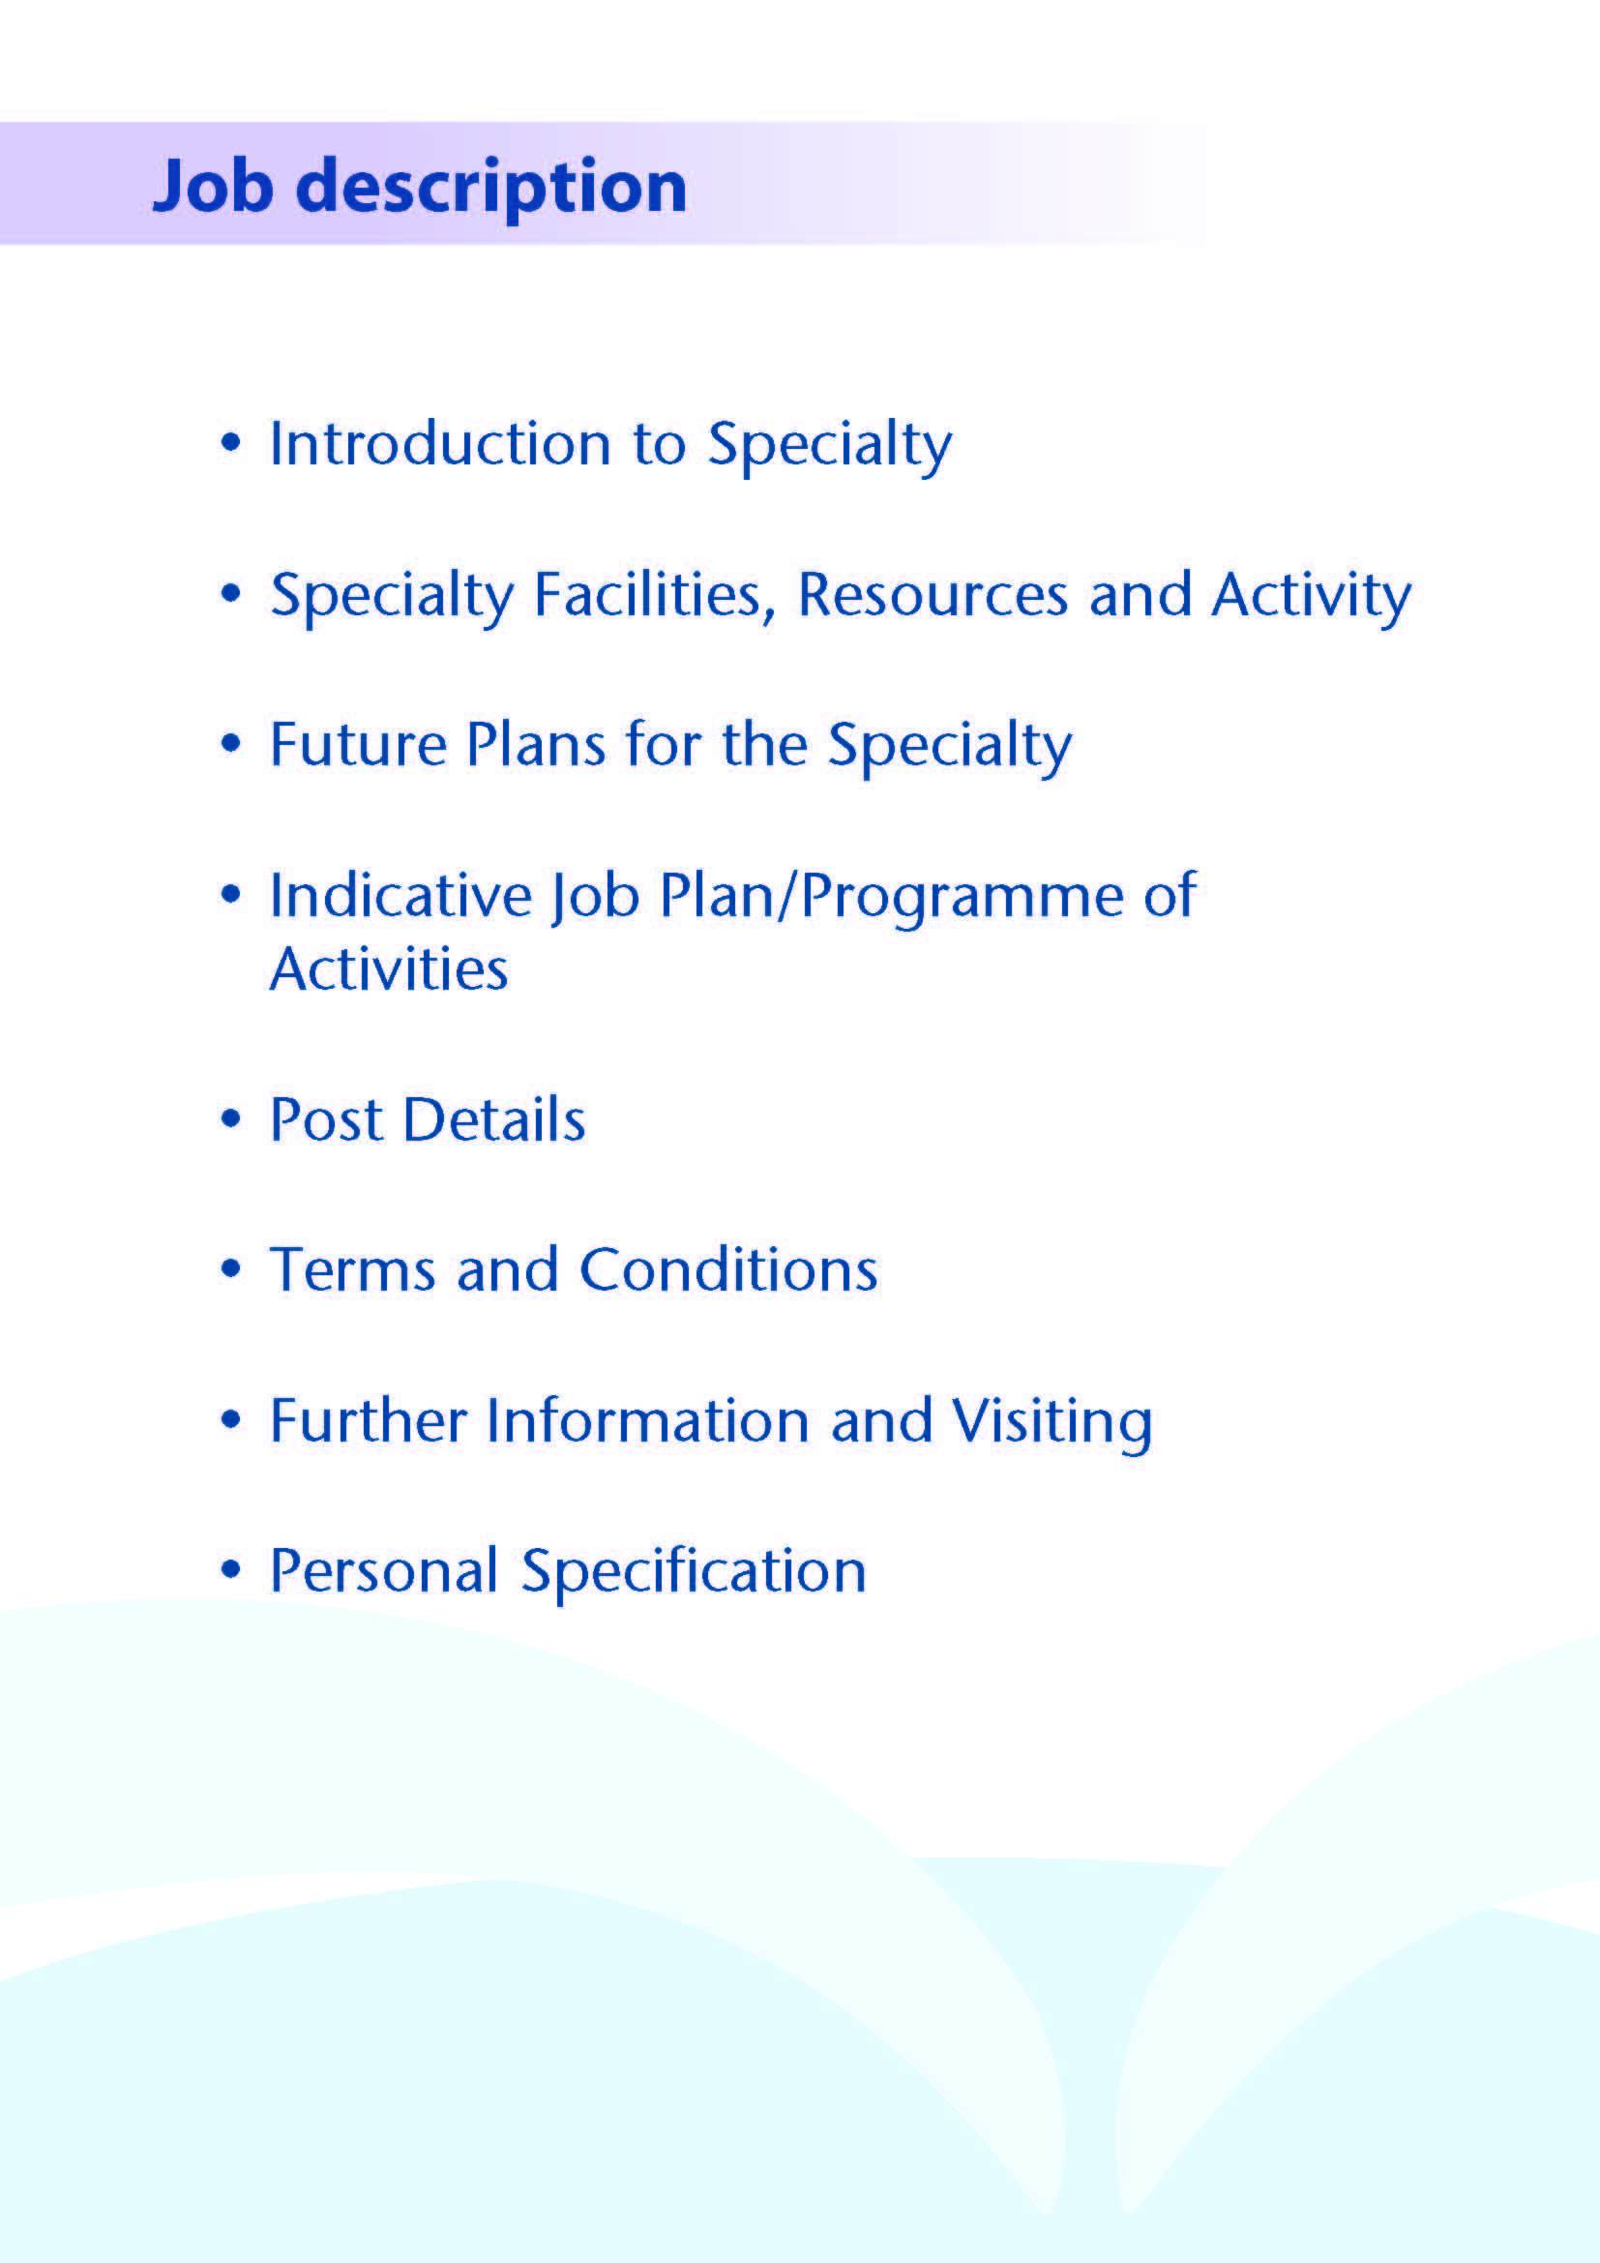



NHS Ayrshire and Arran has invested significantly in mental health service development over recent years following a major strategic review, and this has resulted in the creation of a 24 hour crisis service, expansion of primary care mental health services and new services for eating disorders. All acute psychiatric beds are now sited in our purpose-built inpatient unit, Woodland View, which opened on the Ayrshire Central Hospital campus in Irvine in 2016.

An opportunity has arisen for a enthusiastic and motivated GP with a Special Interest in General Adult Psychiatry to join our Community Mental Health Team within the East Ayrshire Health & Social Care Partnership. A GP with a Special Interest supplements their core generalist role by delivering an additional high quality service to meet the needs of patients. Working principally in the community, they deliver a service beyond the scope of their core professional role or may undertake advanced interventions not normally undertaken by their peers. They will have demonstrated appropriate skills and competencies to deliver those services without direct supervision.

The successful candidate will work closely with the 2.4 WTE Consultant Psychiatrists and other members of the multidisciplinary team to provide high quality outpatient care and treatment to adults residing within East Ayrshire. East Ayrshire has a total population of around 122 000, encompassing both urban and rural settings.

The post holder will provide 2 programmed activities with activities which could include assessing and reviewing routine and urgent outpatients via clinics, participating in multidisciplinary team meetings, and potentially contributing to under-and post-graduate teaching and training, as well as quality improvement and clinical governance activities. Continuing professional development and appraisal will be supported.



Adult inpatient mental health services in Ayrshire are provided within our purpose built community hospital, Woodland View, with general adult (acute), elderly, continuing care, rehabilitation, IPCU and alcohol rehabilitation wards. There is a smaller unit providing elderly and rehabilitative services based on the Ailsa Hospital site in South Ayrshire.

There are three General Adult Community Mental Health Teams (CMHTs) in Ayrshire: East, North and South.

The East Ayrshire CMHT is based at the North West Kilmarnock Area Centre in Kilmarnock, and consists of:

4.0 Consultants

1.0 Staff Grade Doctor

3-4 Core/GPST/F2 trainees

1 Higher Trainee

1 Nursing Team Leader

6.0 WTE Charge Nurses

7.0 WTE staff nurses

1.0 WTE Health Assistant

0.9 WTE Consultant Clinical Psychologist

4.5 WTE Clinical Psychologists

2.5 WTE Clinical Associates in Applied Psychology (Primary Care)

7.96 WTE Occupational Therapy

8.23 WTE Admin staff

**Medical Staff Resources**

**Consultant Grade:**

**ADULT**

**East Locality**

Dr Aileen Guthrie (East Community Clinical Director)

Dr Morag Henderson

Dr Anna Ulanova

Vacancy

**North Locality**

Dr Alison MacRae (North Community Clinical Director)

Dr Everett Julyan

Dr Eilidh Orr

Dr Alex Maclean

Vacancy

**South Locality**

Dr Jacqui Scott (South Community Clinical Director)

Dr Alistair Gibb

Dr Tim Johnston

Dr Adrian Nitu

Dr Steve Moorhead

**Rehabilitation**

Dr Krzysztof Tyczynski

**Liaison**

Dr Ben Checuti (Acting Clinical Director)

Dr Kim Newlands

Dr Julie Langan Martin

**Perinatal**

Dr Malcolm Cameron

**Psychotherapy**

Dr John Prestwich

**Forensic/IPCU**

Dr Dawn Carson (Inpatient, Rehabilitation & Forensic Clinical Director)

Dr Gillian Howieson

Dr Partha Gangopadhyay

**Elderly**

Dr Debbie Browne (Deputy Medical Director)

Dr Mark Luty (Clinical Director)

Dr Gillian Scott

Dr Stephanie Cowan

Dr Dominic Gallagher

Dr Susan Maxwell

**Elderly Liaison**

Dr Joseph Sharkey

Dr Alan Spratt

**CAMHS**

Dr Helen Smith (Clinical Director)

Dr Ali Tahir

**Learning Disability**

Dr Claire Hughes (Clinical Director)

Dr Douglas Paterson

Dr Omer Rashid

**Addictions**

Dr Beinn Wilson (Clinical Director)

Dr Clare Duncan

Dr Karthik Kessavelou

Dr Caroline Woolston

**Non-consultant Grade:**

The consultant posts are supported by 6 Specialty Grade Doctors, approximately 14 junior trainees (FY2/ST1-3) and a varying number of Higher Trainees in Psychiatry (ST4-6)

**Administrative Support**

The post holder will have access to such general administrative support as is required for the discharge of his/her duties.

**Education**

Woodland View has its own library and training facilities on site for local Postgraduate teaching. Crosshouse and Ayr Hospitals have the Alexander Fleming Education Centre and MacDonald Education Centre, respectively. These facilities have well stocked libraries with good electronic facilities, a lecture theatre with state-of-the-art equipment and meeting rooms.

The post holder will have the opportunity to participate in the local postgraduate psychiatric training programme and to be involved in the teaching of medical undergraduates.



A new low secure unit opened on the Woodland View site in January 2017 and Woodland View is the location of the new national medium secure adolescent unit, opening later this year.



The post will consist of 2 programmed activities. The nature and day/timing of activities shown in the timetable are indicative and the precise nature of the duties will be agreed with the successful candidate at a job planning meeting with the Clinical Director. Timetables will be reviewed to meet the changing needs of the service and post-holder, subject to discussion and job planning.

|  |  |  |  |  |  |
| --- | --- | --- | --- | --- | --- |
|  | Mon | Tues | Wed | Thur | Fri |
| am | - | - | Clinic  (North West Area Centre)  Educational supervision  (North West Area Centre) | - | - |
| pm | - | - | Clinical administration/MDT & urgent duties  (North West Area Centre) | - | - |

**Proposed Weekly Programme**

The proposed weekly programme is illustrated above. Activities with fixed time commitments will be carried out as detailed in the work programme, e.g. clinic and clinical administration, with flexibility as required.

Urgent duties may include individual or joint assessments or home visits, depending on the dynamic needs of the service.

Clinical supervision will be provided by the Consultant Psychiatrists when required, and educational supervision is timetabled. Details of other activities will be agreed with the post holder.

The job plan incorporates all the professional duties and commitments, including agreed Supporting Professional Activities.

Opportunities may exist for other activities to be undertaken subject to service requirements and the post holder’s individual professional needs and preferences.

Administration: This activity covers the management of individual patients including outpatient administration, results reporting, letters/phone calls to patients, carers, GPs and members of the wider multidisciplinary team involved in patient care, as well as medico-legal documents.

Travel: Any travel allocation will be included within the Total Programmed Activities and will be determined by location at which Direct Clinical Care and Supporting Professional Activities are carried out.



The main duties and responsibilities of the post, with appropriate training and supervision where necessary, include:

* 2 sessions/programmed activities per week
* Assessment, diagnosis and treatment for patients presenting to services acutely or with severe and enduring illness
* Medical input to the multidisciplinary team for relevant patients
* Communicating with mental health colleagues across disciplines and with health and social care partners in support of comprehensive patient care, in addition to GPs and third sector agencies
* Undertaking domiciliary visits and emergency assessments where appropriate
* Compliance with NHS Ayrshire & Arran Clinical Governance policies
* Involvement in appraisal and job planning.



Hours: 2 sessions per week (each session equates to 4 hours)

Salary: As per Salaried GP Scale

Superannuation: This post is superannuable

Annual Leave: 12 sessions per annum

Contracted activities for this appointment will be defined and agreed with the post holder and the Clinical Director, to whom the post holder will be professionally responsible.

Formal appointment will be conditional upon satisfactory completion of all pre-employment checks, including satisfactory medical screening and meeting the requirements of entry to the NHS Ayrshire & Arran Performers List.

This appointment will be superannuable under the NHS Superannuation Scheme, which is contracted out of the State Earnings Related Pension Scheme (SERPS). New employees will automatically be enrolled in the scheme unless they opt out. For further information, please contact the Scottish Public Pensions Agency (SPPA) on 01896 893100 or visit www.sppa.gov.uk

The employment is subject to three calendar months’ written notice on either side.

The successful candidates will require to engage with NHS Ayrshire & Arran arrangements for annual GP Appraisal or other approved arrangement to ensure appropriate revalidation and continued registration on the GMC and GP Registers for the purpose of maintaining their License to Practice. This is also a requirement of the NHS (General Medical Services Contracts) (Scotland) Regulations 2004 to retain registration of the Board’s Performers List.

Annual leave entitlement is six normal working weeks per year (pro rata for part time post holders), with additional statutory holiday entitlement as agreed by the Local Negotiating Committee and published annually.



For further information or to arrange an informal visit please contact **Dr Aileen Guthrie**, Clinical Director, or **Dr Morag Henderson**, Consultant Psychiatrist, on **01563 578593**; or **Dr Debbie Browne**, Deputy Medical Director, on **01563 578646**.



**POST OF : GP with a Special Interest IN GENERAL ADULT PSYCHIATRY**

## LOCATION : EAST AYRSHIRE CMHT

## QUALIFICATIONS:

|  |  |
| --- | --- |
| ESSENTIAL | DESIRABLE |
| Full GMC Registration (with Licence to Practice) |  |
| Certificate of Completion of Training - Certificate of Prescribed Experience from JCPTGP or equivalent and be registered on both the GMC and GP Registers by time of appointment | MRCGP (or equivalent) |
| A minimum of 5 years full time postgraduate training | Experience in psychiatry |
|  | Full Driving Licence |

|  |  |  |
| --- | --- | --- |
| **SKILLS/**  **KNOWLEDGE/**  **COMPETENCE** | **ESSENTIAL** | **DESIRABLE** |
| **General Experience** | Knowledge, skills and experience relevant to psychiatry | Experience in General Adult Psychiatry |
|  | Ability to communicate effectively with all levels of staff and patients |  |
|  | Ability to work efficiently with good time management |  |
|  | IT literacy |  |
|  | Good record keeping skills |  |
| **Team Working** | Commitment to being an effective team player, establishing and maintaining patient-centred collaborative relationships |  |
|  | Ability to recognise value of and develop working relationships with partnership agencies |  |
| **CPD** | Evidence of relevant Continuing Professional Development |  |
| **Teaching and Training** | Willingness to participate in teaching and training | Interest in and knowledge of advances in medical education and training |
| **Research and Publications** |  | Evidence of publications in peer reviewed journals |
| **Clinical Audit** | Participation in regular medical audit |  |
| **Management and Administration** | Appropriate organisational skills |  |
| **Personal and Interpersonal Skills** | Flexibility to meet the changing needs of the service |  |
|  | Effective communicator and negotiator |  |
|  | Open and non-confrontational |  |
| **Professional values and practice** | Committed to practicing according to the GMC’s Good Medical Practice, and the RCPsych’s Good Psychiatric Practice |  |