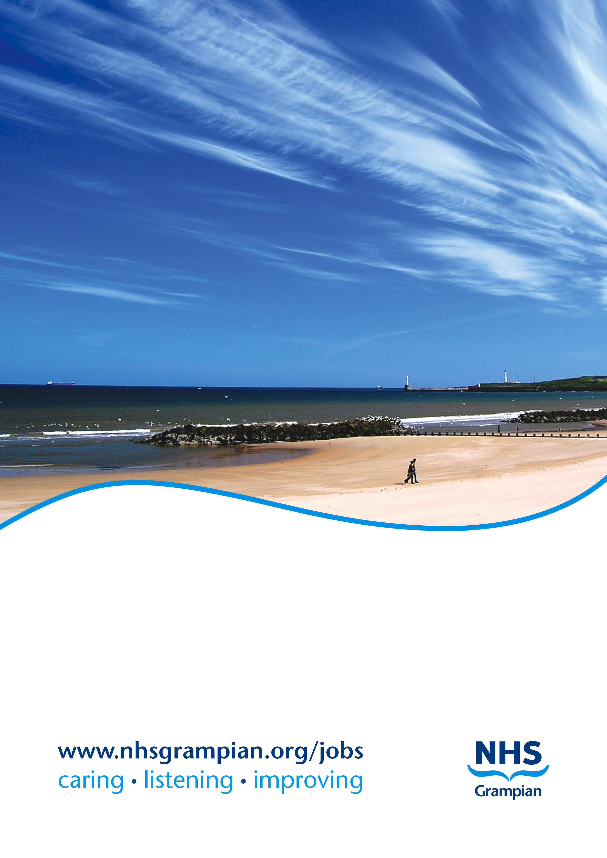

**Job Title: Consultant in Oral Surgery**

**Location: Aberdeen Dental Hospital & Institute of Dentistry**

**Ref No: ST165657**

**Closing Date: Sunday 10th December 2023**

###### NHS_Grampian_faxlogo

**CONSULTANT IN ORAL SURGERY**

**(Full time 40 hours per week)**

**REF: ST165657**

**JOB DESCRIPTION**

###### THE POST

To provide an Oral Surgery service of the highest quality, ensuring that standards are maintained and developed through clinical audit, evidence based research, job planning and appraisal. To work flexibly with colleagues to achieve the business strategy, and to collaborate with the University of Aberdeen contributing to Undergraduate and Postgraduate Education.

**Main duties and responsibilities**

The successful applicant will be responsible for the provision of a comprehensive, effective and modern Oral Surgery service to the catchment area.

To provide specialist assessment, diagnosis and treatment planning for patients referred from Hospital Consultants, the NHS Grampian Minor Oral Surgery Network and General Dental and Medical Practitioners.

To assess, consent and provide treatment for patients under general anaesthetic, IV sedation and local anaesthetic where appropriate.

To assist in the professional supervision and management of other staff in training, and to explore the development of Specialist Training pathways in Oral Surgery.

The post holder will contribute to the provision and development of Oral Surgery teaching but also in the broad academic development of the Institute of Dentistry at the University of Aberdeen. The Institute delivers a graduate-entry Bachelor of Dental Surgery degree programme: participants are exempt from the first year of the BDS programme which is normally 5 years by virtue of possessing a primary degree. The graduate entry programme is therefore completed over 4 years. The Institute further wishes to develop a portfolio of postgraduate opportunities which focus on the development of a local and national dental workforce.

**Clinical base and facility**

The post will be based at Aberdeen Dental Hospital and Institute of Dentistry, which is co-located on the Foresterhill site with Aberdeen Royal Infirmary, the Aberdeen Maternity Hospital and the Royal Aberdeen Children’s Hospital.

Aberdeen Dental Hospital is modern and well equipped with dedicated radiology, laboratory and decontamination services on site.

The Dental Hospital provides specialist secondary care services and multidisciplinary joint clinics in Orthodontics, Restorative Dentistry and Oral Medicine. Primary care services for Adult Special Care Dentistry and Paediatric Dentistry are also provided within the building.

Full clinical support including nursing, secretarial and reception will be provided.

**Management and governance**

The post holder would be responsible to the Clinical Lead of Aberdeen Dental Hospital and the Unit Operational Manager for Surgery 1 within the Surgical Directorate for the treatment of oral surgery patients and will work collaboratively with the Managed Clinical Network (MCN) in Oral Surgery and Consultant colleagues in Oral and Maxillofacial Surgery at Aberdeen Royal Infirmary. The post holder will also develop working relationships with other specialties within NHS Grampian and elsewhere as required with primary care GMPs and GDPs.

An active role will be played in the provision of the service in such a way as to take into account the views of patients and their carers.

Full participation in Clinical Governance arrangements will be expected, including participation in clinical audit, research (where appropriate), pursuing any agreed agenda with colleagues and the Senior Management Team and fully co-operating in implementing the results in order to achieve best practice.

Participation, on at least an annual basis in consultant appraisal and job planning reviews, and compliance with NHS Grampian policies and procedures where appropriate. This will include active participation in the reporting of incidents and near misses and responding to complaints. In addition, staff will undertake such statutory and mandatory training which has been agreed with NHS Grampian.

All intellectual property rights of NHS Grampian and the University of Aberdeen will be observed.

**THE DEPARTMENT OF ORAL SURGERY**

There are currently two Consultants in Oral Surgery based in NHS Grampian.

There are five Consultants and five experienced Specialty surgeons in the local Oral & Maxillofacial Surgery (OMFS) Department. The successful candidate will work alongside the OMFS Department and Public Dental Service within the Oral Surgery Clinical Network in Grampian.

The Oral and Maxillofacial service is based at Aberdeen Royal Infirmary.

The Department of Oral & Maxillofacial Surgery provides a Consultant Service to medical and dental practitioners of the North East of Scotland, including Moray, Orkney and Shetland. Total population: 630,000. The Outpatient Department is situated within Aberdeen Royal Infirmary and inpatients are in a shared ENT ward. Currently we have 3 all-day inpatient operating sessions a week in the general theatre complex. There are also three half-day operating sessions a month held in the Royal Aberdeen Children’s Hospital. There are 15 LA outpatient sessions per week.

There is a day case operating list at Stracathro Hospital which is dedicated to Minor Oral Surgery and plans are at an advanced stage to build a dedicated day surgery unit on the Foresterhill site, which Oral Surgery / OMFS will be expected to use.

There are also Departments of Restorative Dentistry and Orthodontics based at Aberdeen Dental Hospital which opened in October 2008.

STAFF:

Consultants – Oral Surgery

Vacant (this post)

Mr A Lalli, Honorary Consultant

Consultants - OMFS

Mr R Morrison (Unit Clinical Director)

Miss M Dhillon

Mr T Lowe

Mr C McDonald

Mr M Ryan

Speciality Dentists

Dr J Boggon

Dr M Burrell (Service Clinical Director)

Dr B McLaughlin

Dr J Mitchell

Dr C Rahman

Junior Staff

2 x DCT1 part-time

2 x DCT2

1 x DCT3

2 x FY2

1 x ST

## **Information about the area**

## **ABERDEEN**

With a population of approximately 250,000, the city stands between the Rivers Dee and Don. This historic city has many architectural splendours and the use of its sparkling local granite has earned Aberdeen the name of the Silver City. Recognised as the oil capital of Europe, Aberdeen nevertheless retains its old-fashioned charm and character making it an attractive place in which to live.

Aberdeen enjoys excellent communication services with other British cities - e.g. flying time to London is just over one hour with regular daily flights, road and rail links to all points north and south are excellent.

Many new housing developments have taken place in surrounding villages providing a wide choice of housing within easy commuting distance by car.

Well known for its superb quality of life, Aberdeen enjoys first class amenities including His Majesty's Theatre, Music Hall, Art Gallery, Museums and the P&J Live Arena. Education facilities are excellent and in addition to Regional Education Authority schools, there are two fee-paying schools for girls, and international school and one co-educational college. All three cater for primary and secondary pupils. In addition the International School of Aberdeen offers an international education for all local and expatriate children from ages 3 through to 18.

To find out more about Aberdeen, visit the Website at http://www.aberdeen.net.uk/

#### THE UNIVERSITY OF ABERDEEN

*Founded in 1495, Aberdeen is Scotland’s third oldest University and the fifth oldest in the UK. Ranked within the world top 140 in the recent QS global league table, Aberdeen is the ‘global University of the north’.*

Aberdeen is a broad based, research intensive University, which puts students at the head of everything it does. It has significant academic strengths and potential across a wide variety of disciplines. Outstanding in a wide range of discipline areas across the entire research spectrum, Aberdeen has also been credited for its international reach and its commercialisation of research ideas into spin out companies.

The University has over 14,000 matriculated students and 3,600 staff representing 120 nationalities. We encourage bold thinking, creativity and innovation and we nurture ambition with many opportunities for professional and personal development in an inclusive learning environment which challenges, inspires and helps every individual to reach their full potential.

The University combines a distinguished heritage with a forward looking attitude. In the past few years, the University has encouraged creativity in its academic staff, broken new ground with an innovative curriculum, and developed state-of-the-art facilities including the new Sir Duncan Rice Library and the Aberdeen Sports Village and Aquatics Centre. In looking to the future, the University seeks to enhance its reputation as one of the world’s leading Universities by moving forward with ever more ground breaking research; ensuring students have an intellectual and social experience second to none; and capitalising upon the dual role as one of the major institutions of the north and as a cornerstone of regional economic and cultural life.

#### THE ROBERT GORDON UNIVERSITY

The Robert Gordon University has earned wide recognition for its pragmatic approach to higher education both in Scotland and internationally.

For generations it has produced qualified professionals across a broad spectrum of careers in the arts, management, engineering, sciences, pharmacy, health and the professions allied to medicine.

Around 9,500 students study almost 100 full-time and part-time courses at undergraduate, post-experience and postgraduate levels.

The University is actively involved in applied research in a variety of fields and many short course programmes are being formulated to meet the growing needs of the community.

MODEL JOB PLAN FORMAT

**Name: Consultant Specialty: Oral Surgery**

**Principal Place of Work: Aberdeen Dental Hospital**

**Contract:** Whole Time

**Programmed Activities: 10 Indicative PA Split: DCC 8 SPA 2**

**Availability Supplement**: None

**Premium Rate Payment Received:**

**Managerially Accountable to: Unit Operational Manager, Acute Surgery 1**

**Clinically Responsible to: Clinical Lead, Aberdeen Dental Hospital**

**a) Timetable of activities which have a specific location and time**

|  |  |  |
| --- | --- | --- |
| **DAY** | **HOSPITAL/ LOCATION** | **TYPE OF WORK** |
| **Monday**  **From / To**  0900-1700 | ADH | AM OP Clinic  PM OP LA Operating Clinic |
| **Tuesday**  **From / To**  0900-1700 | ADH | AM OP Clinic  PM DCC Patient Admin |
| **Wednesday**  **From / To**  0900- 1700 | ADH | AM OP Clinic  PM SPA |
| **Thursday**  **From / To**  0900-1700 | ADH | AM OP Clinic  PM SPA |
| **Friday**  **From / To**  0900-1700 | ADH | AM OP LA/Sedation Operating Clinic  PM OP LA Operating Clinic |
| **Saturday**  **From / To** |  | N/A |
| **Sunday**  **From / To** |  | N/A |

Note: GA operating list at new Day Surgery Unit once a week when available.

***NB: The detailed Job Plan will be agreed with the successful candidate at the time of the appointment, taking account of the experience, skills and interests of the candidate and how they can best be used within the Consultant team.***

**PERSON SPECIFICATION**

**CONSULTANT IN ORAL SURGERY**

|  |  |  |
| --- | --- | --- |
| **REQUIREMENTS** | **ESSENTIAL** | **DESIRABLE** |
| **Registration**  **Specialist listing**  **Professional Qualifications** | Full registration with United Kingdom General Dental Council (GDC )  On the Specialist GDC List in Oral Surgery or within 6 months of eligibility for inclusion  Membership in Oral Surgery, or equivalent | Intercollegiate Specialty Fellowship Exit Examination in Oral Surgery, or equivalent  Fellowship in Dental Surgery or Membership of Faculty of Dental Surgery, or equivalent |
| **Training** | Successful completion of an SAC approved training program in Oral Surgery, or within 6 months of completion | Qualification in Dental Sedation |
| **Clinical Experience** | All aspects of Oral Surgery.  Understanding and management of patients with multidisciplinary problems and ability to coordinate care with other disciplines and other health care providers.  Experience of innovative treatments.  High quality management of patients in Oral Surgery demonstrated by successful outcomes.  Dealing with medically compromised patients | Experience of UK healthcare systems |
| **Teaching** | Experience of chairside clinical teaching and training.  Experience of giving lectures, presentations and formal teaching to a variety of clinical groups.  Commitment to training and CPD | Teaching qualification  Previous experience of teaching at undergraduate and post graduate level |
| **Audit** | Effective participation in clinical audit and clinical governance |  |
| **Research** |  | Research relevant to oral surgery  Research qualifications such as MSc, MClinDent or PhD  Publications in refereed journals |
| **Management** |  | Experience of management of clinical service  Advanced management skills  Experience in managing primary or secondary care teams or developing clinical care networks |
| **Personal** | Good team member who communicates well with staff and patients.  Disability & Equality awareness |  |

**NHS GRAMPIAN**

**CONSULTANT IN ORAL SURGERY**

**REF: ST165657**

CONDITIONS OF APPOINTMENT

1. The appointment will be made by the Board on the recommendation of an Advisory Appointments Committee, constituted in terms of the National Health Service (Appointment of Consultants) (Scotland) Regulations, 1993 - NHS Circular 1993 No 994 (S.140) which will include University representatives. Any person suitably qualified and experienced who is unable for personal reasons to work full-time, will be eligible to be considered for the post.

2. (a) The whole-time salary, exclusive of any distinction award, will be a starting salary of £91,474 - £121,548 progression of salary is related to experience.

Appendix 8 of the contract sets out the code of conduct for private practice which applies to all interested parties. In general consultants will be free to undertake private practice as long as this is undertaken out with the agreed job plan and employers are informed, in writing, of private commitments. While employers have discretion to allow some private practice to be undertaken alongside a consultant’s NHS duties, such provisions of private service should not prejudice the interests of NHS patients or disrupt NHS services.

(b) Job plans must be agreed and signed off in association with the appropriate Clinical Lead. Changes will be discussed and agreed by these officers and yourself in line with Clinical Grouping service needs and changes in service requirements as well as at annual review.

3. The person appointed will be expected to take part in undergraduate and postgraduate teaching programmes. You will therefore be awarded appropriate Aberdeen University Honorary Status.

4. Consultants are expected to undertake research and development in their own field and to link with the University research areas.

5. Day to day arrangements for undertaking the specified duties of the post will be made in consultation with the Head of Service, other consultants in the department and with the Board.

6. The person appointed will have a continuing responsibility for the care of patients in his or her charge and will undertake the administrative duties associated with the care of his or her patients and an appropriate share in the running of the clinical department.

7. The person appointed will act as an adviser to the Board in Oral Surgery.

8. You may exceptionally be required to undertake duties at other hospitals in the Grampian Area or other Health Board areas and at hospitals in Orkney, Shetland and elsewhere for which service agreements would be arranged.

9. The Board, in partnership with the BMA Local Negotiating Committee has a study leave policy for all Career Grade Medical and Dental staff Policy available on request from the Human Resources Department.

10. The appointment will be superannuable if the person appointed so chooses. He or she will be subject to the regulations of the National Health Service Superannuation Scheme and the remuneration will be subject to deduction of contributions accordingly, unless he or she opts out of the Scheme.

11. The private residence of the person appointed should not normally be more than 10 miles by road from their principal place of work unless otherwise agreed locally. They must be contactable by phone.

12. NHS Grampian is legally liable for the negligent acts or omissions of employees in the course of their NHS employment. Medical staff are however advised to ensure that they have defense cover for activities not covered by the Board’s indemnity.

13. The officer appointed will be required to be registered on the General Dental Council’s Specialist Register for Oral Surgery.

14. As a result of guidance issued by the Scottish Office on "Protecting Health Care Workers and Patients from Hepatitis B” NHS Grampian is required to:-

Ensure health care workers who may be at risk of acquiring hepatitis B from a patient are protected by immunisation.

Protect patients against the risk of acquiring hepatitis B from an infected health care worker. Due to the nature of this post, any offer of appointment will be conditional upon the successful applicant either:-

* Undergoing a process of screening/immunisation/monitoring in accordance with the Board's Policy and Procedure, or
* Producing acceptable documentary evidence that he/she is not an infective risk to others.

In the event that he/she is an infective risk to others or if he/she fails to comply with the above requirements, the conditional offer of appointment will be withdrawn.

As a condition of his/her subsequent employment in this post he/she is also required to undergo further immunisation and monitoring at the intervals specified by the Board's Occupational Health Service in order to boost/maintain his/her level of immunity. Should he/she become hepatitis B e antigen positive and therefore an infective risk to others at any stage in the future the appointment will be subject to review in accordance with the Board's agreed Procedure for dealing with such situations where the post holder is involved in "Exposure Prone Procedures". This review may result in the post holder having to alter his/her clinical exposure to remove risk to patients and others. In circumstances where this is not a practical option, it will be necessary to provide industrial compensation for this prescribed industrial disease prior to the post holder leaving the Board's employment.

15. The appointment is made subject to satisfactory fitness for employment. The candidate will therefore be required to complete a pre-employment health screening questionnaire and may/will subsequently be required to attend for health screening.

16. Termination of the appointment is subject to three months' notice on either side.

1. The Board is required to instigate a check to be made with the Disclosure Scotland Office for any convictions recorded before an offer of appointment can be made (rehabilitation of Offenders Act 1974 amended 1985 and 1986) and (Disclosure of Criminal Convictions of NHS Staff with Substantial Access to Children 1989).

**NOTES TO CANDIDATES**

Canvassing in connection with appointments is not permitted but this does not debar candidates who wish from visiting the hospitals concerned.

Further information can be obtained and an appointment to view the Department arranged by contacting:

**Mr Mark Burrell, Service Clinical Director**

**mark.burrell@nhs.scot or by calling 01224 559245/551028**

**Dr Dean Barker, Clinical Lead, Aberdeen Dental Hospital & Institute of Dentistry**

**dean.barker@nhs.scot or by calling 01224 559382**

Mr P Bachoo Dr N Fluck

Medical Director – Acute Services Medical Director

NHS Grampian NHS Grampian

3rd Floor West Wing, Ashgrove House Summerfield House

ARI Site Eday Road, Aberdeen

Contact: Gavin Davidson Lyndsay Cassie

Personal Assistant Personal Assistant

Direct Line: 01224 554299 Direct Line: 01224 558577

Apply for this post by visiting apply.jobs.scot.nhs.uk and search for Ref No quoted above. Closing date: Sunday 10th December 2023

NHS Grampian has a process of induction for all newly appointed Consultants. You will have a local department induction and orientation led by your Head of Service. In addition we believe it important that you have an opportunity to meet with key personnel in NHS Grampian. This allows them to explain their role in the organisation and to discuss key information on the organisation and strategic planning processes we operate. We believe it important that all newly appointed Consultants even if they have previously worked in Grampian should have this opportunity once appointed to a Consultant post. Your Head of Service along with you will be responsible for ensuring this is undertaken. Heads of Service are supplied with the names of those you should meet.

NHS Grampian are obliged to bring to your notice that the Rehabilitation of Offenders Act 1974 provides for many people who have been convicted of certain criminal offences, the opportunity to have no need to refer to any conviction or circumstances relating to it in the course of daily lives. Certain convictions can, therefore, be regarded as “spent” after the lapse of a period of years under the terms of the Act. The National Health Service employment for which you are applying, however, has been excluded from the provisions of the Act and you are, therefore, required no withhold information about convictions which for other purposes are “spent” under the provisions of the Act. In the event of employment, any failure to disclose such convictions could result in dismissal or disciplinary action by the Board. Any information given, however, will be completely confidential and will be considered only in relation to the post to which this job description refers.

There is a Day Nursing facility for children of staff employed by NHS Grampian. ‘Little Acorns Day Nursery’ which has been specially designed can accommodate 24 children between the ages of 6 months and 5 years. Please contact the Nursery Manager on (01224) 557828 for further details.

In The Interest Of Health Promotion We Operate a **No Smoking Policy.**