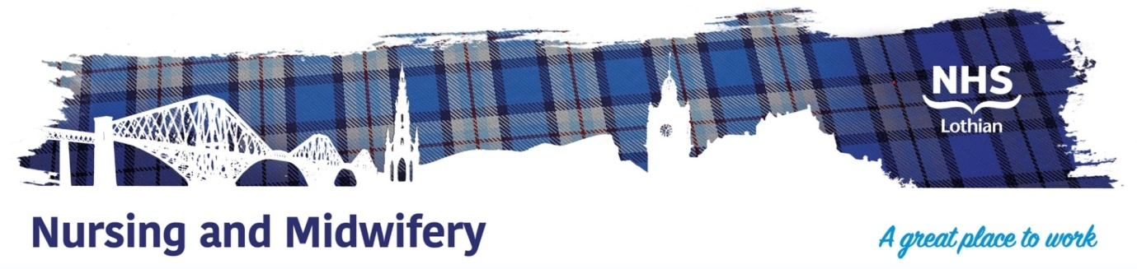

**CAMHS Melville Inpatient Unit and Day Services**

Exciting opportunities are available to join The Melville Unit inpatient and day service teams based at the Royal Hospital for Children and Young People at Little France in Edinburgh Lothian. We have multiple Band 5 positions available for Registered Nurses and we are looking for passionate, caring, motivated people to join our highly skilled nursing teams.

CAMHS Recruitment Video…..Find Out More



**What We Can Offer You**

Working within these areas would involve being a member of a dynamic and progressive multi-disciplinary team who put the care of young people at the centre of what they do. The multidisciplinary team includes Nurses, Occupational Therapists, Psychiatrists, Dieticians, Psychologists, Social Workers, music and art therapists and Family Therapists. Opportunities for ongoing learning, development and training is also given within a supportive team environment

There are available positions within the Melville inpatient Unit, a 12 bedded unit looking after young people between the ages of 12 and 18 who may be experiencing a range of different mental health difficulties. These posts would include night and weekend working.

Patient and family’s information on the Melville Unit





