Physiotherapy Job Description: Additional Specialism Information
Specialism: Consultant physiotherapist in neurology and neurological rehabilitation North Ayrshire Grade: Band 8b
Job description linked to: Band 8b Consultant physiotherapist
Organisational position (including chart) | 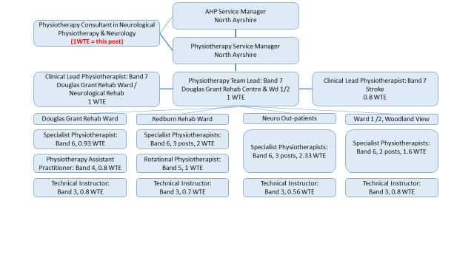  - The Physiotherapy Neurological out-patient service delivers physiotherapy to adults living with neurological conditions across North Ayrshire. This service also provides pan-Ayrshire physiotherapy services for those living with MND and MS. This is supported by other neuro outpatient services in the South and East HSCPs.  - This post is based at the Douglas Grant Rehabilitaiton Centre within the Ayrshire Central Hospital campus, but may deliver input to patients throughout Ayrshire & Arran.  - The post will work closely with neurology and neurolocial rehabilitation consultants and consultant OT based at Douglas Grant rehablitation centre.
Job Purpose | - The post will provide expert clinical physiotherapy practice in Neurology and neurological rehabilitation bringing innovation and influence to clinical leadership and strategic direction in the field of neurology for the benefit of patients with a neurological condition in Ayrshire and Arran  - The post holder will play a pivotal role in the initiation and integration of research evidence into practice. This will be delivered by enhancing quality in the areas of assessment, diagnosis, management and evaluation to improve the outcomes for patients.  - The post holder will provide a person-centred approach to care and will seek to incorporate the uses perspective in future developments.  - The post holder will collaborate with other professional groups within and across boundaries to provide consultant level clinical leadership in the acute, community and intermediate care settings.  - The post holder will represent physiotherapy in local, regional and national planning groups for neurology services working across boundaries to improve the integration of care.  - The post holder will work closely with the clinical lead for neurological rehabilitation in Ayrshire & Arran
Key Result Areas | - Develop and lead tone management service for neuro and neuro rehab , on a pan Ayrshire basis - assessment, treatment and management of patients with complex tone management issues, both in- patients and outpatient ( 2 sessions per week)  - Scoping of development of spasticity/ tone management service throughout A&A, consideration of inclusion of CYP,LD, stroke  - Physiotherapy management of complex neurological / Neurological rehabilitation patients - complex case management, (1- 2 sessions per week) escalation from physiotherapy staff – teaching model  - After training detailed below- complex assessment of neurology patients to divert this work from neurology consultants and reducing wait lists for lower risk patients.( 2 sessions per week)  - Develop pathways/criteria for managing patients from A&E/acute wards/ITU to rehabilitation wards and manage expectations of patient and relatives  - Link with HEIs for physiotherapy education( to include supervisor of masters, PhD students)  - Link strategically with Scottish government  - Link with advance practice groups and promote advanced neurology physiotherapy  - Links with physiotherapy neurology/neurological rehabilitation throughout  Scotland/UK  - Promote/Lead research for physiotherapy in Neurology and north Ayrshire  - Link with other consultant physiotherapists to embed a culture receptive to research within NHS A&A
Other relevant information | Training to be undertaken for post – complex patient assessment modules, IRMER training, blood interpretation, advanced assessment techniques, prescriber training, injection training spasticity management training Expectation of this being completed within the first 18 months.

