JOB DESCRIPTION 

JOB IDENTIFICATION
Job Title: Personal Assistant

Responsible to (insert job title): General Manager - Women, Children and Clinical Services

Department(s): Directorate Management

Directorate: Women, Children and Clinical Services

Operating Division: Acute Services Division

No of Job Holders: 1

Last Update: October 2023

2. JOB PURPOSE
To provide comprehensive personal assistant support, including provision of a secretarial/administrative service, to the General Manager of the Women, Children and Clinical Services (WCCS) Directorate and to support the general running of the Department.

3. DIMENSIONS
Women, Children and Clinical Services:
Total budget: c£58.7m
Total staff: c840 wte

Women & Children’s Services includes:
- Obstetrics & Gynaecology
- Paediatrics & Neonates.

Clinical Support includes services for the following specialties:
- Laboratories(Fife-wide)
- Radiology (Fife-wide)
- Therapies and Rehabilitation

4. ORGANISATIONAL POSITION

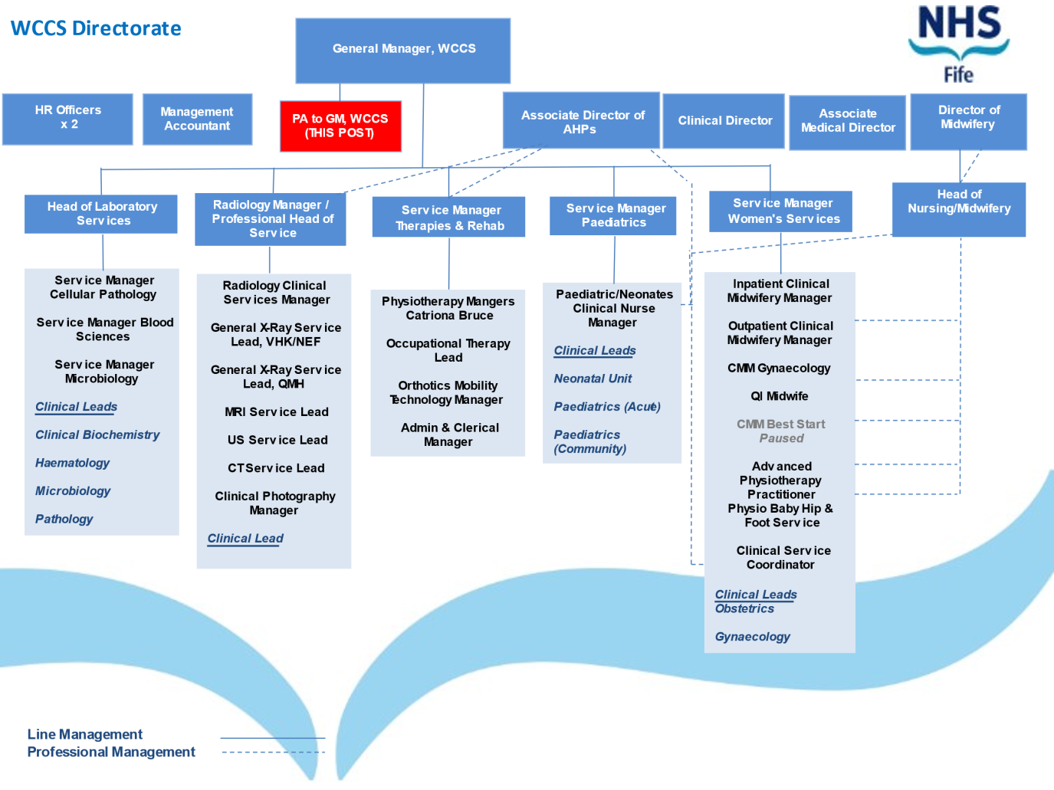

5. ROLE OF DEPARTMENT
The Women, Children and Clinical Services Directorate will provide a full range of secondary clinical services to a population of approximately 355,000.

The role of the Directorate is to work within a single system with health and social care, primary care, and secondary care colleagues, co-ordinating and managing the functions within the allocated resources to enable the effective and sustainable delivery of high quality patient services.

In an ethos of continuing improvement to provide high quality safe patient services while ensuring attainment and maintenance of national performance standards (e.g., Emergency Access standard, infection control rates etc), overall working towards improvements to the patient experience in line with the National Quality Strategy and Scottish Patient Safety Programme.

Effective communications across the health care system, including interface with Fife Council and other agencies / partners to maximise effective patient pathways.

6. KEY RESULT AREAS
- Responsible for provision of a high quality PA/secretarial/administrative service including personal assistant duties
- Compilation of electronic documentation, typing of reports, creation of spreadsheets for departmental use, and taking/constructing and typing up of minutes for onward distribution
- Management of electronic diaries. The post holder is required to plan and organise appointments/ meetings to ensure effective time management of workload, exercising judgement when prioritising meetings; seeking clarification as required
- To deal with incoming communications (Microsoft Teams/telephone/email/post) to the department attending to matters personally and/or referring to appropriate staff member
- Responsible for the management of master documents ensuring up to date and available for departmental reference
- Collation and preparation of statistical data for, among other things, monthly Performance Review purposes. This information is obtained from various teams and departments, collated and input into a master document to form a monthly report
- Co-ordinate commencement of new staff by completing start papers and relevant documentation ensuring ready for authorisation. Maintain up to date Induction Pack information and organise uniform and badges
- Calculate, compile and maintain absence, annual leave/public holiday forms for staff and produce and maintain Trackers
- Monitor and order supplies and maintain adequate stock levels. Authorise delivery notes.
- Responsible for monitoring of WCCS incidents and risks in DATIX
- SSTS for Senior Management Team
- Responsible for management of, producing papers and minuting various meetings
- Ensure compliance with all NHS Fife Staff Governance standards and data protection/IT policies
- Minute Disciplinary and Investigatory Hearings and prepare reports of meetings
- Set up Consultant Interviews
- Collate data and present the virtual Patient Safety Huddle on a rota basis with colleagues from other Directorates
- May be required to work some P/Hs

7a. EQUIPMENT AND MACHINERY
- Computer/Laptop
- Printer /Photocopier/scanner
- Telephone

7b. SYSTEMS
- Microsoft Offices packages (Word/Excel/Outlook/Powerpoint/MS Teams)
- Department filing systems, including personal files, management of electronic file storage and archiving
- Electronic Data Storage: Excel, Word, PowerPoint
- DATIX
- PECOS
- SSTS
- PatientTrak (for Safety Huddle)
- Electronic Room Booking System
- eRostering

8. ASSIGNMENT AND REVIEW OF WORK
- Work is generated by the General Manager
- Support is provided by the General Manager on an ad hoc basis and at weekly 1:1 meetings and annual performance review
- The post holder is responsible for managing their own workload with ongoing prioritisation of work to ensure delivery of objectives

9. DECISIONS AND JUDGEMENTS
- Post holder works using own initiative and is responsible for organisation and prioritisation of own workload with no direct supervision
- Takes action on own initiative on enquiries received
- ‘Sense checks’ letters, emails, reports, etc making changes/amendments as necessary and being aware of when to query
- The post holder is expected to balance conflicting workload demands
- Be aware of, and sensitive to, the highly confidential nature of information regarding staff issues and treat these with the utmost discretion and confidentiality
- Identify inconsistencies and anomalies and highlight to the relevant Service Manager or escalate to the General Manager

- Be pro-active in identifying and implementing process improvements, as well as planning ahead and continuously reviewing own performance to ensure high standards are met
- Access and work with complex and/or sensitive information

10. MOST CHALLENGING/DIFFICULT PARTS OF THE JOB
- Complexity and quantity of systems within the department
- Being aware of all processes and procedures outside own role to enable effective team working and cohesiveness in the directorate
- Quantity of key result areas makes the role complex. Time has to be managed effectively and work prioritised to meet competing demands and deadlines
- Meeting strict deadlines for and on behalf of the General Manager

11. COMMUNICATIONS AND RELATIONSHIPS
Within own Department
- Act as point of contact for the GM
- Office colleagues, face to face daily
- All levels of staff within directorate: MS Teams, telephone, face to face, email, daily

With other Unit/division/Departments
- Staff within NHS Fife, frequently, verbal, telephone, MS Teams and email
- Medical/Administrative Secretaries, telephone, email
- Payroll Department, telephone, MS Teams, email

External
- Scottish Government Departments
- Staff at all levels throughout NHS Fife and within the South East region as required.
- Patients/relatives
- External suppliers

12. PHYSICAL, MENTAL, EMOTIONAL AND ENVIRONMENTAL DEMANDS OF THE JOB
Physical Skills
- Advanced keyboard skills (require speed and accuracy – min 50wpm)
- Able to operate a variety of office equipment
Physical Demands
- Large proportion of work is computer based
- Occasional lifting of boxes

Mental Demands
- Prolonged concentration required when inputting data, transcribing hearings/notes
- Constant interruptions and competing demands requiring post holder to frequently change tasks

Emotional Demands
- Exposure to patient and staff information
- The post holder will be aware of sensitive, contentious and confidential information regarding staff and will be expected to deal with this tactfully and professionally, maintaining confidentiality at all times

Working Conditions
- High proportion of VDU use.

13. KNOWLEDGE, TRAINING AND EXPERIENCE REQUIRED TO DO THE JOB
- HNC in Business Administration or equivalent experience
- Skills and competencies associated with significant experience working in a busy office environment, preferably within the NHS
- Advanced keyboard and IT skills
- Proficient in the use of Microsoft Office packages including Word, Excel, Outlook, MS Teams and PowerPoint
- Medical terminology advantageous
- Excellent communication and numeracy skills
- The ability to cope with the pressure of a busy working environment and to work to deadlines
- Good influencing and negotiating skills
- Self-motivated and able to use own initiative reliably and appropriately
- Ability to work within a team
- Good interpersonal and organisational skills
- Ability to prioritise own workload
- Excellent organisation and planning skills
- A level of English Language competency and communication skills necessary to perform this role safely and effectively

On appointment
Statutory training and other training requires to be attended and performance monitored to ensure wider knowledge of procedures are gained:

- Departmental systems and processes
- Training on DATIX (Risk Management system)
- Training on PECOS (ordering system)
- Various policies and procedures/legislation (Divisional & Local)

Mandatory Induction Standards and Code of Conduct for Healthcare Support Workers – NHS Circular CEL(2010)23

Your performance must comply with the “Mandatory Inductions Standards for Health Care Support Workers in Scotland” 2009; and with the Code of Conduct for Health Care Support Workers, both as amended from time to time, which will be issued with your contract (further copies can be obtained from Human Resources). Failure to adhere to the Standards or to comply with the code may result in poor performance measures or disciplinary action and could lead to dismissal; or if you are self-employed, such failure will be deemed to be a breach of an essential term of your contract, allowing us to terminate with or without notice.

14. JOB DESCRIPTION AGREEMENT
A separate job description will need to be signed off by each jobholder to whom the job description applies.  Job Holder’s Signature:  Head of Department Signature: | Date:  Date:

