**NHS Lothian Theatres & Anaesthetics**

Exciting opportunities are available to join the Theatre & Anaesthetic Team within one of the Hospital sites across NHS Lothian. We have multiple Band 5 positions available for Nurses and Operating Department Practitioners and we are looking for passionate, caring, motivated people to join our highly skilled nursing teams. We offer the opportunity to work with talented teams within multidisciplinary environments and impact positively on the lives of thousands of patients and their families.

Find out what our staff say about working in NHS Lothian Theatres https://careers.nhslothian.scot/acute-specialist-nurses/who-we-are/

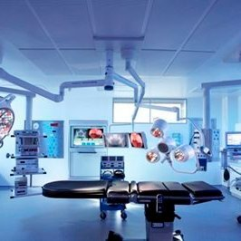

**What We Can Offer You**

We have a range of vacancies for experienced and Newly Qualified Nurses to join our innovative and dynamic teams across NHS Lothian – providing you with the opportunity to gain a breadth of knowledge and exposure to multiple specialties.

**Roles**

* Theatre Practitioner – (Diagnostics Anaesthetics Theatre Critical Care)
* Staff Nurse (Neonatal Unit)
* Staff Nurse (Adult Critical Care)

**Salary**

* Band 5 Range £30,229 to £37,664 (pro rata) per annum

**Benefits**

* A minimum of five weeks annual leave increasing with length of service
* A range of supportive employment policies including Flexible Working
* Full or part time hours considered
* We provide an extensive induction programme and excellent professional training and development opportunities.
* Access to the NHS pension scheme and staff benefits

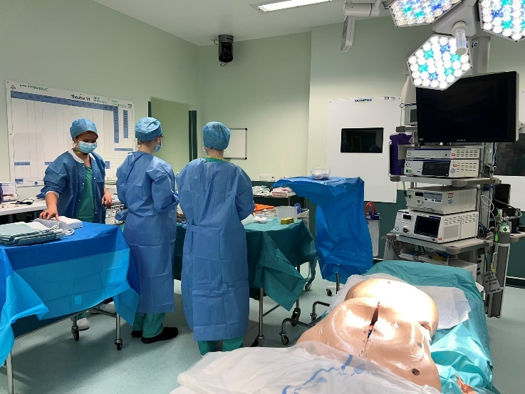The range of surgical specialities provides the unique opportunity to enhance professional knowledge and learn highly desirable skills in Anaesthetics, Scrub and Recovery disciplines through the surgical specialities’ rotation programme, staff simulation training and a range of perioperative development courses provided by our dedicated Education Coordinators across the sites. Our friendly, caring, and approachable multidisciplinary team take pride in providing excellent standards of perioperative care to our patients while nurturing our team member’s professional development in a supportive learning clinical environment.

SJH Theatre Department provides many Specialist Surgical Services for Southeast Scotland, including Maxillofacial, ENT, Burns and Plastics, Gynaecology and Obstetrics, Orthopaedics, Urology, General, Hand, Ophthalmic and 24/7 Emergency Theatres.

The specialities on the RIE site include Obstetrics, Gynaecology, Cardiothoracic, Hepatobiliary, Upper GI, Transplant and Organ Retrieval, Vascular, Trauma, Orthopaedic as well as our 24/7 Emergency Theatre. This is an exciting time to join the team as the site has recently become a Major Trauma Centre and the department are developing Robotic Surgery in a number of specialities. DCN is now co-located on the RIE site offering opportunities in Neurology and Neurosurgery.

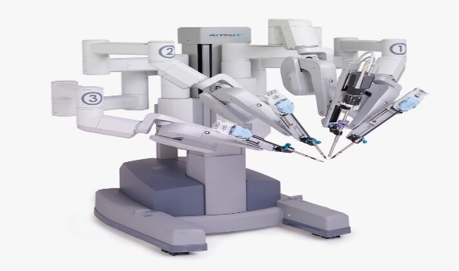Theatres within the WGH undertake a wide range of specialities including Colorectal, Urology, Breast Surgery and 24/7 Emergency Theatre. The team are used to being at the cutting edge of technology as one of the first units in Scotland to establish a Robotic Urological service using the DaVinci Robotic system and thereafter were the first team in Europe to use the innovative Versius robotics.

Theatres can be an intense fast-paced environment with a team-working ethos being at the heart of the services we provide. If you enjoy a challenge and would like to join one of our busy but friendly units, this might be the post for you, and we would look forward to welcoming you into our team.

  