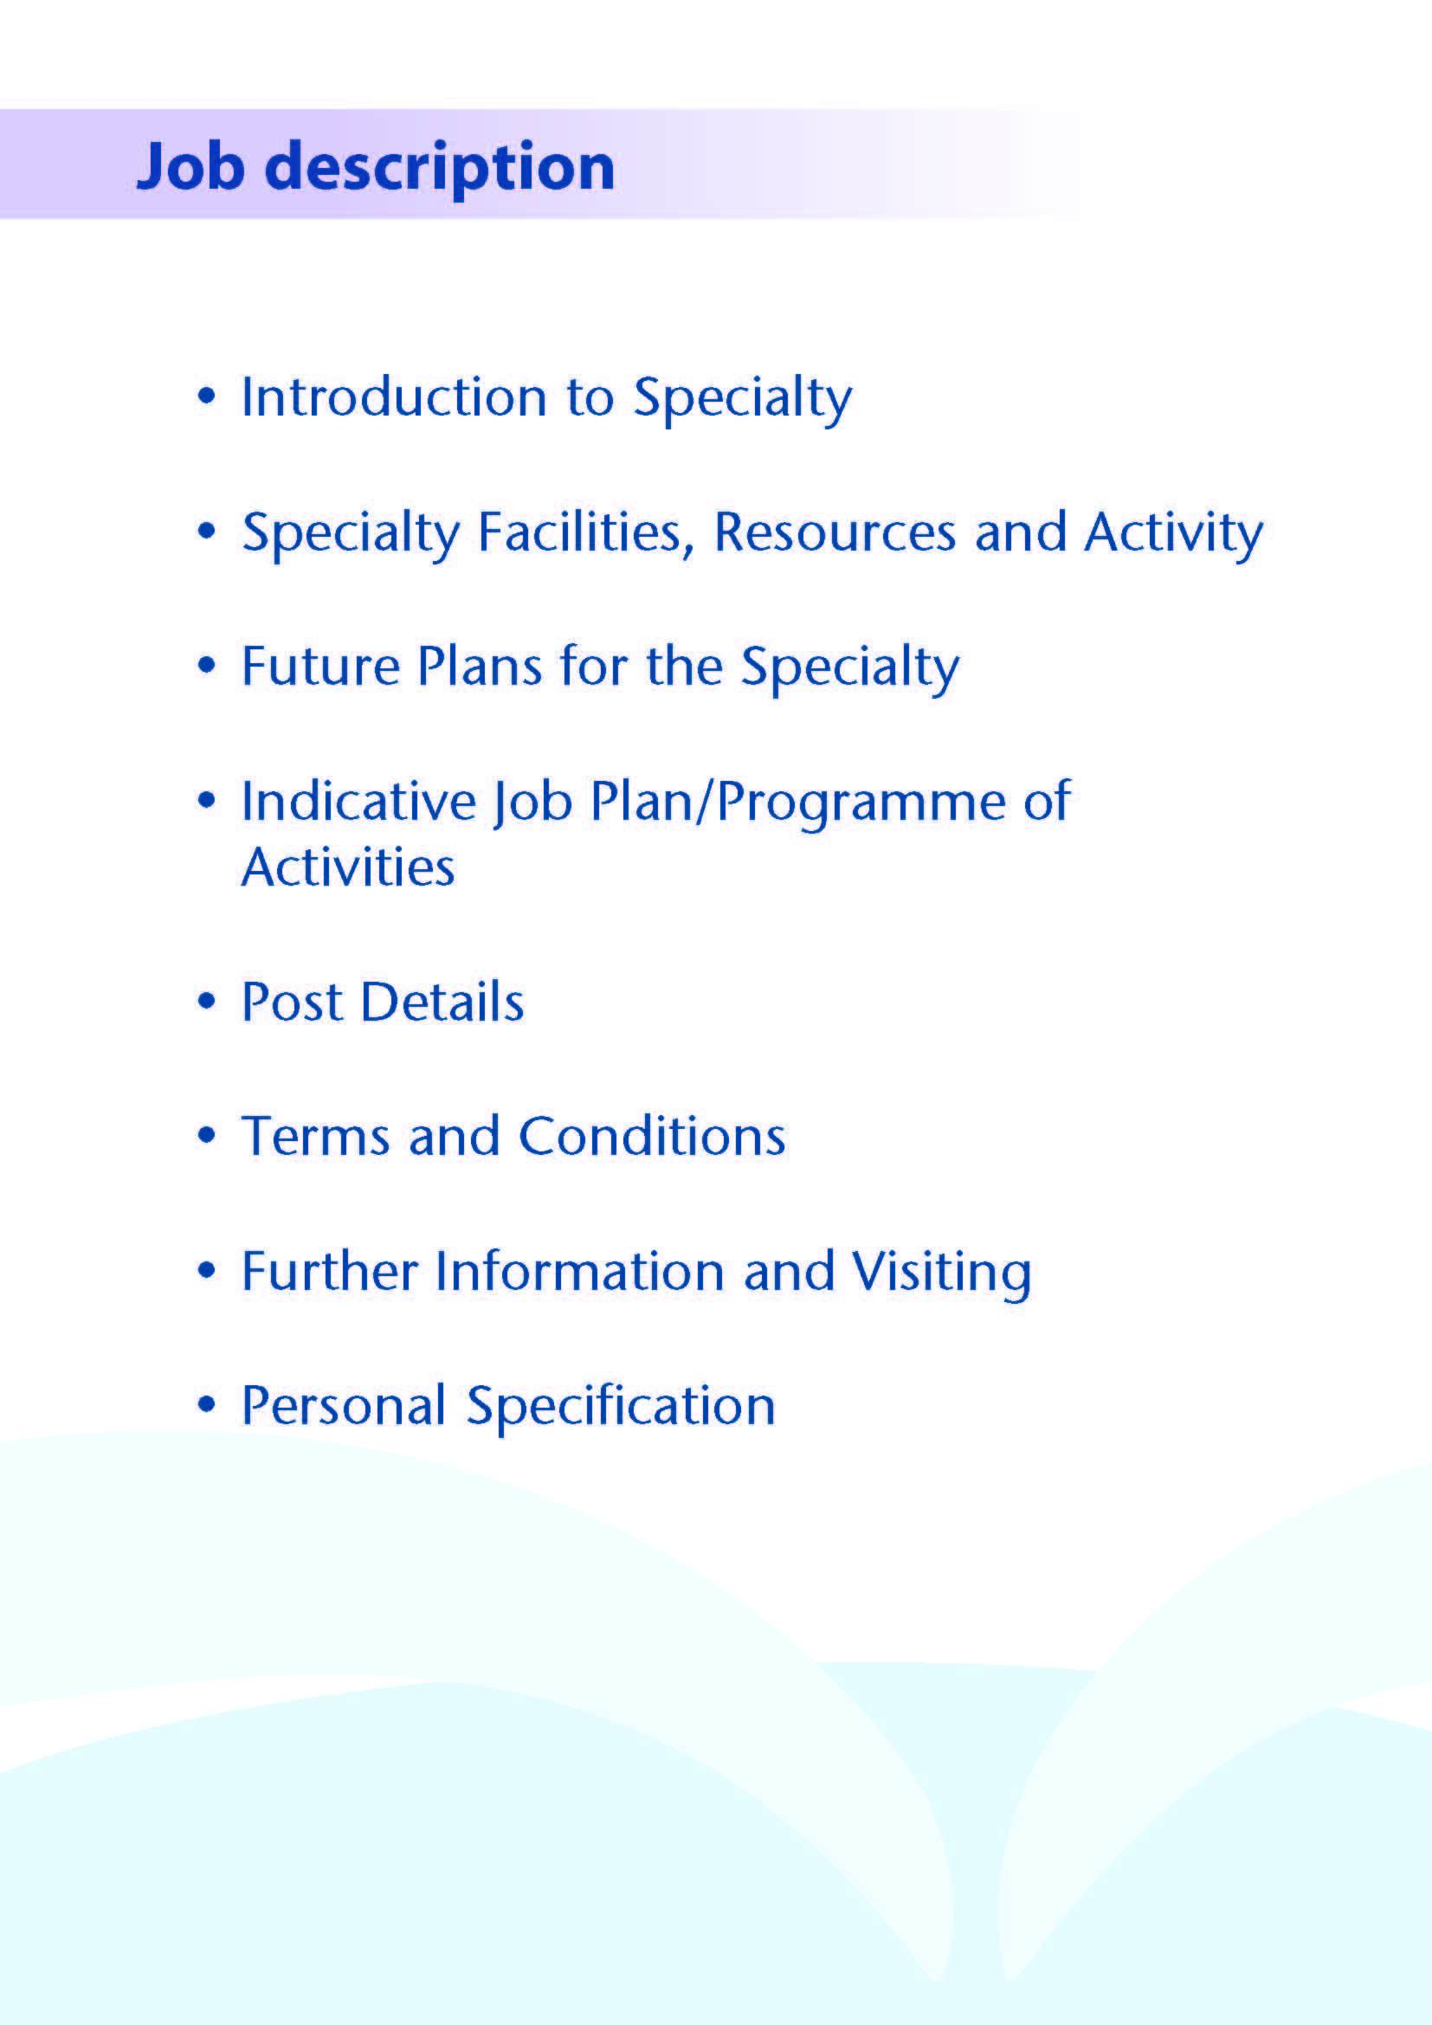



This Specialty Doctor posts are based within the Department of anaesthesia of NHS Ayrshire & Arran (NHSAA). NHSAA has two District General Hospitals, University Hospital Ayr (UHA) and University Hospital Crosshouse (UHC).  The department of Anaesthesia comprises of 43 Consultants, 15 SAS doctors, 20 Trainee Anaesthetists and 3 Anaesthesia Associate trainees.

This post will be based at University Hospital Ayr (UHA).

UHA is a 350 bedded general hospital, opened in 1991 which has a range of laboratory and investigative facilities. The hospital provides acute and elective care in General Surgery & Urology & Ophthalmology. There is an area wide bariatric service, interventional radiology and UHA has been developed as a centre of excellence for elective orthopaedic surgery. UHA serves a population of approximately 175,000.

The medical department provides care in all aspects of general medicine, cardiology, respiratory, endocrinology, haematology and oncology. The regional renal service is provided from University Hospital Crosshouse (UHC) however there is a satellite community unit at UHA.

The regional obstetrics, paediatric and trauma and intensive care services are based at UHC.

Whilst consultant support is always available, it is anticipated that the successful applicant would be competent to safely anaesthetise most ASA I – III for minor or moderate surgery independently. This post will involve participation on the on-call rotas for Critical Care and Emergency Theatre on a 1:8 basis at Ayr Hospital. The successful candidates will also provide cover for an Ayrshire wide critical care transport service.

Ayr Hospital is easily accessed by road, with the recently upgraded M77 providing rapid access to Glasgow (40 minutes from the Ayr Hospital). Rail services also link Ayr to Glasgow and other surrounding towns. There is an extensive bus link from the surrounding area to the hospital. Europe and the wider world are easily accessible by airport links of Glasgow Prestwick International Airport and Glasgow International Airport. Ayr Hospital provide free car parking facilities. Active transport is encouraged with readily available cycle lockers and showering facilities on site. There is an on-site nursery providing child care.



**THEATRE FACILITIES**

The theatre suite consists of 6 main theatres, 3 Day Surgery Theatres an Interventional Radiology theatre and 2 Outpatient procedure rooms.  The nearby Endoscopy suite has 3 fully equipped Endoscopy rooms.

A dedicated Emergency Theatre is available throughout the week and over the weekend for 24 hours a day.

The Anaesthetic Department is located adjacent to the theatre suite.

|  |  |  |
| --- | --- | --- |
| **No. of Facilities** | **University Hospital Ayr** | **University Hospital Crosshouse** |
| Main Theatres | 6 plus interventional theatre | 8 |
| Day Surgery Theatres | 3 | 3 |
| DSU Treatment Room | 2 | 1 |
| Endoscopy Procedure Rooms | 3 | 4 |

**BEDS**

|  |  |  |
| --- | --- | --- |
| **Surgical Specialty** | **University Hospital Ayr** | **University Hospital Crosshouse** |
| General Surgery | 22 | 84  (including 8 Level 2 and 4 Level 1 beds) |
| Orthopaedic | 38 | 70 |
| Ophthalmology | 2 | - |
| Urology | 23 | - |
| ENT / Maxillofacial Surgery | 0 | 17 |
| Plastic Surgery | 0 |  |
| Paediatrics (medical & surgical) | 0 |  |
| Oncology | 0 | 12 |
| High Dependency | 8 | 16 across the hospital |
| ICU | - | 15 |

Additionally there is a Day Surgery Unit which has 20 trolley spaces for day case work at Ayr Hospital.

**Critical Care in Ayrshire**

The Intensive Care Unit is based at UHC is currently funded for 15 beds, including an isolation room. This is increasing to 15 by the end of 2023.

UHA has an 8 bedded level 2 facility which the department of anaesthesia provides input to aspects of care, however base specialties remain responsible for the patients.

# IMAGING

An extensive range of imaging facilities are available including spiral CT with 3D reconstruction, MRI, MRA, radio-isotope facilities and digital subtraction angiography.

**ACCIDENT AND EMERGENCY DEPARTMENT**

UHA provides full Accident Emergency facilities staffed by teams of consultants in Accident and Emergency medicine, supported by Middle grade careers grade and trainee doctors and Emergency Nurse Practitioners.

# NURSE SPECIALIST SERVICES

The Department is supported by specialist pain nurses in both Chronic and Acute pain.

# EDUCATION CENTRES

Excellent post-graduate facilities are provided at UHA in the MacDonald Education Centre. The centres include a full size lecture theatre, classrooms and a number of tutorial rooms. The facilities are supported with modern audio visual and information technology, including teleconferencing facilities. There is an excellent up-to-date library with a resident librarian.

**MEDICAL PHOTOGRPAHY**

The Medical Illustrations Department can provide a full service for clinical photography, preparation of slides, PowerPoint etc, for lecture purposes.

**DEVELOPMENT OPPORTUNITIES**

We are committed in NHS AA to assist our team to develop their career. We actively support our SAS grade staff to develop, with opportunities to join regional and national committees.

***We actively encourage and support those who wish to, to undertake the CESR process.***

**Medical Staff Resources**

**Consultant Anaesthetists**

|  |
| --- |
| **UHA (on call rota)** |
| Dr N Alaouabda |
| Dr S Bhatt (Deputy CD) |
| Dr K Dick (Pain Management) |
| Dr P Hamilton (College Tutor) |
| Dr K Kerr (SAS support) |
| Dr D McLaughlan ADME |
| |  | | --- | | Dr J Mitchell | | Dr J Ramsey (ITU) | | Dr G Scott (Rota Administrator) | |
| Dr J Todd |
| Dr K Walker |

|  |
| --- |
| **UHC ( General on call rota)** |
|  |
| Dr I Anderson (Rota Administrator) (Deputy CD) |
| Dr A Bielinska (trauma) |
| Dr R Bonar (Obstetric Lead) |
| Dr N Brown |
| Dr A Clark |
| Dr A Clyde |
| Dr J Collie (trauma) |
| Dr K Flatman |
| Dr L Hunter |
| Dr P Jacobs |
| Dr R Junkin |
| Dr C Johnstone (Clinical Director) (trauma) |
| Dr E Kerr |
| Dr L McGarrity (Pre op lead) |
| Dr E Neale |
| Dr H Neill (trauma) |
| Dr C Pow |
| Dr J Robertson (College Tutor) |
| Dr K W Tan |
| Dr M Watson (trauma) |
| Dr C Whymark (Pain Management) |

|  |
| --- |
| **UHC (ICU rota)** |
| Dr J Allan (Clinical Director) |
| Dr G Brannan (Specialist Doctor) |
| Dr D Finn |
| Dr T Geary |
| Dr G Houston (Department Chair) |
| Dr P Korsah |
| Dr A Meikle |
| Dr P O’Brien |
| Dr J Selfridge |
| Dr A Spiers |



The department maintains a good working relationship with all surgical specialties and supports the many initiatives in place including same day admission, increasing day case rates and generally supportive in ensuring theatre utilisation is maximised. There are several developing Enhanced Recovery programs in operation.

The trauma reconfiguration plan UHA has been developed as a centre-of-excellence for elective orthopaedic surgery. Where all adult, in-patient & day surgical, elective orthopaedic surgery will be provided.



**SPECIALTY DOCTOR IN ANAESTHESIA**

|  |
| --- |
| A variable and flexible programme of elective theatre lists, emergency theatre lists, emergency cover and on-call, reviewing patients for emergency theatre and responding to Hospital emergency situations.  SPA activities undertaken at variable locations and times. |

1. **Description of Activities during Premium Rate Hours of Work e.g. hours outwith 7am-7pm Monday to Friday**

|  |
| --- |
| Resident first on call for Emergency theatres, Critical Care and Hospital emergencies.  Review and prepare patients for emergency theatre. Assist in management of Critical Care patients in cooperation with respective teams.  Transfer of patients from UHA to UHC or to tertiary centres for treatment. |

1. **Additional Programmed Activities**

|  |
| --- |
| This Job is for 10 PA’s with 9 DCC sessions and 1 SPA session.  The possibility of Additional Programmed Activity may be reviewed after appointment of the successful candidate and job plan reviews. |

**JOB DESCRIPITON**

|  |  |  |
| --- | --- | --- |
| **Type of activity** | **Description of activity including when and where activity is conducted.** | **Average number of hours spent on each activity per week including travel where appropriate** |
| **Direct Clinical Care (DC)**  (work that directly relates to the prevention, diagnosis or treatment of illness) | | |
| Emergency duties (including work carried out during or arising from on-call) . | **Resident on call (12 hr shift).**  **Carry 1st on call Duty page for Theatres & Critical Care**  Respond to referrals/requests from all surgical specialities, medical and A&E. Attend cardiac arrests and A&E standbys. Assess patients and provide advice or Pre-op workup if planned for theatre or stabilise and transfer patient to ITU for further management.  Participate in Critical Care management and liaise with consultant for advice and deal with any unexpected problems in Critical Care. Assist in management of patients in Critical Care in conjunction with respective teams.  Deal with management of acute pain issues. | 16 |
| Operating sessions including pre-operative and post-operative care | Variable and flexible programme of elective theatre lists, emergency theatre lists, emergency cover and on-call, reviewing patients for emergency theatre and responding to Hospital emergency situations.  There is a robust system for the provision of Consultant support for all operations for which anaesthesia is required. | 20 |
| Ward rounds | Critical care and Acute Pain Rounds where appropriate | As part of above |
| Outpatient activities | Out-patient pre-operative assessment clinics where appropriate | As part of above |
| Clinical diagnostic work |  |  |
| Other patient treatment |  |  |
| Public health duties |  |  |
| Multi-disciplinary meetings about direct patient care | Attend Weekly Departmental Meeting Meetings where appropriate | As part of above |
| Patient-related administration linked to clinical work i.e. Directly related to the above (primarily, but not limited to, notes, letters and referrals) | Case note reviews and associated administration where appropriate | As part of above |
| **Total Direct Clinical Care Activities** |  | 36 hours |

|  |  |  |
| --- | --- | --- |
| **Type of activity** | **Description of activity including when and where activity is conducted.** | **Average number of hours spent on each activity per week including travel where appropriate** |
| **Supporting Professional Activities (SPA)**  (activities that underpin Direct Clinical Care) | | |
| Audit | Attendance and participation in Departmental meetings, M&M meetings.  Preparation for and presentation at weekly Journal club meetings. Personal Audit activity is actively encouraged. |  |
| Continuing professional development | Personal reading of online and subscribed journals and attendance at educational meetings internally and externally. | 3 |
| Local clinical governance activities | Attendance and participation in Departmental meetings, M&M meetings. | 0.5 |
| Training | Supervision of new-start trainees in preparation for going on the on-call rota. |  |
| Formal teaching |  |  |
| Appraisal | As participant – keep folder up to date and annual formal review | 0.25 |
| Job planning | As participant | 0.25 |
| Research |  |  |
| Any other supporting professional activities  (including external duties) |  |  |
| **Total Supporting Professional Activities** |  | 4 |

# Proposed Weekly Programme

The post offers 10 sessions with 9 Direct Clinical Care sessions and 1 Supporting Professional Activity session. All activities are currently flexibly worked with sessional commitments planned on a month to month basis.

This will be reviewed three months following appointment and should therefore be regarded as an interim job plan. Opportunities may exist for Additional Programmed Activities to be undertaken subject to service requirements and in accordance with national terms and conditions of service.

A minimum of one SPA will reflect activities such as appraisal, personal audit, professional development (occurring outside study leave time) but dependent on local conditions, may also provide enough time to reflect teaching and other activities.

Further SPA time may be negotiated for specific, clearly identified additional Supporting Activities provided that these are acceptable to the Specialty Doctor and desired by the Board.

**Notes on the Programme**

**Patient Administration**. This activity covers the management of individual patients including Out Patient administration, results reporting, letters/phone calls to patients, carers, GP’S and members of the wider multidisciplinary team involved in the patients care.

**Ward Rounds**: the time allocated is indicative and will be discussed with the appointee. Ward work will include teaching ward rounds as required.

**Travel:** Any travel allocation will be included within the Total Programmed Activities and will be determined by location at which Direct Clinical Care and Supporting Professional activities are carried out.

**On call arrangements:**

**Supporting Professional Activities**: A minimum of 1 SPA is included in the indicative job plan, amounting to 168 hours per annum which shall normally be sufficient to reflect activities such as revalidation, appraisal, personal audit, and professional development (occurring outwith the 30 days of study leave entitlement in any three year period).

Time permitting, it may also cover minimal teaching, training and non-clinical administration. Any additional SPA allocation will require to be evidenced as mutually beneficial and required by the department. Adjustment to the programme to incorporate additional SPA will require other activities to be reviewed to accommodate any increase as necessary. It will be requested that SPAs are delivered at the normal place of work, unless there are mutual advantages to it being performed elsewhere. The exact timing and location of SPAs, and flexibility around these, will be agreed during the 1:1 meeting with the Clinical Director/Associate Medical Director and included in the prospective job plan.

**Research:** Research is encouraged and supported by an active Research and Development Committee. The appointee will be encouraged to develop research interests associated with their specialist interest.

**Teaching**: The post holder will be responsible for the training and supervision of post-graduates and under-graduates and will be expected as part of their SPA allocation to devote time to this activity on a regular basis. In addition he/she will be expected to ensure that Junior Staff and medical students receive adequate support and advice and may act as a contact as the person responsible for overseeing their training and as an initial source of advice.



The post holder will be accountable to the Clinical Director who will agree the Job Plan.

They will be expected to work with local managers and professional colleagues in the efficient running of services and will share with Consultant colleagues in the medical contribution to management. Subject to the provisions of the Terms and Conditions of Service, they are expected to observe NHS Ayrshire and Arran’s agreed policies and procedures, drawn up in consultation with the profession on clinical matters, and to follow the standing orders and financial instructions of NHS Ayrshire & Arran.

In particular, where they formally manage employees of NHS Ayrshire and Arran, the post holder will be expected to follow the Local and National Employment and Personnel Policies and Procedures.

They will be expected to make sure that there are adequate arrangements for hospital staff involved in the care of patients to be able to make contact with the post holder when necessary.

The post holder is required to comply with NHS Ayrshire and Arran’s Health and Safety Policies.

They will be responsible for the training and supervision of Junior Medical Staff who work with the post holder and will be expected to devote time to this activity on a regular basis.

**Resources**

The staff resources of the Directorate are listed elsewhere. The post holder will have access to such general administrative support as is required for the discharge of their duties and responsibilities.

This will include the provision of adequate secretarial and clerical support and the availability of accommodation, equipment etc.

The post holder will receive support from such other professional staff as are employed within NHS Ayrshire and Arran and are deployed to his/her area of patient care.

**Duties and Responsibilities**

The main duties and responsibilities of the post include:

* Continuing responsibility for the care of patients in their care.
* Administrative duties associated with the care of their patients.
* Responsibility for continuing care of patients as scheduled in job plan / programmed activities.
* Responsibilities for carrying out teaching, accreditation and examination duties as required, and for contributing to undergraduate andpostgraduate medical education. The postholder will be expected to comply with College recommendations on Continuing Medical Education.
* The postholder will be required to comply with NHS Ayrshire and Arran’s Policies on Clinical Governance.
* The successful applicant will be encouraged to participate in research and to develop a relevant subspecialty interest, subject to resources and local priorities.
* Requirements to participate in medical audit and in continuing medical education.
* Managerial, including budgetary, responsibilities (where appropriate).

**Annual Appraisal & Job Planning**

You shall also be required to participate in annual appraisal. Job planning is linked closely with, but is separate to, the agreed appraisal scheme for consultants. The job plan review will take into account the outcome of the appraisal discussion and reflect the agreed personal development plan.



Are those determined by the Terms and Conditions of the New Specialty Doctor grade (Scotland) as amended from time to time. The distance that a specialty doctor can reside from the principal base hospital, where travel time is seen as more important than mileage, is subject to the agreement of the Medical Director.



Applicants wishing further information about the post are invited to contact Dr M Watson, Clinical Director for Anaesthesia, Tel 01563 827172 (Secretary) or 01563 521133 (Switchboard), email martin.watson@aapct.scot.nhs.uk, with whom visiting arrangements can also be made.

You may also wish to contact either of the Deputy Clinical Directors, Dr Joellene Mitchell 01292 610555 (switchboard), or Dr Chris Johnstone 01563 521133 (switchboard).

Cameron Sharkey, General Manager for Surgical Services is also happy to be a point of contact and can be contacted as follows: Cameron.sharkey@aapct.scot.nhs.uk / 01563 827361



**Post of**: SPECIALTY DOCTOR IN ANAESTHESIA

**Location**: University Hospital Ayr

## QUALIFICATIONS:

|  |  |
| --- | --- |
| ESSENTIAL | DESIRABLE |
| Full GMC Registration with a current Licence to Practice |  |
| Medical Degree | Fellowship of the Royal College of Anaesthetists |
| Completion of a least 4 years’ full-time postgraduate training (or its equivalent gained on a part-time or flexible basis) at least 2 of which will be in a specialty training programme in Anaesthesia, or as a fixed term specialty trainee in relevant Anaesthesia, or shall have equivalent experience and competencies. |  |

**Skills/Knowledge/Competence**

**SKILLS/KNOWLEDGE/COMPETENCE**

|  |  |  |
| --- | --- | --- |
| **REQUIREMENTS** | **ESSENTIAL** | **DESIRABLE** |
| **General Experience:**   * Expertise in generalist field * Expertise in sub-specialty field | * *Knowledge of and skill relevant to the management of patients requiring anaesthesia for elective and emergency surgery.* * *Ability to communicate effectively with all levels of staff and patients* * *Ability to work efficiently and timeously* * *IT literacy* | * *Ability to develop and maintain a*   *database of clinical practice* |
| **Team Working** | * *Ability to lead appropriate others in the theatre environment as appropriate and to think strategically* * *Effective Team Player* |  |
| **Development** | * *Evidence of relevant Continuing Professional Development* * *Evidence of satisfactory compliance with appraisal requirements* |  |
| **Teaching & Training** | * *Ability to deliver good quality teaching* | * *Interest in and knowledge of*   *advances in medical education and*  *training.* |
| **Research & Publications** |  | * *Evidence of publications or*   *presentations relating to Anaesthesia.* |
| **Clinical Audit** | * *Evidence of involvement in medical audit* |  |
| **Management and Administration** | * *Commitment to effective departmental management and participation in a multidisciplinary group* * *Proven organisational skills* | * *Appropriate management experience* * *Understanding of resource*   *management and quality assurance.* |
| **Personal and Interpersonal Skills** | * *A willingness to accept flexibility to meet the changing needs of the NHS in Scotland* * *Effective communicator and negotiator* * *Demonstrate effective leadership* * *A willingness to develop special interests which conform to the needs of NHS Ayrshire and Arran* * *Ability to operate on a variety of different levels* * *Open and non-confrontational* | * *Knowledge of recent changes in the*   *NHS in Scotland* |