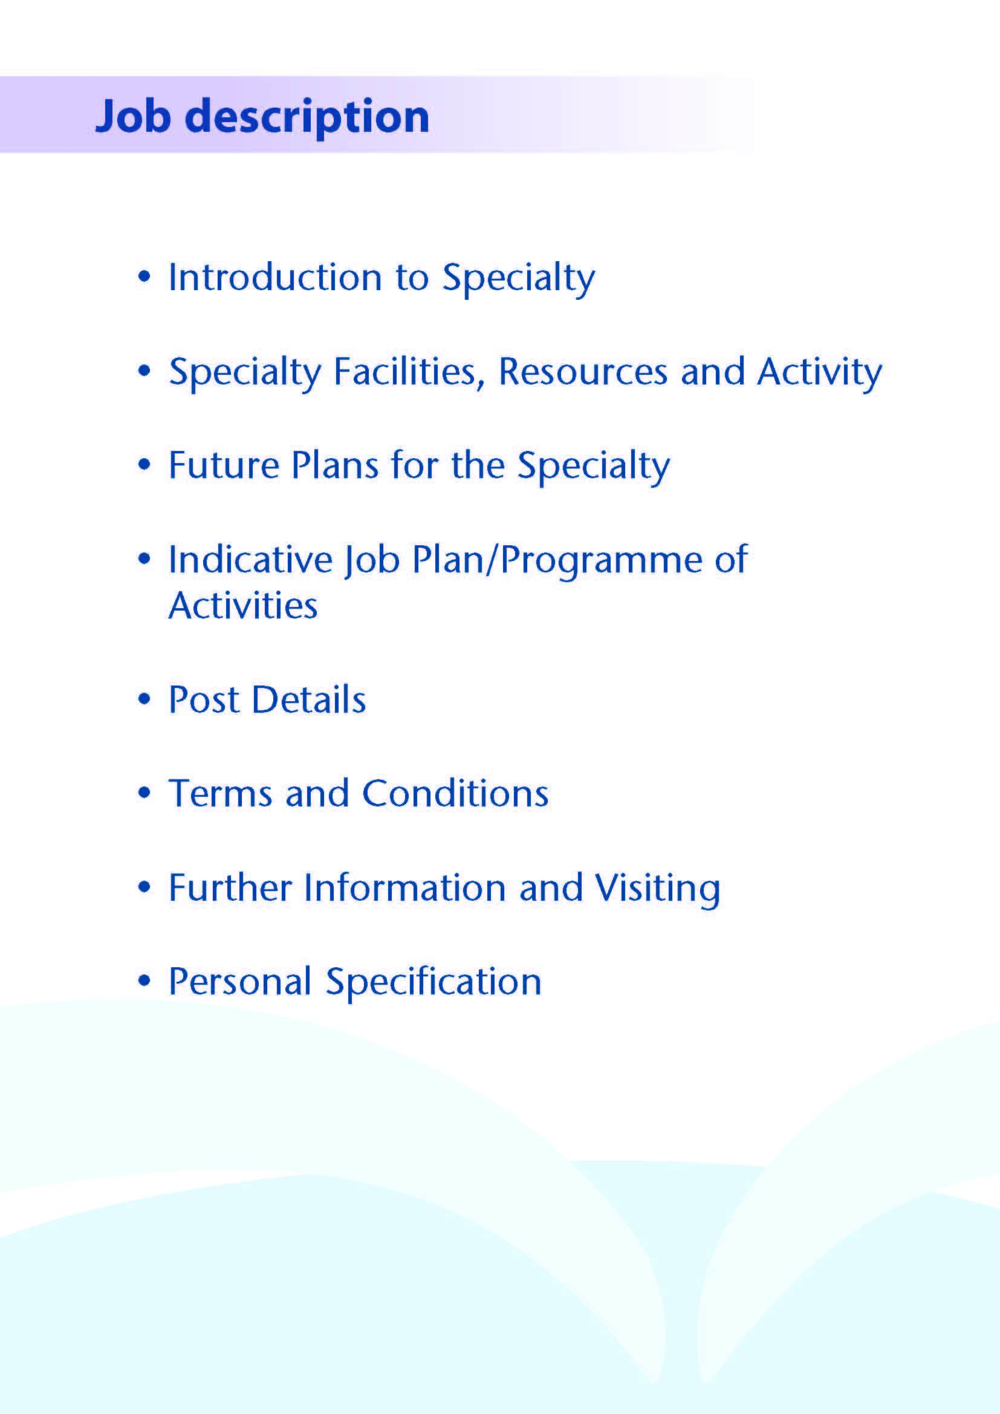



This replacement Consultant post is being offered to support the Oral and Maxillofacial Team within NHS Ayrshire & Arran.

NHS Ayrshire & Arran has two large District General Hospitals; University Hospital Crosshouse and University Hospital Ayr. The Oral and Maxillofacial Department forms part of the Head & Neck Directorate, along with ENT, Orthodontics, Maxillofacial Prosthetics Laboratory and Restorative Dentistry services.

Oral and Maxillofacial services are provided to the Ayrshire & Arran catchment population of 388,000 citizens.

The main base for this post is University Hospital Crosshouse where Oral and Maxillofacial in-patient and day-case services are located. Outpatient Clinics are mainly provided at University Hospital Crosshouse with some at University Hospital Ayr.

The scope of the service within Ayrshire is: -

1. **Dento-alveolar surgery.**

This still constitutes the majority of the work carried out by the unit, which is mainly dealt with by the Speciality Doctor(s) and Trainees under supervision. The Consultants also undertake dento-alveolar surgery in the day surgery unit.

**2. Orthognathic surgery.**

A complete facial deformity service is provided, treating both acquired and congenital deformities in conjunction with the orthodontists, developments include a 3D Printer and funding for a Cone Beam CT Scanner.

**3. Trauma and trauma deformity.**

Hard and soft tissue trauma of the face, jaw and neck is dealt with on an on-call basis by NHS Ayrshire and Arran consultants between Monday and Thursday. The regional consultant on-call service, which the applicant would contribute too, is in place to deal with calls between 1700 on Friday evening and 0800 on Monday morning.

1. **Head and Neck Oncology and Reconstructive Surgery.**

The department has undergone sub-specialisation with one consultant taking responsibility for the maxillofacial input to the head and neck oncology and reconstruction service. The ENT consultants provide the otolaryngology input. Major cases will have had their microvascular surgery in Greater Glasgow and Clyde since 2013. There is cross referral and joint operating on patients. The head and neck oncology managed clinical network supports this service.

1. **Facial cancer.**

There are 6 consultant dermatologists within NHS Ayrshire and Arran. The Oral and Maxillofacial department works collaboratively with the Dermatology team. A well-equipped Treatment Theatre is available within the OMFS clinic suite. There is a well-established fortnightly local skin MDT with links to the weekly regional MDT and Skin Cancer Managed Clinical Network.

### TMJ Disease

All temporomandibular joint problems, but not currently including joint reconstruction, are dealt with by the consultant team. There are already in place established relationships with the radiology department for the provision of MRI and CT scanning

### Implantology

Implantology, both intra- and extra-oral is available for the rehabilitation of both cancer and the congenital and acquired deformity patients. A consultant in Restorative Dentistry carries out the restorative aspects of treatment.

### Cleft Lip and Palate

After reorganisation a team approach exists with three surgeons two OMFS and a Plastic Surgeon undertaking the Surgical Cleft service at RHC, Glasgow. There is a regular joint clinic held in Crosshouse.



# Inpatient Beds

The Head and Neck Directorate operate from the general surgical ward floor at University Hospital Crosshouse. There is a suite of Oral and Maxillofacial offices located at University Hospital, Crosshouse. The consultant would have shared office accommodation. There are currently 4 medical secretaries within the Oral and Maxillofacial department to help with any administrative duties at University Hospital Crosshouse.

# Clinics

At University Hospital Crosshouse the general outpatient department comprises some 50 consulting rooms. There is also a dedicated clinic area for the Oral and Maxillofacial and Orthodontic Departments.

At University Hospital Ayr outpatient services are provided from both a dedicated area and some rooms shared with other specialties.

#### Theatres and Day Surgery

Theatre services supporting the Oral and Maxillofacial department are provided at Crosshouse Hospital. There are 8 main theatres in the theatre complex and 3 day surgery theatres with one treatment room. There are 12 overnight beds for 23-hour cases.

#### Diagnostics

Crosshouse also has a full supporting diagnostic facility including a spiral CT scanner with 3D reconstruction and a new MRI scanner. Cone Beam CT scanning is available within University Hospital Crosshouse.

# Oral and Facial Laboratory

There is a fully equipped oral and facial laboratory, including 3D printer, this is led by a Consultant Maxillofacial Prosthetist and Technologist. Both intraoral and craniofacial prostheses are made at University Hospital Crosshouse.

###### Education Facilities

Both hospitals have extensive facilities for educational support. The MacDonald Education Centre at University Hospital Ayr and the Alexander Fleming Centre at University Hospital Crosshouse have an auditorium, tutorial rooms and up-to-date audio-visual facilities.

Both Education Centres house well stocked libraries which include good IT facilities offering access to Medline and the Internet.

**Medical Staff Resources**

The staffing of the Head & Neck Directorate is as follows:

|  |  |  |
| --- | --- | --- |
| **Consultant Staff** | **Base** | **Specialist Interest** |
| Ms Deborah Boyd (Clinical Director Head and Neck) | Crosshouse | Oral and Maxillofacial /Orthognathic/Facial Deformity/ Trauma |
| Mr Roger Currie (Associate Medical Director, Surgery) | Crosshouse | Oral and Maxillofacial /Skin Cancer/ Orthognathic |
| Mr Ewen Thomson | Crosshouse | Oral and Maxillofacial /Head and Neck Oncology |
| Vacancy (this post) | Crosshouse | Oral and Maxillofacial /Orthognathic/Facial Deformity/ Trauma |
| Ms Lorna Langstaff | Crosshouse | General ENT/Head & Neck Oncology  (Clinical Lead ENT) |
| Mr Andrew Whymark | Crosshouse | General ENT/Rhinology  Clinical Lead CfSD Specialty Delivery Group (ENT) |
| Mr Richard Townsley | Crosshouse | General ENT/Head & Neck Oncology |
| Ms Lyndsay Fraser | Crosshouse | General ENT/Paediatrics & Cochlear Implant |
| Mr Peter Wardrop | Crosshouse | General ENT/Cochlear Implant |
| Ms Natasha Grimmond | Crosshouse | General ENT/Cochlear Implant |
| Mr Padraig Ferry | Crosshouse | Locum Consultant Orthodontics |
| Ms Sue Thomas | Crosshouse | Locum Consultant Orthodontics |
| Mr Andrew McInnes | Crosshouse | Consultant Restorative Dentistry (visiting) |

|  |  |  |
| --- | --- | --- |
| **Speciality Doctor** | **Base** | **Specialist Interest** |
| Dr Julie Cross | Crosshouse | Oral and Maxillofacial (P/T) |
| Dr Alison Murray | Crosshouse | Oral and Maxillofacial (P/T) |
| Dr Louisa McCaffrey | Crosshouse | Oral and Maxillofacial (F/T) |
| Dr Xixi Zhu | Crosshouse | Oral and Maxillofacial (F/T) |

The department is supported by junior staff as part of the Pan Scotland StR Training Programme 1 Dual qualified StR on rotation. Four DCT2’s, one DCT1, and 4 Specialty Doctors.

**Activity (average per annum):**

|  |  |  |  |  |
| --- | --- | --- | --- | --- |
|  | **In-patient Admissions** | **Day Case Admissions** | **New Out-patient Appointments** | **Out-patient Treatments** |
| Maxillofacial Department | 513 | 458 | 3187 | 927 |
| ENT Department | 1681 | 604 | 6597 | 409 |
| Orthodontics | 0 | 0 | 826 | 4770 |



The OMFS department is very forward thinking and has been at the forefront of many innovations. Any contribution by this new post would be welcome in terms of the department’s development. As this is a new post the successful candidate will be supported to develop a complementary interest to the current consultants and expand the opportunities for team working across the West of Scotland Region.

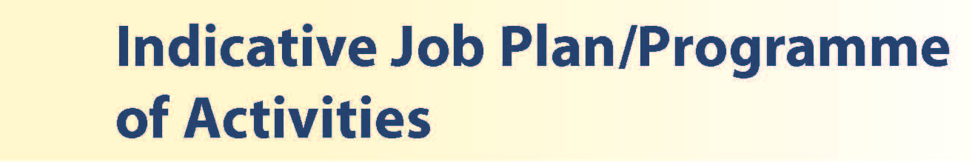

# Proposed Weekly Programme

The proposed weekly programme is shown below. Activities with current fixed time commitments will be carried out as detailed in the work programme e.g. clinics. Other DCC and SPA activities are shown with indicative timings within the weekly programme and will be discussed with the appointee.

**Notes on the Programme**

**Patient Administration**. This activity covers the management of individual patients including Out Patient administration, results reporting, letters/phone calls to patients, carers, GP’S and members of the wider multidisciplinary team involved in the patients care.

**Ward Rounds**: the time allocated is indicative and will be discussed with the appointee. Ward work will include teaching ward rounds as required.

**Travel:** Any travel allocation will be included within the Total Programmed Activities and will be determined by location at which Direct Clinical Care and Supporting Professional activities are carried out.

**On call arrangements:** The postholder will be part of the current OMFS rota. On call will be on a 1:4, Monday through Thursday for Ayrshire and Arran and potentially 1:8 weekends on the Regional Rota covering the West of Scotland. The availability supplement is currently 8%

**Supporting Professional Activities**: NHS Ayrshire and Arran recognise the important role Job Planning has in ensuring consultants are supported in delivering high quality, safe, sustainable clinical care to patients. It is therefore important to ensure there is an adequate balance between direct clinical care activities and activities which support both the personal and professional development of the consultant workforce and facilitates agreed contribution to activities including:

* Under and post graduate teaching/training
* Clinical Governance
* Quality and Patient Safety
* Research and Innovation
* Service management and planning
* Work with professional bodies

All consultants will have 1 SPA as a minimum to support job planning, appraisal and revalidation. However the final balance of SPA and DCC activity will be agreed between the appointee and clinical manager prior to contracts being agreed.

There may be a requirement to vary the DCC outlined in the indicative timetable below when the final balance of DCC and SPA is subsequently agreed. There may also be opportunities to contract for Extra Programmed activities Opportunities subject to service requirements and in accordance with national terms and conditions of service.

If the post-holder will be responsible for the formal training and supervision of post-graduates and under-graduates, a suitable additional allocation of SPA time will be made in accordance with national guidance.

**Job Plan Review**

New appointees will discuss the indicative job plan with the Clinical Director, prior to commencement and will at that time review the balance of activities. Where it is possible to agree a revisions to the indicative plan in advance of commencement this will be acted upon. In any event however, there must be an interim Job Plan review conducted at 3 months post commencement to agree and finalise the Job Plan. The consultant at time of induction should ask for an interim review date to be scheduled. The agreed job plan will include all the consultant’s professional duties and commitments, including agreed Supporting Professional Activities.    Thereafter Job Planning will be carried out annually as part of the Boards Job Planning process.

**Private Practice:** If the post-holder wishes to undertake any private practice, they are obliged to inform their employer at the time of appointment of their intentions to do so. This should be submitted in writing to the Clinical Director. The conduct of private practice will be in accordance with the Consultant Contract (Scotland) Terms and Conditions.

The post-holder shall be free to undertake private practice without approval provided such work is undertaken outside the time agreed in the job plan for programmed activities. (Refer Section 6 of the New Consultant Contract).

|  |  |  |  |  |  |  |  |  |  |  |  |  |  |  |  |  |  |  |  |  |  |  |  |  |  |  |  |  |  |  |  |  |  |  |  |  |  |  |  |  |  |  |  |  |  |  |  |  |  |  |  |  |  |  |  |  |  |  |  |  |  |  |  |  |  |  |  |  |  |  |  |  |  |  |
| --- | --- | --- | --- | --- | --- | --- | --- | --- | --- | --- | --- | --- | --- | --- | --- | --- | --- | --- | --- | --- | --- | --- | --- | --- | --- | --- | --- | --- | --- | --- | --- | --- | --- | --- | --- | --- | --- | --- | --- | --- | --- | --- | --- | --- | --- | --- | --- | --- | --- | --- | --- | --- | --- | --- | --- | --- | --- | --- | --- | --- | --- | --- | --- | --- | --- | --- | --- | --- | --- | --- | --- | --- | --- | --- |
| **PROPOSED WEEKLY PROGRAMME**   |  |  |  |  |  |  |  |  |  |  |  |  |  |  |  |  |  |  |  |  |  |  |  |  |  |  |  |  |  |  |  |  |  |  |  |  |  |  |  |  |  |  |  |  |  |  |  |  |  |  |  |  |  |  |  |  |  |  |  |  |  |  |  |  |  |  |  |  |  |  |  |  |  |  | | --- | --- | --- | --- | --- | --- | --- | --- | --- | --- | --- | --- | --- | --- | --- | --- | --- | --- | --- | --- | --- | --- | --- | --- | --- | --- | --- | --- | --- | --- | --- | --- | --- | --- | --- | --- | --- | --- | --- | --- | --- | --- | --- | --- | --- | --- | --- | --- | --- | --- | --- | --- | --- | --- | --- | --- | --- | --- | --- | --- | --- | --- | --- | --- | --- | --- | --- | --- | --- | --- | --- | --- | --- | --- | | |  |  |  |  | | --- | --- | --- | --- | | **DAY** | **HOSPITAL/ LOCATION** | **ACTIVITY** | **HOURS PER ACTIVITY INC TRAVEL** | | **FROM / TO** | | **Monday** |  |  |  | | 08.30-9.00  9.00-12.00 | Crosshouse | Ward Round  SPA/Admin weeks 1,3 | 0.5  3.5 (1.5) | | 1.00 – 5.00 | Crosshouse | Orthognathic Planning Clinic | 3.5 | | **Tuesday** |  |  |  | | 08.00-08.30  09.00 - 13.00. | Crosshouse | Skin Cancer MDT Weeks 2&4  Clinic weeks 1,3,5 | 4 | | 13.30 - | Crosshouse | Theatre weeks 1 and 3  SPA weeks 2,4 and 5 | 4 | | **Wednesday** |  |  |  | | 08.30 - 9.00  09.00 - 13.00 | Crosshouse | Ward Round  Clinic Crosshouse | 0.5  4 | | p.m. | Crosshouse | Admin | 4 (2.5) | | **Thursday** |  |  |  | | 09.00 to 13.00. | Crosshouse | Clinic | 4 | | 13.00 to 17.00. | Crosshouse | Orthognathic Clinic | 4 | | **Friday** |  |  |  | | 08.00 – 17.00 | Crosshouse | Theatre Dual operating | 9 | | **Saturday** |  |  |  | | **Sunday** |  |  |  | | **Total** |  |  | 40 hours | | |



The postholder will be accountable to the Clinical Director of the Head and Neck Directorate who will agree the Job Plan.

He/she will be expected to work with local managers and professional colleagues in the efficient running of services. Subject to the provisions of the Terms & Conditions of Service, he/she is expected to observe NHS Ayrshire & Arran’s agreed policies and procedures, drawn up in consultation with the profession on clinical matters, and to follow the standing orders and financial instructions of NHS Ayrshire & Arran.

He/she will be expected to make sure that there are adequate arrangements for hospital staff involved in the care of patients to be able to make contact with the postholder when necessary.

The postholder is required to comply with the NHS Ayrshire & Arran Health and Safety Policies.

He/she will be responsible for the training and supervision of Junior Medical/Dental Staff who work with the postholder and will be expected to devote time to this activity on a regular basis. In addition, he/she will be expected to ensure that Junior Staff have access to advice and counselling. If appropriate, the postholder will be named in the Contracts of Doctors/Dentists in training grades as the person responsible for overseeing their training, and as the initial source of advice to such Doctors/ Dentists on their career.

**Resources**

The postholder will have access to such general administrative support as is required for the discharge of his/her duties and responsibilities.

The postholder will receive support from such other professional staff as are employed within the Division and are deployed to his/her area of patient care.

**Duties and Responsibilities**

The main duties and responsibilities of the post include:

* Responsibility for the care of patients in his/her care and for the proper functioning of the Department.
* Administrative duties associated with the care of his/her patients.
* Opportunities to undertake clinical audit and to be an active participant in the regular educational meetings within the department.
* The postholder will be required to comply with Organisational Policies on Clinical Governance.
* Requirements to participate in medical audit and in continuing medical education.

**Annual Appraisal & Job Planning**

You shall also be required to participate in annual appraisal. The job plan review will take into account the outcome of the appraisal discussion and reflect the agreed personal development plan.



The Terms and Conditions of Service are those determined by the Terms and Conditions of the New Consultant Grade (Scotland) as amended from time to time. The distance that a consultant can reside from the principal base hospital, where travel time is seen as more important than mileage, is subject to the agreement of the Executive Medical Director, but it is usually anticipated that a journey that takes no more than 30 minutes for any emergency situation would be acceptable.



Applicants wishing further information about the post are invited to contact Ms Debbie Boyd, Clinical Director and Consultant in Oral and Maxillofacial Surgery, Tel: (01563) 827293, with whom visiting arrangements can also be made.



**Post of**: Consultant in Oral & Maxillofacial Surgery

**Location**: University Hospital Crosshouse

## QUALIFICATIONS:

|  |  |  |
| --- | --- | --- |
| REQUIREMENTS | ESSENTIAL | DESIRABLE |
| GMC Post-graduate qualifications | Full GMC Registration with current Licence to Practice | Intercollegiate Fellowship of the Royal College of Surgeons in OMFS or Equivalent |
| Specialist Register | Certificate of Completion of Training (CCT) or Evidence of Higher Speciality Training leading to CCT or be within 6 months of confirmed entry to the Specialist Register from the date of interview.  Inclusion on the GMC Specialist Register | Inclusion on the GDC Specialist Register |

**SKILLS/KNOWLEDGE/COMPETENCE**

|  |  |  |
| --- | --- | --- |
| **REQUIREMENTS** | **ESSENTIAL** | **DESIRABLE** |
| **General Experience:** | Broad experience in OMFS | Post CCT experience in head and neck oncology |
| **Team Working** | Effective Team Player  Evidence of working with other specialties e.g. ENT / Orthodontics /Restorative |  |
| **Development** | Evidence of audit and involvement in clinical improvement activity. |  |
| **Teaching & Training** | Experience in teaching  Desire to promote education for training grade staff | Proven ability to deliver high quality teaching  Interest in and knowledge of advances in medical education and training. |
| **Research & Publications** |  | Evidence of publications in a Peer-reviewed Journal. |
| **Clinical Audit** | Evidence of previous audit activity | Peer reviewed publications and presentations |
| **Management and Administration** | Commitment to effective departmental management and the organisation and management of a multidisciplinary team. | Proven ability to lead a clinical team.  Proven management experience.  Understanding of resource management and quality assurance.  Proven organisational skills |
| **Personal and Interpersonal Skills** | Effective communicator and negotiator.  Demonstrate effective team leadership.  A willingness to develop special interests which conform to the needs of NHS Ayrshire and Arran.  Ability to operate on a variety of different levels  The ability to work flexibly and constructively with a team of colleagues. | Knowledge of recent changes in the NHS in Scotland  A willingness to accept flexibility to meet the changing needs of the NHS in Scotland |