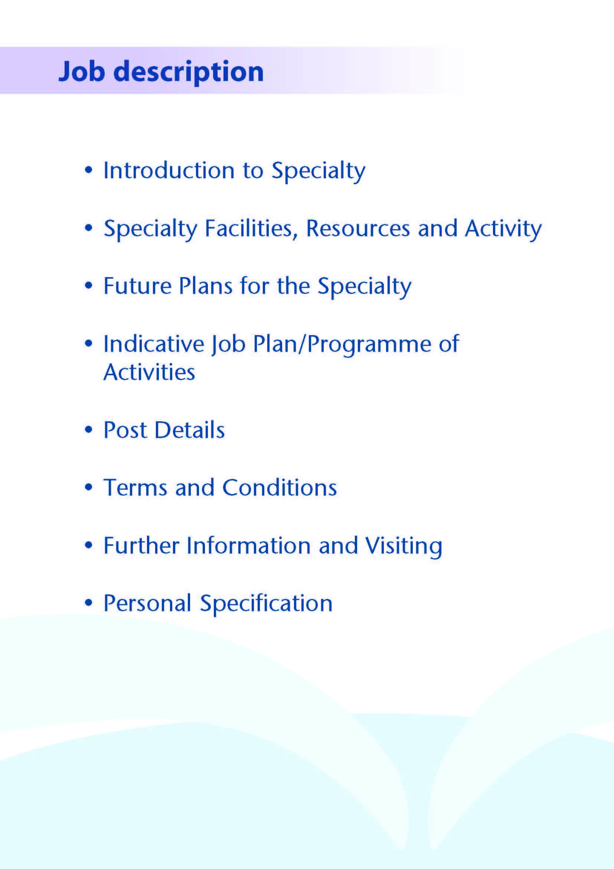

Post: Specialty Doctor – Ear Nose and Throat



An opportunity has arisen for a motivated and ambitious individual to join the team in the Ayrshire Ear, Nose and Throat (ENT) department. This is a Locum Speciality Doctor post and will support the ENT team within NHS Ayrshire & Arran on a one year fixed term basis in the first instance.

We are delighted that you are interested in applying for a Specialty Doctor post. Ayrshire is a wonderful location to live and work with excellent local schools.

Ayrshire and Arran covers an area of some 2,500 square miles and serves a population of around 388,000 citizens (approximately 7% of the population of Scotland).

Ayrshire and Arran’s area is co-terminus with the three local authorities of East, North and South Ayrshire and includes the island communities of Arran and Cumbrae. NHS Ayrshire & Arran invests around £750 million annually in health improvement and service delivery on behalf of its population. It employs around 11,000 staff (9,000 WTEs).

We have beautiful islands and beaches on our doorstep yet still an easy distance to Glasgow City and surrounding areas. There are excellent road and rail links to Glasgow, Central Scotland, and the Western Highlands and beyond. There are domestic and international flight connections at Glasgow Airport, south and west side of the city.

We have world class outdoor pursuits and recreational facilities, with wonderful opportunities for sailing, walking, cycling - and many golf courses.

NHS Ayrshire and Arran currently has two large District General Hospitals, one at University Hospital Crosshouse (UHC) and one at University Hospital Ayr (UHA)

The ENT Department forms part of the Head & Neck Directorate, along with Oral and Maxillofacial Surgery, Orthodontics (complex IOTN and Orthognathic cases) and Restorative Dentistry (oral cancer rehabilitation, hypodontia and trauma). The Directorate is part of the Surgical Division.

Adult and Paediatric Emergency and elective ENT services are provided to the Ayrshire & Arran catchment population of 375,000 residents and the department also provides the National Cochlear Implant Service which serves all patients in Scotland.

We are looking for experienced ENT middle grade staff to provide care to patients attending the ENT Department under the direction of the ENT Consultants, and to be fully involved in all clinical aspects.

The postholder will participate in the on-call rota fully supported by the Consultant team

NHS Ayrshire and Arran is committed to maintaining and improving ENT services for the population of Ayrshire and is fully involved in the teaching of Glasgow University undergraduates.

**THE DEPARTMENT**

The department is based in University Hospital Crosshouse and covers the whole Ayrshire population from that base. Crosshouse ENT department hosts the Scottish National Cochlear Implant Centre and some duties will involve looking after these patients. This gives the post a unique exposure to this very specialised area of ENT surgery.



# Inpatient Beds

The Head and Neck team hold beds within the main surgical floor of University Hospital Crosshouse. There is a suite of Head and Neck offices located at Crosshouse. The postholder would have shared office accommodation. There are currently 4 medical secretaries within the ENT department to help with any administrative duties at University Hospital Crosshouse and 2 secretaries supporting the ENT department at University Hospital Ayr.

# Clinics

At University Hospital Crosshouse the main outpatient department comprises some 50 consulting rooms. There is a dedicated fully equipped area for the ENT clinics.

There is also a dedicated clinic area for the Audiology, Oral and Maxillofacial and Orthodontic Departments.

At University Hospital Ayr outpatient services are provided from both a dedicated area and some rooms shared with other specialties.

#### Theatres and Day Surgery

Theatre services supporting the ENT department are provided at Crosshouse Hospital. There are 8 main theatres in the main theatre suite and 3 day surgery theatres with one treatment room. There are overnight beds for 23-hour cases although much of our work is carried out as true day surgery. There is a 12 bed ICU facility co-located with theatres.

#### Diagnostics

Crosshouse also has a full supporting diagnostic facility including two spiral CT scanner with 3D reconstruction and a new MRI scanner. Cone Beam CT scanning is also available within University Hospital Crosshouse, along with a 3D printer in the maxillofacial laboratory.

###### Education Facilities

Both hospitals have extensive facilities for educational support. The Alexander Fleming Centre at University Hospital Crosshouse and MacDonald Education Centre at University Hospital Ayr both have an auditorium, tutorial rooms and up-to-date audio-visual facilities and simulation suite.

Both Education Centres house well stocked libraries which include good IT facilities offering access to online journals.

**Medical Staff Resources**

The staffing of the Head & Neck Directorate is as follows:

|  |  |  |
| --- | --- | --- |
| **Consultant Staff** | **Base** | **Specialist Interest** |
| Ms Lorna Langstaff  Clinical Lead ENT | Crosshouse | General ENT/Head and Neck Oncology |
| Mr Andrew Whymark | Crosshouse | General ENT/Rhinology/ Otology |
| Ms Lyndsay Fraser | Crosshouse | General ENT/Paediatrics & Cochlear Implant |
| Mr Peter Wardrop | Crosshouse | General ENT/Paediatrics & Cochlear Implant |
| Mr Richard Townsley | Crosshouse | General ENT/Head and Neck Oncology |
| Ms Natasha Grimmond | Crosshouse | General ENT/Paediatrics & Cochlear Implant |
| Mr Roger Currie | Crosshouse | Oral and Maxillofacial / Facial Deformity/ Skin Cancer / Associate Medical Director, Surgery |
| Ms Debbie Boyd | Crosshouse | Oral and Maxillofacial /Orthognathic/Facial Deformity/ Trauma; Clinical Director for Head and Neck and Dermatology |
| Mr Ewen Thomson | Crosshouse | Oral and Maxillofacial / Head and Neck Oncology |
| Miss Mhairi Little | Crosshouse | Oral and Maxillofacial /Orthognathic/Facial Deformity/Trauma |
| Mr Padraig Ferry | Crosshouse | Locum Consultant Orthodontics |
| Ms Sue Thomas | Crosshouse | Locum Consultant Orthodontics |
| New Appointment | Crosshouse | Consultant Orthodontics (starting January 2025) |
| Dr Andrew McInnes | GDH/Crosshouse | Consultant Restorative Dentistry (visiting) |

|  |  |  |
| --- | --- | --- |
| **Speciality Doctor ENT** | **Base** | **Specialist Interest** |
| This post | Crosshouse | ENT |
| Dr Stuart Benzie | Crosshouse | ENT |
|  |  |  |
| **Speciality Doctor OMFS** | **Base** | **Specialist Interest** |
| Ms Louisa McCaffrey | Crosshouse | Oral and Maxillofacial (F/T) |
| Ms Xixi Zhu | Crosshouse | Oral and Maxillofacial (F/T) |

The ENT department is staffed by 6 consultants, 2 specialty doctors, 2 ENT specialist trainees on the West of Scotland training programme, one FY2 and 2 GP trainees and two Clinical Development Fellow. The ward is staffed by the junior trainees during the day and Hospital at Night rota overnight. There are two Head and Neck Oncology nurses (CNS).



The ENT department are very forward thinking and have been at the forefront of many innovations. NHS Ayrshire & Arran host the National Cochlear Implant Service and were at the forefront of advancing practice/extended scope roles for nursing staff. Any contribution by this new post would be welcome in terms of the department’s development.

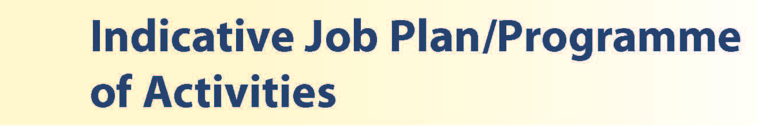

# Proposed Weekly Programme

The proposed weekly programme is shown below. Activities with current fixed time commitments will be carried out as detailed in the work programme e.g. clinics. Other DCC and SPA activities are shown with indicative timings within the weekly programme and will be discussed with the appointee.

**CONDITIONS AND HOURS OF DUTY**

These include routine care of all in patients in ENT dept. including ward rounds. Outpatient clinics, elective surgery lists and middle grade non-resident on call. Until 9pm there is an ENT grade on call in the hospital, overnight it is the hospital at night team who report to the middle grade rota. GP and Emergency Department (ED) refer to the middle grades overnight.

National Terms and Conditions of Services apply to this post.

The working arrangements are based upon flexibility rostering and your pattern of work may be subject to amendment at short notice to cover the absence of colleagues sharing the rota.The nature of this post is such that it falls within the maximum permissible hours for junior staff.

Therefore you are not permitted to undertake locum medical or dental work for this or any other employer where such work could cause your contracted hours to breach the controls set out in the Terms and Conditions of Service.

In addition to the annual leave entitlement as detailed in your Contract of Employment, you are also entitled to a proportion of a maximum of 30 days per annum for the provision of Study Leave (proportionate to the duration of your fixed term contract). Requests for study leave must be authorised by the Consultant in Charge, and are subject to the exigencies of the service.

**On call arrangements**

The middle grade on call is a 1:6 Rota with prospective cover.

**PROPOSED WEEKLY PROGRAMME - INDICATIVE**

|  |  |  |  |  |  |  |  |  |  |  |  |  |  |  |  |  |  |  |  |  |  |  |  |  |  |  |  |  |  |  |  |  |  |  |  |  |  |  |  |  |  |  |  |  |  |  |  |  |  |  |  |  |  |  |  |  |  |  |  |  |  |  |  |  |  |  |  |  |  |  |  |  |  |  |  |  |  |
| --- | --- | --- | --- | --- | --- | --- | --- | --- | --- | --- | --- | --- | --- | --- | --- | --- | --- | --- | --- | --- | --- | --- | --- | --- | --- | --- | --- | --- | --- | --- | --- | --- | --- | --- | --- | --- | --- | --- | --- | --- | --- | --- | --- | --- | --- | --- | --- | --- | --- | --- | --- | --- | --- | --- | --- | --- | --- | --- | --- | --- | --- | --- | --- | --- | --- | --- | --- | --- | --- | --- | --- | --- | --- | --- | --- | --- | --- |
| |  |  |  |  | | --- | --- | --- | --- | | **DAY** | **HOSPITAL/ LOCATION** | **ACTIVITY** | **HOURS PER ACTIVITY INC TRAVEL** | | **FROM / TO** | | **Monday** |  |  |  | | am | Crosshouse | Ward Round  Emergency Clinic | 4 | | pm | Crosshouse | Paediatric Clinic | 4 | | **Tuesday** |  |  |  | | am | Crosshouse | Clinic | 4 | | pm | Crosshouse | Theatre | 4 | | **Wednesday** |  |  |  | | am | Crosshouse | Clinic | 4 | | pm | Home | Time off in Lieu of On Call | 4 | | **Thursday** |  |  |  | | am | Crosshouse | Clinic | 4 | | pm | Crosshouse | Teaching / Supervision / Admin | 4 | | **Friday** |  |  |  | | am | Home | TOIL for On call | 4 | | pm | Crosshouse | Department Meeting/ CPD | 4 | | **Saturday** |  |  |  | | **Sunday** |  |  |  | | **Total** |  |  | 40 hours | |



**Job Plan**

The post holder is required to agree a detailed job plan. Efforts will be made to complete job planning prior to the date of commencement in post, or, if this is not possible, as soon as possible following this date. The detail of fixed sessions, including any special interest, will be finalised following appointment of the successful applicant. It is expected initially that 9 programmed activities per week will be devoted to direct clinical care, with 1 programmed activity allocated for supporting professional activities Attendance at multi-disciplinary team meetings, pre-procedure consultations, are included within the 9 programmed activities of direct clinical care and will be appropriately timetabled. Subject to completion of job planning, the proposed weekly timetable will follow a rolling pattern and will be linked to a consultant pairing. The work will include elective theatres and out-patient clinics.

Contracted activities for this appointment will be defined and agreed with the post holder and the Clinical Director for ENT. The post holder will be professionally responsible to the Associate Medical Director and managerially responsible to the General Manager Surgical Services.

This post is available on a full-time basis and part time basis but the Board welcomes applications from individuals who are unable to undertake a full time commitment and who may wish to work on either a part-time or job share basis.



The terms and conditions of service applicable to this appointment are the Specialty Doctor Terms and Conditions of Service (Scotland) 2008 as amended from time to time. NHS Ayrshire & Arran will require the post holder to agree with the Lead Clinician and General Manager, a job plan of fixed and other commitments, which will be reviewed on an annual basis and revised as necessary to meet the requirements of the local and national service issues.

Specialty Doctors will be required to participate in an annual appraisal. Formal appointment to this post will be conditional upon satisfactory completion of all pre-employment checks, including satisfactory medical screening.

On commencement of employment, salary will be determined in accordance with Schedule 14 of the terms and conditions of service. This appointment will be superannuable under the NHS Superannuation Scheme. New employees will automatically be enrolled in the scheme unless they opt out. For further information, please contact the Scottish Public Pensions Agency (SPPA) on 01896 893100 or visit www.sppa.gov.uk.

The employment is subject to three calendar months’ notice on either side.



Interested applicants are invited to visit the departments and/or discuss the posts further with Ms Lorna Langstaff, Clinical Lead and Consultant ENT Surgeon on 01563 827861 or by email at elizabeth.langstaff@aapct.scot.nhs.uk



**Post of**: Locum Speciality Doctor - ENT Surgery

**Location**: University Hospital Crosshouse

|  |  |  |
| --- | --- | --- |
|  | ESSENTIAL | DESIRABLE |
| QUALIFICATION | Eligible for full registration and licensing with GMC.  MBChB or equivalent.  Satisfactory completion of Foundation Year 2 Competencies – For those entering through the Foundation Years. | Distinctions Awards  Prizes  MRCS |
| EXPERIENCE | Completion of FY2 or equivalent with successful completion of competencies.  6 months ENT experience  Logbook documentation of surgical exposure to date.  Demonstration of clear, successful progression of training consistent with personal circumstances | Evidence of ENT procedures / operations completed |
| CLINICAL KNOWLEDGE & TECHNICAL EXPERTISE | Completion of the competencies laid out for achievement by the end of FY2.  Evidence of an aptitude for surgery with good manual dexterity.  Knowledge of evidence based practice. | Development of strong clinical skills and knowledge. |
| ACADEMIC ACHIEVEMENT | Reflective approach  Understanding of research method  Insight of audit process | Actively involved in audit project |
| ORGANISATIONAL SKILLS | Ability to achieve a balance between urgent and important demands  Ability to manage under pressure  IT skills | Participation in meetings, journal clubs etc. |
| COMMUNICATION SKILL | Evidence of ability to communicate effectively written and spoken  Evidence of effective interpersonal skills  Ability to work in an multidisciplinary team |  |
| PERSONAL QUALITIES | Personal integrity and respect for others  Ability to follow instructions  Potential to benefit from available training | Approachable, confident, assertive |
| HEALTH | Meets professional health requirements – evaluated by OHS |  |