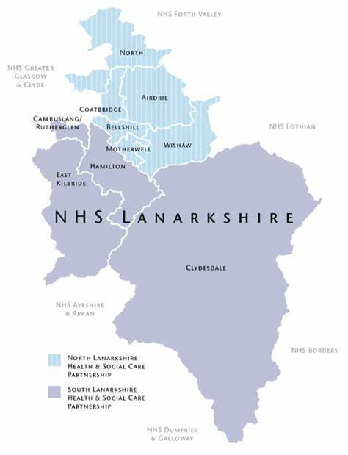

**Working for NHS Lanarkshire**

JOB TITLE: Specialty Doctor in Sexual Health

JOB REFERENCE: 170016 JOB REFERENCE: 170016

CLOSING DATE: 15th December 2023 INTERVIEW DATE: 15th January 2024

|  |
| --- |
| **Contents** |

|  |  |
| --- | --- |
| **Section** |  |
| Section 1: | Introduction to Appointment |
| Section 2: | Departmental and Directorate Information |
| Section 3: | Person Specification |
| Section 4: | Main Duties and Responsibilities |
| Section 5: | Job Plan |
| Section 6: | Contact Information |
| Section 7: | Terms and Conditions of Employment |

|  |
| --- |
| **Section 1: Introduction to Appointment** |

**Job Title: Specialty Doctor in Sexual Health**

**Base: Coathill Hospital, Coatbridge ML5 4DN**

**Hours / PA’s: 8 PAs per week (fewer sessions may be considered)**

**Salary Scale: £58,198 - £90,688 per annum based on 10 PAs per week**

**Interview Date: 15th January 2024**

Thank you for expressing an interest in the above job within NHS Lanarkshire.

All applications for the job are made through https://apply.jobs.scot.nhs.uk/vacancies.aspx Guidance notes for the completion of the Medical & Dental Application Form are available on the advert. Please note CV’s will not be accepted.

Please follow the link below should you wish any further information on NHS Lanarkshire

Recruitment | NHS Lanarkshire (scot.nhs.uk)

NHS Lanarkshire are happy to consider requests for this publication to be in another accessible format i.e. large print, braille, etc.  Please contact us via either of the undernoted methods clearly stating which format is required:

For any application queries, please contact

Lynn Cliens, HR Assistant on 01698 754351 or email: medical.dentalSAS@lanarkshire.scot.nhs.uk

For further information regarding NHS Lanarkshire and its hospitals, please visit our website:

NHS Lanarkshire Recruitment Website

Care to join us?

We are an Equal Opportunities Employer and Disability Confident Employer.

Unfortunately, we cannot accept CVs as a form of application and only application forms completed via the Jobtrain system will be accepted. Please visit **https://apply.jobs.scot.nhs.uk** for further details on how to apply.

**You will receive a response acknowledging receipt of your application.**

|  |
| --- |
| **This post requires the post holder to have a PVG Scheme membership/record. If the successful applicant is not a current PVG member for the required regulatory group i.e. child and/or adult, then an application will need to be made to Disclosure Scotland and deemed satisfactory before the successful post holder can commence work.** |

|  |
| --- |
| **Section 2: Departmental and Directorate Information** |

**Lanarkshire Sexual Health Service**

Lanarkshire Sexual Health Service is hosted within the North Health & Social Care Partnership and provides a comprehensive range of Sexual Health services including Genitourinary Medicine and Sexual Reproductive Health Service. The main administrative base is at Coathill Hospital with clinics based in several locations within the community in Lanarkshire. The service provides open access for integrated Sexual Health care, with patients attending mostly generic services with a wide range of issues. Specialist clinics are also offered for complex contraceptive and genitourinary medicine issues with clinician referral system.

The comprehensive Genitourinary Medicine service includes STI screening, treatment and partner notification whereas, comprehensive Contraceptive Service includes provision of all methods of contraception including long-acting reversible contraception. There is provision of Psychosexual Therapy clinic provided by a specialist.

We support priority access to vulnerable groups as well as fast-track referrals for post-abortion and post-pregnancy contraception including LARC.

Sexual Health in Lanarkshire is involved in training and education of health care professionals at varying levels including the Faculty of Sexual & Reproductive Health’s Diploma (DFSRH), Letter of Competence in Intrauterine Techniques & Subdermal Implants.

Sexual Health in Lanarkshire offers clinics at various locations across North & South of Lanarkshire. These are fully integrated Sexual Health clinics incorporating SRH and GU medicine.

NHS Lanarkshire Sexual Health is part of West of Scotland Manage Clinical Network for Sexual Health where Sexual Health services in five NHS boards cooperate in planning and delivery, with the aim of achieving continuous service improvement.

Lanarkshire Sexual Health Service provides dedicated walk-in clinics for young people located at various locations across Lanarkshire. These are fully integrated clinics for young people up to the age of 20 years. There is a specialist vulnerable young people team staffed by Sexual Health Lifestyle Nurses and Lead Clinician.

The successful applicant will join the medical team of three consultants, four specialty doctors and one specialist doctor.

**The Post**

Applications are invited from suitably experienced and enthusiastic Doctors for the post of Specialty Doctor in an Integrated Sexual Health Service. The Lanarkshire Sexual Health Service delivers a full range of sexual and reproductive health and genitourinary medicine clinical services. In addition, the successful applicant will be expected to participate in teaching and training, Clinical Governance activities and also the necessary administrative duties related to clinical services.

To be eligible for this appointment, you should have Postgraduate experience in Genitourinary Medicine, Contraception and Sexual Health.

The precise details of the job plan will be dependent on the successful candidate’s subspecialty training and interests.

The job is offered as an 8 PA post. Applications will be accepted for those wishing to work less than 8 PAs per week. The precise details of the job plan will be dependent on the successful candidate’s subspecialty training and interests.

All new Specialty Doctor are initially offered 1 PA for SPA duties.

NHS Lanarkshire is supportive of applications from individuals with well-developed ideas for improving services who are able to demonstrate a commitment to quality improvement, patient safety (including human factors training), Medical Education and Research & Development.

**General Provisions:**

You will report to the Lead Clinician, who will agree your job plan.

**Health and Safety:**

You are required to comply with NHS Lanarkshire Health and Safety Policies.

**Junior Medical Staff:**

You will be responsible for the training and supervision of Junior Medical staff who work with you, and you will be expected to devote time to this on a regular basis. In addition, you will be expected to ensure that staff have access to advice and counseling. If appropriate, you will be named in the contracts of Doctors in training grades as the person responsible for overseeing their training and as the initial source of advice to such Doctors on their career.

**Resources:**

|  |  |  |
| --- | --- | --- |
| The following department resources are available:- | | |
| **Consultants** | **Special Interest** | |
| Dr Alison Currie | Genital Dermatoses | |
| Dr Rashmi Ronghe | Medical Gynaecology / Clinical Lead | |
| Dr Laura Gillespie | HIV | |
|  |  | |
| **Specialist Doctor** |  | |
| Dr Elaine Monaghan | Teaching and training | |
|  | |  |
| **Specialty Doctors** | | 4 WTE |
| **Secretarial Support:** | |  |
| WTE Secretaries | | 2.53 WTE |
| WTE Receptionists | | 4 WTE |

**Integrated Health and Social Care Partnerships**

Legislation requiring the integration of health and social care came into effect in April 2016. This resulted in significant change to the way we care for and improve the health of our people in their community. NHS Lanarkshire has 2 Health and Social Care Partnerships one in the North and one in the South.

NHS Lanarkshire, our Local Authority Partners in North and South Lanarkshire Councils, our third sector partners and the people of Lanarkshire recognise the importance of a system of health and social care that is robust, effective and efficient and which reliably ensures a high quality of support and care which is the right of the people of Lanarkshire.

Further details on the Integration of Adult Health and Social Care are available at: www.scotland.gov.uk/publications/2012/07/5082/0

**Management Structure**

The supporting operational and clinical management structures are focused on enhancing patient safety, quality improvement and local delivery at hospital level, with visibility of clinical leadership and support for individual professional accountability. Our Medical Managers will provide professional leadership to medical staff, ensuring that they are effectively developed, organised, integrated and managed to support the strategic aims of each Division and meet the needs of the patient.

Management Structure Overview (HSCPs)

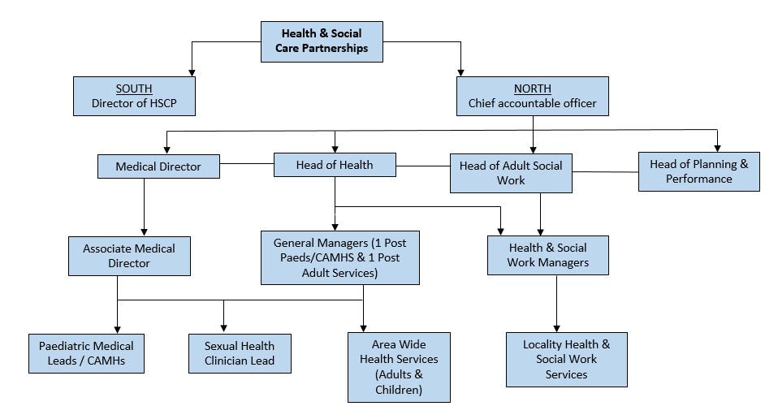

Lead Clinician

**Supporting your Development:**

Specialty Doctors are key members of our senior medical/dental workforce and provide a wide range of experience and skills. NHS Lanarkshire is committed to supporting your continued professional development as a Specialty Doctor. We strive to support a culture of development that embodies the aims of the SAS Charter and the NES SAS Development Programme.

Further information regarding professional development as a Specialty Doctor or Dentist in Scotland is available here : https://www.scotlanddeanery.nhs.scot/your-development/specialist-and-associate-specialist-doctors-and-dentists/

An overview of the NES SAS Development Programme is available here: SAS Development Programme Brochure

|  |
| --- |
| **Section 3: Person Specification** |

|  |  |  |
| --- | --- | --- |
| **PERSON PROFILE – Demonstrated on Application** | | |
| **ATTRIBUTES** | **ESSENTIAL** | **USEFUL** |
| Qualifications | MBChB or equivalent.  DFSRH  Current full registration with GMC with a license to practice. | Higher Degree or other Diploma eg: DFSRH  MFSRH  Dip GUM  Further educational certificates, diploma etc.  Other e.g.  Faculty Registered Trainer  Loc IUT  Loc SDI |
| Training | Completed at least four years’ full-time postgraduate training (or its equivalent gained on a less than full time or flexible basis) at least two of which will be in a Specialty Training Programme or specialty registrar locum appointment for training (LAT) : or shall have equivalent training, experience or competencies, either in the UK or overseas. | Training at ST/SPR level in communication, teaching or management.  Experience within UK training establishments  Human Factors Training |
| Experience | Post graduate experience in sexual health care including all methods of contraception and testing and treatment of STIs.  Ability to take clinical responsibility for independent management of patients as agreed with the consultants.  Ability to supervise the clinical work of doctors in training and relevant staff in other disciplines. | Well-developed specialty interest.  Administrative / Management experience. |
| Knowledge and  Skills | Broad based knowledge and skills in diagnosis and clinical management within the Specialty and encompassing most sub-disciplines. |  |
| Audit/Research | Understanding of the principles of medical audit. | Experience and interest in audit of the practice and experience of design of audit.  Research within the practice.  Involvement in design of research relevant to the practice. |
| Publications |  | Presentations/Publications relevant to the practice. |
| Teaching | Previous involvement in the delivery of undergraduate or postgraduate teaching.    Experience of providing supervision and or mentorship | Interest in and commitment to teaching and training.  Experience of organising teaching programmes. |
| Managerial |  | Involvement in service re-design.  Involvement in project delivery.  Involvement in NHS-related meetings. |

|  |  |  |
| --- | --- | --- |
| **PERSON PROFILE – Demonstrated at Interview** | | |
| **ATTRIBUTES** | **ESSENTIAL** | **USEFUL** |
| Knowledge and Skills |  | Good IT Skills |
| Disposition | Committed to Quality Patient Care.  Able to be understanding of and sensitive to the needs of patients.  Excellent communication skills (verbal and written).  Ability to work effectively in a multidisciplinary team.  Responsive to change and innovation, promoting a culture for organisational development.  A flexible approach to duties, which satisfies the needs of the Service in a changing environment.  Ability to demonstrate reflective practice with evidence of regular appraisal with clear Personal Development Plan relating to Continuing Professional and Personal Development.  Good time management and organisation.  Demonstrates commitment and enthusiasm to service delivery. | Problem solver  A natural leader. |
| Managerial | Knowledge of service provision at a local level. | Awareness of the principles and core practices involved in service management, project management and effective meetings. |
| Other | Fluent in medical English  Willing to travel as required by the duties of the post |  |

|  |  |  |  |  |  |
| --- | --- | --- | --- | --- | --- |
| **PERSON PROFILE – Demonstrated at Pre-Employment Check** | | | | | |
| **ATTRIBUTES** | **ESSENTIAL** | | | **USEFUL** | |
| Other | Satisfactory medical clearance by NHS Lanarkshire Occupational Health Service.  Satisfactory PVG Check.  Current full driving license and access to a vehicle (required for jobs where an immediate return to site or travel between sites is required) | | |  | |
| If there is any reason why a disabled person should not be considered suitable for this post, please provide details: | | | **The post requires physical dexterity. Uncorrected visual or hearing defect would be incompatible with the nature of the work.** | | |
|  | | Prepared By: | | | Approved By: |
| Name | | Dr Rashmi Ronghe | | | Dr Adam Daly |
| Designation | | Consultant/Clinical Lead | | | Associate Director |
| Date | | November 2023 | | | November 2023 |
|  | |  | | |  |

|  |
| --- |
| **Section 4: Main Duties and Responsibilities** |

**Main Duties:**

The main duties and responsibilities of the post include;

• Providing a full range of contraception services including all LARC methods

• A full range of STI testing including BBV testing

• Managing patients presenting with sexual health problems

• Treatment for STIs

• Departmental teaching

**Work Programme:**

As required under Section 3 of the Terms and Conditions of Service, the duties and responsibilities are supported by a job plan and work programme detailed as follows:

**Job Planning/Programmed Activities:**

The job plan will be dependent on the successful candidate’s subspecialty training and interests.  SPA will be included in the job plan but please refer to the guidance above under the general description of the post.

On taking up post a Job Plan will be agreed between the person appointed and the Lead Clinician. This job plan is subject to review at least once a year by the post holder and the Lead Clinician as noted in the terms and conditions. The procedures set out in the ‘Terms & Conditions of Service’ must be followed if it is not possible to agree a job plan, either initially or at an annual review.

The timetable is indicative and subject to negotiation with the Lead Clinician. The core 8 PA working week will be based on 7 PA’s of Direct Clinical Care (DCC) duties and 1 PA of SPA time for a full-time post-holder. This will be pro-rata for part-time posts.

The timetable below is for illustration and may be subject to change dependent on negotiation with the Clinical Director.

In addition, other activities not occurring at fixed times.

* To discussing management/investigation of patients with colleagues or other specialties
* To expeditiously complete patient administration duties e.g. verifying letters, signing off results etc.
* To work with colleagues to ensure effective and efficient development and implementation of support systems
* To contribute to generic and specialty objectives of the service and organisation
* To participate fully in appraisal and personal development planning activities
* To participate in audit activities of the department

**Audit and Research:**

The successful candidate will be expected to participate in audit processes and there is an active clinical audit department available to assist. NHS Lanarkshire is ambitious to build a portfolio of research projects backed by enthusiastic and dynamic individuals. It has an active Research and Development department and would welcome discussion regarding a potential research interest.

**Continuing Professional Development:**

Study leave is available within the terms and conditions of service with the approval of the Clinical Director/Clinical Lead. The appointee will be required to fulfill such demands for continuing professional development as the Faculty of Sexual Health and Reproductive Health (or other relevant bodies) may make.

**Honorary Academic Status:**

If involved in undergraduate teaching status can be applied for. Applications can be made via the Hospital Sub-dean and then to the appropriate academic department within the University.

|  |
| --- |
| **Section 5: Job Plan** |

|  |  |  |  |  |  |
| --- | --- | --- | --- | --- | --- |
|  | **Mon** | **Tue** | **Wed** | **Thu** | **Fri** |
| **AM**  **(8.30 – 12.30)** | Urgent Care Clinic  *Coathill Hospital* | Sexual Health Clinic  *Coathill Hospital* | CPD / Admin  *Coathill Hospital* |  | Sexual Health Clinic  *Viewpark Health Centre* |
| **PM**  **(Variable)** | Office / YP clinic  *Central Health Centre* | Sexual Health Clinic  *Motherwell Health Centre* |  |  | Urgent Care Telephone Clinic  *Coathill Hospital* |
| **Evening**  **(Variable)** | Sexual Health Clinic  *Central Health Centre* |  |  |  |  |

|  |
| --- |
| **Section 6: Contact Information** |

**Information enquiries regarding this post will be welcomed by:**

Dr Rashmi Ronghe, Consultant/ Lead Clinician in Sexual & Reproductive Health, Coathill Hospital: 🕿 01698 753662

Dr Alison Currie, Consultant in GU Medicine, Coathill Hospital: 🕿 01698 753661

Dr Adam Daly, Associate Medical Director H&SCPs, North Lanarkshire: 🕿 01698 858320

|  |
| --- |
| **Section 7: Terms and Conditions of Employment** |

1. This appointment is offered on the Terms and Conditions of the Specialty Doctor Contract (2022).
2. Our pension scheme is provided by Scottish Public Pensions Agency, and all benefits are explained on the SPPA website (http://www.sppa.gov.uk/). Here you can also access an annual statement showing how much service has built up in your pension. If you wish to opt out or have previous NHS Service, you should refer to the SPPA website for further information about any implications for your pension benefits.

Superannuable pay will include basic salary (up to 10 programmed activities, but not any extra programmed activities about this level), on-call availability supplements, discretionary points, distinction awards, and any other pay or allowances agreed by the Scottish Government, to be superannuable. Superannuable pay will be subject to HMRC legislation.

1. The employment is subject to 3 months’ notice on either side subject always to the appeal and other provisions of schedule 2 of the Terms and Conditions of the Specialty Doctor 2022 Contract (NHS Circular PCS (DD) 2022/2)
2. The successful candidate must be contactable throughout any on-call period. NHS Lanarkshire will provide the facility for this.
3. The successful candidate, if not already employed by the NHS Lanarkshire, will be required to complete a medical questionnaire to obtain medical clearance from the Occupational Health Physician.
4. The successful candidate will be required to complete a Disclosure Scotland PVG (Protecting Vulnerable Groups Scheme) form. An e mail link will be sent to the successful candidate for completion. No approach will be made without written permission of the successful applicant who will be asked to sign and complete a disclosure PVG application, giving authorisation for the check to be undertaken. If you are a non EEA National and are currently based out with the UK a Country of Origin check/criminal records certificate will also be required from each country in which you have resided continuously or cumulatively for 12 months or more in the last 10 years.
5. NHS Lanarkshire does not negotiate salary placements. On commencement the salary will be in line with Schedule 10 of the Terms and Conditions of the Specialty Doctor Contract (2022). Appointees start on the scale minimum except in the circumstances of paragraphs 6 - 9 of Schedule 10 of the terms and conditions of service.
6. From 1st April 2023, the starting salary for the post is £58,198 per annum (based on 10 Programmed Activities per week). The successful candidate’s total salary will be dependent on his/her previous service history. Remuneration for any extra programmed activities will be dependent upon the job plan agreed at the time of appointment.
7. Dependent upon present place of residence, NHS Lanarkshire may require the successful candidate to undertake to remove home to a distance acceptable to NHS Lanarkshire, normally within 10 miles of the base Hospital, in which case removal expenses will be payable in accordance with NHS Lanarkshire Policy. In some cases, however, a residence more than 10 miles distant from the base hospital will be acceptable and in this case removal expenses will be subject to the prior approval of the Associate Medical Director for such a residence. The position will be made clear to the successful candidate on application.

|  |
| --- |
| **Section 8: General Information about Lanarkshire** |

**Lanarkshire – The Place**

NHS Lanarkshire is the third largest health system in Scotland with around 12,500 staff and a baseline recurring budget of £1.4bn, serving a community of circa 655,000 people, through

* Three acute hospitals – University Hospital Hairmyres, University Hospital Monklands and University Hospital Wishaw
* Around 102 GP Practices with 367 wte GPs
* Spans two local authority areas – North Lanarkshire Council and South Lanarkshire Council with 2 Integration Joint Boards, North Lanarkshire IJB and South Lanarkshire IJB.

NHS Lanarkshire and North and South Lanarkshire Councils formed the North and South Lanarkshire Heath and Social Care Partnerships to develop a wide range of community facing health improvement, health and social care services with locality based planning and delivery.

The Partnerships include a range of community health and social care services, community hospitals (mainly for long term conditions and continuing care for older people), as well as a wide range of services for patients with mental health problems and learning disabilities. Services also include GP Practices providing many primary and community care services throughout Lanarkshire.

https://www.hscnorthlan.scot/

https://www.southlanarkshire.gov.uk/slhscp/info/1/about_us

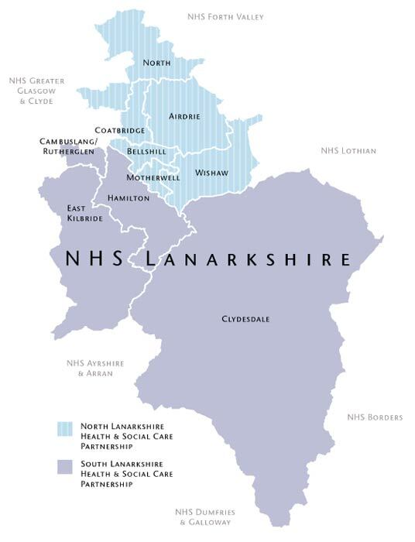

**Living in Lanarkshire**

***Living in the area***

Within the UK, Lanarkshire is situated in the heart of Scotland's central belt, the area offers an ideal combination of tranquil parks and market towns, with something for everyone.

Centrally located between Glasgow (c. 20 minutes) and Edinburgh (c. 40 minutes) you can easily commute or, should you wish to relocate, you can choose either a substantial Lanarkshire town or a more relaxed rural location and still have the attractions of two major cities on your doorstep. The county offers accessible links to major cities with easy access to major motorway/rail routes and international airports allowing you to travel across Scotland, the UK and beyond.

There are many attractions within Lanarkshire, including:

* New Lanark World Heritage Site,
* Antonine Wall World Heritage Site,
* The Falls of Clyde,
* Summerlee - The Museum of Scottish Industrial Life,
* The National Museum of Rural Life,
* Strathclyde Country Park,
* Scottish Wildlife Reserves on the shores of the River Clyde,
* Various museums, galleries, castles, heritage centres,
* Numerous country parks.

***Where Schools Are Located***

The majority of Glasgow's independent schools are located just outside the city centre. https://www.mytopschools.co.uk/private-schools-glasgow/

St Aloysius’ College https://www.staloysius.org/

Hutchesons’ Grammar School https://www.hutchesons.org/

Hamilton College - https://www.hamiltoncollege.co.uk/

**To find more information about living and working in Scotland please visit:**

www.visitlanarkshire.com

www.visitscotland.com/destinations-maps/glasgow-clyde-valley/

www.southlanarkshire.gov.uk

www.northlanarkshire.gov.uk

https://www.scotland.org/

https://www.talentscotland.com/

https://moverdb.com/moving-to-glasgow/