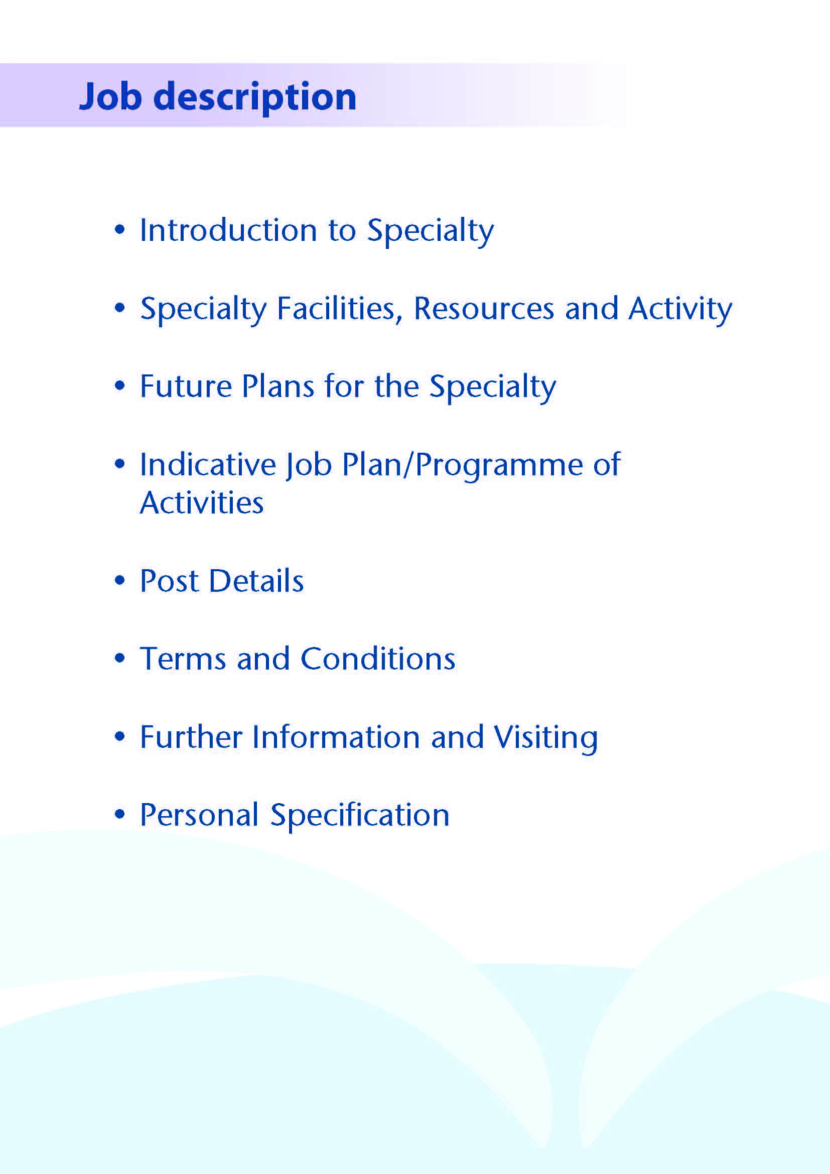



This post will complement the current team of 8 Consultant Haematologists, 1 speciality registrar, 4 clinical fellows and 3 FY1/FY2 doctors to support the delivery and development of clinical and laboratory Haematology services within Ayrshire. The post is based within both Surgical and Diagnostic Services of NHS Ayrshire & Arran at University Hospital Crosshouse (UHC), near Kilmarnock and University Hospital Ayr (UHA), in Ayr. The Haematology Department provides an area-wide clinical and laboratory service to all inpatient areas, primary care and community services. The population of Ayrshire is approximately 384,000.



**Clinical Haematology Services**

Clinical Haematology services are provided both at UHC for North and East Ayrshire and at University Hospital Ayr (UHA) for South Ayrshire. It is expected that the appointee would work principally from the UHC site although some duties (outpatient/day-case) may be covered on both sites.

Inpatient beds are available on the UHC site, and both hospitals run general Haematology, and Haemato-Oncology outpatient clinics. UHC has a combined Oncology / Haematology inpatient unit with 14 beds and a busy day-case unit. New off-site facilities are also provided at UHA for low risk/supportive treatments, this was developed as a response to the Covid19 pandemic to ensure safe patient flow outwith the acute site. Both sites are large busy District General Hospitals providing a comprehensive range of services requiring frequent clinical haematological input.

Clinical Haematology services are organised from within the Surgical Directorate from where the budget is managed. Junior medical support consists an FY1 and FY2 at UHC who take part in Acute Medical receiving, a Clinical Teaching Fellow and Clinical Development Fellow in Haematology on each site. A Specialist Doctor in oncology is also available at UHC. NHS Greater Glasgow provide consultant oncologist support for breast, urology, lung and colorectal/upper GI tumour types. Anticoagulant clinics are held daily at various locations delivered by anticoagulant pharmacists and nurses, utilising the Dawn management system

Weekly Multidisciplinary Team Meetings (MDT) include all consultant Haematologists supported by Consultant Pathologist and Radiologists. The department participates in the West of Scotland regional MDT via teleconference on a weekly basis. This is now followed by the National CAR-T MDT. The Haemato-Oncology service is supported by 4 full-time haematology clinical nurse specialists who works across both sites, and by dedicated pharmacy and AHP services. There are also close links with the palliative care service, based at the Ayrshire Hospice.

UHC receives medical students (years 1-5) from The University of Glasgow Medical School, and the postholder would be expected to devote some of his / her SPA time to undergraduate teaching activities. Postgraduate teaching is coordinated by Dr Hugh Neil, Director of Medical Education.

There is a Haematology education meeting on a Friday lunch time where all grades of doctor participate. We have recently invested money in a new multi-header microscope and TV monitor to aid laboratory teaching.

**Medical Staff Resources**

|  |  |
| --- | --- |
| *Consultant* | *Departmental responsibility* |
| Dr Peter Maclean | Clinical Director, Cancer and Haematology |
| Dr Dean Smyth | Laboratory Governance Lead |
| Dr Fiona Cutler | SACT Lead |
| Dr Fiona Nicholson | Clinical Lead Haematology |
| Dr William Gordon | Undergraduate teaching Lead |
| Dr Ian Devanny | Anticoagulation Lead and lead for post graduate education |
| Dr Samantha Duncan | Transfusion Lead |

The staffing of the Haematology Department is as follows:



The Haematology Department is a participant in a wider review of Chemotherapy Services within NHS Ayrshire & Arran. The Health Board has approved a West of Scotland Cancer Network review recommendation to reorganise chemotherapy services such that there will be one primary site for chemotherapy prescribing, complex chemotherapy delivery and inpatient Haematology inpatient services, while at least one other site will provide low risk day case SACT delivery. The specific configuration of the future service is still to be confirmed, but work is in progress to take this forward. This reorganisation is an excellent opportunity to develop a suite of inpatient and day-case facilities to match ongoing developments in the safe and effective delivery of chemotherapy.



# Clinical activity within the post

Clinical duties will include outpatient clinics, on treatment clinics, haematology day unit cover and hospital liaison. The appointee will also be expected to participate in the bone marrow lists on a rotational basis. Training will be given to those not competent in this skill. Some clinical activities may be based at the Kyle Unit Ailsa Hospital, Ayr. This would not be expected to comprise more than 20% of the role.

# Proposed Weekly Programme

The job plan will initially be balanced at 9 DCC to 1 SPA.

As this is a new post the exact job plan will be agreed with the successful candidate.

A 10 PA contract this will approximately equate to the following;

6 clinical sessions comprising clinics, on treatment clinics, bone marrow biopsy list, day unit cover and hospital liaison

1 session for MDT

1 clinical administration

1 session for on call

1 session for supporting professional activity

**Template Job plan**

Based on Monday to Friday 9-5 pm

|  |  |  |
| --- | --- | --- |
| Day | AM | PM |
| Monday | Admin | Clinical duty |
| Tuesday | MDT | Clinical duty |
| Wednesday | Clinical duty | Clinical duty |
| Thursday | Clinical duty | Clinical duty |
| Friday | SPA | OFF |

The job plan will be reviewed with the successful candidate no later than 3 months following appointment and where possible discussion may take place in advance of appointment. Job plan review thereafter will be no less frequent than annually.

The agreed job plan will include all the appointee’s professional duties and commitments, including agreed Supporting Professional Activity.

**Notes on the Programme**

**Patient Administration**. This activity covers the management of individual patients including Out Patient administration, results reporting, letters/phone calls to patients, carers, GP’S and members of the wider multidisciplinary team involved in the patients care.

**Travel:** Any travel allocation will be included within the Total Programmed Activities and will be determined by location at which Direct Clinical Care and Supporting Professional activities are carried out.

**On call arrangement-** 1 session. Exact pattern to be agreed with the successful applicant.

**Supporting Professional Activities**: NHS Ayrshire and Arran recognise the important role Job Planning has in ensuring doctors are supported in delivering high quality, safe, sustainable clinical care to patients. It is therefore important to ensure there is an adequate balance between direct clinical care activities and activities which support both the personal and professional development of the medical workforce and facilitates agreed contribution to activities including:

* Under and post graduate teaching/training
* Clinical Governance
* Quality and Patient Safety
* Research and Innovation
* Service management and planning
* Work with professional bodies

All specialty doctors will have 1 SPA as a minimum to support job planning, appraisal and revalidation. However the final balance of SPA and DCC activity will be agreed between the appointee and clinical manager prior to contracts being agreed.

There may be a requirement to vary the DCC outlined in the indicative timetable at section 4 when the final balance of DCC and SPA is subsequently agreed.



**Duties and Responsibilities**

The main duties and responsibilities of the post include:

* Carrying out teaching as required, and for contributing to undergraduate andpostgraduate medical education. The post holder will be expected to comply with College recommendations on Continuing Medical Education.
* The post holder will be required to comply with NHS Ayrshire and Arran’s Policies on Clinical Governance.
* The successful applicant will be encouraged to participate in research and to develop a relevant subspecialty interest, subject to resources and local priorities.
* Requirements to participate in medical audit and in continuing medical

education.

* Managerial responsibilities (where appropriate).

You shall integrate with other middle grade staff in the day-to-day service and commitments of the department. Accordingly, the duties would be flexible and rotate between team members.

All members of the department participate in weekly meetings which may combine audit review or case discussions with our radiological and pathological colleagues.

You will be accountable to the Clinical Director who will agree the weekly timetable.

**Annual Appraisal**

You shall be required to participate in annual appraisal and agree a personal development plan.



The Terms and Conditions of Service are those determined by the Terms and Conditions of the New Consultant Grade (Scotland) as amended from time to time. The distance that a consultant can reside from the principal base hospital, where travel time is seen as more important than mileage, is subject to the agreement of the Executive Medical Director, but it is usually anticipated that a journey that takes no more than 30 minutes for any emergency situation would be acceptable.



Applicants wishing further information about the post are invited to contact Dr Peter MacLean, Clinical Director peter.maclean@aapct.scot.nhs.uk or Dr Fiona Nicholson fiona.nicholson@aapct.scot.nhs.uk with whom visiting arrangements can also be made.



**Post of**: Specialty Doctor in Haematology

**Location**: University Hospital Crosshouse

**Qualifications:**

|  |  |
| --- | --- |
| **Essential** | **Desirable** |
| * MBChB/MBBS or equivalent medical qualification | * MRCP or equivalent |
| * Full GMC Registration with a Licence to Practice at time of appointment * Evidence of achievement of Foundation competences by time of appointment in line with GMC standards/ Good Medical Practice including:   + Good clinical care   + Maintaining good medical practice   + Good relationships and communication with patients   + Good working relationships with colleagues   + Good teaching and training   + Professional behaviour and probity   + Delivery of good acute clinical care * Completion of a minimum of 4 years full-time postgraduate training (or equivalent) with evidence of achievement of at least 2.5 years experience in competences relevant to general internal medicine at time of appointment. * At least 12 months previous post graduate NHS experience in clinical Haematology * Eligibility to work in the UK | * At least 24 months previous post graduate NHS experience in clinical Haematology . |

**Skills/Knowledge/Competence**

|  |  |  |
| --- | --- | --- |
| **Requirements** | **Essential** | **Desirable** |
| **General Experience:**   * Expertise in generalist field | * Strong basic medical and haematological knowledge commensurate with completion of general medical training * Ability to deal with acute medical problems with indirect supervision * Ability to communicate effectively with all levels of staff and patients * Ability to work efficiently and timeously * IT literacy | * Specialist knowledge of Haematology |
| **Team Working** | * Effective Team Player |  |
| **Development** | * Evidence of relevant Continuing Professional Development * Ability to provide a complete employment history * Evidence of satisfactory career progression * No unexplained career breaks |  |
| **Teaching & Training** |  | * Experience of small group teaching of undergraduates |
| **Research & Publications** |  | * Evidence of publications. |
| **Clinical Audit** | * Evidence of participation in audit |  |
| **Management and Administration** | * Proven organisational skills   All applicants to have demonstrable skills in written and spoken English adequate to enable effective communication about medical topics with patients and colleagues demonstrated by one of the following:   * + a) that applicants have undertaken undergraduate medical training in English; or   + b) have the following scores in the academic lnternational English Language Testing System (IELTS) – Overall 7, Speaking 7, Listening 6, Reading 6, Writing 6. * If applicants believe they have adequate communication skills but do not fit into one of these examples they must provide supporting evidence | * Understanding of resource management and quality assurance. |
| **Personal and Interpersonal Skills** | * A willingness to accept flexibility to meet the changing needs of the NHS in Scotland * Effective communicator * Open and non-confrontational | * Knowledge of recent changes in the NHS in Scotland |