

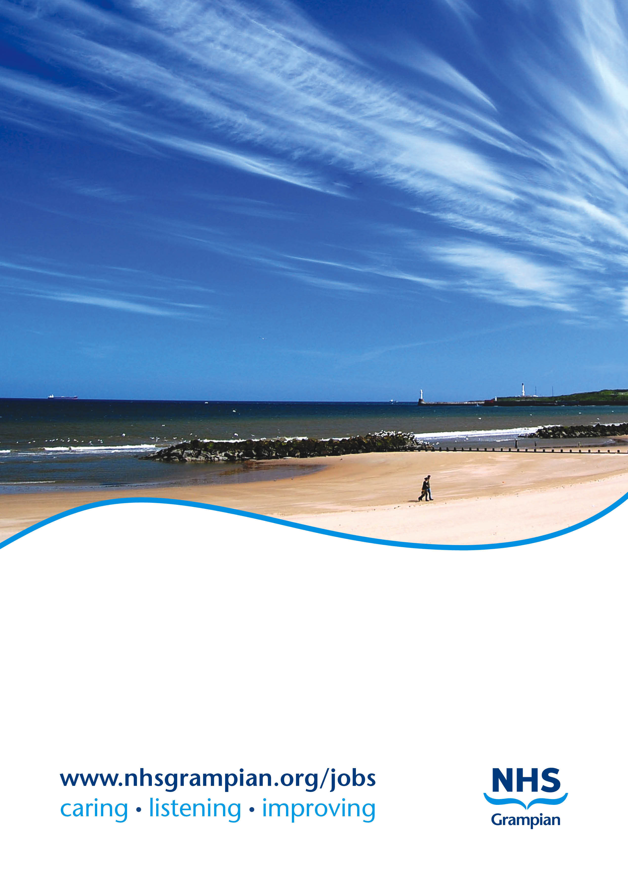**NHS GRAMPIAN**

**Job Title: Consultant Orthodontist**

**Location: Aberdeen Dental Hospital & Institute of Dentistry**

**Ref No: SM191092**

**Closing Date: 1 September 2024**

**CONSULTANT ORTHODONTIST**

**Full time (10 PA’s per week)**

**Ref: SM191092**

|  |
| --- |
| **Role details**  Job Title**: Consultant Orthodontist**  Location: **Aberdeen Dental Hospital, Foresterhill, Aberdeen**    Reports to: **Clinical Lead, Aberdeen Dental Hospital & Institute of Dentistry** |
| **Aberdeen and surrounding area**  Scotland’s third largest city, Aberdeen sits on the coast between the mountains of Aberdeenshire and the stunning North Sea coastline.  Renowned as a Global Energy Hub, Aberdeen is a vibrant, entrepreneurial region, home to a unique mix of business opportunities and specialist skills across various sectors including energy, technology, life sciences and food & drink. More than 20% of Scotland’s top businesses are located in this region which is taking great strides to ensure that it continues to compete on a world stage. Investments of more than £10 billion of public and private infrastructure is due to be delivered before 2030, marking an exciting time to be part of a genuine world-class location.  Built from sparkling local granite Aberdeen has earned the name of the Silver City. As the energy capital of Europe, Aberdeen nevertheless retains its old-fashioned charm and character making it an attractive place in which to live, work and study. Due to its global business and international energy industry credentials, Aberdeen is well served by local and national transport infrastructure with excellent rail networks that run to both the North and South of Scotland and the rest of the UK. It also acts as an international travel hub. Flying time to London is just over one hour with regular daily flights and Aberdeen airport serves international travel to European centres such as Amsterdam (Schiphol) and Paris (Charles de-Gaulle) as well as flights to other European destinations.  The City and the surrounding countryside provide a variety of urban, seaside and country attractions. Aberdeen has first class amenities including His Majesty’s Theatre, Music Hall, Art Gallery, the P&J Live Arena, Museums and Aberdeen Sports Village. The City is framed by its accessible beach front which is within a short walk of the city centre and there are an array of activities available across the region such as golf, hill walking; mountaineering; sailing; surfing; windsurfing; salmon, trout and sea fishing. The surrounding countryside, known as Aberdeenshire, is also one of Scotland’s most appealing regions. Royal Deeside and the Cairngorms National Park are within easy access of the city.  The city and the surrounding area have ranked consistently highly in nationally recognised quality of life surveys, coming out top 10 as one of the best places to live in Scotland in 2020 in the annual Bank of Scotland survey.  To find our more visit www.visitabdn.com |

|  |
| --- |
| **Introduction to NHS Grampian**  NHS Grampian consists of acute services, corporate services and three Health and Social Care Partnerships. The Health Board works closely with the local authorities in Aberdeen City, Aberdeenshire and Moray to cover a population of over 500,000. Its main base is the Foresterhill Health Campus in Aberdeen, one of the largest hospital sites in Europe. Institutions on the Foresterhill Site include Aberdeen Royal Infirmary, Royal Aberdeen Children’s Hospital, Aberdeen Maternity Hospital, The University of Aberdeen’s Medical School, Aberdeen Dental Hospital & Institute of Dentistry, Institute of Medical Sciences, the Rowett Institute of Nutrition and Health and The Suttie Centre for Teaching and Learning in Healthcare. The Baird Family Hospital and the ANCHOR Centre for cancer care are currently under construction.  There are close links between NHS Grampian, The University of Aberdeen and Robert Gordon’s University. The University of Aberdeen is one of the UK’s ancient universities, founded in 1495. It maintains a high level of teaching and learning, underpinned by a first class portfolio of research programmes. Robert Gordon’s University has courses including pharmacy, health and the professions allied to medicine. More recently links have developed with The University of the Highlands and Islands (UHI). Founded in 2001, UHI is Scotland’s newest university and is a federation of thirteen colleges and research institutions. It offers a BSc in Oral Health Science leading to a career in dental hygiene and dental therapy. |

|  |
| --- |
| **Aberdeen Dental Hospital & Institute of Dentistry**  Aberdeen Dental Hospital is a purpose-built building on the Foresterhill Health Campus which opened in 2009. It includes state-of-the–art clinical and teaching facilities including open plan clinics as well as comprehensive facilities for NHS services including technical facilities. The Dental Hospital and Institute of Dentistry complex also includes an outreach teaching facility for the University of Dundee’s Dental School, the Aberdeen Postgraduate Dental Education Centre, and a salaried NHS practice. |

|  |  |  |  |  |  |  |  |  |  |  |  |  |  |  |  |  |  |  |  |  |
| --- | --- | --- | --- | --- | --- | --- | --- | --- | --- | --- | --- | --- | --- | --- | --- | --- | --- | --- | --- | --- |
| **The Orthodontic Service**  The main base of the Orthodontic service is within Aberdeen Dental Hospital which is on the Foresterhill site. This facility also includes Restorative Dentistry and Oral Surgery which are in adjoining clinical accommodation, and an academic unit providing a graduate entry BDS programme.  The Department provides a Consultant Orthodontic service for the diagnosis and treatment of multidisciplinary patients referred from the General Dental Service including Specialist Orthodontic Practices, Public Dental Service and other Hospital based Specialties.  The Orthodontic service also has a peripheral unit in Dr Gray’s Hospital, Elgin with an established part-time Consultant in post. Dr Grays Hospital is located approximately 70 miles North-West of Aberdeen in Moray. The outpatient department hosts Orthodontic and Oral and Maxillofacial Surgery clinics.  The Orthodontic service sits within the Division of Surgery which is part of the Integrated Specialist Care Services Portfolio. It enjoys excellent collaborative working with the Oral and Maxillofacial Surgery and Restorative Dentistry Departments with weekly combined clinics in the Dental Hospital. There are currently five Consultants in Oral and Maxillofacial Surgery, two Consultants in Oral Surgery and one Consultant in Oral Medicine, as well as five Consultants in Restorative Dentistry.  The department provides a service for Cleft Lip and Palate patients in Grampian working within the Scottish managed clinical network (Cleft Care Scotland). Currently one Orthodontic Consultant is involved with providing input to the local Cleft service.  The service also provides Consultant support for multi-disciplinary patients for the patients living in the Northern Isles.  **Facilities of the Department**  Clinical accommodation comprises 6 modern dental surgeries. All clinical areas have dedicated IT terminals to support digital imaging including radiographs. There is a dedicated Orthodontic laboratory and a dedicated radiographic facility within the building including CBCT.  **Teaching and Research**  The Department is actively engaged in teaching, including junior staff as detailed below. There is also the opportunity to be involved with undergraduate and postgraduate teaching including lecturing and clinical teaching. There is an excellent Medical School Library with a selection of dental literature and periodicals as well as a small Departmental Library.  An Honorary University Senior Lecturer appointment is normally awarded to the holder of this post which gives access to the University recreational/sporting, library and social facilities. **Current staffing** The appointee will become part of the Orthodontics team working with the following colleagues:   |  |  | | --- | --- | | **NHS Consultants** | WTE | | Dr Karen Shaw | 1.00 | | (this post) | 1.00 | | Dr Felicity Borrie (Elgin) | 0.50 | | Prof Khaled Khalaf (Honorary) | 0.20 | |  |  | | **Non Consultant staff** |  | | ST4/5* | 0.20 | | ST1-3** | 0.20 | | Orthodontic Therapist | 0.20 |   * ST4/5 based at Dundee Dental Hospital with sessions in Aberdeen.  ** ST1-3 based at Raigmore, Inverness with sessions in Elgin |

|  |
| --- |
| Duties and responsibilities The post will be based in the Orthodontic Department at Aberdeen Dental Hospital.  **Clinical**   * Orthodontic assessment and treatment provision within Aberdeen Dental Hospital * Multidisciplinary planning and treatments * Supervision and teaching of junior staff * Share in the responsibility of administration for the proper functioning of the Orthodontic department * Provision of support to the Northern Isles to help shape the future service * The post-holder will be required to comply with NHS Grampian’s policies on Clinical Governance   **Administration**  The post-holder will be expected to contribute towards the development, organisation and administration of the service and its relationship with other stakeholders.  Participation in case conferences and committee meetings as appropriate.  **Audit**  The post-holder will be actively involved in and committed to clinical audit in line with the NHS Grampian’s Clinical Audit Policy and will develop clinical audit in his/her area of responsibility with support from the Acute Sector clinical Audit Committee. |

MODEL JOB PLAN FORMAT

**Name:** Consultant Orthodontist **Specialty:** Orthodontics **Principal Place of Work:** Aberdeen Dental Hospital & Institute of Dentistry

**Contract:** Whole Time

**Programmed Activities:** 10 **Indicative PA Split: DCC** 8 **SPA** 2

**Availability Supplement**: None

**Premium Rate Payment Received: %**

**Managerially Accountable to:** Clinical Lead, Aberdeen Dental Hospital & Institute of Dentistry /

Unit Operational Manager, Acute Sector, Surgery 1

1. **Timetable of activities which have a specific location and time**

|  |  |  |
| --- | --- | --- |
| **DAY** | **HOSPITAL/ LOCATION** | **TYPE OF WORK** |
| **Monday**  **From / To** | Aberdeen Dental Hospital | AM – Treatment (DCC)  PM- Treatment (DCC) |
| **Tuesday**  **From / To** | Aberdeen Dental Hospital | AM- Treatment (DCC)  PM- SPA |
| **Wednesday**  **From / To** | Aberdeen Dental Hospital | AM- N/P (DCC)  PM- Treatment (DCC) |
| **Thursday**  **From / To** | Aberdeen Dental Hospital | AM- Combined clinic (DCC)  PM- Orthognathic planning clinic (DCC) |
| **Friday**  **From / To** | Aberdeen Dental Hospital | AM Treatment (DCC)  PM SPA |
| **Saturday**  **From / To** |  |  |
| **Sunday**  **From / To** |  |  |

On call arrangements: There is no on-call associated with this post.

***NB: The detailed Job Plan will be agreed with the successful candidate at the time of the appointment, taking account of the experience, skills and interests of the candidate and how they can best be used within the Consultant team.***

**NHS Grampian**

**Person Specification Form**

**Consultant Orthodontist**

|  |  |  |
| --- | --- | --- |
| **CRITERIA** | **ESSENTIAL** | **DESIRABLE** |
| **Registration** | Full GDC Registration  Appear and remain on GDC Specialist List for Orthodontics |  |
| **Education, training and experience** | Membership in Orthodontics (M.Orth.)  Intercollegiate Speciality Fellowship Exit examination in Orthodontics (ISFE), before commencing post  Successful completion of a SAC-approved 2-year minimum training programme in a Fixed Term Training Appointment (FTTA) in Orthodontics, or within 6 months of completion of training, or equivalent.  Experience of a broad range of malocclusions and treatment modalities to an advanced level. | Higher degree in Orthodontics, e.g. D.Clin.Dent/MSc  Postgraduate dental diplomas e.g. other Royal College memberships or fellowships  Additional post CCST training and experience in the management of complex surgical orthodontics, hypodontia etc. |
| **Ability**  *Knowledge*  *Clinical Skills and*  *Technical Skills* | Ability to take full responsibility for independent management of patients    Ability to communicate effectively and clearly with patients and other team members  Experience of working in a multidisciplinary team | Information Technology Skills  Presentation skills |
| **Personality Personal and Interpersonal skills** | Effective communicator and negotiator  Ability to demonstrate effective team leadership potential  Ability to work flexibly and constructively with colleagues, according to the needs of the service  Contribute to team and skills development. |  |
| **Clinical Governance and Audit** | Participation in and evidence of previous research or clinical audit activity to improve patient care and involvement in clinical governance |  |
| **Research & Publications** | Knowledge of current Orthodontic literature  Able to devise, organise and complete projects | Peer reviewed publications and presentations  Formal research training; demonstrated ability to design a research or audit project |
| **Teaching & Training** | Participation in departmental teaching  Experience of postgraduate teaching | Experience of teaching undergraduates and postgraduates |
| **Management and Administration** | Commitment to effective departmental management  Awareness of management issues.  Understanding of the organisation of the NHS. | Proven ability to lead a clinical team  Relevant management experience  Understanding of resource management  Proven organisational skills |
| **Other** | Ability to work flexibly according to the needs of the service, and contribute to team and skills development. | Innovative, enthusiastic and ability to inspire others |

**NHS GRAMPIAN**

**CONSULTANT ORTHODONTIST**

**REF SM191092**

CONDITIONS OF APPOINTMENT

1. The appointment will be made by the Board on the recommendation of an Advisory Appointments Committee, constituted in terms of the National Health Service (Appointment of Consultants) (Scotland) Regulations, 1993 - NHS Circular 1993 No 994 (S.140) which will include University representatives. Any person suitably qualified and experienced who is unable for personal reasons to work full-time, will be eligible to be considered for the post.

2. (a) The whole-time salary, exclusive of any distinction award, will be a starting salary of £96,963 - £128,841 progression of salary is related to experience.

Appendix 8 of the contract sets out the code of conduct for private practice which applies to all interested parties. In general consultants will be free to undertake private practice as long as this is undertaken outwith the agreed job plan and employers are informed, in writing, of private commitments. While employers have discretion to allow some private practice to be undertaken alongside a consultant’s NHS duties, such provisions of private service should not prejudice the interests of NHS patients or disrupt NHS services.

(b) Job plans must be agreed in association with the appropriate General Manager and Clinical Managers; for signature on behalf of the Chief Operating Officer. Changes will be discussed and agreed by these officers and yourself in line with Clinical Grouping service needs and changes in service requirements as well as at annual review.

3. The person appointed will be expected to take part in undergraduate and postgraduate teaching programmes. You will therefore be awarded appropriate Aberdeen University Honorary Status.

4. Consultants are expected to undertake research and development in their own field and to link with the University research areas.

5. Day to day arrangements for undertaking the specified duties of the post will be made in consultation with the Head of Service, other consultants in the department and with the Board.

6. The person appointed will have a continuing responsibility for the care of patients in his or her charge and will undertake the administrative duties associated with the care of his or her patients and an appropriate share in the running of the clinical department.

7. The person appointed will act as an adviser to the Board in Orthodontics.

8. The person appointed will be expected to undertake domiciliary consultations as may be required by the Board.

9. The person appointed will be expected to undertake advisory ("pastoral") visits to hospitals in the Area.

10. You may exceptionally be required to undertake duties at other hospitals in the Grampian Area or other Health Board areas and at hospitals in Orkney, Shetland and elsewhere for which service agreements would be arranged.

11. The person appointed may undertake the diagnosis and treatment of patients occupying accommodation made available under Sections 57(1), 57(2) and 58 of the National Health Service (Scotland) Act 1978 at the above hospitals insofar as the patients have not made private arrangements for such treatment.

12. The Board, in partnership with the BMA Local Negotiating Committee has a study leave policy for all Career Grade Medical and Dental staff Policy available on request from the Human Resources Department.

13. The appointment will be superannuable if the person appointed so chooses. He or she will be subject to the regulations of the National Health Service Superannuation Scheme and the remuneration will be subject to deduction of contributions accordingly, unless he or she opts out of the Scheme.

14. The private residence of the person appointed should not normally be more than 10 miles by road from their principal place of work unless otherwise agreed locally. They must be contactable by phone.

15. NHS Grampian is legally liable for the negligent acts or omissions of employees in the course of their NHS employment. Medical staff are however advised to ensure that they have defence cover for activities not covered by the Board’s indemnity.

16. The officer appointed will be required to be registered on the General Medical Council’s Specialist Register.

17. As a result of guidance issued by the Scottish Office on "Protecting Health Care Workers and Patients from Hepatitis B" NHS Grampian is required to:-

Ensure health care workers who may be at risk of acquiring hepatitis B from a patient are protected by immunisation.

Protect patients against the risk of acquiring hepatitis B from an infected health care worker. Due to the nature of this post, any offer of appointment will be conditional upon the successful applicant either:-

* Undergoing a process of screening/immunisation/monitoring in accordance with the Board's Policy and Procedure, or
* Producing acceptable documentary evidence that he/she is not an infective risk to others.

In the event that he/she is an infective risk to others or if he/she fails to comply with the above requirements, the conditional offer of appointment will be withdrawn.

As a condition of his/her subsequent employment in this post he/she is also required to undergo further immunisation and monitoring at the intervals specified by the Board's Occupational Health Service in order to boost/maintain his/her level of immunity. Should he/she become hepatitis B e antigen positive and therefore an infective risk to others at any stage in the future the appointment will be subject to review in accordance with the Board's agreed Procedure for dealing with such situations where the postholder is involved in "Exposure Prone Procedures". This review may result in the postholder having to alter his/her clinical exposure to remove risk to patients and others. In circumstances where this is not a practical option, it will be necessary to provide industrial compensation for this prescribed industrial disease prior to the postholder leaving the Board's employment.

18. The appointment is made subject to satisfactory fitness for employment. The candidate will therefore be required to complete a pre-employment health screening questionnaire and may/will subsequently be required to attend for health screening.

19. Termination of the appointment is subject to three months' notice on either side.

20. The Board is required to instigate a PVG (Protecting Vulnerable Groups) Scheme Check, to be made with Disclosure Scotland, for any convictions recorded before an offer of appointment can be made (Rehabilitation of Offenders Act 1974 (Exclusions and Exceptions) (Scotland) Amendment Order 2015)

**NOTES TO CANDIDATES**

Canvassing in connection with appointments is not permitted but this does not debar candidates who wish from visiting the hospitals concerned.

Further information can be obtained and an appointment to view the Department arranged by contacting Dr Karen Shaw - karen.shaw@nhs.scot

Mr P Bachoo Dr N Fluck

Medical Director – Acute Services Medical Director

NHS Grampian NHS Grampian

3rd Floor West Wing, Ashgrove House Summerfield House

ARI Site Eday Road, Aberdeen

Contact: Ann-Marie Park Lyndsay Cassie

Personal Assistant Personal Assistant

Direct Line: 01224 553734 Direct Line: 01224 558577

Apply for this post by visiting apply.jobs.scot.nhs.uk and search for Ref No quoted above. Closing date: Sunday, 1 September 2024.

NHS Grampian has a process of induction for all newly appointed Consultants. You will have a local department induction and orientation led by your Head of Service. In addition we believe it important that you have an opportunity to meet with key personnel in NHS Grampian. This allows them to explain their role in the organisation and to discuss key information on the organisation and strategic planning processes we operate. We believe it important that all newly appointed Consultants even if they have previously worked in Grampian should have this opportunity once appointed to a Consultant post. Your Head of Service along with you will be responsible for ensuring this is undertaken. Heads of Service are supplied with the names of those you should meet.

NHS Grampian are obliged to bring to your notice that the Rehabilitation of Offenders Act 1974 provides for many people who have been convicted of certain criminal offences, the opportunity to have no need to refer to any conviction or circumstances relating to it in the course of daily lives. Certain convictions can, therefore, be regarded as “spent” after the lapse of a period of years under the terms of the Act. The National Health Service employment for which you are applying, however, has been excluded from the provisions of the Act and you are, therefore, required no withhold information about convictions which for other purposes are “spent” under the provisions of the Act. In the event of employment, any failure to disclose such convictions could result in dismissal or disciplinary action by the Board. Any information given, however, will be completely confidential and will be considered only in relation to the post to which this job description refers.

There is a Day Nursing facility for children of staff employed by NHS Grampian. ‘Little Acorns Day Nursery’ which has been specially designed can accommodate 24 children between the ages of 6 months and 5 years. Please contact the Nursery Manager on (01224) 557828 for further details.

In The Interest Of Health Promotion We Operate A **No Smoking Policy**