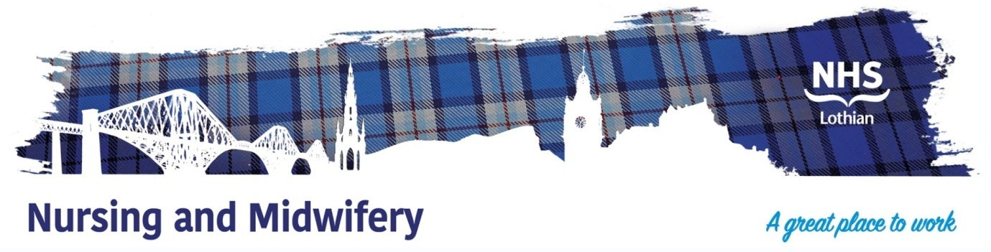

**NHS Lothian Intensive Home Treatment Team (IHTT)**

Exciting opportunities are available to join the Intensive Home Treatment Team within the Community Mental Health Team, No.11, Dalkeith, Midlothian. We have multiple Band 5 positions available for Registered Nurses and we are looking for passionate, caring, motivated people to join our highly skilled nursing teams.

We offer the opportunity to work with talented teams within multidisciplinary environments and impact positively on the lives of thousands of patients and their families.

Find out what our staff say about working in NHS Lothian at https://careers.nhslothian.scot/acute-specialist-nurses/who-we-are/

**Responsibilities**

In partnership with the registered nurse, assesses and reviews the plan of care, using the patient’s individual care plan. Implement the plan of care to ensure delivery of a high standard. Works on a regular basis without direct supervision from a registered nurse.

**Key Requirements**

* SCQF Level 7 in Healthcare related subject with previous experience working in a healthcare setting.
* Effective written and verbal communication skills.
* Ability to work with people and as part of a multidisciplinary team.
* Ability to show initiative, take responsibility and work without supervision daily.
* Organisational and time management skills.

**Further Information**

The Intensive Home Treatment Team works between 8am and Midnight 7 days per week. The postholder is therefore expected to work shifts within these hours.

**What We Can Offer You**

We have a range of vacancies for experienced and newly qualified nurses to join our innovative and dynamic teams across NHS Lothian – providing you with the opportunity to gain a breadth of knowledge and exposure to multiple specialties.

**Salary**

* Band 3 Range £25,468 – £27,486 (pro rata) per annum

**Benefits**

* A minimum of five weeks annual leave increasing with length of service
* A range of supportive employment policies including Flexible Working
* Full or part time hours considered
* We provide an extensive induction programme and excellent professional training and development opportunities.
* Access to the NHS Pension Scheme and Staff Benefits

For further information please contact Team Manager Louise Healey

Tel: 0131 2859618

Email: louise.healey@nhs.scot

  