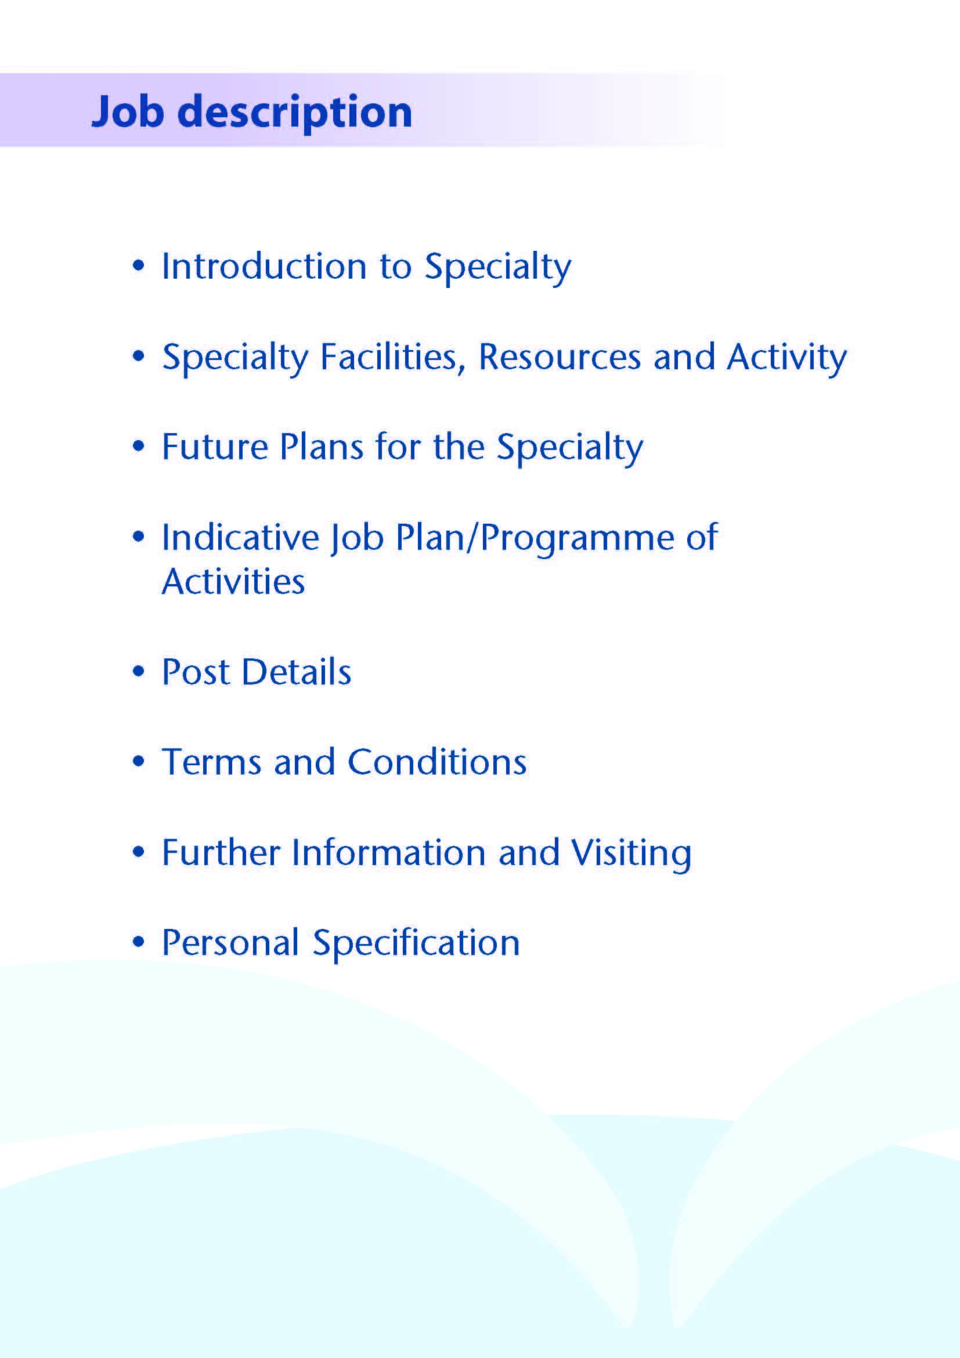



We are delighted that you are interested in applying for this Specialist post that is available to support the Oral and Maxillofacial Team within NHS Ayrshire & Arran.

Ayrshire is a wonderful location to live and work with excellent local schools. We have beautiful islands and beaches on our doorstep yet still an easy distance to Glasgow City and surrounding areas. There are excellent road and rail links to Glasgow, Central Scotland, and the Western Highlands and beyond. There are domestic and international flight connections at Glasgow Airport, south and west side of the city.

We have world class outdoor pursuits and recreational facilities, with wonderful opportunities for sailing, walking, cycling - and many golf courses.

NHS Ayrshire and Arran serve a population of 390 000.

We are committed to providing an enjoyable and rewarding working experience through supporting and developing our medical workforce to achieve their ambitions and support our aspiration to build the best medical workforce that supports an outstanding training environment.

NHS Ayrshire and Arran currently has two large District General Hospitals, one at University Hospital Crosshouse (UHC) and one at University Hospital Ayr (UHA).

The Oral and Maxillofacial Department forms part of the Head & Neck Directorate, along with ENT, Orthodontics, Maxillofacial Laboratory and Restorative Dentistry services.

The main base for this post is University Hospital Crosshouse where Oral and Maxillofacial in-patient and day case services are located. Outpatient Clinics are provided at both University Hospital Crosshouse and University Hospital Ayr.

We are looking for experienced middle grade staff with a minimum of six years’ specialty doctor experience, to provide first line medical care to patients attending the OMFS Department under the direction of the OMFS Consultants, and to be fully involved in all clinical aspects.

NHS Ayrshire and Arran is committed to maintaining and improving OMFS services for the population of Ayrshire and is fully involved in the teaching of Higher Surgical Trainees in Maxillofacial Surgery, Dental Core Trainees, Clinical Fellows & Undergraduate students.

The scope of the service within Ayrshire is: -

1. **Dentoalveolar surgery.**

Mainly carried out by the Speciality Doctor(s) and Trainees under our supervision. The Consultants also undertake dentoalveolar surgery in the day surgery unit for more complex cases.

**2. Orthognathic surgery.**

A complete facial deformity service is provided, treating both acquired and congenital deformities alongside our Orthodontic colleagues.

Developments include a 3D Printer, Cone Beam CT scanning and KLS orthognathic planning software.

**3. Trauma.**

Hard and soft tissue trauma of the face, jaws and neck is dealt with on an on-call basis by NHS Ayrshire and Arran consultants between Monday and Thursday. The regional consultant on-call service is in place to deal with calls between 5 o’clock on Friday evening and 8 o’clock on Monday morning.

1. **Head and Neck Oncology and Reconstructive Surgery.**

The department has undergone sub-specialisation with one consultant taking responsibility for the maxillofacial input to the head and neck oncology and reconstruction service. The ENT consultants provide the otolaryngology input. The major cases will have had their microvascular surgery in Greater Glasgow and Clyde since 2013. There is cross referral and joint operating on patients. The head and neck oncology managed clinical network supports this service.

1. **Skin Cancer**

There are 4 consultant Dermatologists within NHS Ayrshire and Arran. The Oral and Maxillofacial department works closely with the Dermatology team.

A Treatment Theatre runs within the OMFS department. There is a well-established fortnightly local Skin MDT with links to the weekly Regional MDT and Skin Cancer managed clinical network.

1. **TMJ Disease**

All temporomandibular joint problems, but not currently including joint reconstruction, are dealt with by the Consultant team. There are already in place established relationships with the Radiology department for the provision of MRI and CT scanning.

1. **Implantology**

Implantology, both intra and extra oral is available for the rehabilitation of both cancer and the congenital and acquired deformity patients. The Consultant in Restorative Dentistry carries out the restorative aspects of treatment.

1. **Cleft Lip and Palate & Craniofacial Services**

Two OMFS surgeons and a Plastic Surgeon undertake the Surgical Cleft service at RHC & QEUH, Glasgow. There is a cleft clinic held in Crosshouse. The Craniofacial service is run by two OMFS surgeons at the RHC and QEUH.



**Inpatient Beds**

The Head and Neck Directorate operate from combined surgical wards at University Hospital Crosshouse. These wards includes a well-equipped treatment room and a counselling room. There is a suite of Oral and Maxillofacial offices located at University Hospital, Crosshouse. The post holder would have shared office accommodation. There are currently 4 medical secretaries within the Oral and Maxillofacial department to help with any administrative duties at University Hospital Crosshouse.

**Clinics**

At University Hospital Crosshouse the main outpatient department comprises some 50 consulting rooms. There is also a dedicated clinic area for the Oral and Maxillofacial and Orthodontic Departments.

At University Hospital Ayr outpatient services are provided from both a dedicated area and some rooms shared with other specialties.

**Theatres and Day Surgery**

Theatre services supporting the Oral and Maxillofacial department are provided at Crosshouse Hospital. There are 11 main theatres in the theatre complex and one treatment room. There is a treatment theatre within the OMFS department.

**Diagnostics**

Crosshouse also has a full supporting diagnostic facility including a spiral CT scanner with 3D reconstruction and a new MRI scanner. Cone Beam CT scanning is also available within University Hospital Crosshouse.

**Oral and Facial Laboratory**

There is a fully equipped oral and facial laboratory, including 3D printer, this is led by a Consultant Maxillofacial Prosthetist and Technologist. Both intraoral and craniofacial prostheses are made at University Hospital Crosshouse.

**Education Facilities**

Both hospitals have extensive facilities for educational support. The MacDonald Education Centre at University Hospital Ayr and the Alexander Fleming Centre at University Hospital Crosshouse have an auditorium, tutorial rooms and up-to-date audio-visual facilities.

Both Education Centres house well stocked libraries which include good IT facilities offering access to Medline and the Internet.

Undergraduates from Glasgow University rotate through NHS Ayrshire and Arran and the department is actively involved in undergraduate teaching.

NHS Ayrshire and Arran has a well-established Clinical Effectiveness Department which supports Audit and Research.

Both Education Centres house well stocked libraries which include good IT facilities offering access to Medline and the Internet

**Medical Staff Resources**

The staffing of the Head & Neck Directorate is as follows:

|  |  |  |
| --- | --- | --- |
| Consultant Staff | Base | Specialist Interest |
| Ms Deborah Boyd (Clinical Director Head and Neck) | Crosshouse | Oral Maxillofacial/Orthognathic/Facial Deformity/ Trauma |
| Mr Roger Currie (Associate Medical Director, Surgery) | Crosshouse | Oral and Maxillofacial /Skin Cancer/ Orthognathic |
| Mr Ewen Thomson | Crosshouse | Oral and Maxillofacial /Head and Neck Oncology |
| Miss Mhairi Little | Crosshouse | Oral Maxillofacial/Orthognathic/Facial Deformity |
|  | | |
| Ms Lorna Langstaff (Clinical Lead ENT) | Crosshouse | General ENT/Head & Neck Oncology |
| Mr Andrew Whymark | Crosshouse | General ENT/Rhinology |
| Mr Richard Townsley | Crosshouse | General ENT/Head & Neck Oncology |
| Ms Lyndsay Fraser | Crosshouse | General ENT/Paediatrics & Cochlear Implant |
| Mr Peter Wardrop | Crosshouse | General ENT/Cochlear Implant |
| Ms Natasha Grimmond | Crosshouse | General ENT/Cochlear Implant |
|  | | |
| Mr Padraig Ferry | Crosshouse | Locum Consultant Orthodontics |
| Ms Sue Thomas | Crosshouse | Locum Consultant Orthodontics |
| New Appointment  (starting 20/01/2025) | Crosshouse | Consultant Orthodontics |
| Mr Andrew McInnes | Crosshouse | Consultant Restorative Dentistry (visiting) |

|  |  |  |
| --- | --- | --- |
| **Speciality Doctor** | **Base** | **Specialist Interest** |
| Dr Louisa McCaffrey | Crosshouse | Oral and Maxillofacial (F/T) |
| Dr Xixi Zhu | Crosshouse | Oral and Maxillofacial (F/T) |
| Vacancy | Crosshouse | Oral and Maxillofacial (F/T) |

The department is supported by junior staff as part of the Pan Scotland StR Training Programme; 1 dual qualified StR on rotation. Four DCT2’s, one DCT1, and 2 Specialty Doctors at the current time.

The orthodontic department is part of the Scottish NES Post CCST training programme and periodically recruits a ST4 level trainee post shared with Glasgow Dental Hospital.

**Activity (average per annum):**

|  |  |  |  |  |
| --- | --- | --- | --- | --- |
|  | **In-patient Admissions** | **Day Case Admissions** | **New Out-patient Appointments** | **Out-patient Treatments** |
| Maxillofacial Department | 513 | 458 | 3187 | 927 |
| ENT Department | 1681 | 604 | 6597 | 409 |
| Orthodontics | 0 | 0 | 826 | 4770 |



The OMFS department is very forward thinking and has been at the forefront of many innovations. Any contribution by this new post would be welcome in terms of the department’s development. As this is a new post the successful candidate will be supported to develop a complementary interest to the current consultants and expand the opportunities for team working across the West of Scotland Region.

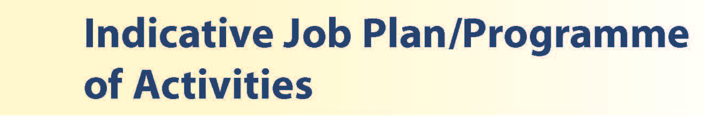

# Proposed Weekly Programme

You will be responsible to the Clinical Director for Head and Neck and Dermatology. As a member of the OMFS team, and you will be encouraged to develop and provide independent OMFS service in outpatients, day surgery and theatre.

The proposed weekly programme is shown below and is indicative. Activities with current fixed time commitments will be carried out as detailed in the work programme e.g. clinics.

There will be time for Continued Professional Development / Personal Study / Audit (one programmed activity a week).

It is important to note, that the current practice is for a variable timetable in order to maintain skills and cover. Therefore, some flexibility in timetabled activities is expected.

Other DCC and SPA activities are shown with indicative timings within the weekly programme and will be discussed with the appointee.

The requirements of this post will change through time in line with clinical advances and developments in services provided by the NHS Ayrshire & Arran.

On call arrangements: the postholder will be expected to participate in the day time on call.

**Private Practice:** If the post-holder wishes to undertake any private practice, they are obliged to inform their employer at the time of appointment of their intentions to do so. This should be submitted in writing to the Clinical Director. The conduct of private practice will be in accordance with the Specialist Doctor Contract (Scotland) Terms and Conditions October 2022.

The post-holder shall be free to undertake private practice without approval provided such work is undertaken outside the time agreed in the job plan for programmed activities. (Refer Schedule 7 of the New Specialist Doctor Contract).

|  |  |  |  |  |  |  |  |  |  |  |  |  |  |  |  |  |  |  |  |  |  |  |  |  |  |  |  |  |  |  |  |  |  |  |  |  |  |  |  |  |  |  |  |  |  |  |  |  |  |  |  |  |  |  |  |  |  |  |  |  |  |  |  |  |  |  |  |  |  |  |  |  |  |  |  |  |  |  |
| --- | --- | --- | --- | --- | --- | --- | --- | --- | --- | --- | --- | --- | --- | --- | --- | --- | --- | --- | --- | --- | --- | --- | --- | --- | --- | --- | --- | --- | --- | --- | --- | --- | --- | --- | --- | --- | --- | --- | --- | --- | --- | --- | --- | --- | --- | --- | --- | --- | --- | --- | --- | --- | --- | --- | --- | --- | --- | --- | --- | --- | --- | --- | --- | --- | --- | --- | --- | --- | --- | --- | --- | --- | --- | --- | --- | --- | --- | --- |
| **PROPOSED WEEKLY PROGRAMME**   |  |  |  |  |  |  |  |  |  |  |  |  |  |  |  |  |  |  |  |  |  |  |  |  |  |  |  |  |  |  |  |  |  |  |  |  |  |  |  |  |  |  |  |  |  |  |  |  |  |  |  |  |  |  |  |  |  |  |  |  |  |  |  |  |  |  |  |  |  |  |  |  |  |  |  |  |  |  | | --- | --- | --- | --- | --- | --- | --- | --- | --- | --- | --- | --- | --- | --- | --- | --- | --- | --- | --- | --- | --- | --- | --- | --- | --- | --- | --- | --- | --- | --- | --- | --- | --- | --- | --- | --- | --- | --- | --- | --- | --- | --- | --- | --- | --- | --- | --- | --- | --- | --- | --- | --- | --- | --- | --- | --- | --- | --- | --- | --- | --- | --- | --- | --- | --- | --- | --- | --- | --- | --- | --- | --- | --- | --- | --- | --- | --- | --- | | |  |  |  |  | | --- | --- | --- | --- | | DAY | HOSPITAL/ LOCATION | ACTIVITY | HOURS PER ACTIVITY INC TRAVEL | | FROM / TO | | Monday |  |  |  | | am | UHC | LA /Sedation List / TT | 4 | | pm | UHC | OPD Clinic | 4 | | Tuesday |  |  |  | | am | UHC | SPA / GA List | 4 | | pm | UHC | LA List / GA List | 4 | | Wednesday |  |  |  | | am | UHC | GA list/LA list alternate weeks/SPA | 4 | | pm | UHC | GA list/LA list alternate weeks | 4 | | Thursday |  |  |  | | am | UHC | LA/sedation list | 4 | | pm | UHC | OPD clinic | 4 | | Friday |  |  |  | | am | UHC | OPD clinic | 4 | | pm | UHC | Admin | 4 | | Saturday | x | x | x | | Sunday | x | x | x | | Total |  |  | 40 hours | | |



**Job Plan**

The post holder is required to agree a detailed job plan which will be reviewed at least annually. Efforts will be made to complete job planning prior to the date of commencement in post, or, if this is not possible, as soon as possible following this date. The detail of fixed sessions, including any special interest, will be finalised following appointment of the successful applicant. It is expected initially that 9 programmed activities per week will be devoted to direct clinical care, with 1 programmed activity allocated for supporting professional activities.

Attendance at multi-disciplinary team meetings, pre-procedure consultations, are included within the 9 programmed activities of direct clinical care and will be appropriately timetabled. Subject to completion of job planning, the proposed weekly timetable will follow a rolling pattern and will be linked to a consultant pairing. The work will include elective and trauma theatres and out-patient clinics

Contracted activities for this appointment will be defined and agreed with the post holder and the *Clinical Director for Head and Neck and Dermatology*. The post holder will be professionally responsible to the Associate Medical Director and managerially responsible to the General Manager Surgical Services.

This post is available on a full-time basis but the Board welcomes applications from individuals who are unable to undertake a full time commitment and who may wish to work on either a part-time or job share basis.

The successful candidate will be expected to be registered for CPD with the General Dental Council and to fulfil requirements for annual certification and for appropriate revalidation.

He/she will be expected to work alongside Consultant colleagues and collaborate appropriately with management to ensure the efficient running of services.

The main duties and responsibilities of this post include:

1. Assessment, treatment and appropriate onward care of patients attending OMFS, with responsibility for the prevention, diagnosis and treatment of illness. This will include in patients
2. Providing direct supervision of the training grade doctors, including instruction in practical procedures and appropriate assignment of routine work in the Department.
3. Provision of cover for colleagues and leading the department during periods of annual, study and unplanned leave.
4. Administrative duties associated with the care of his/her patients including, but not limited to, review of radiology and laboratory reports.
5. Assisting and leading with the clinics and provision of advice as and when requested by nursing colleagues.

1. Professional supervision and management of junior medical staff.
2. Teaching and supervision of the training grade doctors, nurse practitioners and nurses who work with the postholder. The postholder will be expected to ensure that junior medical staff have access to advice and counselling.
3. Responsibilities for carrying out teaching, accreditation and examination duties as required, and for contributing to undergraduate and postgraduate medical education.
4. The postholder will be expected to comply with College recommendations on Continuing Medical Education.
5. Requirements to participate in medical audit, continuing medical education and leading departmental QI projects.
6. The postholder will be required to comply with NHS Ayrshire and Arran’s Policies on Clinical Governance.
7. The successful applicant will be encouraged to participate in research and to develop a relevant subspecialty interest, subject to resources and local priorities.

**General Provisions**

The post is within the Surgical Directorate and the postholder will be accountable to the Clinical Director for Head and Neck and Dermatology who will agree the Job Plan.

Subject to the provisions of the Terms and Conditions of Service, he/she is expected to observe the NHS Ayrshire & Arran’s agreed policies and procedures, drawn up in consultation with the profession on clinical matters, and to follow the standing orders and financial instructions of NHS Ayrshire & Arran.

He/she will be expected to make sure that there are adequate arrangements for hospital staff involved in the care of patients to be able to make contact with the postholder when necessary.

The postholder is required to comply with NHS Ayrshire and Arran’s Health and

Safety Policies.

**Resources**

The postholder will have access to such general administrative support as is required for the discharge of his/her duties and responsibilities.

This will include the provision of adequate secretarial and clerical support and the availability of accommodation, equipment etc.

The postholder will receive support from such other professional staff as are employed within NHS Ayrshire and Arran and are deployed to his/her area of patient care.

**Annual Appraisal & Job Planning**

You shall also be required to participate in annual appraisal. Job planning is linked closely with, but is separate to, the agreed appraisal scheme for Specialist Doctors. The job plan review will take into account the outcome of the appraisal discussion and reflect the agreed personal development plan.



Determined by the Terms and Conditions of the New Specialist Doctor in Scotland contract (October 2022):

FINAL_SAS Specialist Doctor Contract_28 Oct 2022.pdf (bma.org.uk)



We would be delighted to meet with any applicants to show them around our department.

Applicants wishing further information about the post are invited to contact Ms Debbie Boyd, Consultant in Oral and Maxillofacial Surgery, Tel: (01563) 827293, debbie.boyd2@aapct.scot.nhs.uk with whom visiting arrangements can also be made.



**Post of**: Specialist in Oral & Maxillofacial Surgery

**Location**: University Hospital Crosshouse

**QUALIFICATIONS:**

|  |  |  |
| --- | --- | --- |
| **REQUIREMENTS** | **ESSENTIAL** | **DESIRABLE** |
| **Qualifications** | Full GDC registration, with licence to practise at time of appointment  Diploma of Membership of Faculty of Dental Surgery | Higher degree e.g. MSc, MD or PhD higher degree, MBA or other relevant diploma |

**Experience, knowledge and skills, development and interpersonal skills**

|  |  |  |
| --- | --- | --- |
| **REQUIREMENTS** | **ESSENTIAL** | **DESIRABLE** |
| **General Experience:** | Knowledge of and skill relevant to the management of patients.  Ability to work efficiently and timeously Demonstrated ability to manage time effectively  Ability to communicate effectively with all levels of staff and patients  Experience of working in a multidisciplinary team  Good information technology and administrative skills |  |
| **Clinical Experience:** | A minimum of 10 years dental postgraduate experience with a minimum of 6 years in OMFS  Meet the criteria of the specialist grade generic capabilities framework | Training and experience in OMFS sub-specialties  Experience of working in the NHS |
| **Clinical Knowledge & Skills** | Ability to take clinical responsibility for independent management of patients  Competence in Minor Oral Surgery | Knowledge of clinical guidelines in the NHS in Scotland |
| **Team Working** | Effective Team Player | Evidence of working with other specialties e.g. ENT, Dermatology |
| **Development** | Ready to contribute to the team  Evidence of commitment to learning and continuous professional development  Evidence of satisfactory compliance with appraisal requirements  Evidence of participation in quality improvement and clinical audit |  |
| **Teaching & Training** | Experience in teaching with evidence of teaching to others available  Committed to formal and informal teaching and training of junior doctors/dentists, medical students and other clinical staff  Desire to promote education for training grade staff. | Proven ability to deliver high quality teaching  Interest in and knowledge of advances in medical education and training.  Post graduate diploma in Education |
| **Research & Publications** |  | Published research relating to specialty  Evidence of publications in a Peer-reviewed Journal |
| **Quality Improvement/Clinical Audit** | Evidence of audit relating to OMFS or relevant subject matter |  |
| **Management and Administration** | Understands managerial role and responsibility of Middle Grade in Dermatology  Proven organisational skills | Proven ability to lead a clinical team.  Proven management experience.  Understanding of resource management and quality assurance. |
| **Personal and Interpersonal Skills** | A willingness to accept flexibility to meet the needs of the patient and the changing needs of the NHS in Scotland  Effective communicator and negotiator  Demonstrate effective leadership  Ability to operate on a variety of different levels  Open and non-confrontational  Demonstrate effective team leadership.  The ability to work flexibly and constructively with a team of colleagues.  Ability to work flexibly according to the needs of the service, and contribute to team and skills development | Knowledge of recent changes in the NHS in Scotland  A willingness to develop special interests which conform to the needs of NHS Ayrshire and Arran. |