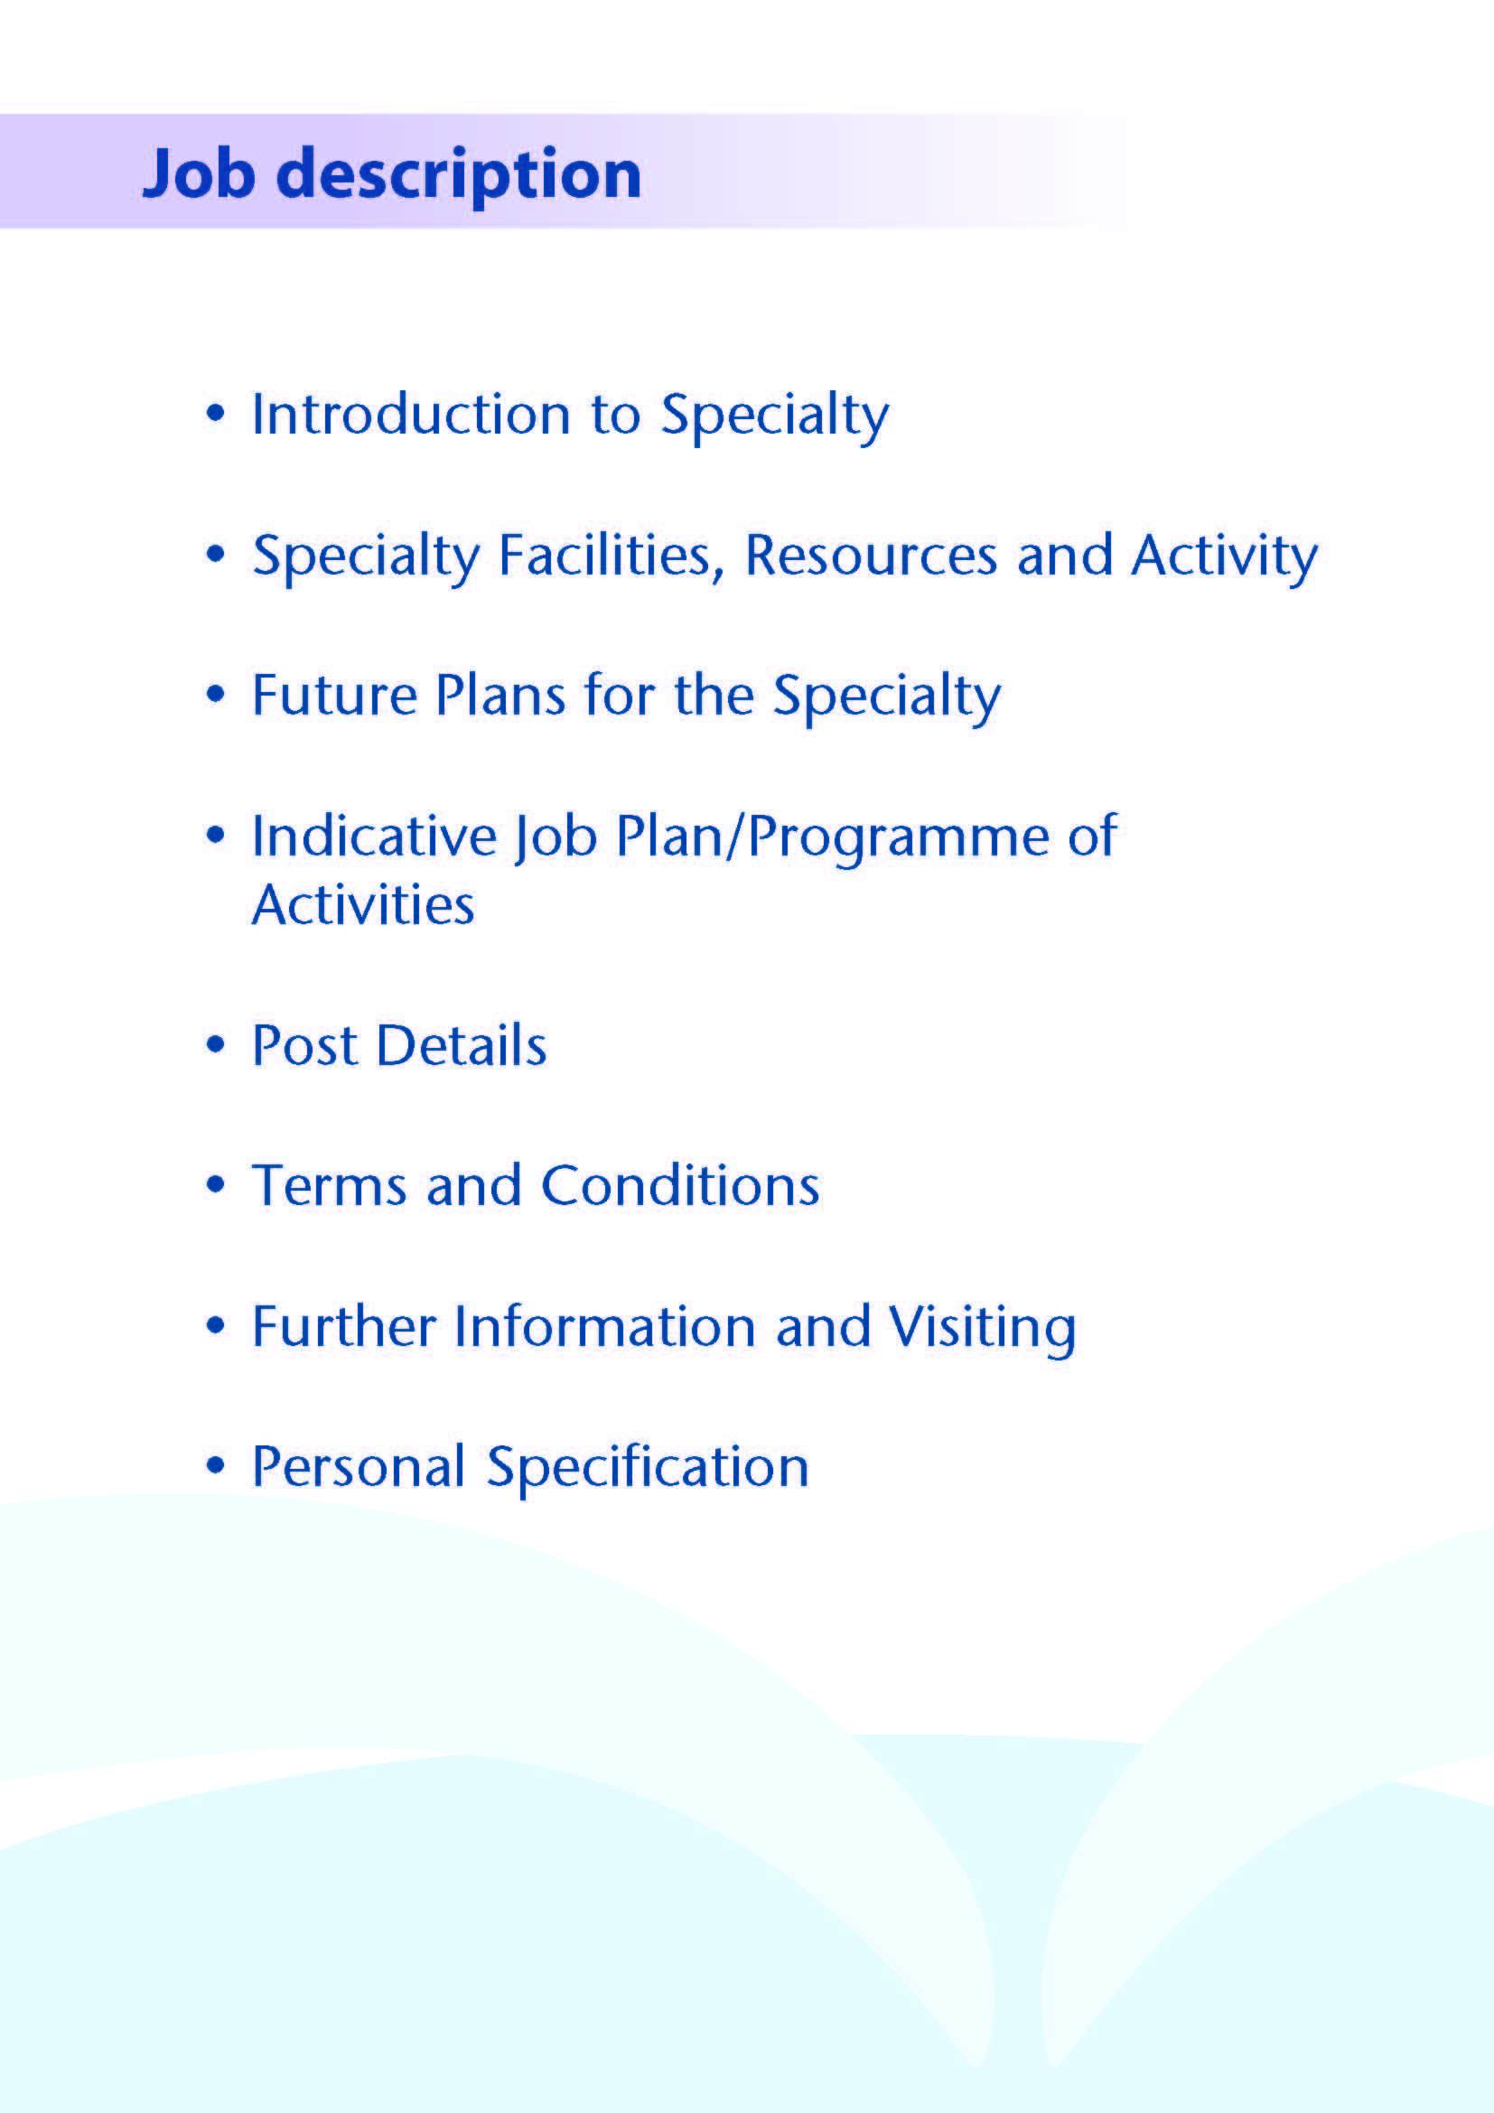



Applications are invited from enthusiastic and forward thinking anaesthetists for this post as a Locum Consultant Anaesthetist based at the University Hospital Ayr within NHS Ayrshire and Arran (NHSAA).

The successful applicant will be joining the Department of Anaesthesia at University Hospitals Ayr (UHA) and University Hospital Crosshouse (UHC), which currently comprises 40 Consultants, 10 SAS doctors and 25 Trainee Anaesthetists. The post will involve delivering anaesthesia for surgical theatres and support for an 8 bedded level 2 critical care area. The post holder will have the opportunity to develop sub-specialty interests to complement the existing expertise and interests of the department.

The post will be based in UHA, which lies just to the east of Ayr, and serves the population of South Ayrshire. It provides an extensive range of both elective and emergency surgical and medical services behind a large Emergency Department. Surgical specialties on site here include orthopaedics, general surgery, urology, interventional radiology and ophthalmology, delivered in a suite with 9 theatres. A focus on elective orthopaedic surgery is being developed on the site, with expertise and innovative practice being used to drive improved quality and efficiency. Has an 8 bedded level 2 facility supported in hours, Monday to Friday by Consultant Intensivists. Base specialties retain responsibility for the care of their patients in this unit. The hospital serves the population of 130,000 located in South and East Ayrshire.

UHC is a 539-bedded general hospital located on the outskirts of Kilmarnock, which was opened in 1982, and has been expanded and upgraded regularly since then, including the co-location of the Ayrshire Maternity Unit in 2006. UHC has 12 funded Level 3 (ICU) beds and 6 co-located level 2 beds. UHC has a separate, dedicated ICU rota, with an additional 11 consultants. The hospital serves the communities of North and most of East Ayrshire, a base population of 225,000.

The post will involve on-call commitments at UHA on a 1:13 basis. The post holder will be on call for Emergency Theatre and for the stabilisation of any patients becoming critically unwell on the UHA site or who present to the Emergency Department. A second separate rota is in place for the transfer of patients requiring ICU care. The post holder will contribute to this rota on a 1:25 basis.

These are senior on-call, non-resident commitment, for which the successful applicant must be available on site within 30 minutes. A junior anaesthetist is resident 24 hours per day.

It is anticipated that the successful applicant will work daytime elective sessions at UHA, as per the indicative job plan. To allow for future service developments, appointees might be asked to work elective sessions at any of NHS Ayrshire and Arran’s clinical sites at a later date, as agreed through the job-planning process.

Both UHC and UHA are easily accessed by road, with the M77 providing access to Glasgow within 30 - 45 minutes. Rail services also link Ayr and Kilmarnock to Glasgow and other surrounding towns, and Prestwick Airport lies approximately a 15 minute drive away. Both sites provide free car parking facilities. The hospitals lie close to the stunning Ayrshire coastline, with many beaches and golf courses among other attractions.



**Facilities**

**Theatre Facilities**

**UHA**

The theatre suite consists of 6 main theatres, 3 Day Surgery Theatres an Interventional Radiology theatre and 2 Outpatient procedure rooms.  The nearby Endoscopy suite has 4 fully equipped Endoscopy rooms.

A dedicated Emergency Theatre is available throughout the week and over the weekend for 24 hours a day.

The Anaesthetic Department is located adjacent to the theatre suite.

**UHC**

The theatre suite consists of 11 theatres (8-main theatres and 3-day surgery theatres), 1 outpatient treatment room, a collocated day of surgery admission suite and endoscopy suite with 4 fully equipped endoscopy rooms.  There is also a 15 bedded critical care unit (9 level 3 plus 6 surgical level 2 beds) located within the theatre complex. ICU beds will increase by 3 following planned changes to critical care delivery in NHSAA

There is one dedicated emergency theatre staffed 24hours per day.  Three orthopaedic trauma theatres staffed Monday to Friday and one at the weekend.

The Anaesthetic department is located adjacent to the theatre suite.

|  |  |  |
| --- | --- | --- |
| **No. of Facilities** | **University Hospital Ayr** | **University Hospital Crosshouse** |
| Main Theatres | 6 plus interventional theatre | 8 |
| Day Surgery Theatres | 3 | 3 |
| DSU Treatment Room | 2 | 1 |
| Endoscopy Procedure Rooms | 3 | 4 |

**Beds**

**The following table provides a breakdown of the bed complement within the Surgical Unit:**

|  |  |  |
| --- | --- | --- |
| **Surgical Specialty** | **University Hospital Ayr** | **University Hospital Crosshouse** |
| General Surgery | 22 | 84  (including 8 Level 2 and 4 Level 1 beds) |
| Orthopaedic | 38 | 70 |
| Ophthalmology | 2 | - |
| Urology | 23 | - |
| ENT / Maxillofacial Surgery | 0 | 17 |
| Plastic Surgery | 0 |  |
| Paediatrics (medical & surgical) | 0 |  |
| Oncology | 0 | 12 |
| High Dependency | 8 | 16 across the hospital |
| ICU | - | 12 |

Additionally University Hospital Crosshouse has 12 funded 23-hour stay beds for patients undergoing 23-hour surgery.

**Critical Care in Ayrshire**

The delivery of Critical Care in NHSAA is led by a team of consultants in Intensive Care Medicine who form a separate rota. All level 3 care is delivered from 12 beds at UHC. There is an 8 bedded level 2 critical care unit at UHA with care shared between consultants in ICM (Mon- Fri, 9am – 5pm) and the patient’s parent specialty consultant. The UHA anaesthetic team provide a level of support for this unit and for patients becoming critically unwell elsewhere in the hospital.

**Obstetric Anaesthesia**

The Ayrshire Maternity Unit (AMU), on the University Hospital Crosshouse site, opened in August 2006, moving all maternity services from Ayrshire Central Hospital in Irvine.

The AMU had approximately 3100 deliveries per annum.  There is an epidural service provided 24 hours a day, 7 days a week. We use Patient Controlled Epidural Analgesia (PCEA) routinely. We provide an elective caesarean section service, with an overall caesarean section rate of 38%.

**Educational Centres**

Excellent post-graduate facilities are provided at both hospitals, with the Alexander Fleming Education Centre based at University Hospital Crosshouse and the MacDonald Education Centre based at the University Hospital Ayr. Both centres include a full size lecture theatre, classrooms and a number of tutorial rooms.

There is a Medium Fidelity (SimMan based) Simulation Room with adjacent Debriefing Room within the Education Centre at University Hospital Crosshouse which is used by all acute specialties for training.

The facilities are supported with modern audio visual and information technology, including teleconferencing facilities and both centres incorporate an excellent up-to-date library with a resident librarian. We have an enthusiastic faculty of trained simulation facilitators from anaesthesia, general medicine, emergency medicine and paediatrics.

**Medical Photography**

The Medical Illustrations Department can provide a full service at both hospitals for clinical photography, preparation of slides, PowerPoint etc, for lecture purposes.

**Medical Staff Resources**

**Consultant Anaesthetists**

|  |
| --- |
| **UHA (on call rota)** |
| Dr N Alaouabda |
| Dr S Bhatt (Deputy CD) |
| Dr K Dick (Pain Management) |
| Dr P Hamilton (College Tutor) |
| Dr K Kerr |
| Dr D McLaughlan (ADME) |
| Dr K Shazzad |
| Dr J Mitchell |
| Dr J Ramsey |
| Dr G Scott (Rota Administrator) |
| Dr K Walker |
| Dr J Todd |

|  |
| --- |
| **UHC (ICU rota)** |
| Dr J Allan (Clinical Director) |
| Dr G Brannan (Specialist Doctor) |
| Dr D Finn |
| Dr T Geary |
| Dr G Houston |
| Dr P Korsah |
| Dr A Meikle |
| Dr P O’Brien |
| Dr J Selfridge |
| Dr A Spiers |
| Dr N Mokhtar (Locum) |
| Dr S Chodavarapu (Locum) |

|  |
| --- |
| **UHC (General on call rota)** |
| Dr I Anderson (Rota Administrator/ Deputy CD) |
| Dr A Bielinska (trauma) |
| Dr R Bonar |
| Dr S Meredith |
| Dr A Clark |
| Dr A Clyde |
| Dr J Collie (trauma) |
| Dr K Flatman |
| Dr L Hunter |
| Dr P Jacobs |
| Dr R Junkin |
| Dr C Johnstone (Clinical Director) (trauma) |
| Dr E Kerr |
| Dr L McGarrity (Associate Medical Director) |
| Dr E Neale |
| Dr H Neill (trauma) |
| Dr C Pow |
| Dr J Robertson |
| Dr K W Tan (College Tutor) |
| Dr M Watson (trauma) |
| Dr G White |
| Dr C Whymark (Pain Management) |
| Dr J Wardlaw |



The department maintains a good working relationship with all surgical specialties and supports the many initiatives in place including same day admission, increasing day case rates and generally supportive in ensuring theatre utilisation is maximised.

The UHA department serves the adult population only.  The UHC department serves the paediatric and adult population for which we provide anaesthetic services.

The UHC provide a regional service for Cochlear implants, with an increasing group of patients down to age 1 year for investigation and operations. The provision of MRI scanning under general anaesthesia has increased with an increase in consultant cover for this service. There is also the exciting development of robotic assisted surgery for the specialties of colorectal, gynaecology and urological surgery. Following reconfiguration of orthopaedics and trauma, UCH has become the trauma site for Ayrshire.

The UHA department specialises in Elective Orthopaedics with a well-established enhanced recovery program and day surgery hip & knee primary arthroplasty.  There is also a well-established interventional radiology service for which anaesthesia services are provided.

We now have an established a Cardio-Pulmonary Exercise Testing service alongside a fully developed consultant-led pre-operative assessment service and are involved in ‘enhanced recovery programs’ within several specialties.

The Scottish Government have published plans to develop a National Treatment Centre within Ayrshire and Arran, with additional theatre real-estate to facilitate elective surgery.

This is an innovative and supportive department which is beginning to look at building links with the Academic department of anaesthesia in Glasgow to facilitate research opportunities in Ayrshire.



# Proposed Weekly Programme

The proposed weekly programmes are shown below. Activities with current fixed time commitments will be carried out as detailed in the work programme e.g. clinics. Other DCC and SPA activities are shown with indicative timings within the weekly programme and will be discussed with the appointee.

**Notes on the Programme**

**Flexible sessions:** Any flexible sessions in the job plan will usually be worked during the period of time between 08:30 – 17:00 Monday to Friday to allow us to flexibly cover elective theatres. Rarely staff may be asked to work flexible evening sessions till 9pm instead.

**Patient Administration**. This activity covers the management of individual patients including Out Patient administration, results reporting, letters/phone calls to patients, carers, GP’S and members of the wider multidisciplinary team involved in the patients care.

**Ward Rounds**: the time allocated is indicative and will be discussed with the appointee. Ward work will include teaching ward rounds as required.

**Travel:** Any travel allocation will be included within the Total Programmed Activities and will be determined by location at which Direct Clinical Care and Supporting Professional activities are carried out.

**On call arrangements:**

The post will involve participation in a 1:13 rota plus a 1:25 patient-transfer rota, both plus prospective cover, based in UHA.

**Supporting Professional Activities**: NHS Ayrshire and Arran recognise the important role Job Planning has in ensuring consultants are supported in delivering high quality, safe, sustainable clinical care to patients. It is therefore important to ensure there is an adequate balance between direct clinical care activities and activities which support both the personal and professional development of the consultant workforce and facilitates agreed contribution to activities including:

* Under and post graduate teaching/training
* Clinical Governance
* Quality and Patient Safety
* Research and Innovation
* Service management and planning
* Work with professional bodies

All consultants will have 1 SPA as a minimum to support job planning, appraisal and revalidation. However the final balance of SPA and DCC activity will be agreed between the appointee and clinical manager prior to contracts being agreed. This post will commence with 2 SPA sessions. The second SPA session will be tied to specific responsibilities as agreed with the clinical manager.

There may be a requirement to vary the DCC outlined in the indicative timetable below when the final balance of DCC and SPA is subsequently agreed. There may also be opportunities to contract for Extra Programmed activities Opportunities subject to service requirements and in accordance with national terms and conditions of service.

If the post-holder will be responsible for the formal training and supervision of post-graduates and under-graduates, a suitable additional allocation of SPA time will be made in accordance with national guidance.

**Job Plan Review**

New appointees will discuss the indicative job plan with the Clinical Director, prior to commencement and will at that time review the balance of activities. Where it is possible to agree a revisions to the indicative plan in advance of commencement this will be acted upon. In any event however, there must be an interim Job Plan review conducted at 3 months post commencement to agree and finalise the Job Plan. The consultant at time of induction should ask for an interim review date to be scheduled. The agreed job plan will include all the consultant’s professional duties and commitments, including agreed Supporting Professional Activities.    Thereafter Job Planning will be carried out annually as part of the Boards Job Planning process.

**Private Practice:** If the post-holder wishes to undertake any private practice, they are obliged to inform their employer at the time of appointment of their intentions to do so. This should be submitted in writing to the Clinical Director. The conduct of private practice will be in accordance with the Consultant Contract (Scotland) Terms and Conditions.

The post-holder shall be free to undertake private practice without approval provided such work is undertaken outside the time agreed in the job plan for programmed activities. (Refer Section 6 of the New Consultant Contract).

|  |  |  |  |  |  |  |  |  |  |  |  |  |
| --- | --- | --- | --- | --- | --- | --- | --- | --- | --- | --- | --- | --- |
| **Work Timetable** | | **Direct Clinical Care (hours)** | | | | | **Supporting Professional Activities**  **(hours)** | | | | | |
|  | Description | Theatre | ICU | Admin | Pre/Post operative | **Total hours** | Teaching | Audit | CPD | Research | Other | **Total hours** |
| Mon | SPA |  |  |  |  |  |  |  | **4** |  |  | **4** |
| Mon | SPA |  |  |  |  |  |  |  |  |  | **4** | **4** |
| Tues a.m. | Orthopaedics Theatre 4 | 4.25 |  |  |  | **4.25** |  |  | |  |  |  |
| Tues p.m. | Orthopaedics Theatre 4 | 4.25 |  |  |  | **4.25** |  |  |  |  |  |  |
| Wed a.m. | General Surgery  Theatre 2 | 4.25 |  |  |  | **4.25** |  |  |  |  |  |  |
| Wed p.m. | General Surgery Theatre 2 | 4.25 |  |  |  | **4.25** |  |  |  |  |  |  |
| Thurs a.m. |  |  |  |  |  |  |  |  |  |  |  |  |
| Thurs p.m. |  |  |  |  |  |  |  |  |  |  |  |  |
| Fri a.m. | CEPOD  Theatre 3 | 4.1 |  |  |  | **4.1** |  |  |  |  |  |  |
| Fri p.m. | CEPOD  Theatre 3 | 4.1 |  |  |  | **4.1** |  |  |  |  |  |  |
| **Variable Between**  **08:30 – 21:00** |  |  |  |  |  |  |  |  |  |  |  |  |
| ICU hot weeks |  |  |  |  |  |  |  |  |  |  |  |  |
| Out of Hours  On Call | UHA | 6.8 |  |  |  | **6.8** |  |  |  |  |  |  |
| **TOTALS** |  |  |  |  |  | **32** |  |  |  |  |  | **8** |

**Indicative Job Plan**



The post holders will be accountable to the Clinical Director, who will agree the job plan.

They will be expected to work with local managers and professional colleagues in the efficient running of services and will share with Consultant colleagues in the medical contribution to management.  Subject to the provisions of the Terms and Conditions of Service, he/she is expected to observe NHS Ayrshire and Arran’s agreed policies and procedures, drawn up in consultation with the profession on clinical matters, and to follow the standing orders and financial instructions of NHS Ayrshire & Arran.

In particular, where they formally manage employees of the organisation, the post holder will be expected to follow the Local and National Employment and Personnel Policies and Procedures.

They will be expected to make sure that there are adequate arrangements for hospital staff involved in the care of patients to be able to make contact with the post holder when necessary.

The post holder is required to comply with NHS Ayrshire and Arran’s Health and Safety Policies.

They will be responsible for the training and supervision of Junior Medical Staff who work with the post holder and will be expected to devote time to this activity on a regular basis.  In addition, they will be expected to ensure that Junior Staff have access to advice and counselling.  If appropriate, the post holder will be named in the Contracts of Doctors in training grades as the person responsible for overseeing their training, and as the initial source of advice to such Doctors on their career.

**Resources**

The staff resources of the Directorate are listed elsewhere.  The post holder will have access to such general administrative support as is required for the discharge of their duties and responsibilities.

This will include the provision of adequate secretarial and clerical support and the availability of accommodation, equipment etc.

The post holder will receive support from such other professional staff as are employed within the organisation and are deployed to their area of patient care.

**Duties and Responsibilities**

The main duties and responsibilities of the post include:

* Continuing responsibility for the care of patients in his/her care and for the proper functioning of the department.
* Administrative duties associated with the care of his/her patients.
* Responsibility for continuing care of patients as scheduled in job plan / programmed activities.
* Provision of cover for consultant colleagues during periods of annual and study leave.
* Professional supervision and management of Junior Medical Staff.
* Responsibilities for carrying out teaching, accreditation and examination duties as required, and for contributing to undergraduate andpostgraduate medical education. The post holder will be expected to comply with College recommendations on Continuing Medical Education.
* The post holder will be required to comply with NHS Ayrshire and Arran’s Policies on Clinical Governance.
* The successful applicant will be encouraged to participate in research and to develop a subspecialty interest, subject to resources and local priorities.
* Requirements to participate in medical audit and in continuing medical education.
* Managerial, including budgetary, responsibilities (where appropriate).

**Annual Appraisal & Job Planning**

You shall also be required to participate in annual appraisal.  Job planning is linked closely with, but is separate to, the agreed appraisal scheme for consultants.   The job plan review will take into account the outcome of the appraisal discussion and reflect the agreed personal development plan.



Are those determined by the Terms and Conditions of the New Consultant Grade (Scotland) as amended from time to time. The distance that a consultant can reside from the principal base hospital, where travel time is seen as more important than mileage, is subject to the agreement of the Medical Director.



Applicants wishing further information about the post are invited to contact Dr Chris Johnstone, Clinical Director for Anaesthesia, Tel 01563 827172 (Secretary) or 01563 521133 (Switchboard), email chris.johnstone@aapct.scot.nhs.uk, with whom visiting arrangements can also be made.

You may also wish to contact either of the Deputy Clinical Directors, Dr Sunny Bhatt 01292 610555 (UHA), or Dr Ian Anderson 01563 521133 (UHC).

Cameron Sharkey, General Manager for Surgical Services is also happy to be a point of contact and can be contacted as follows: email: Cameron.Sharkey@aapct.scot.nhs.uk

Telephone: 01292 616899.



# 

**Post of: Locum Consultant in Anaesthesia**

**Location: NHS Ayrshire and Arran**

|  |  |  |  |
| --- | --- | --- | --- |
|  | **Essential** | **Desirable** | **How or where judged?** |
| **Qualifications** | MBChB or equivalent  FRCA or equivalent | Higher research degree  Evidence of mandatory  training e.g. resuscitation,  hand hygiene and fire  training.  On GMC specialist register or  eligible to be within 6 months | Application  Application  Application |
| **Training/Experience** | Extensive training in Anaesthesia | Recent experience of  working within the NHS  provider.  Specialist training in  regional anaesthesia.  European Society of  Regional Anaesthesia  (ESRA) diploma | Application/Interview  Application/Interview  Application/Interview |
| **Skills/Knowledge** | Effective MDT working  Excellent team working skills | Experience in ultrasound for regional anaesthesia  IT skills including the use of clinical systems | Interview/Application  Interview |
| **Teaching and Education** | To provide clinical supervision  of postgraduate training  doctors  Teaching undergraduates and  other health professionals | Ability to become an  educational supervisor  “Training the trainers”  qualification | Application /interview  Application /interview |
| **Research and innovation** | Previous and current active  interest in research with  evidence of publications | Peer-reviewed  publications in recognised  journals reflecting perioperative  medicine  Previous contributions  to innovative service  developments | Application /interview  interview |
| **Understanding of GMC requirements** | Knowledge of “Good medical practice) | Knowledge of appraisal/  revalidation process  Understanding of the GMC  and its new roles | Interview  Interview |
| **Leadership/ Management** | Demonstrate leadership potential | Previous management  and Clinical Leadership  roles | Interview/Application |