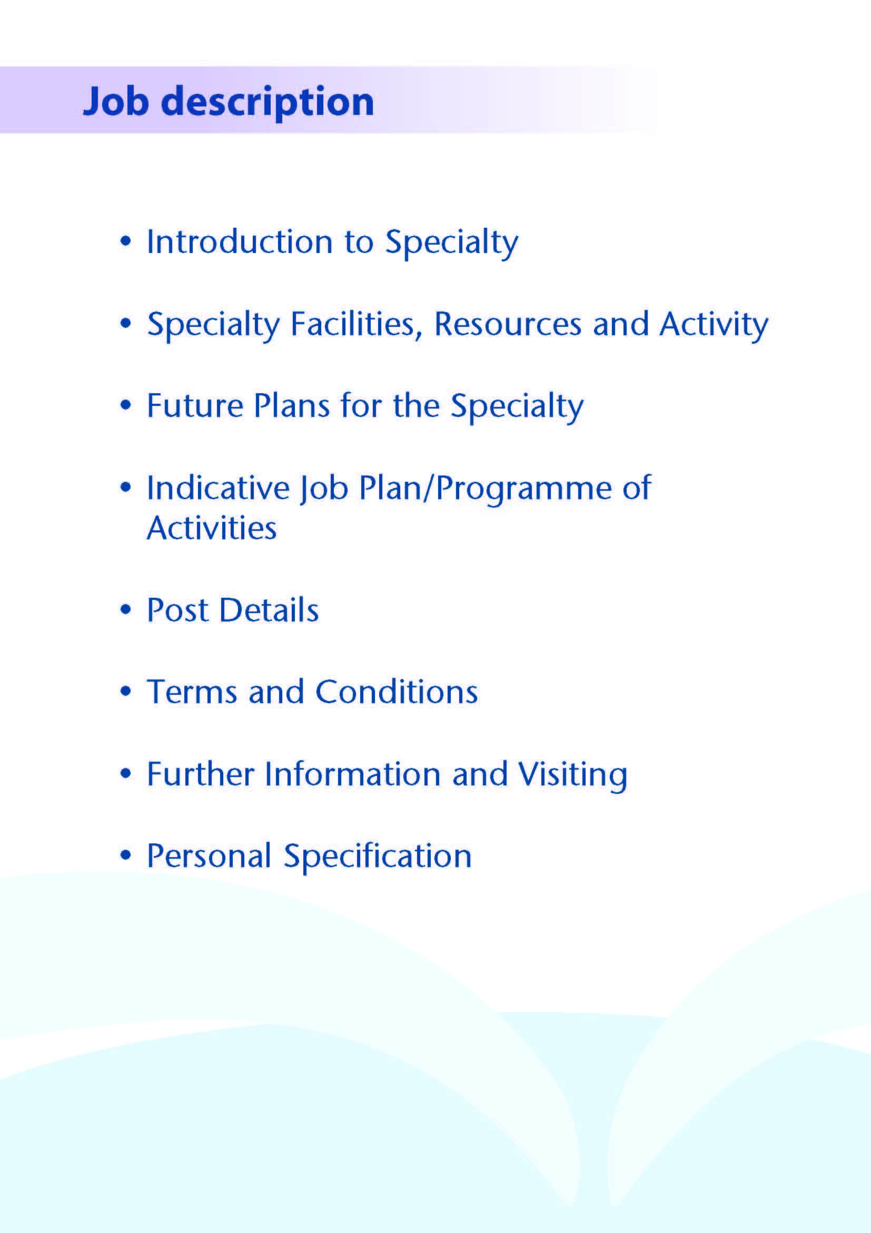



The Ophthalmology Department is based at University Hospital, Ayr where inpatient and day surgery facilities are situated. Outpatient services are provided at University Hospital, Ayr and University Hospital, Crosshouse as well as the War Memorial Hospital in Lamlash, Isle of Arran.

The department provides ophthalmic healthcare on an area basis for a population of approximately 375,000.

The department is able to offer training opportunities in most sub-specialty areas and are willing to support continued training for the successful candidate.



**2.1 Facilities**

**CLINICS**

### University Hospital Ayr

The clinic at Ayr is equipped with a Humphrey Visual Field Analyser, non-mydriatic camera, digital fundus imaging system, slit-lamp camera, corneal topographer automated refractometer, B-scan ultrasound, OCT and laser delivery systems (slit-lamp, indirect and YAG)

The Day Surgery Unit is also equipped to function as a clinic with ‘one stop’ cataract and lid surgery sessions having been established.

Intra vitreal treatments for wet ARMD are now administered on a regular basis in a clean treatment room.

### University Hospital, Crosshouse

The clinic at University Hospital, Crosshouse is equipped with a digital fundus imaging, B-scan ultrasound, OCT, Humphrey visual field analyser and automated refractometer. A nurse led glaucoma service has been established at both Ayr and Crosshouse Hospitals.

A screening service for retinopathy of prematurity is provided to the Special Care Baby Unit. Close liaison between Paediatricians and Ophthalmologists in relation to all aspects of paediatric eye care is maintained.

### War Memorial Hospital, Lamlash, Isle of Arran

The clinic is conducted at this site six times per year and facilities for minor procedures are available.

### INPATIENT FACILITIES

Adult inpatient beds are located in Station 3 at University Hospital, Ayr. Paediatric beds are all based at Crosshouse Hospital in Kilmarnock. In addition, 23 hour beds are located in the Day Surgery Unit at The Ayr Hospital.

**THEATRES**

There are two dedicated ophthalmic theatres within the Day Surgery Unit. Both theatres are equipped for phacoemulsification surgery and vitreo-retinal surgery. A Cyclodiode laser is also available in the Day Surgery Theatre.

###### **EDUCATION FACILITIES**

Both hospitals have extensive facilities for educational support. The MacDonald Education Centre at the University Hospital, Ayr and the Alexander Fleming Centre at University Hospital, Crosshouse have an auditorium, tutorial rooms and up-to-date audio-visual facilities.

The library at the Ayr Hospital subscribes to the following ophthalmic journals: BJO, AJO, Archives of Ophthalmology, Survey of Ophthalmology, and Retina.

There is also an extensive selection of reference textbooks in the library and a slide collection.

IT facilities within the Ayr Hospital Library offer access to Med-Line, the Cochrane Library and the Internet.

**2.2 Medical Staff Resources**

The staffing of the ophthalmology directorate is as follows:

|  |  |  |
| --- | --- | --- |
| **Consultant Staff** | **Base** | **Specialist Interest** |
| Dr A Syrogiannis | The Ayr Hospital | Glaucoma |
| Dr A Ullah | The Ayr Hospital | Paediatric |
| Dr B Hutchison | The Ayr Hospital | Medical retina, including diabetes |
| Dr K Merchant | The Ayr Hospital | Vitreoretinal surgery |
| Dr A Inglis | The Ayr Hospital | Glaucoma |
| Dr S Bhagat | The Ayr Hospital | Oculoplastic Surgery  General Ophthalmology |
| Dr G Fincham | The Ayr Hospital | Oculoplastic Surgery  General Ophthalmology |
| Dr M Varikkara | The Ayr Hospital | Medical retina including management of wet ARMD. |
| Mr S Srinivasan | The Ayr Hospital | Cornea, external eye diseases and anterior segment |
| Dr Z Koshy | The Ayr Hospital | Vitreoretinal surgery |
| Dr K Michael | The Ayr Hospital | Vitreoretinal surgery |

|  |  |
| --- | --- |
| **Associate Specialist** | **Base** |
|  |  |
| Dr Krishnapriya | The Ayr Hospital |
| **Staff Grade/ Specialty Doctor** |  |
| Dr Hirae | The Ayr Hospital |
| Dr Ambrose | The Ayr Hospital |
| Dr Anna Murphy | The Ayr Hospital |
| Dr Niyonkuru | The Ayr Hospital |
| Dr Rashid | The Ayr Hospital |

There are two educationally approved trainee posts and one FY2.

|  |  |
| --- | --- |
| **Support Staff:** | Seven full time and two part time Orthoptists |
|  | One part time Visual Field Technician |
|  | Two part time Optometrists |
|  | Extensive nursing support |

* 1. **Activity (average per annum):**

|  |  |
| --- | --- |
| Inpatients and Daycases | Approx 150 - inpatients  Approx 10000 – daycases (including injections) |
| Outpatients New  Return | 15000  40000 |



The department is continually looking to take forward new initiatives. We have a nurse led wet macular degeneration follow up service in place and a nurse led glaucoma service is embedded on both acute hospital sites.

The department has now set up a fast track service to deliver the introduction of new treatments available for patients with age related macular degeneration.

The well established screening programme for diabetic retinopathy is supported by accredited optometrists.

The department is proactive in trying to ensure that it is fully equipped with up-to-date technology and equipment and routinely makes bids for funding from any sources which become available.



# Proposed Weekly Programme

The proposed weekly programme is shown below. This in a typical job plan but sessions may vary depending on the sub specialty interest of applicants. Activities with current fixed time commitments will be carried out as detailed in the work programme e.g. clinics. Other DCC and SPA activities are shown with indicative timings within the weekly programme and will be discussed with the appointee.

The nature of the post will require flexibility in the programme and may therefore be subject to change on a monthly basis to meet the needs of the Service in the achievement of national waiting times and targets. The following represents a provisional programme subject to discussion with the successful candidate and consultant colleagues. The programme as shown below is provisional and could be amended based on the specialty interest of the potential candidate but also prioritising available clinical team resources and needs.

|  |  |  |  |  |  |
| --- | --- | --- | --- | --- | --- |
|  | **Monday** | **Tuesday** | **Wednesday** | **Thursday** | **Friday** |
| **AM** | Theatre | Clinic Ayr | Clinic Ayr | Admin | Clinic Ayr |
| **PM** | Theatre | Clinic Ayr | Casualty | SPA | Casualty Ayr |

The successful candidate will be required to take part in the on call rota and the weekly timetable will be amended to allow time off to compensate for work undertaken while on-call.

Opportunities may exist for Additional Programmed Activities to be undertaken subject to service requirements and in accordance with national terms and conditions of service.

Minimum of one SPA will reflect activities such as appraisal, personal audit, professional development (occurring outside study leave time) but dependent on local conditions, may also provide enough time to reflect teaching and other activities.

Further SPA time may be negotiated for specific, clearly identified additional Supporting Activities provided that these are acceptable to the Specialty Doctor and desired by the Board.

**Notes on the Programme**

**Patient Administration**. This activity covers the management of individual patients including Out Patient administration, results reporting, letters/phone calls to patients, carers, GP’S and members of the wider multidisciplinary team involved in the patients care.

**Ward Rounds**: the time allocated is indicative and will be discussed with the appointee. Ward work will include teaching ward rounds as required.

**Travel:** Any travel allocation will be included within the Total Programmed Activities and will be determined by location at which Direct Clinical Care and Supporting Professional activities are carried out.

**On call arrangements**: The postholder will have the option to be part of the current Ophthalmology rota. This rota is currently a 1:6 for out of hours cover including weekends.

**Supporting Professional Activities:** The agreed job plan will include all of the Specialty Doctor’s professional duties and commitments, including agreed supporting professional activities (SPAs). NHS Ayrshire & Arran supports the identification of 4 hours of SPA work for full-time employees (part- time allocations will be similarly encouraged against the relevant table in the T&Cs) and commits to manage this in a high trust, low bureaucracy fashion. It will be requested that SPAs are delivered at the normal place of work, unless there are mutual advantages to it being performed elsewhere. The exact timing and location of SPAs, and flexibility around these, will be agreed during the 1:1 and included in the prospective job plan.

**Research:** Research is encouraged and supported by an active Research and Development Committee. The appointee will be encouraged to develop research interests associated with their specialist interest.

**Teaching**: The post holder will be expected to ensure that Junior Staff and medical students receive adequate support and advice and may act as a contact as the person responsible for overseeing their training and as an initial source of advice.

**Job Plan Review:** New appointees will discuss the indicative job plan with the Clinical Director, prior to commencement and will at that time review the balance of activities. Where it is possible to agree a revisions to the indicative plan in advance of commencement this will be acted upon. In any event however, there must be an interim Job Plan review conducted at 3 months post commencement to agree and finalise the Job Plan. The consultant at time of induction should ask for an interim review date to be scheduled. The agreed job plan will include all the consultant’s professional duties and commitments, including agreed Supporting Professional Activities.    Thereafter Job Planning will be carried out annually as part of the Boards Job Planning process.



The postholder will be accountable to the Clinical Directors, who will agree the Job Plan.

He/she will be expected to work with local managers and professional colleagues in the efficient running of services and will share with colleagues in the medical contribution to management. Subject to the provisions of the Terms and Conditions of Service, he/she is expected to observe NHS Ayrshire and Arran’s agreed policies and procedures, drawn up in consultation with the profession on clinical matters, and to follow the standing orders and financial instructions of NHS Ayrshire & Arran.

He/she will be expected to make sure that there are adequate arrangements for hospital staff involved in the care of patients to be able to make contact with the postholder when necessary.

The postholder is required to comply with NHS Ayrshire and Arran’s Health and Safety Policies.

**5.1 Resources**

The staff resources of the Directorate are listed elsewhere. The postholder will have access to such general administrative support as is required for the discharge of his/her duties and responsibilities.

This will include the provision of adequate secretarial and clerical support and the availability of accommodation, equipment etc.

The postholder will receive support from such other professional staff as are employed within the Division and are deployed to his/her area of patient care.

**5.2 Duties and Responsibilities**

The main duties and responsibilities of the post include:

* Appropriate assessment and management of outpatients assigned to postholder.
* Responsibilities for carrying out teaching, accreditation and examination duties as required, and for contributing to undergraduate andpostgraduate medical education. The postholder will be expected to comply with College recommendations on Continuing Medical Education.
* The postholder will be required to comply with NHS Ayrshire and Arran’s Policies on Clinical Governance.
* The successful applicant will be encouraged to participate in research and to develop the relevant subspecialty interest, subject to resources and local priorities.
* Requirements to participate in medical audit and in continuing medical education.
* Participate in on-call rota as outlined

**5.3 Annual Appraisal**

You shall also be required to participate in annual appraisal. The job plan review will take into account the outcome of the appraisal discussion and reflect the agreed personal development plan.



Are those determined by the Terms and Conditions of the New Specialty Doctor grade (Scotland) as amended from time to time. The distance that a specialty doctor can reside from the principal base hospital, where travel time is seen as more important than mileage, is subject to the agreement of the Executive Medical Director but it is usually anticipated that a journey that takes no more than 30 minutes for any emergency situation would be acceptable.



Applicants wishing further information about the post are invited to contact Dr Mohan Varikkara (01292) 616482 Ext. 16482, Clinical Director in Ophthalmology whom visiting arrangements can also be made.

The last date for application is



**POST OF** : LOCUM SPECIALTY DOCTOR IN OPHTHALMOLOGY

**LOCATION** : AYR HOSPITAL

## QUALIFICATIONS:

|  |  |
| --- | --- |
| ESSENTIAL | DESIRABLE |
| Full GMC Registration with a current Licence to Practice | Royal College Membership/Fellowship |
| A minimum of 3 years full-time postgraduate Ophthalmology training.  Required IELTS score |  |

**SKILLS/KNOWLEDGE/COMPETENCE**

| **REQUIREMENTS** | **ESSENTIAL** | **DESIRABLE** |
| --- | --- | --- |
| **General Experience:**   * Expertise in generalist field | * Knowledge of and skill relevant to the management of patients. * Ability to communicate effectively with all levels of staff and patients * Ability to work efficiently and timeously * IT literacy | * Ability to develop areas of clinical practice |
| **Team Working** | * Effective Team Player |  |
| **Development** | * Evidence of Continuing professional development   (CEPD)   * Evidence of satisfactory compliance with appraisal requirements |  |

|  |  |  |
| --- | --- | --- |
| **Teaching & Training** | * Experience of Teaching. | * Interest in and knowledge of medical education |
| **Research & Publications** | * Evidence of publications relating to specialty | * Evidence of publications relating to specialty |
| **Clinical Audit** | * Evidence of audit relating to Ophthalmology |  |
| **Management and Administration** | * Proven organisational skills | * Understanding of quality assurance |
| **Personal and Interpersonal Skills** | * A willingness to accept flexibility to meet the changing needs of the NHS in Scotland * Effective communicator and negotiator * A willingness to develop special interests which conform to the needs of NHS Ayrshire and Arran * Ability to operate on a variety of different levels * Open and non-confrontational | * Knowledge of recent developments in NHS Scotland |