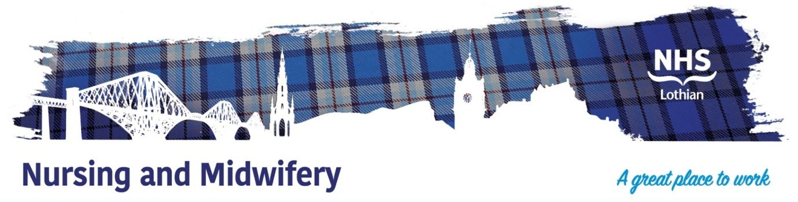

**NHS Lothian MHIST Team, Learning Disabilities Service**

Exciting opportunities are available to join The Mental Health Intensive Support and Treatment (MHIST) Team within one of the hospital sites across NHS Lothian. We have multiple Band 5 positions available for Registered Nurses and we are looking for passionate, caring, motivated people to join our highly skilled nursing teams.

We offer the opportunity to work with talented teams within multidisciplinary environments and impact positively on the lives of thousands of patients and their families.

Find out what our staff say about working in NHS Lothian at https://careers.nhslothian.scot/acute-specialist-nurses/who-we-are/

**What We Can Offer You**

We have a range of vacancies for experienced and newly qualified nurses to join our innovative and dynamic teams across NHS Lothian – providing you with the opportunity to gain a breadth of knowledge and exposure to multiple specialties.

**Roles**

STAFF NURSE – BAND 5

MENTAL HEALTH INTENSIVE SUPPORT AND TREATMENT TEAM (MHIST)

PERMANENT FULLTIME 37.5 HOURS PER WEEK

This post provides an excellent opportunity for an enthusiastic and experienced registered RNLD/RMHN to join the multi-professional MHIST Team, which provides a specialist inreach, home treatment and crisis intervention service to adults with learning disabilities and additional mental health needs. The team is based in Woodlands House, Astley Ainslie Hospital, Edinburgh and covers both domiciliary and psychiatric inpatient areas across Lothian.

For further information and discussion please contact Barbara MacPherson, Senior Charge Nurse – 0131 446 4470

**Salary**

* Band 5 Range £30,229 – £37,664 (pro rata) per annum

**Benefits**

* A minimum of five weeks annual leave increasing with length of service
* A range of supportive employment policies including Flexible Working
* Full or part time hours considered
* We provide an extensive induction programme and excellent professional training and development opportunities.
* Access to the NHS Pension Scheme and Staff Benefits

  