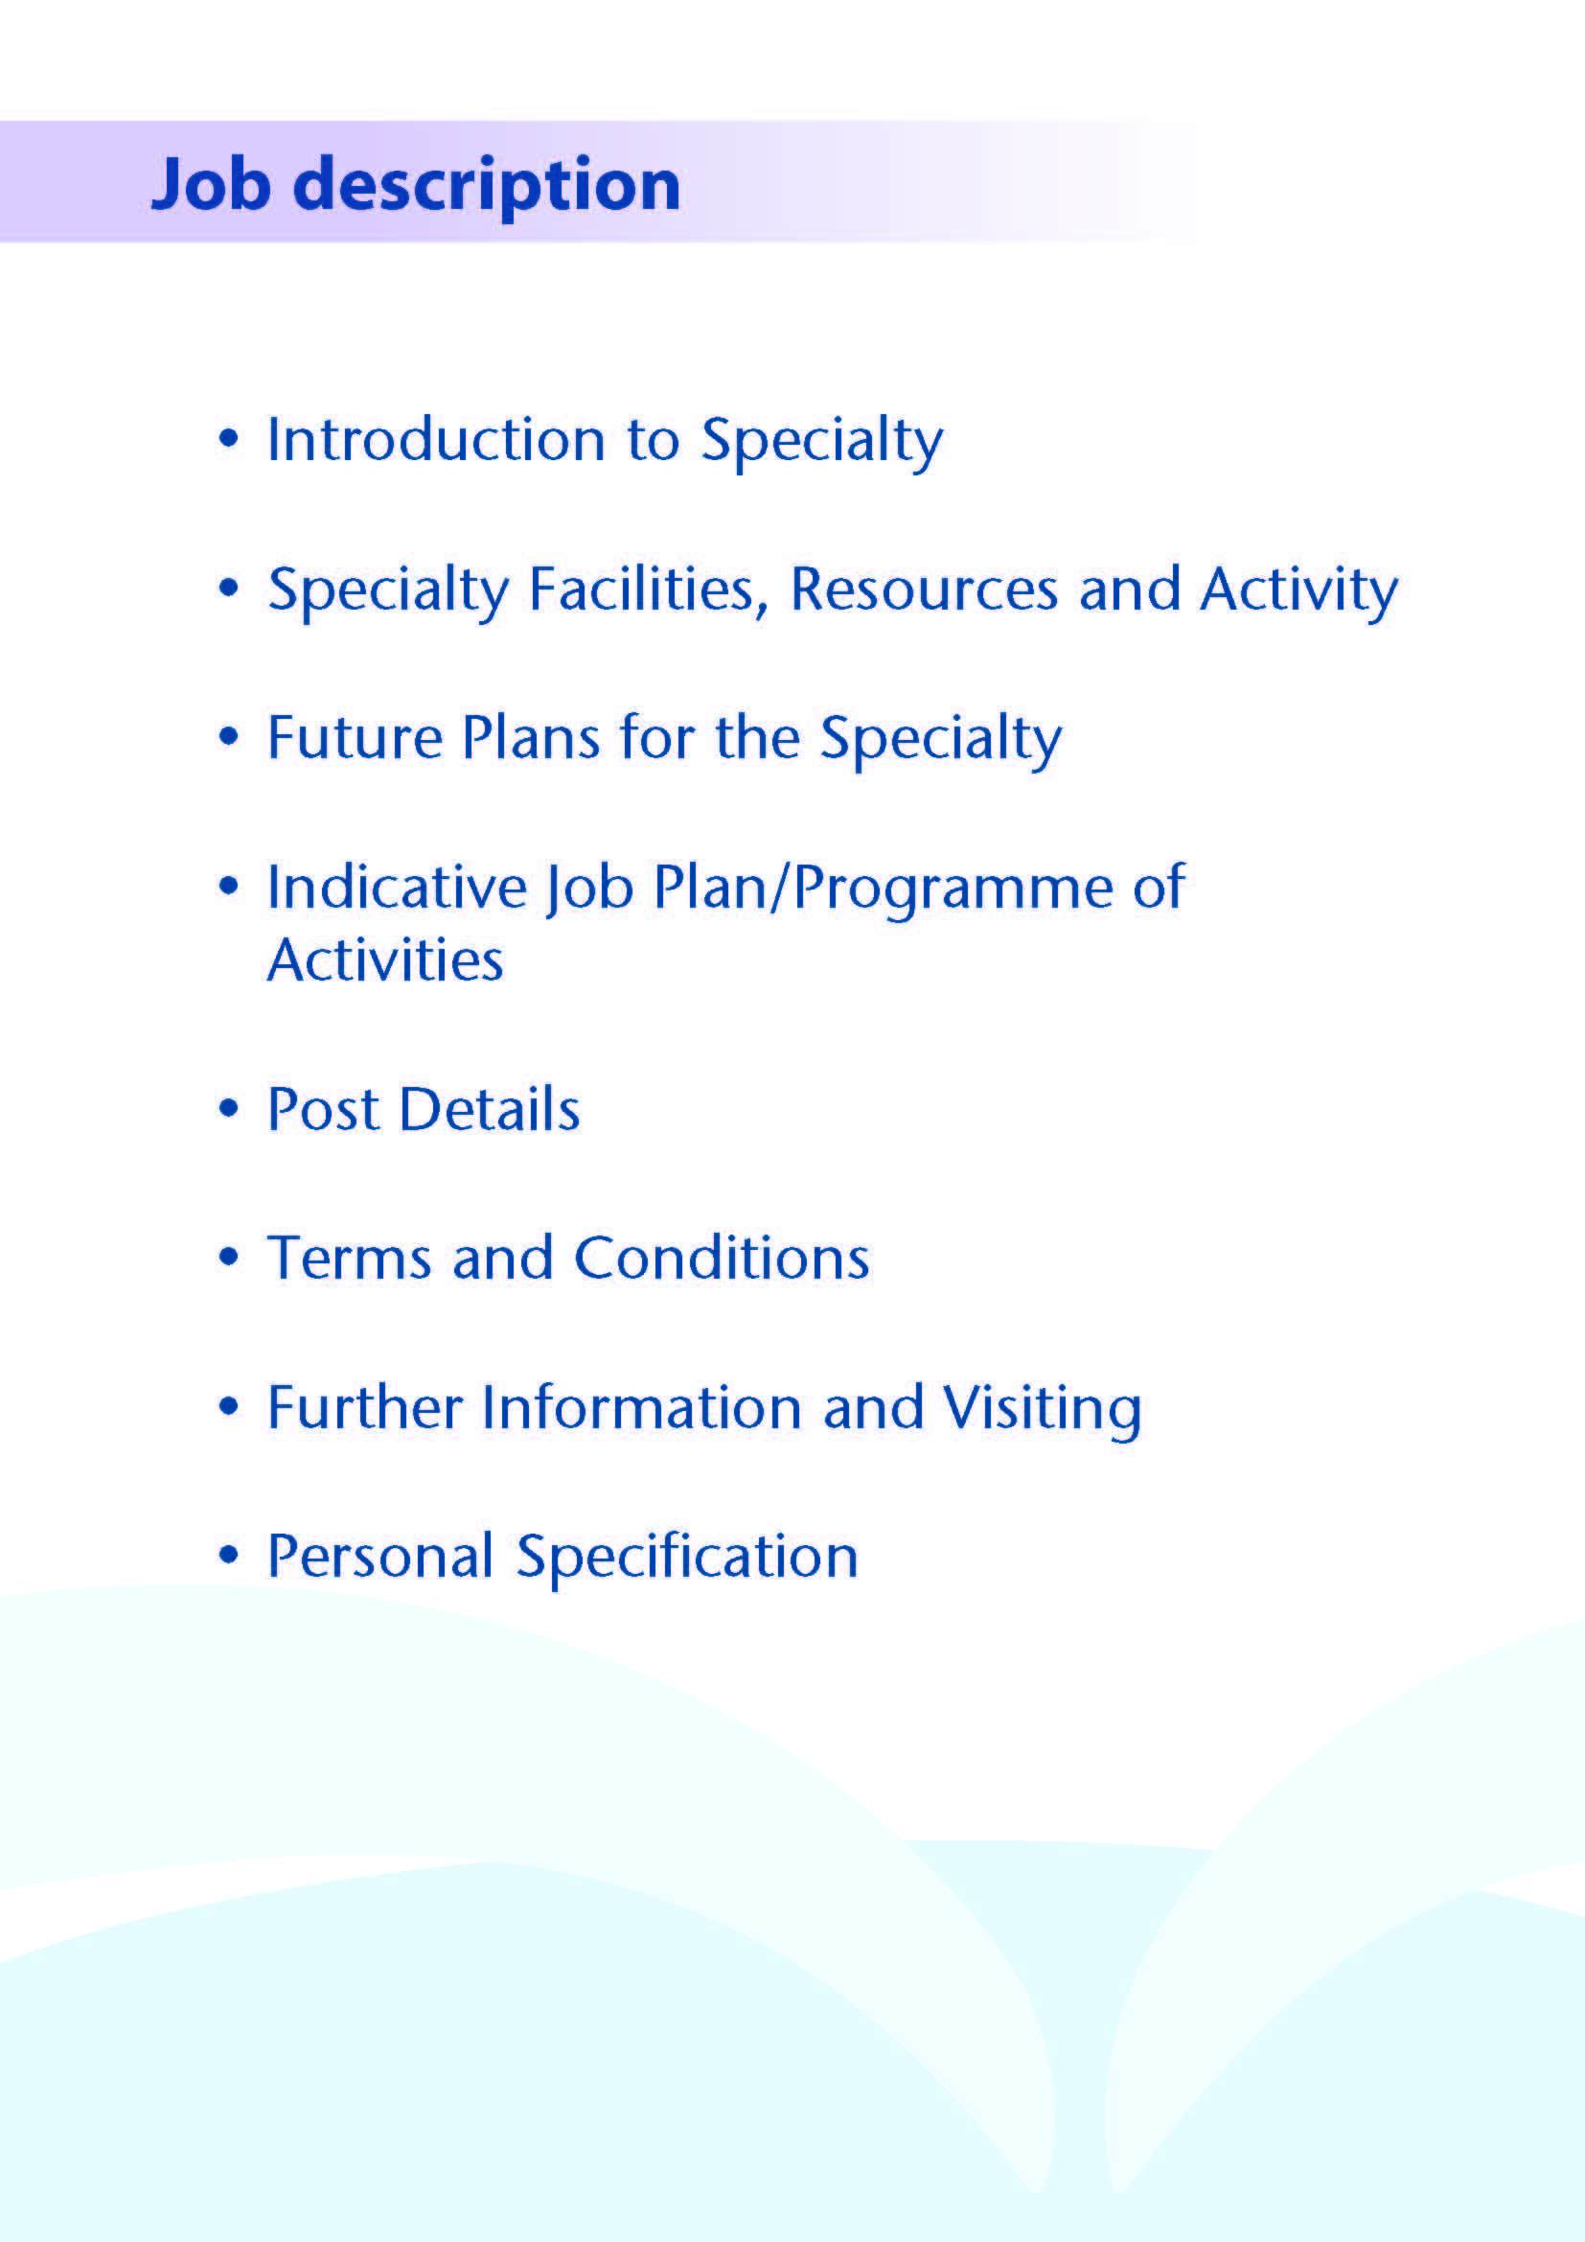

Post: Specialty Doctor – Dermatology



We are delighted that you are interested in applying for a Specialty Doctor post within Dermatology in NHS Ayrshire and Arran. Ayrshire is a wonderful location to live and work with excellent local schools. We have beautiful islands and beaches on our doorstep yet still an easy distance to Glasgow City and surrounding areas. There are excellent road and rail links to Glasgow, Central Scotland, and the Western Highlands and beyond. There are domestic and international flight connections at Glasgow Airport, south and west side of the city.

We have world class outdoor pursuits and recreational facilities, with wonderful opportunities for sailing, walking, cycling - and many golf courses.

NHS Ayrshire and Arran serve a population of 390 000.

We are committed to providing an enjoyable and rewarding working experience through supporting and developing our medical workforce to achieve their ambitions and support our aspiration to build the best medical workforce that supports an outstanding training environment.

NHS Ayrshire and Arran currently has two large District General Hospitals, one at University Hospital Crosshouse (UHC) and one at University Hospital Ayr (UHA)

This post is based at University Hospital Crosshouse in Kilmarnock although some clinics may be delivered at University Hospital Ayr.

We are looking for experienced Dermatology middle grade staff to provide care to patients attending the Dermatology Department under the direction of the Dermatology Consultants, and to be fully involved in all clinical aspects.

NHS Ayrshire and Arran is committed to maintaining and improving Dermatology services for the population of Ayrshire and is fully involved in the teaching of Glasgow University undergraduates.



NHS Ayrshire & Arran has a population of approximately 388,000 residents stretching from Skelmorlie on the Clyde coast to Ballantrae in the rural South. The Health Board boundary is co-terminus with North, South and East Ayrshire health and Social Care Partnerships and councils.

**Clinics**

NHS Ayrshire and Arran’s Dermatology Department’s main base is at University Hospital Crosshouse (Kilmarnock) where most services are provided from a purpose-designed Dermatology Centre supplemented by a suite within the Out-patient department. There is a smaller base at University Hospital Ayr. A redesign of the unit at University Hospital Crosshouse provided enhanced clinic and Day Treatment Unit facilities. The unit has busy Day Treatment Units at Crosshouse and Ayr.

Additionally some clinics are delivered from the Maxwell Suite which forms part of the outpatient department at University Hospital Crosshouse. At University Hospital Ayr outpatient services are provided from both a dedicated area and some rooms shared with other specialties.

**Surgical Procedures**

These are performed within the dedicated biopsy rooms on both sites. Consultants and Specialty Doctors currently operate a total of 5 sessions per week. This service is crucially supported by a team of 7 Nurse Biopsy Specialists who additionally perform a wide range of surgical procedures in stand-alone and one-stop clinics.

This service is also supported by Oral Maxillofacial Surgery and Plastic Surgery colleagues.

**Patch Test Clinics**

Patch testing clinics operate with a full range of allergens. This Consultant led clinic is supported by 2 experienced Deputy Charge Nurses.

**Genodermatoses**

A specialist clinic for inherited genodermatoses, particularly inherited disorders of keratinisation is offered in Ayrshire, with links to the tertiary referral adult genodermatoses clinic and combined Clinical Genetics/Paediatric and Adult Genodermatoses meetings in Glasgow. This clinic provides a base for ongoing clinical research, and is involved with the Scottish Telelinked Epithelial Genetics MDTs.

**Phototherapy**

The unit participates in Photonet, the Scottish-wide managed clinical network (MCN) for phototherapy. TL01, PUVA and Photodynamic therapy are performed within the busy Day Treatment Unit on both sites. A home phototherapy service is also provided.

**Nurse Led Clinics**

Our team of Specialist dermatology nurses (including Nurse Prescribers) operate return clinics for eczema, psoriasis and general dermatology patients, and assist with Isotretinoin and Biologics clinics.

**Isotretinoin Clinics**

A very successful Nurse Led Isotretinoin service has been established for many years within NHS Ayrshire. This is currently under review in light of recent MHRA advice.

**Medical Photography**

Medical Photography services are available at both sites and have facilities for taking dermoscopic images. The department also provides appointments each week to support the photo triage service.

**Links with other Departments / MDT**

The Dermatology Department enjoys close relationships with Maxillofacial Surgery and Plastic Surgery.

Monthly clinic-pathological meetings are held maintaining close links between the departments.

There is a fortnightly local skin cancer MDT meeting and the unit also participates in the regional skin cancer MDT and Lymphoma MDT meetings.

###### Education Facilities

Both hospitals have extensive facilities for educational support. The MacDonald Education Centre at University Hospital Ayr and the Alexander Fleming Centre at University Hospital Crosshouse have an auditorium, tutorial rooms and up-to-date audio-visual facilities.

Both Education Centres house well stocked libraries which include good IT facilities offering access to Medline and the Internet.

Undergraduates from Glasgow University rotate through NHS Ayrshire and Arran and the department is actively involved in undergraduate teaching.

NHS Ayrshire and Arran has a well-established Clinical Effectiveness Department which supports Audit and Research.

The department is also involved in postgraduate teaching for GPs, GP trainees and the West of Scotland Dermatology trainee teaching programme.

**Dermatology CME**

The Dermatology Department CME programme is organised on an academic term basis with monthly clinical review meetings for discussion of challenging cases, regular clinical governance and audit meetings, journal club meetings, and external speakers. The regional centre in Glasgow organises postgraduate meetings with presentations from external speakers. The hospital medical unit operates an active CME programme.

**Medical Staff Resources**

|  |  |
| --- | --- |
| **Consultant Staff** | **Base** |
| Dr Jane Colgan | University Hospital Crosshouse |
| Dr Catriona Glen | University Hospital Crosshouse |
| Dr Alison Honan | University Hospital Crosshouse |
| Dr Alex Waters | University Hospital Crosshouse |
| Dr Mozheh Zamiri | Greater Glasgow and Clyde (supports the NHS A&A genodermatoses clinic fortnightly) |
| Dr Sherine Tavadia (Bank) | University Hospital Crosshouse |
|  |  |
| **Specialty Grade** | **Base** |
| Dr Abdullah Al-Dallaali | University Hospital Crosshouse |
| Vacancy | University Hospital Crosshouse |
| Dr Omosefe Okpaise | University Hospital Crosshouse |
| **Sessional GPwER** |  |
| Dr Karen Clark | University Hospital Crosshouse |
| Dr Jennifer May | University Hospital Crosshouse |
| Dr Richy Morais | University Hospital Crosshouse |
| Dr Lorna Patterson | University Hospital Crosshouse |

The department is supported by the West of Scotland Dermatology StR Training Programme 1 specialist trainee, 2 GPSTs and 1 FY2.

Crucially the Medical Staff are supported by a team of nursing and administrative colleagues.

There is a Senior Charge Nurse, 2 Deputy Charge Nurses, 3 Nurse Practitioners, a Skin Cancer Nurse Specialist and an experienced team of Dermatology Nurses to support all clinics, including 3 additional nurse biopsy specialists. The Senior Nurse team are supported by 2 admin assistants.

The service is supported by a total of 8 medical secretaries and 1 audio typist.

#### Activity (average per annum):

For planning purposes, NHS Ayrshire and Arran serves a catchment population of 388,000.

|  |  |
| --- | --- |
| Referrals 2023 | 10521 |
| Activity 2023  New Patients  Review OP and Treatments | 5201 23844 |



Further developments including service redesign are planned in the future.

This includes further development of the photo triage service and NHS Ayrshire and Arran are involved in the 3rd tranche of the Accelerated National Improvement Adoption (ANIA) Digital Dermatology Project. This project is driven by the centre for Sustainable Delivery (CfSD) anticipated to be in place by the end of 2024. A local short life working group is working closely with Primary Care, Digital Services and ANIA Project team to take this forward.

Our aim is to enhance access to Dermatology Services, to deliver quality patient care, support and advice in line with the Board’s Caring for Ayrshire strategy work.



# The Post

Title: Specialty Doctor – Dermatology

NHS Ayrshire and Arran is the employing Authority

**Duties and Responsibilities**

The main duties and responsibilities of the post include:

* Attendance at outpatient clinics seeing new and review patients under the supervision of the consultant dermatologists.
* Care of in-patient and Day Treatment Unit patients.
* Review of results of investigations and arranging appropriate action where necessary
* Liaising with GPs, patients, nurses and other medical team members
* Review of ward referrals under consultant supervision.
* Attendance and presentation of cases at monthly clinical CME.
* Administrative duties associated with the care of their patients.
* The post-holder will be required to comply with organisational policies on clinical governance.
* Requirements to participate in medical audit and in continuing medical education.
* Seeing day-time on-call emergencies within a rota system

# Proposed Weekly Programme

The proposed contract is for 40 hours per week. The proposed weekly programme is shown below. Activities with current fixed time commitments will be carried out as detailed in the work programme e.g. clinics. Other Direct Clinical Care (DCC) and Supporting Professional Activities (SPA) within the weekly programme will be discussed with the appointee. Activities will be undertaken at Crosshouse and a supportive role at Ayr as required.

**Patient Administration**. This activity covers the management of individual patients including Out Patient administration (letters, emails), results reporting, letters/phone calls to patients, carers, GP’s and members of the wider multidisciplinary team involved in the patients care.

**Supporting Professional Activities**: NHS Ayrshire and Arran recognise the important role Job Planning has in ensuring staff are supported in delivering high quality, safe, sustainable clinical care to patients. It is therefore important to ensure there is an adequate balance between direct clinical care activities and activities which support both the personal and professional development of the medical workforce and facilitates agreed contribution to activities including:

* Under and post graduate teaching/training
* Clinical Governance
* Quality and Patient Safety
* Research and Innovation
* Service management and planning
* Work with professional bodies

The final balance of SPA and DCC activity will be agreed between the appointee and clinical manager prior to contracts being agreed.

There may be a requirement to vary the DCC outlined in the indicative timetable when the final balance of DCC and SPA is subsequently agreed. There may also be opportunities to contract for Extra Programmed activities Opportunities subject to service requirements and in accordance with national terms and conditions of service.

If the post-holder will be responsible for the formal training and supervision of post-graduates and under-graduates, a suitable additional allocation of SPA time will be made in accordance with national guidance.

**Job Plan Review**

New appointees will discuss the indicative job plan with the Clinical Director, prior to commencement and will at that time review the balance of activities. Where it is possible to agree a revision to the indicative plan in advance of commencement this will be acted upon. In any event however, there must be an interim Job Plan review conducted at 3 months post commencement to agree and finalise the Job Plan. The Specialty Doctor at time of induction should ask for an interim review date to be scheduled. The agreed job plan will include all the Specialty Doctor’s professional duties and commitments, including agreed Supporting Professional Activities.    Thereafter Job Planning will be carried out annually as part of the Boards Job Planning process.

|  |  |
| --- | --- |
| **Proposed timetable** | |
|  | Description |
| Mon a.m. | Outpatient clinic |
| Mon p.m. | Admin, ward referrals |
| Tues a.m. | Outpatient clinic |
| Tues p.m. | Study |
| Wed a.m. | Outpatient clinic |
| Wed p.m. | Admin, ward referrals |
| Thurs a.m. | Outpatient clinic |
| Thurs p.m. | Combined medical meeting, SPA |
| Fri a.m. | Biopsy clinic |
| Fri p.m. | Ward referrals, admin |

No overnight or weekend duties are required.



**Post Details / Advert Text**

NHS Ayrshire and Arran are looking to appoint a motivated and enthusiastic individual to join the Dermatology Team as a Specialty Doctor

Applications are invited for a full-time (10 PA) dermatology specialty doctor post. Flexible working or job sharing will also be considered.

The post-holder will be required to assist in dermatology clinic, working alongside a consultant. This is an excellent opportunity to extend your knowledge and skills in dermatology, and would also be suitable for GPs wishing to gain further dermatology experience.

You will be welcomed to join our friendly, caring team who provide Dermatology Services across Ayrshire. A recent redesign of the unit at University Hospital Crosshouse has provided enhanced clinic and Day Treatment Unit. The unit has busy Day Treatment Units at Crosshouse and Ayr providing dressings, TL01, PUVA and Photodynamic therapy. A home phototherapy service is also provided. Minor surgery facilities are available in the Dermatology Centre and in the out-patient area. There are fortnightly genodermatosis, and monthly patch test clinics. Specialist dermatology nurses operate review clinics for eczema, psoriasis and acne patients.

The existing team is comprised of 5 Consultants Dermatologists, 3 Specialty Doctors, 4 GPwER, 1 Registrar, 2 GPST, an FY2, a Skin Cancer Nurse Specialist and 3 Nurse Practitioners. You will also work closely with our excellent team of nurses, led by our Senior Charge Nurse and the rest of the multi-disciplinary team. We enjoy close relationships with our colleagues in Maxillofacial Surgery and Plastic Surgery. The duties of the post will cover the full range of the unit’s activity.

There is an active programme of postgraduate education to which all doctors are invited and encouraged to participate in.

The hospital medical unit operates an active CME programme. Undergraduates from Glasgow University rotate through NHS Ayrshire and Arran and the department is actively involved in undergraduate teaching. The department is also involved in postgraduate teaching for GPs, GP trainees and the West of Scotland Dermatology trainee teaching programme.

The Dermatology Departments CME programme is organised on an academic term basis with monthly clinical review meetings for discussion of challenging cases, regular clinical governance and audit meetings, journal club meetings, and external speakers. The regional centre in Glasgow organises postgraduate meetings with presentations from external speakers.

The post is offered on a 10 programmed activity basis, but opportunities may exist for Extra Programmed Activities to be undertaken subject to service requirements and in accordance with national terms and conditions of service.

A minimum of 4 years full-time postgraduate training, at least 2 years of which will have been within dermatology or a related specialty. Those also working towards CESR would be encouraged.

You will have Full GMC Registration, including a current Licence to Practice.

The distance that a specialty doctor can reside from the principal base hospital, where travel time is seen as more important than mileage, is subject to the agreement of the Executive Medical Director but it is usually anticipated that a journey that takes no more than 30 minutes for any emergency situation would be acceptable.

Informal visits are encouraged.

To find out more or to arrange an informal visit, please contact

Dr Alison Honan (Consultant Dermatologist) on 01563 827924 or

Dr Alex Waters (Consultant Dermatologist) on 01563 825212



Terms and Conditions of service are those determined by the New Specialty Doctor Grade (Scotland) 2008, as amended from time to time.

Candidates must be fully registered with the General Medical Council with a current Licence to Practice and have completed at least 4 years post-graduate medical experience, at least 2 years of which will have been within dermatology or a related specialty.

The distance that a specialty doctor can reside from the principal base hospital, where travel time is seen as more important than mileage, is subject to the agreement of the Executive Medical Director but it is usually anticipated that a journey that takes no more than 30 minutes for any emergency situation would be acceptable.



Informal visits are encouraged.

To find out more or to arrange an informal visit, please contact

Dr Alison Honan (Consultant Dermatologist) on 01563 827924 or

Dr Alex Waters (Consultant Dermatologist) on 01563 825212



**Post of**: Specialty Doctor in Dermatology

**Location**: University Hospital Crosshouse (NHS Ayrshire and Arran)

## Qualifications:

|  |  |
| --- | --- |
| Essential | Desirable |
| Full GMC Registration with a current Licence to Practice |  |
| A minimum of 4 years full-time postgraduate training   * At least 2 years of which will have been within dermatology or a related specialty | MRCGP or MRCP |

**Skills/Knowledge/Competence**

|  |  |  |
| --- | --- | --- |
| **Requirements** | **Essential** | **Desirable** |
| General Experience:   * Expertise in generalist field * Expertise in sub-specialty field | Four years post graduate training, at least two of which must be in dermatology training programme or a related specialty and  evidence of achievement of Foundation Competencies and  GPST1/2 or CMT 1/2 competencies  At least 6 months NHS experience within dermatology  Ability to assess patients efficiently in an out-patient setting  Good medical knowledge with a breadth of experience  Some knowledge of common of skin conditions | Diploma in dermatology  Working towards CESR  Attendance at dermatology courses  Clinical Audit experience  Skin surgery skills |
| Teaching and Training |  | Experience in supervision / sharing of knowledge with others as the role involves supporting specialist nursing colleagues and nurse led services  Clinical teaching experience |
| Development | Evidence of relevant continuing professional development |  |
| Research and Publications |  | Evidence of publications relating to Dermatology |
| Clinical Audit | Evidence of participation in audit | Evidence of participation in audit relating to Dermatology |
| Management and Administration | Capacity to manage/prioritise time and information effectively  Evidence of thoroughness, is well prepared, shows self-discipline / commitment, is punctual and meets deadlines | Evidence of involvement in management commensurate with experience  Understanding of resource management and quality assurance  Demonstrates information technology skills |
| Personal and Interpersonal Skills | Demonstrates clarity in written / spoken communication and capacity to adapt language as appropriate to the situation  Able to build rapport, listen, persuade and negotiate  Uses logical / lateral thinking to solve problems / make decisions, indicating an analytical / scientific approach  Able to work in multi professional teams  Effective team player  Takes others’ perspectives and treat others with understanding and respect  Demonstrates initiative and resilience to cope with changing circumstances | Evidence of effective leadership in and outside medicine  Ability to make decisions, organise and motivate other team members for the benefit of patients e.g. through audit and quality improvement projects |