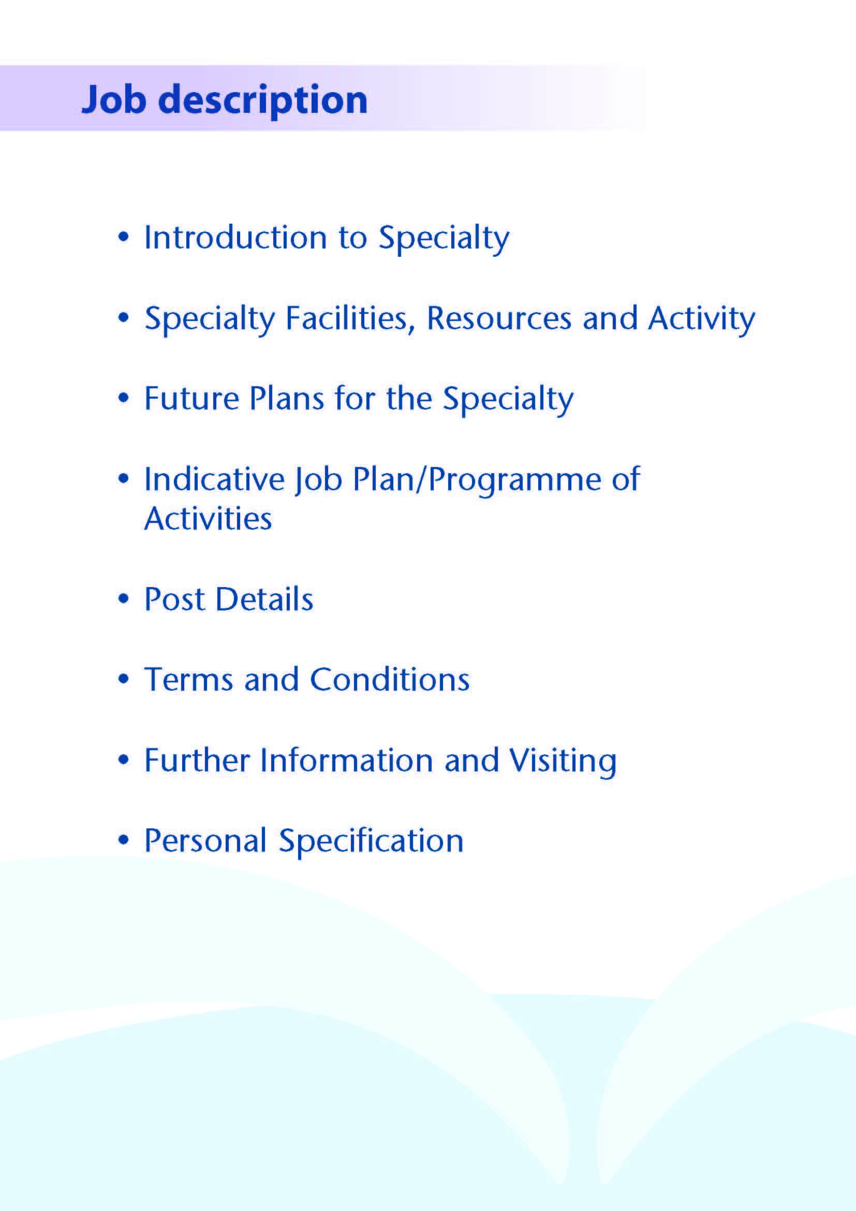



NHS Ayrshire and Arran has invested significantly in mental health service development over recent years following a major strategic review. This has resulted in the creation of a 24 hour crisis service, expansion of primary care mental health services, new services for eating disorders and development of mental health practitioners within local GP practices. All acute psychiatric beds are now sited in our purpose-built inpatient unit, Woodland View, which opened on the Ayrshire Central Hospital campus in Irvine in 2016.

A vacancy has arisen for a dynamic and enthusiastic Consultant in General Adult Psychiatry to join our East Ayrshire Community Mental Health Service (EACMHS), and to play a key role in supporting ongoing exciting and innovative developments.

There is one full time (1.0 WTE) post currently available with community and inpatient responsibilities which can be negotiated on job planning with the responsible Clinical Director. The successful candidate will be one of 4.5 WTE Consultants providing input to the multidisciplinary EACMHS based at the North West Kilmarnock Area Centre, part of the East Ayrshire Health & Social Care Partnership.



Adult inpatient mental health services in Ayrshire are provided within our purpose built community hospital, Woodland View, with general adult (acute), elderly, continuing care, rehabilitation, IPCU and alcohol rehabilitation wards. There is a smaller unit providing elderly and rehabilitative services based on the Ailsa Hospital site in South Ayrshire. There are three General Adult Community Mental Health Teams (CMHTs) in Ayrshire: East, North and South.

The East Ayrshire CMHT consists of:

4.0 Consultants

1.0 Staff Grade Doctor

3-4 Core/GPST/F2 trainees

1 Higher Trainee

1 Nursing Team Leader

6.0 WTE Charge Nurses

7.0 WTE staff nurses

1.0 WTE Health Assistant

0.2 WTE Community Mental Health Pharmacist

0.9 WTE Consultant Clinical Psychologist

4.5 WTE Clinical Psychologists

2.5 WTE Clinical Associates in Applied Psychology (Primary Care)

7.96 WTE Occupational Therapy

8.23 WTE Admin staff

**Medical Staff Resources, Consultant Grade:**

**ADULT**

**East Locality**

Dr Aileen Guthrie (East Community Clinical Director)

Dr Morag Henderson

Dr Anna Ulanova

Dr Yasmin Whitelaw

Vacancy (this post)

**North Locality**

Dr Alison MacRae (North Community Clinical Director)

Dr Everett Julyan

Dr Alex McLean

Dr Eilidh Orr

**South Locality**

Dr Jacqui Scott (South Community Clinical Director)

Dr Tim Johnston

Dr Adrian Nitu

**Rehabilitation**

Dr Krzysztof Tyczynski

**Perinatal**

Dr Malcolm Cameron

**Liaison**

Dr Ben Chetcuti (Acting Clinical Director)

Dr Kim Newlands

Dr Julie Langan Martin

**Psychotherapy**

Dr John Prestwich

**Forensic/IPCU**

Dr Dawn Carson (Inpatient, Rehabilitation & Forensic Clinical Director)

Dr Partha Gangopadhyay

Dr Gillian Howieson

Dr Ishbel MacFarlane

**Elderly**

Dr Debbie Browne (Deputy Medical Director)

Dr Mark Luty (Clinical Director)

Dr Gillian Scott

Dr Stephanie Cowan

Dr Dominic Gallagher

Dr Susan Maxwell

**Elderly Liaison**

Dr Joseph Sharkey

Dr Alan Spratt

**CAMHS**

Dr Helen Smith (Clinical Director)

Dr Tahir Ali

**Learning Disability**

Dr Claire Hughes (Clinical Director)

Dr Douglas Paterson

Dr Omer Rashid

**Addictions**

Dr Beinn Wilson (Clinical Director)

Dr Clare Duncan

Dr Karthik Kessavelou

Dr Caroline Woolston

Dr Moninder Saagar

**Non-consultant Grade:**

The consultant posts are supported by several Speciality Doctors, up to 20 trainees (FY2/GPST/ST1-3) and a varying number of Higher Trainees in Psychiatry (ST4-6)

**Administrative Support**

Successful applicants will have access to such general administrative support as is required for the discharge of their duties.

**Education**

Woodland View has its own library and training facilities on site for local postgraduate teaching. Crosshouse and Ayr Hospitals have the Alexander Fleming Education Centre and MacDonald Education Centre, respectively. These host well stocked libraries with good electronic facilities, a lecture theatre with state-of-the-art equipment and meeting rooms.

Successful applicants will be expected to participate in the local postgraduate psychiatric training programme and to be involved in the teaching of medical undergraduates.



A new low secure unit opened on the Woodland View site in January 2017 and Woodland View will host the new national medium secure adolescent unit later this year.



The post will consist of up to 10 programmed activities. The nature and timing of activities shown in the timetables are indicative and the precise nature of the duties will be agreed with the successful candidates at a job planning meeting with the Clinical Director. Timetables will be reviewed to meet the changing needs of the service and post-holder, subject to discussion and job planning. Flexible working is encouraged.

|  |  |  |  |  |  |
| --- | --- | --- | --- | --- | --- |
|  | Mon | Tues | Wed | Thur | Fri |
| am | Out-patient Clinic  (North West Area Centre) | Ward Reviews Reviews/CMHT work | Division of Psychiatry  (monthly) | SPA  Teaching | Ward Round  Woodland View Hospital, Irvine |
| pm | CPA/Mental Health Act work/Home Visits  Trainee Supervision | Out-patient Clinic  (North West Area Centre) | CMHT MDT | Clinical Admin/Tribunal Work | SPA |

**Proposed Weekly Programme**

The proposed weekly programme is illustrated above. Activities with current fixed time commitments will be carried out as detailed in the work programme, e.g. clinics, multidisciplinary meetings (MDT) and on-call, with flexibility as required.

CMHT work can include medical input to the crisis team, urgent individual or joint assessments, home visits, clinic appointments, mental health act work, CPA or AWI work, depending on the dynamic needs of the service.

Other DCC and SPA activities are shown with indicative timings within the weekly programme and will be agreed with the consultant.

The job plan incorporates all the consultant’s professional duties and commitments including agreed Supporting Professional Activities.

Opportunities may exist for Extra Programmed Activities to be undertaken subject to service requirements and in accordance with national terms and conditions of service.

Administration: This activity covers the management of individual patients including outpatient administration, results reporting, letters/phone calls to patients, carers, GPs and members of the wider multidisciplinary team involved in patient care as well as medico-legal documents.

Travel: Any travel allocation will be included within the Total Programmed Activities and will be determined by location at which Direct Clinical Care and Supporting Professional Activities are carried out.

On call arrangements: The successful applicants will be part of the rota, currently 1 in 26. The availability supplement is level 1 (currently 3%).

**Supporting professional activities and job plan review**

NHS Ayrshire and Arran recognise the important role job planning has in ensuring consultants are supported in delivering high quality, safe, sustainable clinical care to patients. It is important, therefore, to ensure there is an adequate balance between direct clinical care activities and those activities which support both the personal and professional development of the consultant workforce and facilitates agreed contribution to activities including:

* Under- and post-graduate teaching and training
* Clinical Governance
* Quality Improvement and Patient Safety
* Research and innovation
* Service management and planning
* Work with professional bodies

All consultants will have one SPA as a minimum to support job planning, appraisal and revalidation. However, the final balance of SPA and DCC activity will be agreed between the appointee and clinical manager prior to contracts being agreed.

There may be a requirement to vary the DCC outlined in the indicative timetable when the final balance of DCC and SPA is subsequently agreed. There may be opportunities to contract for Extra Programmed Activities subject to service requirements and in accordance with national terms and conditions of service.

If a post holder will be responsible for the formal training and supervision of post-graduates and undergraduates, allocation of SPA time will be made in accordance with national guidance.

Job plan review: New appointees will have an interim job plan review three months post commencement to review the balance previously agreed. The agreed job plans will include all the consultants’ professional duties and commitments, including agreed Supporting Professional Activities.    Thereafter job planning will be carried out annually as part of the Board’s job planning process.

Research: Research is encouraged and supported by an active Research and Development Committee. Appointees will be encouraged to develop research interests associated with their specialist interest.



The main duties and responsibilities of the posts include:

* Providing consultant level leadership and medical input to the service
* Providing consultant level assessment, diagnosis and treatment of new and existing patients presenting to services
* Liaising with mental health colleagues across disciplines and with health and social care partners in support of comprehensive patient care
* Liaising with GPs and third sector agencies
* Acting as RMO for patients subject to mental health legislation
* Undertaking domiciliary visits and emergency assessments where appropriate
* Undertaking Mental Health Act/Adults with Incapacity Act work
* Providing medical input to the East Ayrshire Crisis Resolution Team when required
* Participation in the local psychiatric training programme
* Involvement in teaching and supervision of medical students and junior doctors (subject to job plan negotiation)
* Participation in medical audit and continuing professional development
* Compliance with NHS Ayrshire & Arran Clinical Governance policies
* Involvement in appraisal and job planning.
* Participation in the consultant on-call rota, currently 1 in 26



Terms and Conditions of Service are those determined by the Terms and Conditions of the New Consultant Grade (Scotland) as amended from time to time. The distance that a consultant can reside from the principal base hospital, where travel time is seen as more important than mileage, is subject to the agreement of the Medical Director.



For further information or to arrange an informal visit please contact **Dr Aileen Guthrie**, Clinical Director or **Dr Morag Henderson**, Consultant Psychiatrist, on **01563 578593** or **Dr Debbie Browne**, Deputy Medical Director, on **01563 578646**.



**POST OF : CONSULTANT IN GENERAL ADULT PSYCHIATRY**

## BASE LOCATION : EAST AYRSHIRE CMHT, NORTH WEST AREA CENTRE, KILMARNOCK

## QUALIFICATIONS:

|  |  |
| --- | --- |
| ESSENTIAL | DESIRABLE |
| Full GMC Registration (with Licence to Practice) |  |
| Existing Consultants: Inclusion on the GMC Specialist  Register for General Adult Psychiatry  .  New Consultants: Be within 6 months of the  anticipated award of CCT/CESR CP  by the time of interview. |  |
| MRCPsych (or equivalent) |  |
| Section 22 approval under the Mental Health (Care and Treatment)(Scotland) Act 2003 |  |
| Full Driving Licence |  |

|  |  |  |
| --- | --- | --- |
| **SKILLS/**  **KNOWLEDGE/**  **COMPETENCE** | **ESSENTIAL** | **DESIRABLE** |
| **General Experience** | Broad experience and knowledge in the field of psychiatry | Training in a relevant psychotherapy, e.g. CBT, EMDR, DBT or MBT |
|  | Ability to communicate effectively with all levels of staff and patients |  |
|  | Ability to work efficiently with good time management |  |
|  | IT literacy |  |
|  | Good record keeping skills |  |
| **Team Working** | Commitment to being an effective team player, establishing and maintaining patient-centred collaborative relationships |  |
|  | Ability to recognise value of and develop working relationships with partnership agencies |  |
|  | Willingness to contribute to development and clinical leadership of the multidisciplinary partnership |  |
| **CPD** | Evidence of relevant Continuing Professional Development |  |
| **Teaching and Training** | Engagement with teaching and training | Interest in and knowledge of advances in medical education and training |
| **Research and Publications** |  | Evidence of publications in peer reviewed journals |
| **Clinical Audit** | Participation in regular medical audit |  |
| **Management and Administration** | Proven organisational skills |  |
| **Personal and Interpersonal Skills** | Flexibility to meet the changing needs of the service |  |
|  | Effective communicator and negotiator |  |
|  | Open and non-confrontational |  |
| **Professional values and practice** | Committed to practicing according to the GMC’s Good Medical Practice, and the RCPsych’s Good Psychiatric Practice |  |