# NHS FORTH VALLEY

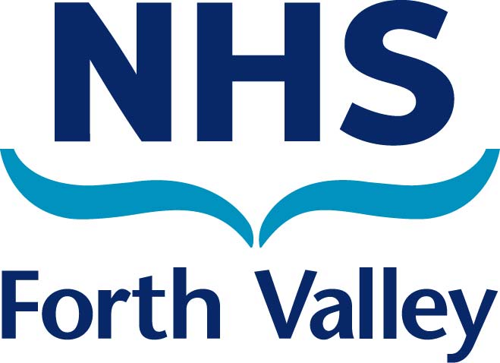

# JOB DESCRIPTION

**1. JOB DETAILS**

**Job Title: Orthodontic Dental Nurse**

**Responsible to: Lead Dental Nurse**

**Department(s): Orthodontic Department**

**Job Holder Reference: A-N-S-065**

**2. JOB PURPOSE**

* To provide specialist four handed chair side assistance to all clinicians including preparation of materials and instruments for specialist Orthodontic care.
* To assist with the preparation and delivery of specialist Orthodontic care to patients with complex malocclusions.
* To provide daily administrative assistance to meet the requirements of the Department.
* Will work in co-operation with the Lead Dental Nurse.

**3. ORGANISATIONAL POSITION**

**ROLE OF DEPARTMENT**

**SEE APPENDIX 1**

**4. DIMENSIONS**

Within Forth Valley, Orthodontics is a Consultant led specialty within the Acute Operating Division, Surgical Unit and is based at Forth Valley Royal Hospital.

The Orthodontic Department comprises:

* Consultant Orthodontists
* Staff grade
* Orthodontic Therapist
* Hygienist
* Senior Dental Technician
* Lead Dental Nurse
* Senior Dental Nurse
* Dental Nurses

**5. KEY DUTIES/RESPONSIBILITIES**

* Provide specialist four handed chair side assistance to all clinicians on a daily basis.
* Preparation of surgeries prior, during and after clinical procedures.
* Act as a chaperone to clinician at all times in the clinical setting
* Assist with the turnaround of the Sterile Services (ASDU) to ensure adequate instrumentation is available for clinical procedures.
* To keep abreast of current trends and developments within Orthodontics, using current evidence based practice.
* Liaise with other medical disciplines to provide continuity of care.
* Provide specialist Oral Health Education to Orthodontic and Orthognathic patients (pre and post operative) to clinicians prescription
* Assist with ordering and maintenance of materials, sundries and equipment.
* Participate in and assist with departmental audits.
* Maintenance of discharge system.
* Use of departmental computer for medical records and associated administration tasks.
* Assist Consultant with patient records, correspondence and appointments.

**6. SYSTEMS AND EQUIPMENT**

**Systems**

* Information Management, TRAK, EDMS, PACS and Dolphin
* Use of departmental computer and email to enable the dept to communicate with others more effectively.
* Recording of referrals from General Dental Practitioners, General Medical
* Assist with the compilation of local statistical information.
* Tracking sterile packs for audit purposes.
* Completion of complaint and repair forms for Sterile Service system.

### Equipment

* Knowledge of all specialist equipment and materials used in Orthodontics e.g. bracket and band systems, with daily clinical involvement.
* Maintenance of discharge system.
* Fault finding skills of specialist clinical equipment e.g. how to dismantle and reassemble hand pieces, using a light meter, determine when intensity of bulb in a light curing unit is not adequate to set dental materials.

**7. ASSIGNMENT AND REVIEW OF WORK**

* Responsible to Consultant Orthodontist and Lead Dental Nurse for clinical guidance and professional management.
* Workload to be assigned by Lead Dental Nurse
* Anticipate the nursing needs and problems of the Dept and resolve these using own initiative.

## Analytical and Judgemental skills

* Implementation of policy and guidelines set out by the Trust.
* Liaise with other professionals eg X-ray Dept, Dental laboratory, Medical Records and Estates, to ensure operational output is maintained.
* Anticipate and identify what instrumentation is required by the operator during specialist dental procedures.
* Fault finding skills of specialist clinical equipment eg how to dismantle and reassemble dental hand pieces with intricate parts.
* IR1 forms completed.

**8. COMMUNICATIONS AND WORKING RELATIONSHIPS**

* Report to Lead Dental Nurse on a daily basis for matters of clinical governance and professional guidelines.
* Participate in quarterly departmental Clinical Governance meetings.
* Specialist Oral Health Education advice to patients eg hygiene and appliance care. Pre and post operative dietary advice to the Clinicians prescription.
* Effective and professional communication skills with patients, relatives and colleagues where the complexity of the information has to be adapted to suit the age comprehension of the patient eg small child, teenager, special needs patient or patients with communication difficulties.
* Liaise with other medical disciplines, specialist practitioners, General Dental Practitioners and other Dental Institutions.
* Liaise with contractors, company representatives and internal trades.

**9a. PHYSICAL DEMANDS OF THE JOB**

* Sustained restricted manoeuvring and positioning during specialist chair side assisting for majority of shift on a daily basis.
* Dental Nurses require developed physical skills where there is a requirement for speed and accuracy. These skills are particularly relevant for four handed dental procedures for the majority of the working day.
* Speed and accuracy are essential for the manipulation of specialist dental materials eg mixing alginate impression material to the correct consistency and right temperature for patient comfort and setting time. Dispensing chemical cure material onto dental brackets for fixed appliance procedures.
* Dismantling and assembly of specialised equipment for clinical procedures eg dental hand pieces.
* Movement of ASDU (sterile services) instrument packs from trolley to storage area.
* Pushing trolleys to transport bulky stores and Orthodontic model boxes.
* Sitting, standing and walking form the daily routine of the post.
* Daily environmental duties include the cleaning and disinfection of clinical areas, occupational spillage and body fluids eg saliva, blood and vomit.

### Working Conditions

* Sustained restricted manoeuvring and positioning during specialist four handed procedures.
* Frequent disinfection of contaminated impressions, adhering to British Dental Association guidelines.
* Environmental duties including the containment of spillages and body fluids on a daily basis using hazardous chemicals eg Actichlor.
* Hazards of sharps injury from dental wires on a daily basis.
* Working at height to retrieve model boxes.
* Dealing with verbal aggression from patients/carers.
* Sit, stand and walk for majority of shift.

**9b. MENTAL/EMOTIONAL DEMANDS OF THE JOB**

* Frequent sustained concentration required whist assisting in the delivery of specialist dental care and advice, processing statistics and assisting in the compilation of confidential medical information, while enduring frequent interruptions from telephone enquiries and work colleagues on a daily basis.
* Acting as liaison for patients/carers whose expectation of treatment differs from what the service can provide eg case complexity for hospital treatment too low.
* Dealing with distressed and anxious patients who present with physical or mental problems.
* Dealing with patients with unpredictable behaviour.
* Ability to adapt quickly to changes at short notice.

**10. KNOWLEDGE, TRAINING AND EXPERIENCE REQUIRED TO DO THE JOB**

* Hold the Certificate from the National Examination Board for Dental Nurses or certificate of proficiency recognised by the Association of Dental Hospitals of Great Britain and Northern Ireland and awarded following a full time course of training of at least one year or an equivalent qualification.
* Knowledge of a range of dental nursing procedures acquired through experience, the equivalent of accepted National benchmark standards.
* A minimum of 2 years experience since qualifying is desirable.
* Specialist clinical and technical knowledge in the area in Orthodontics.
* Understand the principles of decontamination and infection control.
* The post holder will be required to participate in continuing professional development.

**11. JOB DESCRIPTION AGREEMENT**

**Job Holder’s Signature:**

**Date:**

**Head of Department Signature:**

**Date:**

**APPENDIX 1**

**NHS FORTH VALLEY**

**JOB DESCRIPTION**

**Job Title: Dental Nurse**

**Responsible to: Lead Dental Nurse**

**Department(s): Orthodontic Unit**

**Job Holder Reference: A-N-S-065**

**A. ROLE OF THE UNIT / FUNCTION**

To provide a high quality, safe and supportive environment in order to care for patients within the Surgical Unit meeting the identified physical and psychosocial needs.

# B. ROLE OF THE DEPARTMENT

To provide high quality effective care for patients requiring Orthodontic procedures. This includes minor surgery, intermediate procedures and major complex procedures. Care is provided during the acute phase and includes rehabilitation and on-going assessment/management within a multi-disciplinary team.

# C. DEPARTMENT ORGANISATION CHART

SERVICE MANAGER

LEAD DENTAL NURSE

SENIOR DENTAL NURSE

ORTHODONTIC DENTAL NURSE - THIS POST

NHS FORTH VALLEY

PERSON SPECIFICATION

**Job Title – Dental Nurse – Orthodontics**

**Band – 4**

**Department / Base – Outpatient Service, Forth Valley Royal Hospital**

|  |  |  |
| --- | --- | --- |
| **ATTRIBUTES** | **ESSENTIAL** | **DESIRABLE** |
| **Skills/Abilities** | Excellent communication skills.  Ability to work on own initiative.  Able to work effectively as part of a team.  Good time management  Ability to prioritise tasks |  |
| **Experience** | Experience of working with  children | Previous experience since qualifying  Experience of working with a multi disciplinary team |
| **I****nter-personal and social qualities** | Good interpersonal skills.  Friendly disposition. |  |
| **E****ducation / Qualifications** | Dental Nursing qualification  Evidence of current GDC registration.  Evidence of continuing professional development | Post qualification in  Oral Health education |