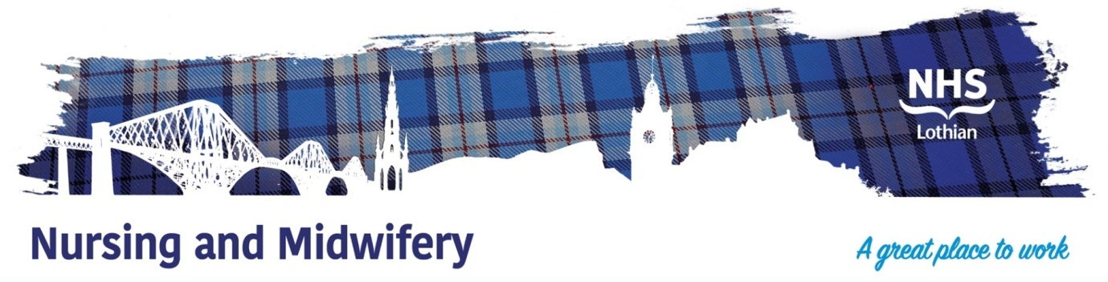

**NHS Lothian Regional Eating Disorders Unit (REDU)**

Exciting opportunities are available to join Regional Eating Disorders Unit (REDU) within St John’s Hospital site within NHS Lothian. We have Band 5 positions available for Registered Nurses and we are looking for passionate, caring, motivated people to join our highly skilled nursing teams.

We offer the opportunity to work within a professional multi-disciplinary team consisting of Nurses, Psychiatrists, Occupational Therapist, Dieticians, Dietetic Support workers, Clinical Support Workers and a range of professionals within health boards that sit within the south east of Scotland. REDU will take admissions from NHS Forth Valley, Fife, Borders and Lothian. You will be able to liaise with the regional community eating disorders teams providing a pivotal link in the care and treatment of REDU patients supporting their recovery journey from admission to discharge.

Find out what our staff say about working in NHS Lothian at https://careers.nhslothian.scot/acute-specialist-nurses/who-we-are/

**What We Can Offer You**

We have vacancies for experienced and newly qualified nurses to join our innovative and dynamic team– providing you with the opportunity to gain a breadth of knowledge and eating disorders specific training opportunities. You will be welcomed into a highly supportive, knowledgeable and fun team.

**Roles:**

* **To co-ordinate the shift**
* **To provide meal support in the dining room to patients**
* **To provide artificial feeding to patients via NG feeding**
* **To support patients during Post Meal Observations**
* **To provide daily 1:1’s to establish patient’s mental state**
* **Keywork patient and focus on an individual piece of work e.g Anorexia Workbook and**
* **Body Image,**
* **Anxiety Management,**
* **Self esteem,**
* **Exposure work,**
* **Perfectionism,**
* **Decider Skills,**
* **To dispense medication as per Hepma to patients,**
* **To complete risk assessments,**
* **To make patient centred care plans in collaboration with patients,**
* **To liaise with families and carers,**
* **To monitor patients physical health e.g**
* **Bloods - venepuncture**
* **ECG**
* **Physical observations**
* **Skin Health**
* **To be part of the group programme within the unit either as a facilitator or co-facilitator**
* **To be part of ward round, review meetings, admission and discharge of patients in the ward.**
* **To be a supervisor and/or assessor of students in the ward for active learning experience.**

**Salary**

* Band 5 Range £30,229 – £37,664 (pro rata) per annum

**Benefits**

* A minimum of five weeks annual leave increasing with length of service
* A range of supportive employment policies including Flexible Working
* Full or part time hours considered
* We provide an extensive induction programme and excellent professional training and development opportunities.
* Access to the NHS Pension Scheme and Staff Benefits

**Regional Eating Disorders Unit (REDU)**

Please see link below for a video tour of the unit and some information about the treatment and services that the unit provides.

(**https://vimeo.com/721439154opens a new window**).

Please see below the link to the website for REDU and the community outpatient teams that are linked into the service.

Regional Eating Disorder Unit – South East Eating Disorders Scotland (nhslothian.scot)

  